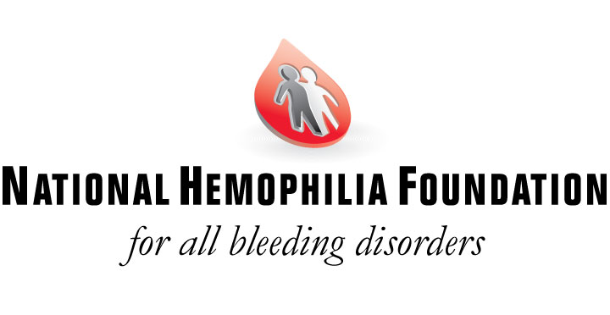

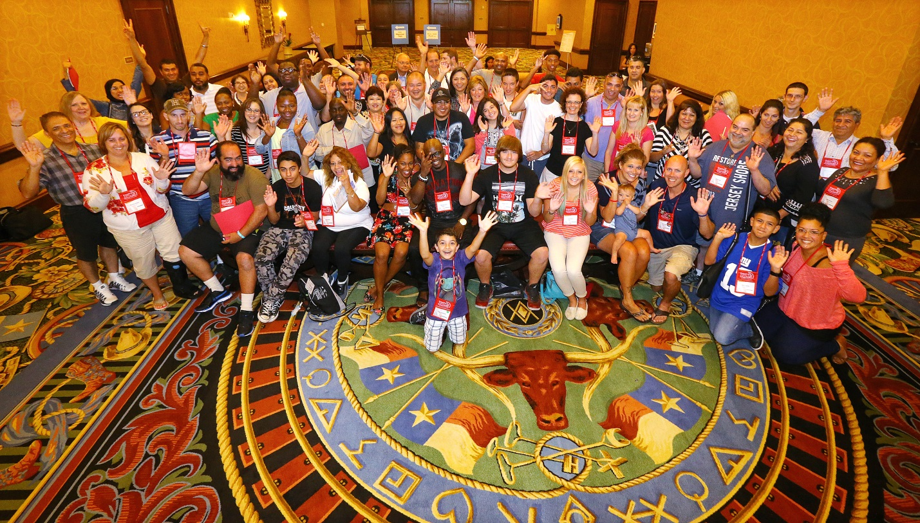
Connections for Learning Families at the 2015 NHF Annual Meeting in Dallas, Texas

Report: Connections for Learning 2015
November 2015

In August 2015, the National Hemophilia Foundation hosted its 67th Annual Meeting in Dallas, Texas. This three-day conference provides the latest research findings, educational sessions from top-notch experts and healthcare professionals, and networking events for individuals and families alike. Close to 3,000 individuals were in attendance - from families with bleeding disorders to chapter staff, healthcare providers and industry partners. This year, thanks to your support, included in our list of attendees were 35 families whose attendance was made possible by the Connections for Learning Program.
It’s been a few months since we all returned from Dallas. Since then, several letters have been received from Connections for Learning participants documenting their experience and thanking NHF for the opportunity. Below are two additional testimonials from this year’s participants:

- I was and am so thankful to say that I had the opportunity to attend the NHF conference this year in Dallas, Texas. The conference was put together so well that I truly enjoyed every moment of it. In addition to that, I was thoroughly impressed by all the different meetings and different types of meetings that attendees were able to choose from. However, my favorite moments by far all included the great conversation and knowledge I was able to obtain from all the different people I was able to speak with. It is amazing to have a time and place where you can mingle with people that know and understand exactly what you're going through. This year I even met another girl that was my own age that also has Glanzmann's Thrombasthenia. It was amazing to be able to share our experiences and treatments that worked or didn't work. We were able to exchange information and now can keep in touch. As I mentioned earlier, I am deeply appreciative that my brother and I were granted with the opportunity of attending the NHF conference and support this outstanding organization down to the core.

- My experience attending the NHF meeting of 2015 was a great one! The people were beyond over the top helpful, friendly and caring. I met so many new families and contacts to remain in touch with. My kids and I had a great time spending much needed time together. My kids and I also enjoyed the afterglow events and the final night event. The grants that NHF provide for families to attend these type of gatherings is so helpful to the community. It enables us to interact, learn new findings, and meet new families and connect with old. Without the support from NHF we would not have been able to attend the meeting and we are forever thankful for the opportunity we had. I hope they can continue to have funding to bring people together again and more often!

These experience and stories would not be possible without donors like you. Again, thank you for your continued commitment to the National Hemophilia Foundation, helping us to ensure we can provide much needed support to the national bleeding disorders community.

