**[the United States Army](http://www.army.mil/)**

Top of Form

* **RESOURCES**

* [**News Archives**](http://www.army.mil/news/jumparchive/)**>**
* **Article**

**'Old Guard' Soldiers, horses assist wounded warriors with therapeutic riding**

June 12, 2012

By [**Sgt. Luisito Brooks**](http://www.army.mil/search/articles/index.php?search=Sgt.+Luisito+Brooks)

* 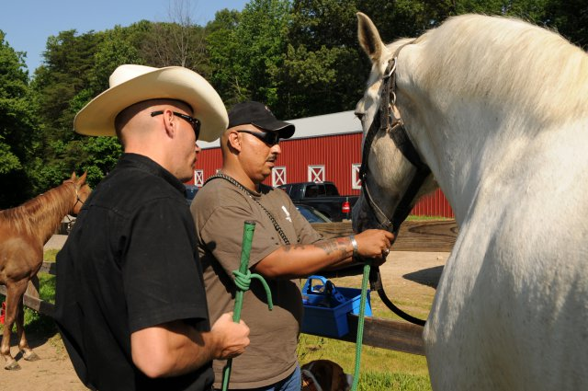
* 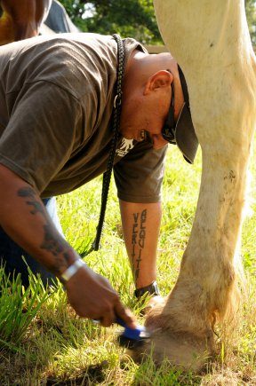
* 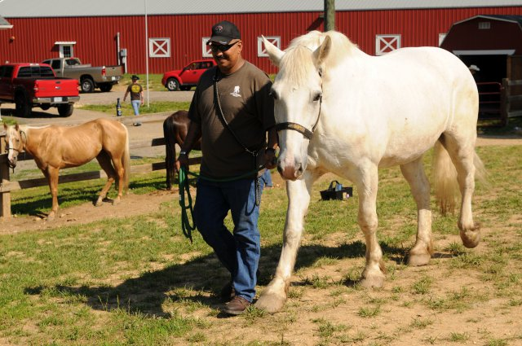
* 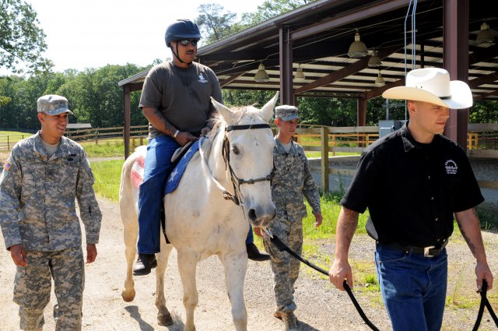
* 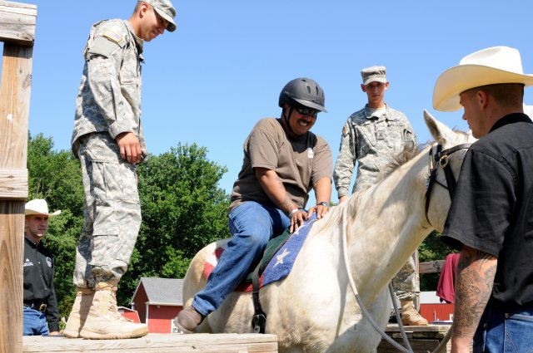

**Related Links**

* [Army.mil: Warrior Care News](http://www.army.mil/warriorcare)
* [Army.mil: Health News](http://www.army.mil/news/health)
* [3d U.S. Infantry Regiment (The Old Guard)](http://www.army.mil/info/organization/unitsandcommands/commandstructure/theoldguard/)
* [3d U.S. Infantry Regiment (The Old Guard) on Facebook](http://www.facebook.com/oldguard)

JOINT BASE MYER-HENDERSON HALL, Va. (June 12, 2012) -- Approximately 175 Wounded Warriors suffering from physical wounds, traumatic brain injuries, and post traumatic stress disorder have been treated by a unique form of therapy, called the Therapeutic Riding Program.  
  
The Therapeutic Riding Program, or TRP, uses Soldiers and horses from the U.S. Army Caisson Platoon, 3d U.S. Infantry Regiment (The Old Guard), to provide equine assisted therapy for Wounded Warriors and military veterans. Those enrolled in this program groom, conduct ground work, and/or ride horses.  
  
During these once-a-week lessons, The Old Guard Soldiers serve as horse leaders and side walkers.   
  
"When we started this program in 2006 on Joint Base Myer-Henderson Hall, Virginia, we did many studies on the effects of this treatment. The facts don't lie, this is a great program," said retired Command Sgt. Maj. Larry Pence, co-founder of Caisson Platoon Equine Assisted Program. "The physical, emotional and therapeutic benefits for these Wounded Warriors are great as they continue in the process of their rehabilitation."  
  
Adam Porras, a Soldier in the Wounded Warrior Program, agrees with how beneficial the program is to service members.   
  
"I was referred by the TBI (traumatic brain injury) technician a while back. I deal with constant headaches and dizziness on a daily basis, and since I came out here a month ago, it has helped with them," said Porras. "It is really relaxing and calming out here. I like to ride, but my favorite part is when I groom the horses. [Instructors] don't try to push me to ride if I don't think I can do it. They really just encourage me because I like connecting with these animals."  
  
Porras grew up on a small farm in Pecos, Texas, and so the benefits of being around animals are obvious, but he encourages other Wounded Warriors that have never tried it to give it a shot.  
  
"This program is great for those Soldiers who want something different than usual. It's a great atmosphere with a great staff and volunteers to help with whatever you need," said Porras, while petting one of the horses. "I like all these horses out here, but I especially like Duke."  
  
He said that he has been working with Duke, an all white pure Percheron, for about a month, and there are many things to like about him.  
  
"For one thing, he was never mean to my service dog [who accompanies Porras and assists with his dizziness.] [Duke] is always nice and likes to be groomed," he said. "What I like most about Duke is his demeanor. He is real calm. I would say that he laughs at my jokes, but he may not get them," he said jokingly.  
  
Porras said that even when he comes out the stables in a bad mood, with his head or back hurting, all he has to do is link up with Duke and eventually it will all go away.   
  
"I won't get mad anymore because he will keep me entertained when I am grooming him," he said. "As long as they will have me, I will continue to come out here. It is my therapy."   
  
Pence also agrees that this program creates strong relationships between wounded warriors, Soldiers and horses in such a way that can't be replicated in any hospital.  
  
"It is both strategically and tactfully important that we have Soldiers helping Soldiers," said Pence. "It really has been one of the greatest blessings of the program."   
  
The program is specifically tailored for the individual needs and well-being of every Wounded Warrior. For the last six years on Joint Base Myer-Henderson Hall, the program has thrived serving 25-30 service members a year. In 2012, TRP was relocated to a newly built barn and stable that sits on nearly 10 acres just minutes from the Fort Belvoir Community Hospital, Va.   
  
"When Walter Reed Army Medical Center closed its doors, its Wounded Warrior Program was stationed [at Fort Belvoir, Va.,] and it's just really convenient for everyone because now everything is so close," said Pence. "With all this space, the Soldiers get to enjoy bright sunshine and a peaceful setting."  
  
Part of this whole effort is to get these Wounded Warriors from a clinical setting into a situation where they can relax and get better.  
  
"This is our first year on Belvoir, and I already see that we have a more complete program here," said Pence. "I have already had Wounded Warriors tell me that they can feel a calmness and serenity just simply driving up the driveway."  
  
There are many other great stories about service members in this program, and Pence, with his passion to help Soldiers, hopes to continue to hear these stories and help those who need it.   
  
"If I had the power to take all the 300,000 or however many Soldiers who suffer from post traumatic stress or traumatic brain injury and put them in formation in an arena and snap your fingers to heal them all I would, but you can't do that. It is a process and sometimes a long one, but as long as we are helping one Soldier, then it is all worth it," said Pence. "For me, it is a pleasure to watch the character and courage of these young men and women in this program. It is really remarkable."

Need help? Try [A-Z](http://www.army.mil/info/a-z/)