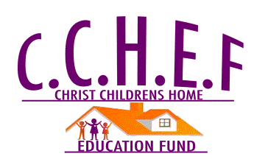
Budget for Comprehensive Academic Cener New Campus at Suakoko Bong County: Building Project in Progress

Extra document for 600 orphans
Phase One: CCH School of Promise (School building project)
Budget: $143,170.00
    - Suakoko Campus –Elementary, Junior, & Senior High School Foundation building started October 5, 2012.
    - Since the start of this project, Mr. &Mrs. Karmue have spent $12,000.00 of personal financial contribution
    - Christ Children Home Education Fund (CCHEF) has spent $5,585.00 on building the school foundation
    - Amount Spent To date on school building $17,585
    - Amount Needed to complete school building $125,585.00

The foundation and part of the west wing of the school building is complete. The school building is about 20% complete, upon completion the school building will be equipped with classes from kindergarten to 12th grade, vocational school, counseling center, nursing office, administrative offices and have the capacity to educate 600 plus students on a yearly basis. Please join us in this fight to care for and educate Liberia’s next generation of leaders

