Shaping the Future of Children at Lord Buddha Home for Children
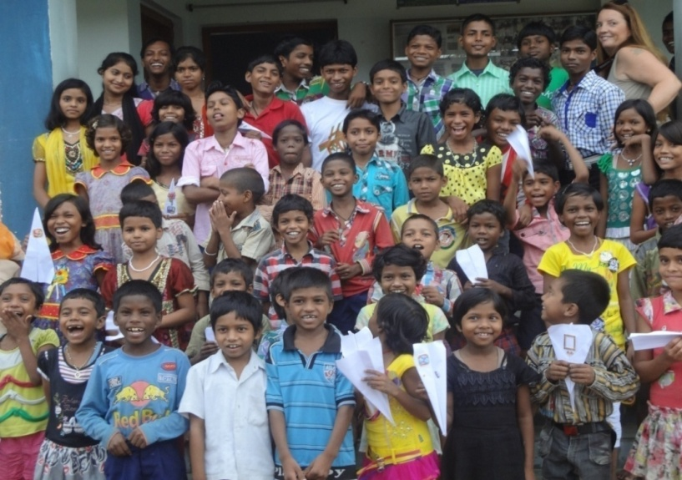
Dear Supporters and Well Wishers
Heartiest Greetings from the Lord Buddha Home for Children!
And very Happy New year to all!
With your love and kind support, children at Lord Buddha Home for children are doing very well and are healthy. During peak period of pandemic the situation for children became sensitive and hard, but by your continuous love, prayers and support all children are doing well.
In last quarter lots of activities were done at LBHC with the kind support of donors, all 70 children were provided with proper meal, opportunity for online education and enjoyed beautiful festival like Dushera, Diwali and Christmas.
All Children participated in Campus Cleaning work which is regularly done weekly. Yoga and Meditation classes are organized weekly for children to keep mind and body calm and fit. Online classes were organized for class 10th students who are preparing for their final exams in month of February 2020. Coaching classes resumed in month of November (3:30 pm to 7:00 Pm). Children also practice self study and complete their assignments and home works.
Other than academics children also participate in music classes, which are held every month. Children have fixed time for sports and games both indoor and outdoor, which is very much essential for physical exercise and for better body development of children.
Some generous guests like Ms. Shubhra and Ms. Usha Raj from Inner Wheel Club, Gaya, visited LBHC in October month and gave good wishes for best future to all children. They distributed shirts, T shirt, some slippers and snacks among the children. Mrs. Ranjeeta Agarwal visited LBHC on 13th November, 2020 and celebrated her daughter Rishika’s birthday with children and distributed cakes and snacks among children. Mr. Sudeep Agarwal from Gaya visited LBHC in December and provided some woolen blanket for children.
Counseling meeting was conducted for children to create awareness about sustainable utilization of energy, electricity, water and resources, to keep body and mind clean and practicing Yoga and meditation for peaceful mind.
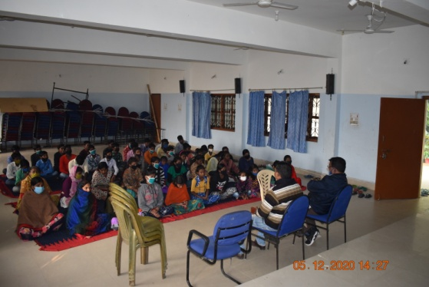
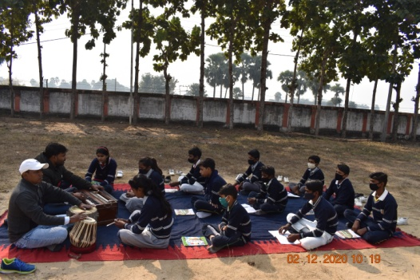
Management committee meeting is also conducted weekly in LBHC with group leaders, house mothers and members for maintaining rules and regulations up to date and also to discuss the modifications in regulations and planning activities for children.

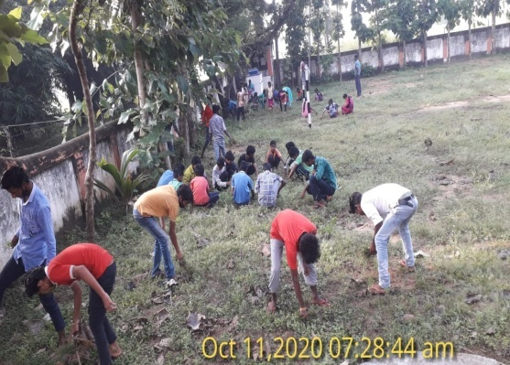
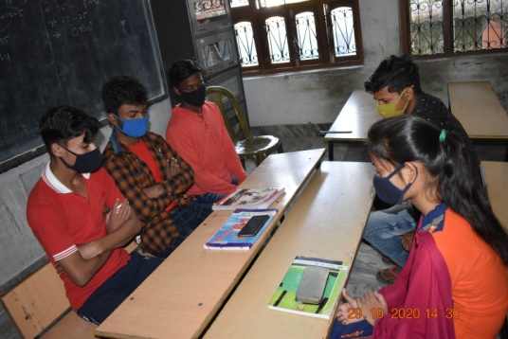
Music Classes Counseling Session

Online Classes Campus Cleaning
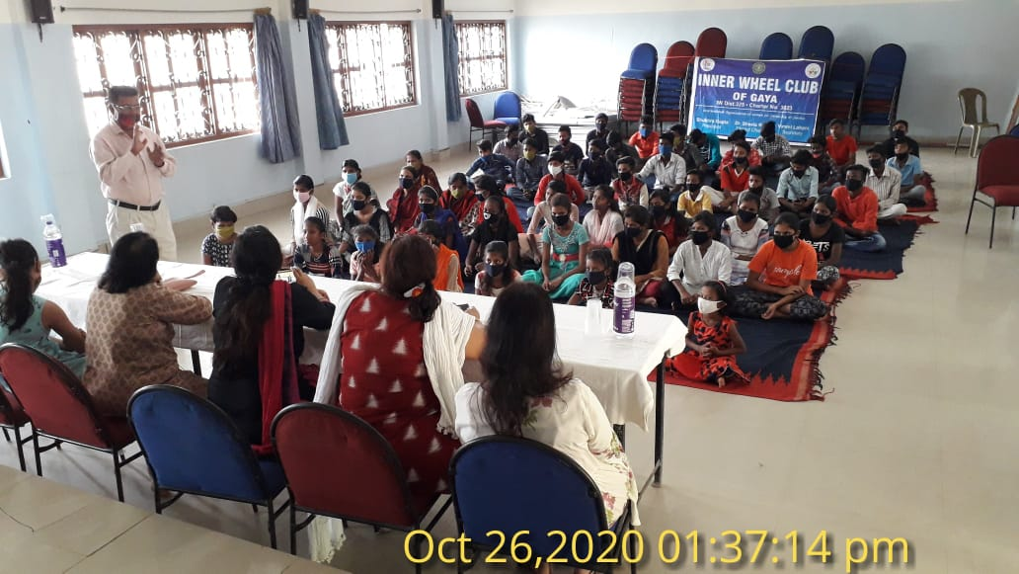
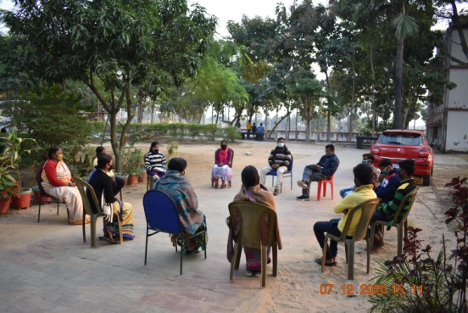

Management Committee meeting Meeting with Guests

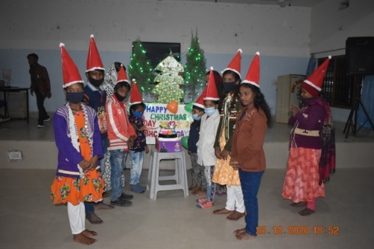
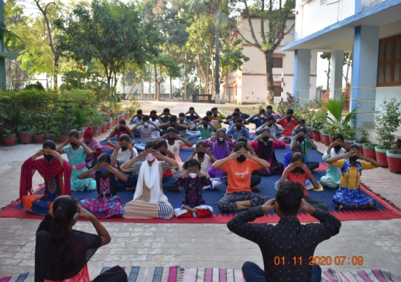

Yoga/Meditation Session Christmas Celebration
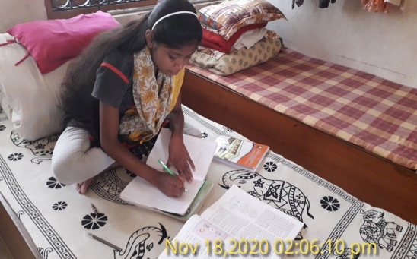
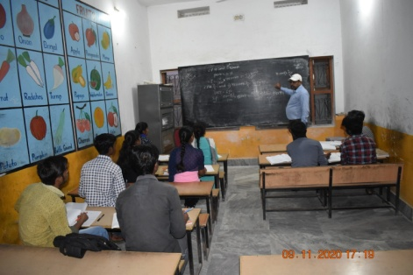

Coaching Classes Self Study

