Foundation for becoming a better human at Lord Buddha Home for children
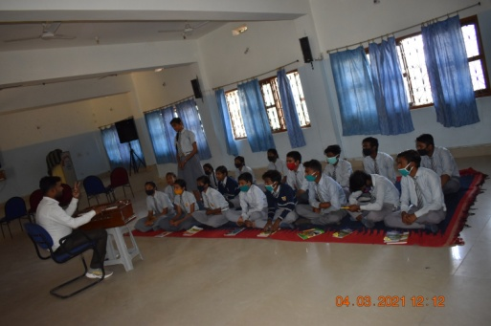

Heartiest Greetings from the Lord Buddha Home for Children!
With your love and kind support, children at Lord Buddha Home for children are doing very well and are healthy. Children are doing well in their studies and going back to school. Pandemic COVID made it difficult for all. But your continuous support helped the children in getting sufficient food and education.
In last quarter, children participated in many celebrations and started their offline classes at school along with coaching classes. Children celebrated Makar Sakranti, Republic day and Holi Festival at LBHC.
All Children participated in Campus Cleaning work which is done regularly every week. Yoga and Meditation classes were organized weekly for children to keep their body and mind fit and calm. Offline classes started from January 2021 for all children at school. Special attention was given on class 10th students who are preparing for their final Board Examination. 6 students appeared for board examination in month of February. Other classes had their annual examination in month of March at their school. Offline coaching classes were taken in their scheduled time (3:30 pm to 7:00 Pm) for all children from class 1st till 10th. Children also practiced self study and use to complete their assignments and home works.
Other than academics children also participate in music classes, which are held every month. Children fixed their time for sports and games both indoor and outdoor, which is very much essential for physical exercise and for growth of body of children. Children played games like chess, carom, cricket and football.
With generous support of Goonj, food grains like Rice, Wheat and pulses were provided for children. Other Essentials like mosquito net, bed sheet, blankets and utensils were also provided for children.
Counseling meeting was conducted for children to create awareness about sustainable utilization of energy, electricity, water and resources, to maintain self hygiene and practicing Yoga and meditation for peaceful mind.
Management committee meeting is also conducted weekly in LBHC with group leaders, house mothers and members for maintaining rules and regulations up to date, to maintain the hygiene and sanitation at LBHC and also to discuss the modifications in regulations and planning activities for children.
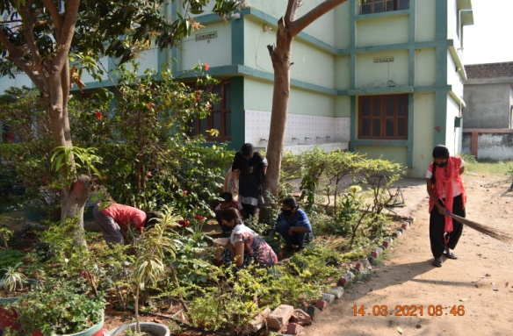
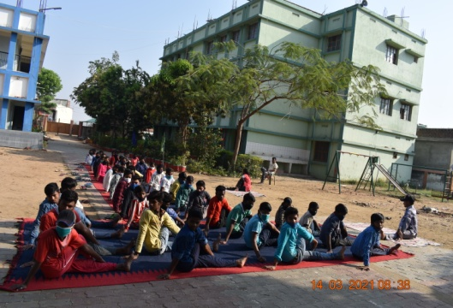

Yoga and Meditation Campus Cleaning
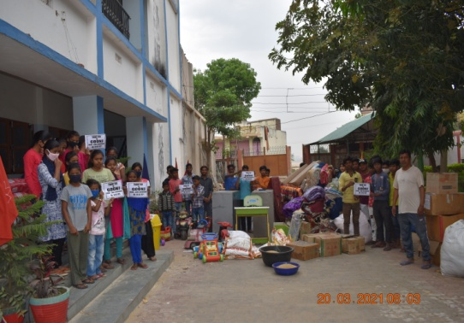
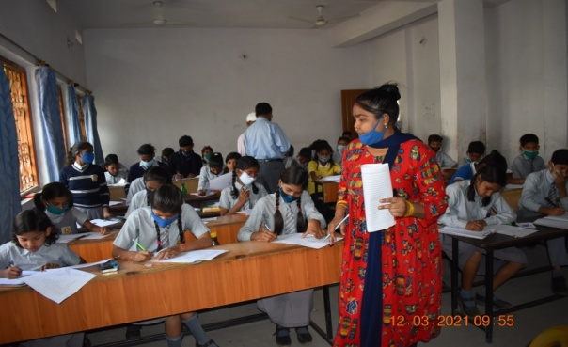
Annual Examination Relief Material from Goonj
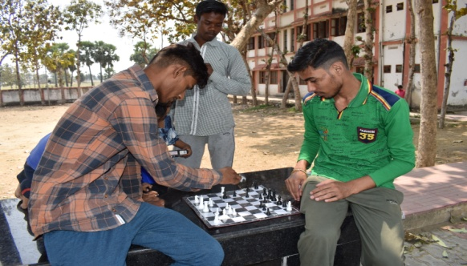
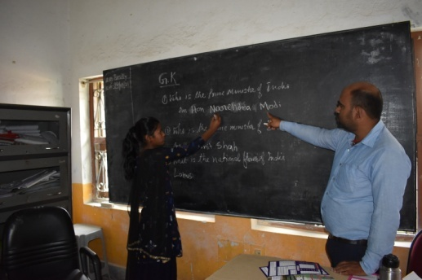

Coaching class Children Playing chess
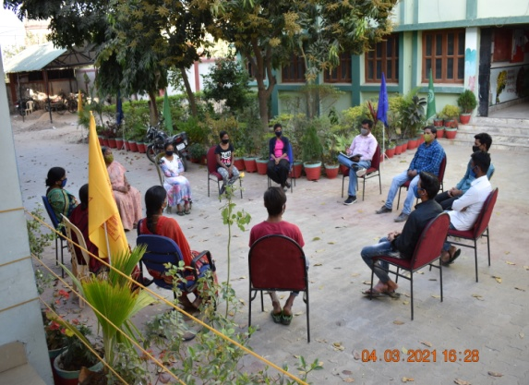
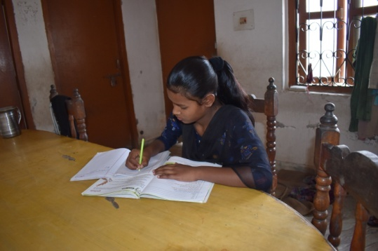

Self Study Management committee Meeting

