Thanks continued…… from our community members who are the direct beneficiaries of your support.
In the current quarter, we have primarily focus on the training of mason in target village and panchyats because the major problem is of trained session availability at village level in last 5 month’s we have conducted 8 training of Mason in Bhagalpur and Biddupur (samastipur)
One Day Mason Training on Sanitation at Baijutola, Kahalgaon Bhagalpur.
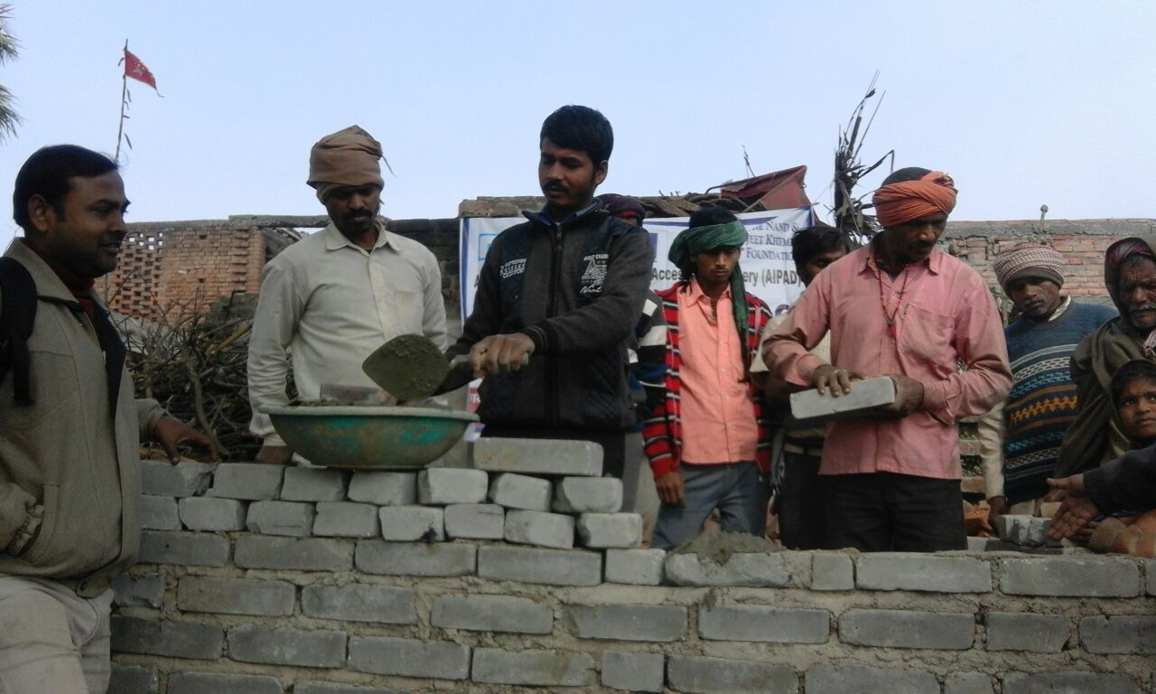
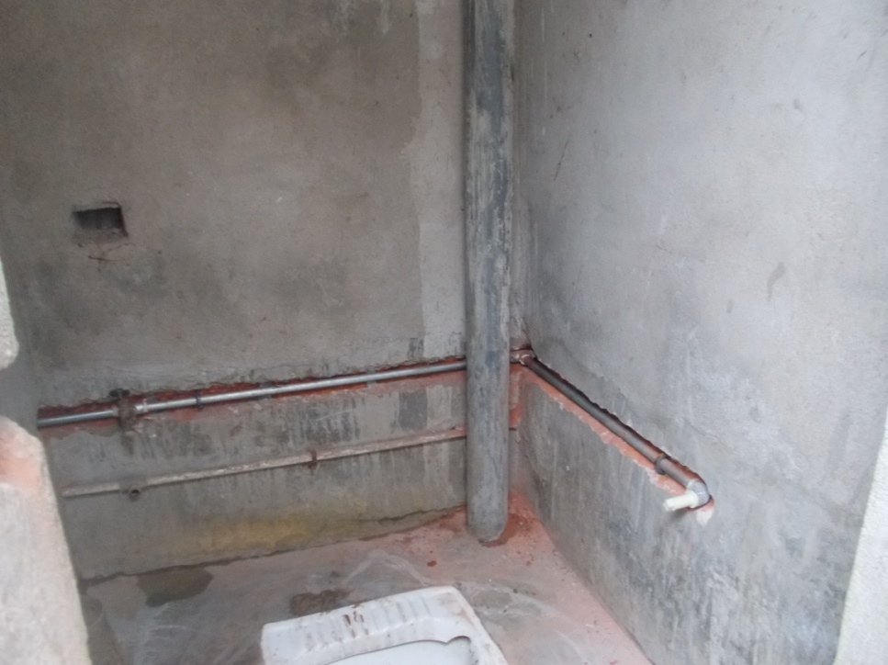
Access to Sanitation by all still remains a dream, the various programs implemented in Bihar failing to deliver the desirable results. Neither the subsidized hardware support nor the demand driven approach had helped Bihar to achieve the goal. Hence team AIPAD is engaged in exploring the community based solution to increase the access and use of toilets through Supporting Sustainable Sanitation Improvement program. This sustainable community based approach for sanitation requires products and services that the consumers are willing to pay the cost. This also demands strengthening of the supply chain and improved knowledge and capacity of the service providers, particularly the key stakeholders. Team AIPAD took the role of capacity building the relevant stakeholders in the project in 5 blocks of Bhagalpur. The project aims to train over 25, some Turnkey solution providers and PRIs members through the project.
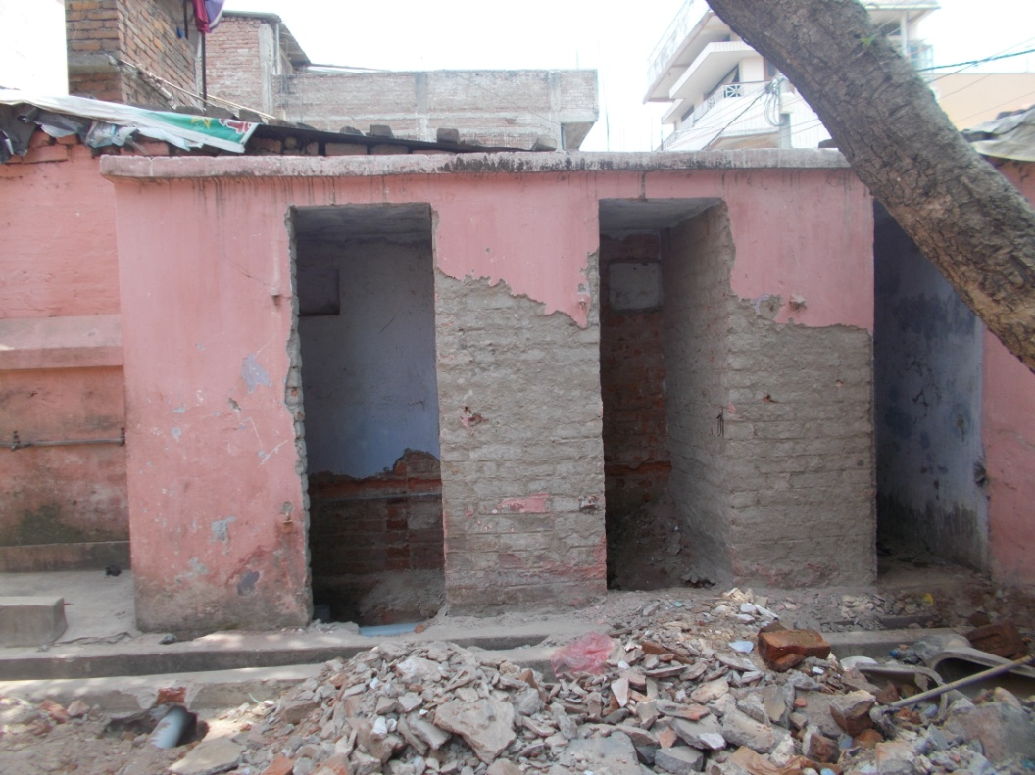
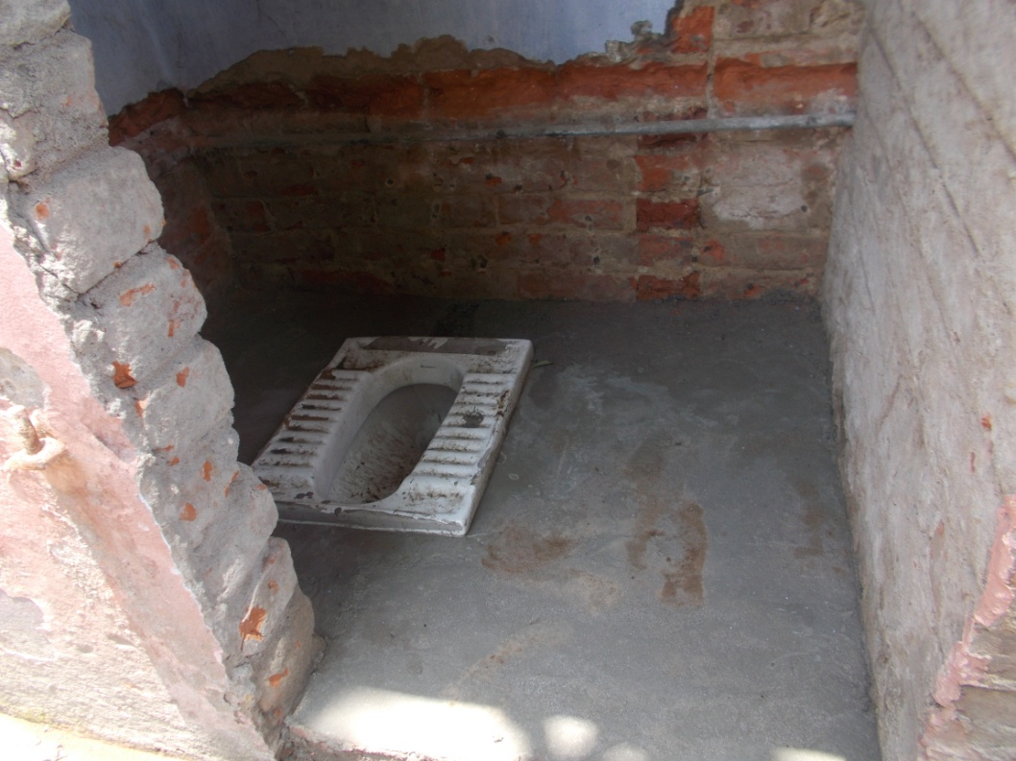
In April 2017, we have incited toilet construction in 3 school of Patna district, all these school toilet condition was in very bad shape which result into less attendance or drop out of girls child. we have taken up the challenge of construction, renovation and maintenance of at lest 50 school in coming two years.
these three school was also added with water supply, with a storage tank, this help in change and flush.
For this we conduct meeting of CRC, H.M and PRI members . these peoples give me lost of thanks and support for these work.

