NAME OF THE PROJECT is PROVIDE EDUCATION TO AIDS ORPHANS IN RURAL UGANDA

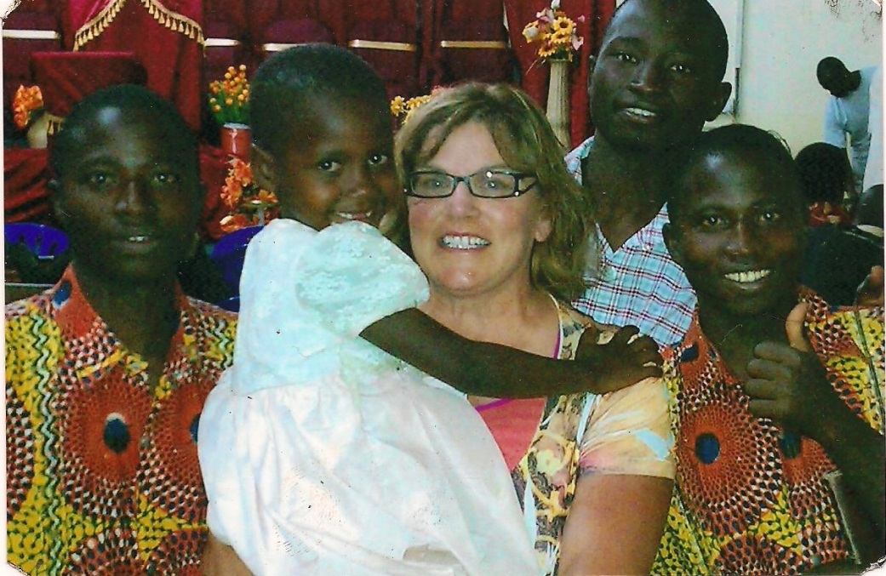

SUMMARY

The BCCBO AIDS Orphans Project is working to free orphaned children aged 6-24 from the cycle of poverty by providing a high-quality, free education, both formal and informal, to children who have been orphaned due to HIV/AIDS in order to counteract pervasive hunger, poverty, and systemic deprivation. Your donation will help provide a student with a uniform, meals, medicine, and supplies for one school year. For your secondary students, your donation will also include transportation to their school. Note these children (aged 6-24) will continue their education up to the University!

What is the issue, problem, or challenge?

Hundreds of thousands of families in Central Uganda have lost breadwinners to HIV/AIDS, and are stuck in systemic poverty cycles where children aged 6-24 lack access to healthcare, education, food, and shelter. Your support helps fight poverty by empowering these children, especially girls, through free, quality education, healthcare, and basic needs. A girl student, Jane, says, "We were suffering in the villages...I am very happy to be in secondary school where I forget about being an orphan."

How will this project solve this problem?

You and your love help operate three free primary schools for over 516 vulnerable children that provides meals, clothes, medical care, vocational training, community potable water, and a HIV/AIDS prevention program. Your love also provides scholarships to over 301 secondary school students. These scholarships cover their tuition, supplies, transportation, health care, and other services.

Potential Long Term Impact
The BCCBO Secondary and Vocational School will open to educate your students in 2015. In 2015, the very first class of students from BCCBO will be attending University, and they will graduate in 2018. Starting in 2017, you will be supporting over 1200 students, from young nursery students to passionate university students, on an annual basis. Each year, as students graduate from University, they will be replaced by 98 new nursery students, and the cycle of empowerment will be continuing.

(THIS IS ADDITIONAL INFORMATION FOR ATTACHEMENT)

The BCCBO AIDS Orphan Project is giving a hand up to thousands of the most deprived orphaned children aged 6-24 in Central Uganda. Education is our Mission but we take unique holistic human rights based approach to ending the cycle of poverty that also incorporates nearly 850 elderly grandmothers.
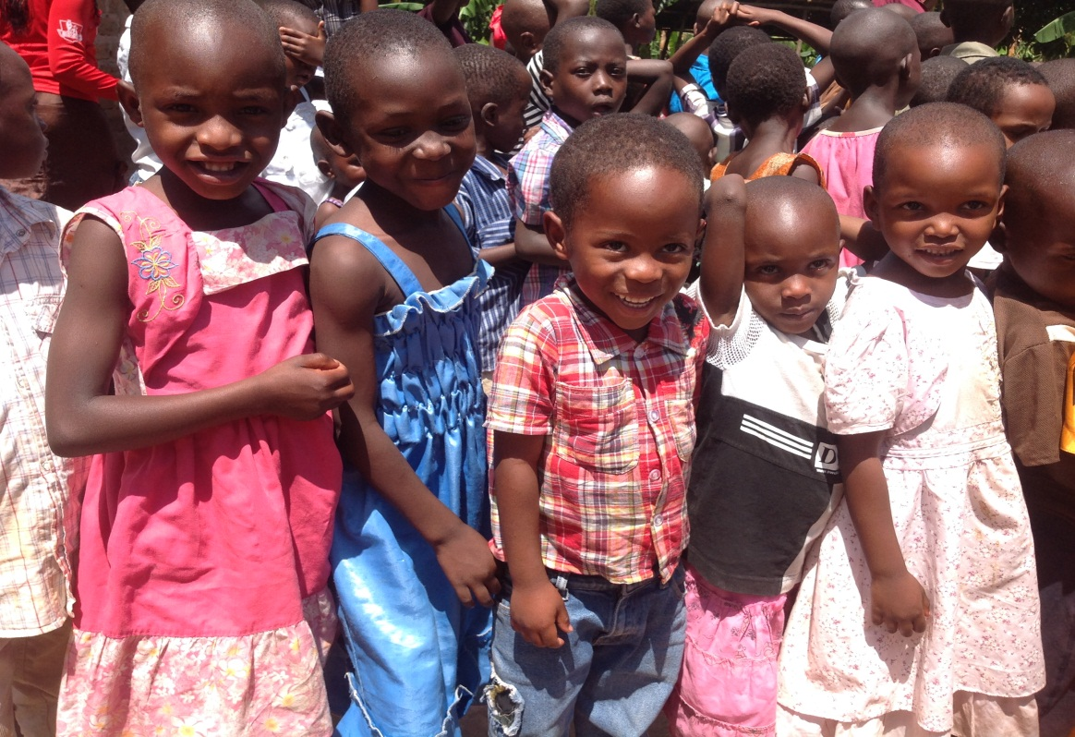

Out a population of approximately 34 million, Uganda’s HIV/AIDS Out of a population of approximately 34 million people, Uganda’s HIV/AIDS pandemic has resulted over 2.5 million orphaned children who have lost one or both parents. In addition to stigmatization and traumatization they experience for losing their parents, orphans go without many basic human needs, such as food, shelter, health care, clothing and education. While the African extended family has traditionally stepped in to support orphans, the devastating impact of HIV/AIDS pandemic has overburdened this traditional safety net. BCCBO provides continuous education to children aged 6-24, that’s to say from Nursery to Primary and from Secondary to the University.

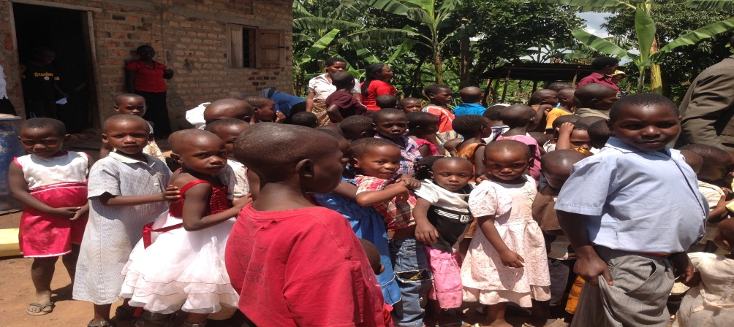
The BCCBO (Bugema Community Child Based Organization) AIDS Orphans Project was born out of this crisis. The BCCBO Orphans Project is working on behalf of orphaned children aged 6-24 in rural Uganda to systemic deprivation, poverty, hunger and suffering through a holistic approach to Community Development, Education and Healthcare.

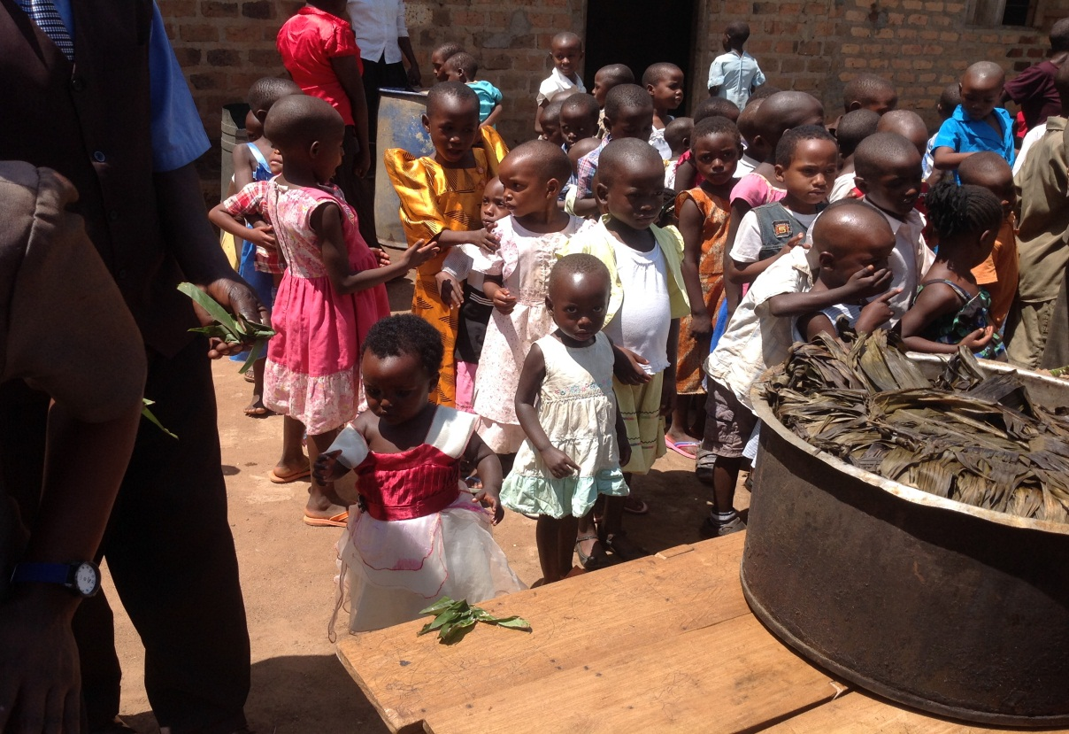

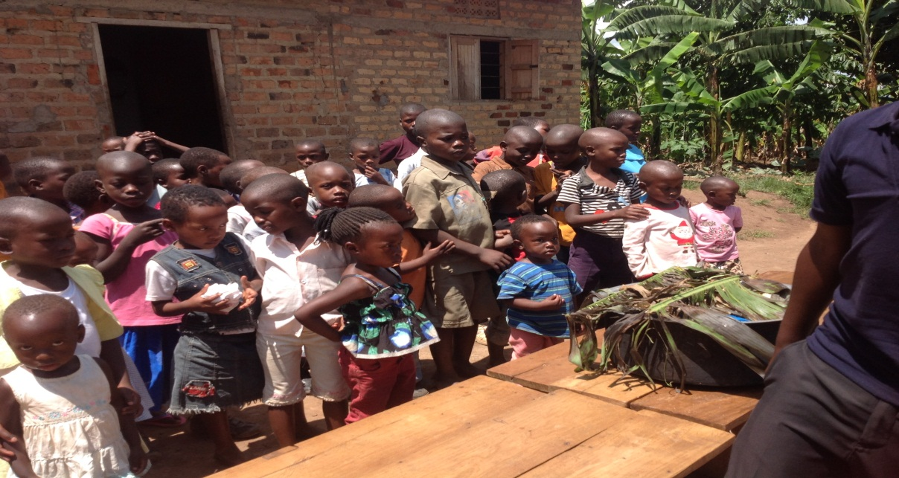

We envision the rural communities of Uganda able to build strong community and family structures using holistic and sustainable approaches that address challenges they face due to the HIV/AIDS pandemic, with a particular emphasis on grandmothers.

BCCBO AIDS Orphans Project operates three primary school in four rural villages in Uganda. Our highly trained teachers and support staff are educating 678 children this year, which include 124 preschool aged children.
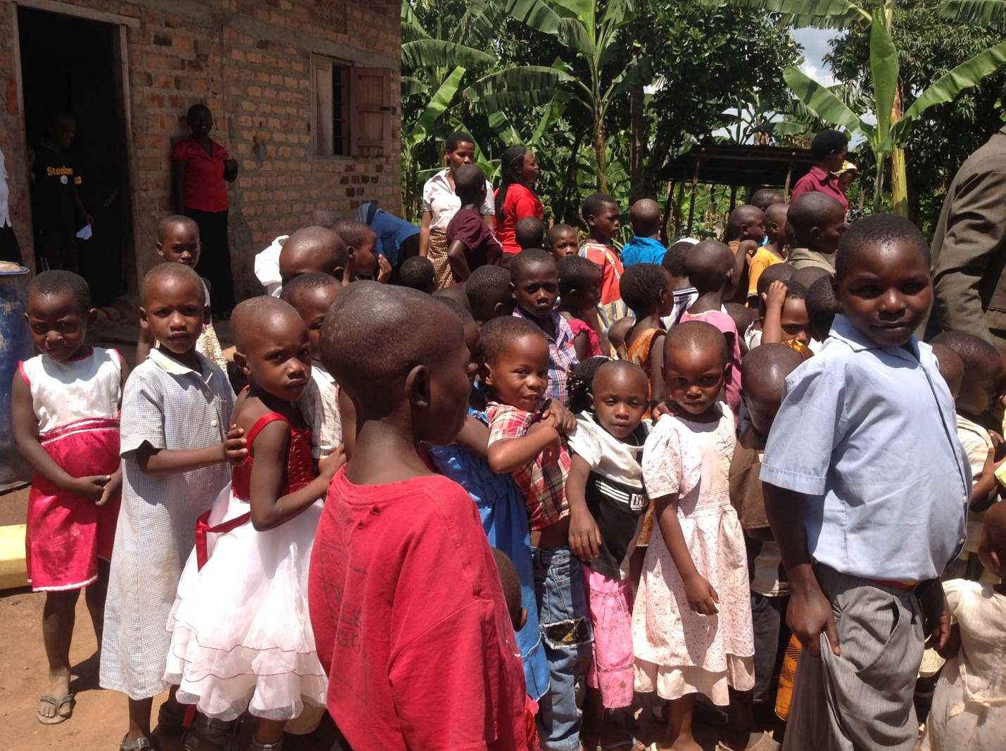

A very unique aspect of our Organization is that our schools are completely free to attend and children are guaranteed an education through high school from the moment they are enrolled.

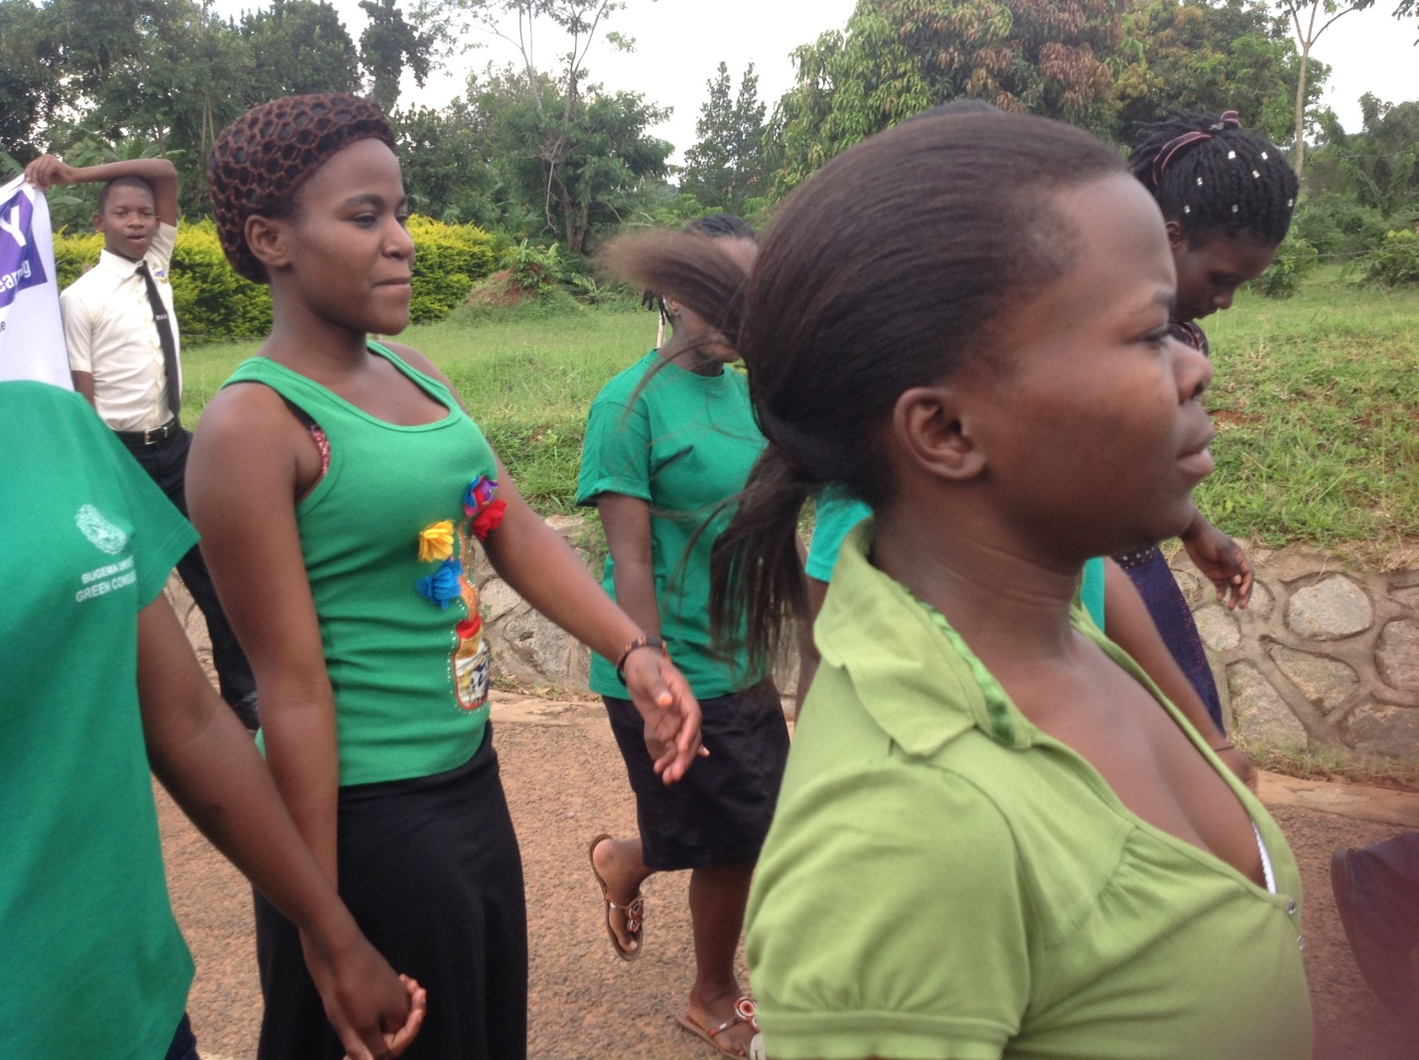

BCCBO students have performed in the top 2% out of the 310 schools in the district 43 out of 45 students graduated with a B+ in 2012. 67 of our Primary Seven students at BCCBO Primary Schools received an A+ on their exams in 2012, and only seven have chosen to attend vocational training in Bugema Vocational School.

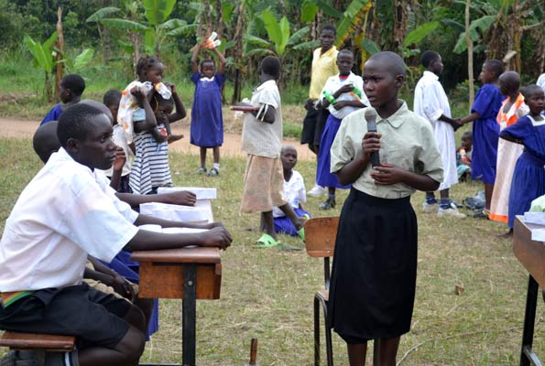

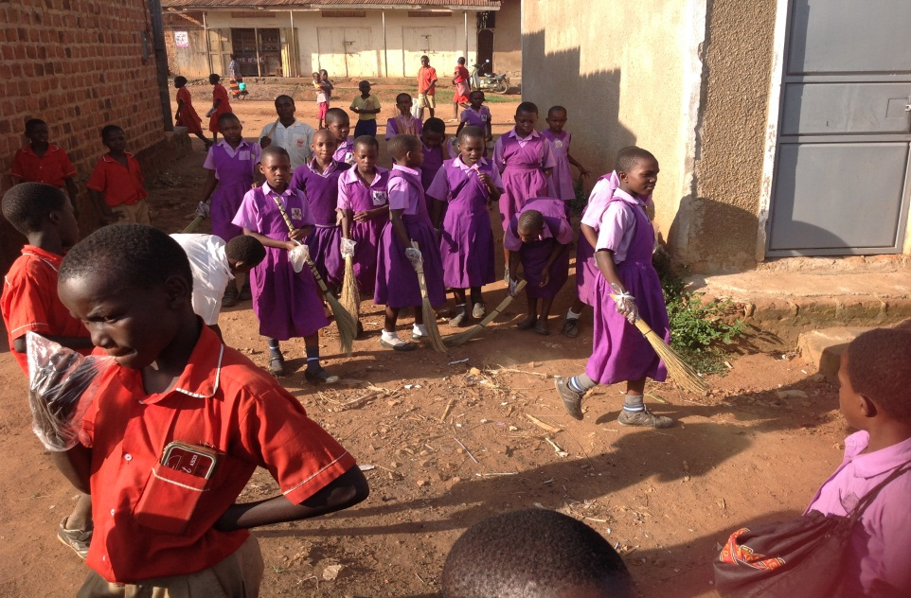

In addition to providing a quality education in a nurturing environment, we include three meals per day, uniforms, books, medical care, and supplies to the students.
As a part of our holistic human rights based approach to combating pervasive hunger and poverty, we serve nearly 850 grandmothers through 102 Support Community Groups working to free orphaned children aged 6-24 from the cycle of poverty.

THE BCCBO
AIDS ORPHANS
PROJECT

