THE ONIL STOVE

The Problem:

More than 3 billion people in developing countries burn traditional biomass fuels indoors as a source of household energy. For centuries, people have cooked their meals using an indoor open fire pit located on the floor of the one room home called a "three-stone fire" with no ventilation to remove the smoke. This method of cooking is the cause for burns and respiratory problems due to inhaling smoke daily from these fires. Cooking on open fires creates several major hazards:

- Acute Respiratory Infection (ARI) results in an estimated 1.6 million premature deaths each year largely among women and children. ARI is an environmental health risk faced by more than 3 billion people in developing countries who burn traditional biomass fuels for household energy in open fires in the home (per World Health Organization).

- Carbon Monoxide Poisoning: Carbon monoxide poisoning is the number one cause of unintentional poisoning deaths in the world.

Carbon Monoxide (CO) is produced by the incomplete combustion of fossil fuels, including wood. Incomplete combustion results from insufficient air to fuel mixtures. CO has no smell, taste or color and it is impossible to know when there is a dangerous build-up of CO levels (without instrumentation).

Dangerous amounts of CO can accumulate when the fuel is not burned properly as in an open fire, or when rooms are poorly ventilated. Carbon Monoxide poisons by entering the lungs and displacing oxygen from the bloodstream. Interruption of the normal supply of oxygen puts at risk the functions of the heart, brain, and other vital bodily functions. HELPS has measured CO concentrations of 160 ppm in homes in Guatemala where the cooking is done on open fires.

- Burn Injuries: In rural Guatemala, burn injuries are all too common. Houses are small with dirt floors. Fires are built on the floor in the center of the one room house where children learn to walk and play around the open fires. Learning to walk, children fall in the fires destroying a hand. Women’s skirts catch fire and ruin a leg for life. Blowing into a fire, women’s hair catches fire burning the face and destroying an eye.

- Wood Gathering Injuries: Huge loads of firewood are carried on villagers’ backs causing hernias. In these areas of Guatemala, there is no medical care for this or any other injuries, other than the HELPS medical teams that serve these areas. HELPS takes twelve medical teams per year to different areas in rural Guatemala to do surgeries and general clinics.

- Deforestation: More and more time and energy are spent by the family, primarily the women and children, in gathering enough firewood for cooking. In many areas, women and children carry heavy loads of firewood over long distances creating hernia problems and loss of productive time.

The Solution:

The ONIL Stove was developed by Don O'Neal, a Project Manager for HELPS International, and it carries his name (ONIL). The aim was for a durable stove which met local cooking needs, while reducing wood use by 70%, minimizing the risk of burns, and removing smoke and combustion gases from inside houses.

The top of the stove is about 400 mm across and 900 mm long, which provides adequate space for two pots and warming areas around them. The stove is normally mounted on concrete blocks, to raise it to a convenient and safe height for cooking.

The main body parts of the stove are made from cast concrete, for cost, strength, and durability. The combustion chamber, where the wood is burned, has a ceramic (fired clay) lining, in order to withstand the high temperatures reached. The space between the concrete and ceramic parts is insulated with ground pumice and ash.

Two steel hot plates fit into three sixteenth-inch steel top plates. A set of covers with graduated holes allows efficient use with different-sized pots, and by covering up the pot hole completely, the stove can also be used to cook tortillas - a popular staple.

A chimney made from galvanized steel takes the smoke out through the roof of the house. A wire mesh cylinder is provided to go over the bottom of the chimney, to guard against people, especially children, accidentally touching the hot steel.

This stove raises the fire off the floor and contains the fire. The sides of the stove are not hot enough to cause a burn.

HELPS places great emphasis on the use of local enterprises to produce the stoves. All components are manufactured within about 100 km of Guatemala City. A factory has been set up to produce concrete parts in Rio Bravo. Ceramic parts are made in Chimaltenango, and the entire production facility is now committed to making stove parts. All steel parts are made in a small engineering company in Quetzaltenango. HELPS has provided micro-credit for this company to purchase improved cutting equipment, and to expand production capacity.

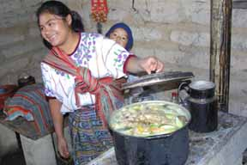
Benefits of the Project

- Health Benefits
Carbon monoxide poisoning is the number one cause of unintentional poisoning deaths in the world.
Carbon Monoxide (CO) is produced by the incomplete combustion of fossil fuels, including wood. Incomplete combustion results from insufficient air to fuel mixtures. CO has no smell, taste or color and it is impossible to know when there is a dangerous build-up of CO levels (without instrumentation).
Dangerous amounts of CO can accumulate when the fuel is not burned properly as in an open fire, or when rooms are poorly ventilated. Carbon Monoxide poisons by entering the lungs and displacing oxygen from the bloodstream. Interruption of the normal supply of oxygen puts at risk the functions of the heart, brain and other vital bodily functions.
In the United States different municipalities have different criteria on which to base estimates of air quality, most however are governed by the Environmental Protection Agency (EPA). Most US codes uses the term "good" to describe air with less than 9 parts per million (ppm) of carbon monoxide (CO), "fair" to describe air with between 9 and 15 ppm, and "poor" to describe air with greater than 15 ppm CO.
HELPS has measured CO concentrations of 160 ppm in homes in Guatemala where the cooking is done on open fires. After these homes receive the HELPS stoves, CO concentrations drop to 3-5 ppm.

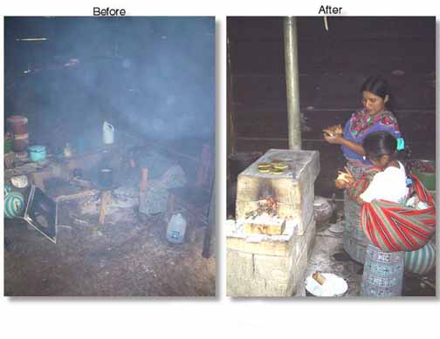
- Safety Benefits:
All these problems are eliminated when cooking on an ONIL Stove:
Burn injuries—like this leg burned when the lady’s skirt caught fire.
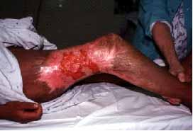
Face burns from falling into the fires or hair catching fire as the lady blows on the fire to keep it burning.
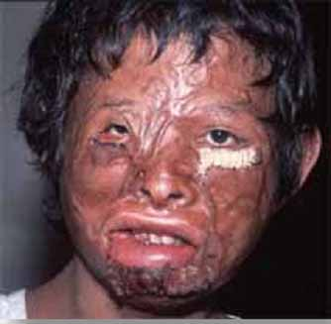 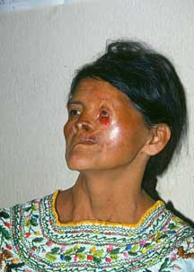
Eye injuries from a popping fire, usually caused from blowing into the fire. Eyes are also often damaged in a hair fire as well.
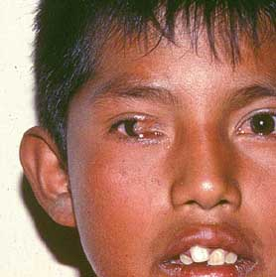
Hand burns created from a small child falling into the fire. The houses are small usually 10 by 12 feet with the open fire in the middle of the room. Children playing or learning to walk in these conditions makes it easy for accidents to happen.
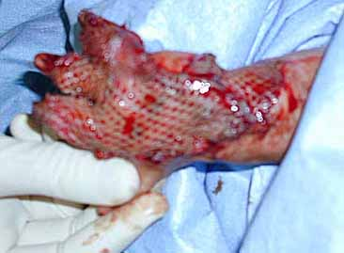
Spilling of boiling water on a child (or on herself) as the mother works in cramped conditions.
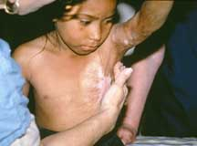
Respiratory problems: According to the World Health Organization, one out of five children in Guatemala does not live to the age of 5. They further state that the leading cause of death in this age range is acute respiratory infection (from breathing the heavy smoke from cooking fires). From the day they are born, the children are carried on their mothers’ back while they cook over the open fires. While respiratory infections are not as visual as burn victims, the results are equally devastating and are a silent killer. A stove gets the fire off the floor preventing skirt fires, kids falling into it, and removes the smoke from the house. Stoves save lives!

The health concerns that led to the development of the stove have been well addressed. The insulated concrete stove body has an exterior that is safe to touch when in use, and the burning wood is contained, virtually removing the risk of burns.

Efficient combustion reduces the production of smoke and soot, and the use of a chimney takes the remaining emissions outside the house. Measurements by HELPS have shown that homes using open fires have about 20 times higher concentrations of carbon monoxide (one of the most serious indoor pollutants) than those with ONIL stoves. Users say that respiratory and eye problems have greatly decreased since the new stoves came into use. In 2007, the 50,000 stoves installed are located in approximately 40,000 households, and thus the health benefits affect over 200,000 people. An additional 9,000 stoves are on order and will be delivered this year.

With open cooking fires, smoke stained the interior walls creating soot icicles, and acid corroded the corrugated tin roofs. These problems have also been eliminated by the ONIL stove.

- Wood Savings of 70%
The ONIL stove reduces wood consumption by 70% resulting in a long-term benefit to the environment and a better quality of life for families. For example, women who have ONIL stoves gained the equivalent of two days a week in time saved from gathering wood, allowing them more time to become involved in social and economic activities, like cultivating vegetable gardens.
While Guatemala is deforesting at 2% per annum, each stove saves 85% of one tree per month per family. Currently, there are over 50,000 Stoves in use, meaning that Guatemalans are saving over 510,000 trees per year.
The ONIL Stove significantly reduces indoor and outdoor air pollution, and frees up time for other productive endeavors. These features have been achieved using innovative technological techniques in the design, manufacture, and distribution of the stoves. The cast concrete stove housings are made using a fiberglass mold. Rapid setting cement allows for two stove housings to be made from each mold each day. The combustion chambers are also molded from fire resistant clay.

University surveys in homes in Guatemala have confirmed that the claimed 60-70% reduction in wood use is indeed achieved in practice. Users also noted that they save time in gathering wood and have to carry less heavy loads, reducing the risk of back problems and hernias. Some women have used their extra time to plant small vegetable gardens, in order to provide better food and cash income.

For some of the NGOs, the motivation for promoting stoves is to reduce the use of firewood. Even though the main reasons for deforestation in Guatemala are related to agriculture and illegal logging, the use of improved stoves does make a contribution to preserving wood stocks.

Significant employment has been established as a result of the program, which is crucial in a country where many ex-combatants from the civil war are still unemployed and coffee prices are at an all-time low. One new factory has been set up to manufacture and assemble stoves, and two others have greatly increased their business because of it. Employment has also been created for suppliers, technicians, and extension workers.

The best evidence of the benefits of the HELPS’ ONlL stove is the enormous demand for them. Suppliers are producing 2,000 sets of components per month to keep up with demand, and NGOs have ordered 9,000 ONIL stoves.

- Distribution and Training

The first project goal was to build a low cost, mass-produced stove, using computer monitoring techniques, in a factory that can be shipped through distribution channels and supported with standardized training material, maintenance material, and spare parts.

The second goal, an innovation, was the distribution of the stoves through other NGOs. Communities in Guatemala are scattered and speak different languages, so it is essential to work with agencies that understand local needs and who have already established trust in the villages. HELPS is now selling to 39 other established NGOs who have on-going projects that need a stove component. A major advantage of selling ONIL stoves to NGOs is that it avoids the distrust of seeing newcomers in the villages.

Since the need for stoves in Guatemala is estimated at one million today and that need is projected to double in twenty years, another goal was to manufacture the product using advanced technology in order to achieve the lowest possible cost and to produce parts in large volume. HELPS extended micro-credit to its subcontractors to allow them to purchase modern plasma cutters and computer controlled cutting tables for the stove’s metal parts.
All components are manufactured in Guatemala and in small shops. HELPS then sells the stoves to the NGOs at the cost price of US $87.00.

HELPS has set up a thorough training system, and provides extensive training materials. Five women from each new community are trained in stove assembly, use, and routine maintenance. A stove technician assists these women to assemble the stoves in their own homes, and then they pass on their skills to their neighbors. Each community will have at least three follow-up visits from a stove technician, to ensure that the stoves are working well.

HELPS suggests that users make some financial contribution to the stove, since this increases the likelihood of successful use. However, it is the responsibility of the individual NGOs to set up an appropriate financing scheme. For instance, some require the user to contribute about one third of the cost before the stove is installed, and others stage payments through a micro-credit facility.

- Evidence of Contribution

Over 50,000 stoves have been installed to date and are located in approximately 40,000 households (a few large homes have two different types of HELPS stoves); thus the health benefits affect over 180,000 people. An additional 9,000 stoves are on order and will be delivered this year (2007).

The project is now supplying stoves to 120 other NGOs and to large farm and manufacturing organizations. Wendy Berger, wife of Oscar Berger the President of Guatemala, has purchased several thousand stoves for her social programs.

ONIL Stoves have been delivered into all 22 Departments (states) of Guatemala. The factory in Rio Bravo is running at capacity and two additional factories are in the planning stage in order to increase capacity.

The best evidence of the benefits of the ONIL stove is the enormous demand for it. Suppliers are producing 200 sets of components per month to keep up with demand.

6. Presentation of Measurable Results: The scale-up of the stove production has been in part funded by the Shell Foundation to whom we report. Carbon Monoxide is measured with an ‘HOBO’ brand CO data logger and the carbon particle measurements are made with an instrument developed by the University of California, Berkley.

A complete testing protocol has been developed by the Shell Foundation and is used in verifying our stove project.

The stove has also been tested in an independent lab and found to reduce carbon monoxide from 408 mg/m3 to 1.1 mg/m3. Carbon particles were reduced from 10.2 mg/m3 to .1 mg/m3. A complete report from the testing lab is available.

In actual field tests, the stove saved 70% of the firewood previously used in open fire pits. It reduces indoor and outdoor air pollution, reduces the amount of firewood carried on villagers’ backs, reduces the risk of burns, and saves time that can be spent in more productive endeavors.

There have been no negative consequences that we have observed nor have any been reported from other NGOs or users.

The need for the ONIL Stove is worldwide. HELPS has already opened an office in Mexico and has already sold its 50 first stoves to the Mexican State. HELPS expects to have two factories opened by the end of 2008. Mexico needs over 8 million Stoves.

