You can sponsor the following Brilliant children, the amount metioned against each child for one year or a part of it. Since there is no government school nearby,These under privileged children has to go to private schools, for which, we seek your support to provide education.
If you wish to get the updates and their status of education, Kindly send us your mail quoting the your beneficiary serial no. and name of the student, so that, we will mark as funded in this page and send you the status report once in three months along with photo
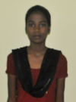22. Kowsalya. 15 years old, studying in 11th grade.
For 12th grade, total amount in need of Rs.9000/= or 220
Father name- Thaniga, Mother-Mohana.
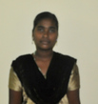23. Priya. 15 years old, studying in 11th grade.
For 12th grade, total amount in need of Rs.9000/= or 220
Father name- Kannadasan, Mother-parvathi
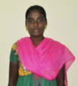24. Soniya. 15 years old, studying in 11th grade.
For 12th grade, total amount in need of Rs.9000/= or 220
Father name- Rajendran, Mother-Shanmugavalli
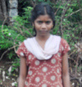25. Sandhiya. 15 years old, studying in 11th grade.
For 12th grade, total amount in need of Rs.9000/= or 220
Father name- Mari, Mother-Manjula
33. Paulina. 15 years old, studying in 11th grade.
For 12th grade, total amount in need of Rs.9000/= or 220
Father name- Rajendran, Mother-Selvi
38. Nagalakshmi. 15 years old, studying in 11th grade.
For 12th grade, total amount in need of Rs.9000/= or 220
Father name- Murugan, Mother-Pushpa
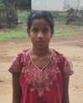39.Priyadarshini. 14 years old, studying in 9th grade.
For 10th grade, total amount in need of Rs.8000/= or 190
Father name- Arumugam, Mother-Indra
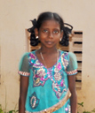44. Pafitha.13 years old, studying in 8th grade.
For 9th grade, total amount in need of Rs.8000/= or $190
Father name- Francis, Mother-Geetha
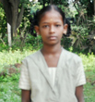45. Elsi Rani.11 years old, studying in 7th grade.
For 8th grade, total amount in need of Rs.7000/= or $170
Father name- Pushparaj, Mother- Sagayaraj
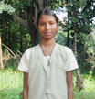46. Jerina.14 years old, studying in 8th grade.
For 9th grade, total amount in need of Rs.8000/= or $190
Father name-Michaelraj, Mother-Pappamma

