The Vicious Cycle of Poverty & Hunger

Involuntary hunger is a huge and complex problem that has consistently plagued around 2 million poor Filipino families for the past twenty years (SWS, 2019) that has resulted into 25% of children under 10 being underweight and up to 30% being stunted (8th National Nutrition Survey, 2013).

When children go hungry on a sustained basis and are undernourished at this young age, their brains and bodies fail to reach the adequate cognitive and physical development that will serve as their life-long foundation for productivity and general well-being—an almost irreversible effect that radically undermines their chances for a better future (WHO, 2014).

Addressing chronic hunger and malnutrition among children is a key step in breaking the vicious cycle that traps people in intergenerational poverty. Better nourished children will be more receptive learners and productive individuals and will thus have greater chances of ending poverty for themselves and their families.

Involuntary hunger results largely from lack of regular income which in turn was caused by the combined lack of opportunities and poor education. Conversely, chronic hunger and malnutrition is often cited as among the top reasons for poor attendance and performance which contributes to drop out rates and eventually compromises the future competency and productivity of these children. Inadequate nutrition and sanitation also leads to highly vulnerable health conditions for poor families. For complex and interconnected problems such as these, there is no preferred starting point for a solution. These kinds of problems can only be untangled when enabling environments are created to allow patterns of success to gain momentum and eventually tip the balance towards comprehensive and lasting change. Solving one problem will inevitably lead to solving the other problems.

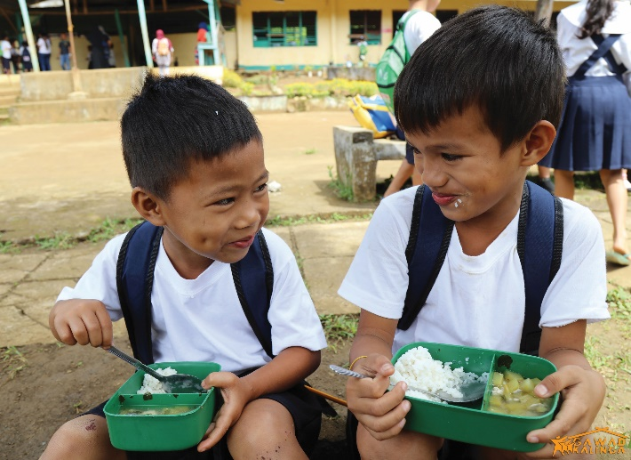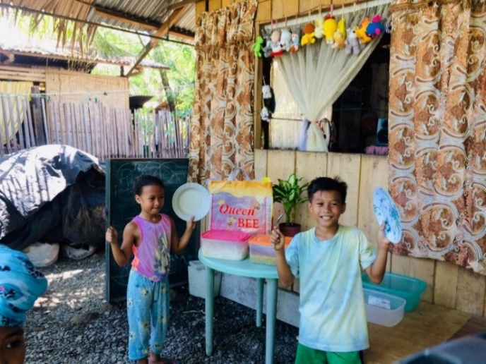

Kusina ng Kalinga Overview
Kusina ng Kalinga (KnK) is Gawad Kalinga’s strategic response to hunger and malnutrition among Filipino children. KnK is a scalable program where thousands of nutritious meals are prepared from central kitchens and then brought to the children in public schools, in communities, on the streets, and even in disaster and conflict areas.

The central kitchens serve nutritious meals from the programs pool of vegetable-based recipes that when paired with rice provides an average of 140 – 150 calories per day. This gives the kids their much-needed daily boost of energy and nutrition. But just as hunger is a condition that goes beyond empty stomachs, the KnK model also goes beyond feeding.

Established through the collaborative efforts of parents, volunteers, local government units, schools, private individuals, organizations and corporate partners, the kitchens are hubs for Bayanihan (solidarity and teamwork). The kitchen staff and volunteers prepare daily the nutritious meals and distribute them to the kids wherever they are.

Through Kusina ng Kalinga, we build caring communities for the young. It is where meals also carry the commitment to care together until no child is left hungry under our watch.

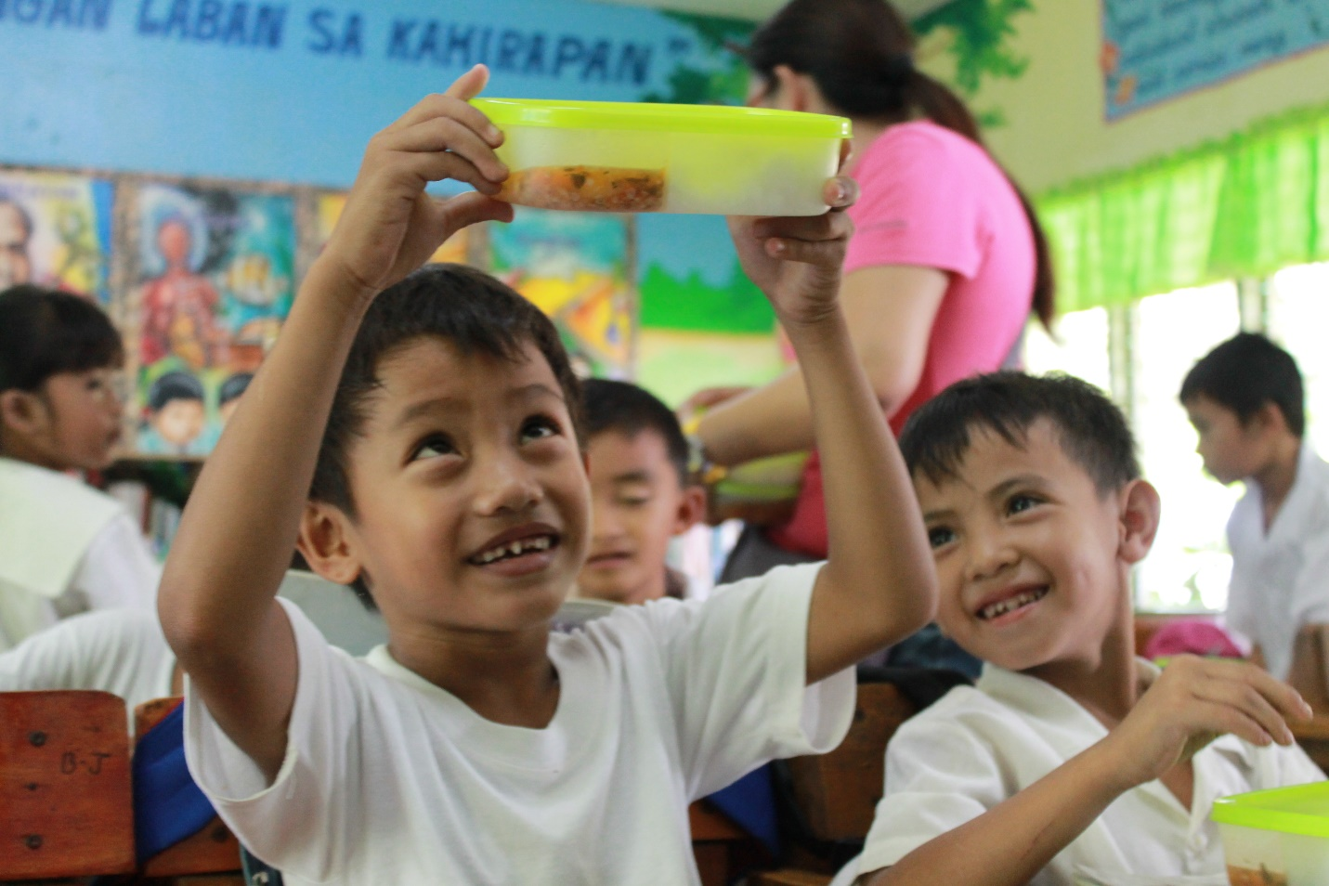

Kusina ng Kalinga Objectives
The KnK program aims to accomplish the following primary objectives:
- Address hunger and malnutrition of children ages 1 – 12 years old wherever they are – in public schools, in communities, on the streets or in disaster-stricken areas;
- Improve student attendance and performance in school;
- Promote family values formation for better nutrition and volunteerism;
- Create impact for small-scale farmer and enterprises in the locality of the KnK Kitchen;
- Create awareness and active involvement from various sectors of society to push for policies, programs, and legislation geared at ending hunger for children;
- Promote the KnK Kitchen modality and universal approach in providing food for hunger children; and
- Respond to short-term hunger in times of disasters.

History of Impact
Kusina ng Kalinga is where the Caring Together can begin. Kitchens cook daily nutritious meals for children where each meal builds hope – that because we are ending their hunger today, they can start imagining tomorrow.

Kusina ng Kalinga in Disaster / Conflict Areas
KnK has served meals in every major disaster / conflict area since 2014.
- KnK Alang-Alang in Leyte was established 9 months after the Typhoon Yolanda (Haiyan) that fed thousands of kids in public schools.
- KnK Tacurong in Sultan Kudarat was established in 2016 to respond to hunger in areas affected by El Nino including Arakan, North Cotabato, Upi, Maguindanao, and Ugis, Esperanza.
- KnK responded to hungry kids in evacuation centers during the sporadic Mayon Volcano eruptions in 2018. The team has fed 2,000 in Albay for a 30 days.
- KnK fed 1,000 kids who were part of families that evacuated during the Siege of Marawi. This was followed by more regular feedings days of up to 5,000 kids in the last S.Y. 2018 – 2019.
- KnK prepared 1,000 meals daily for two months and distributed these meals to children in various evacuations centers for those affected by the series of earthquakes in Makilala, North Cotabato in October to November 2019.

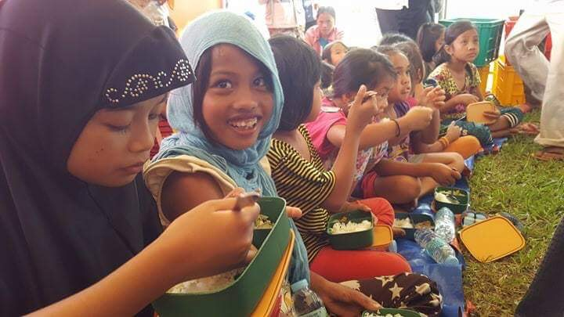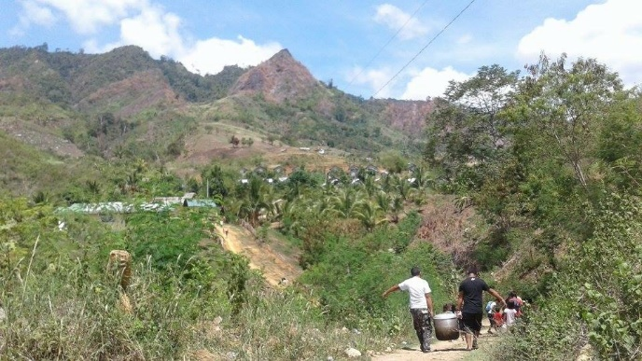
Operation Walang Iwanan – Marawi Operation Walang Iwanan – El Nino

Kusina ng Kalinga in Public Schools (S.Y. 2014 – 2020)
At its forefront, KnK is a sustained in-school feeding program for elementary public school children, conducted over the course of one school year. Daily meals are prepared in central kitchens, packed in lunch boxes, and delivered to the students, to restore them to normal nutritional status.

Island Group | Number of Kitchens | Total Kids Reached | Total Schools Served
Luzon | 51 | 30,513 | 582
Visayas | 17 | 23,628 | 81
Mindanao | 73 | 39,775 | 296
Total | 141 | 93,916 | 959

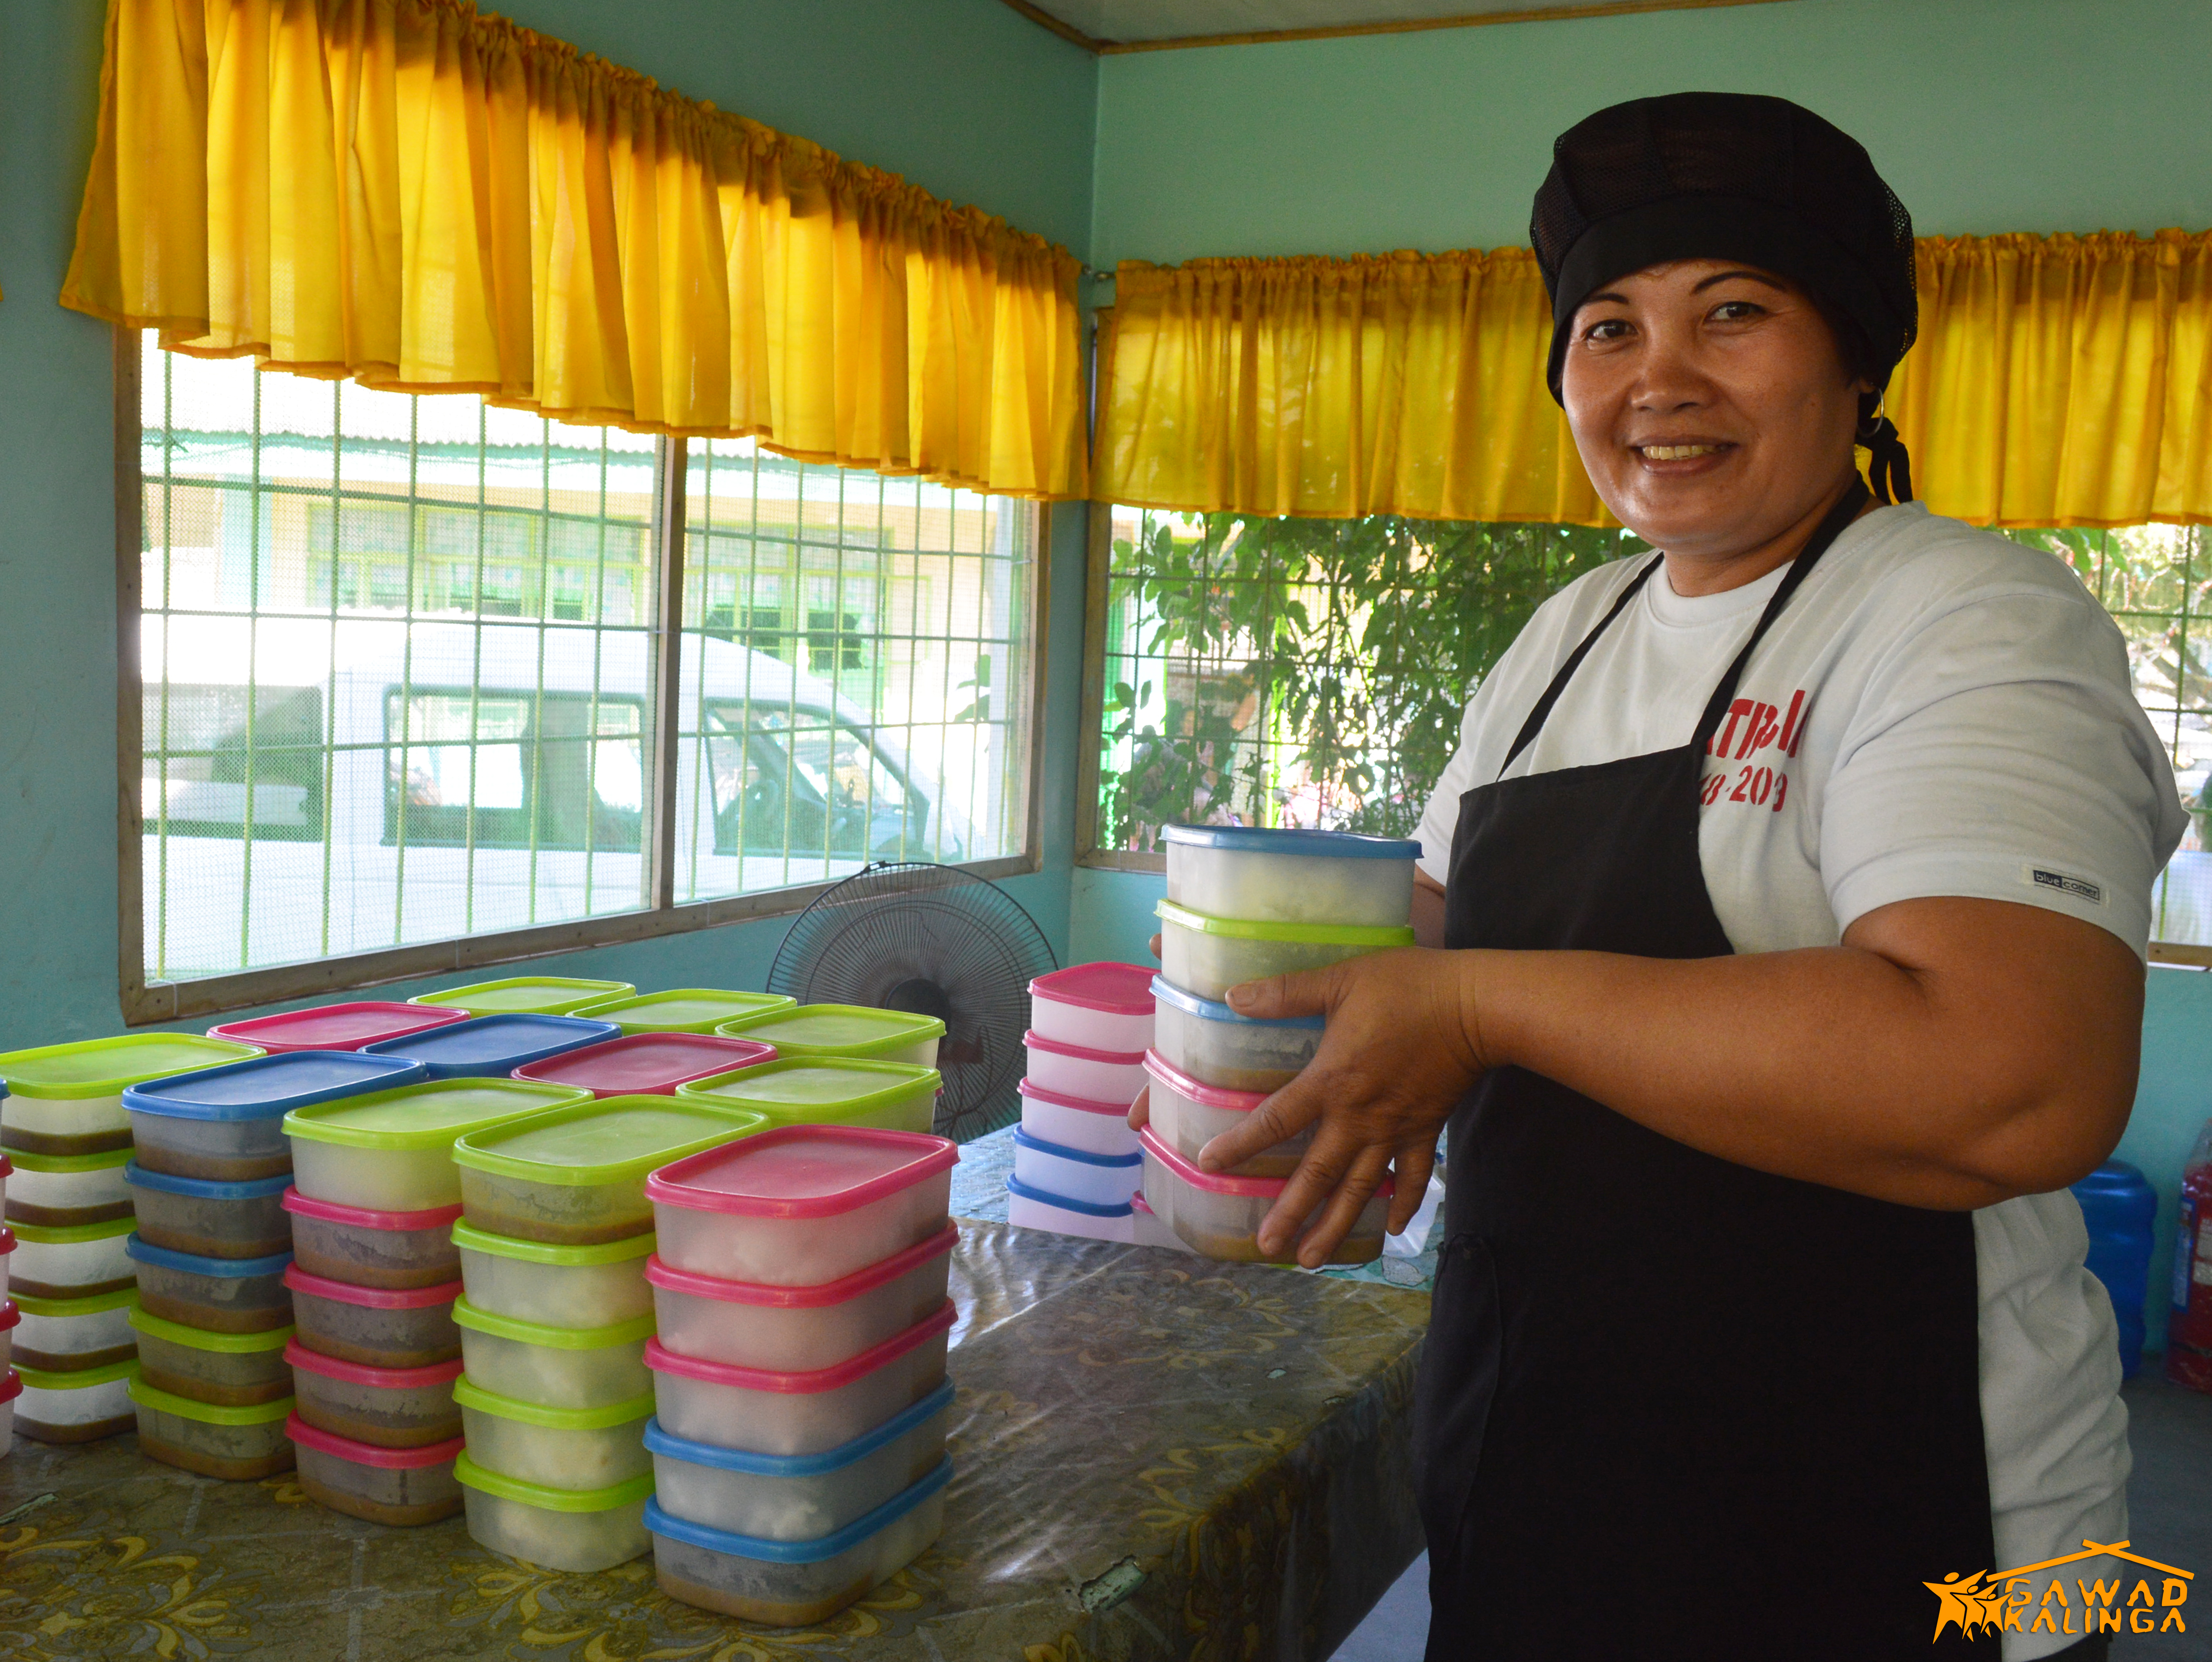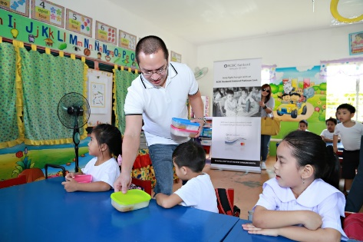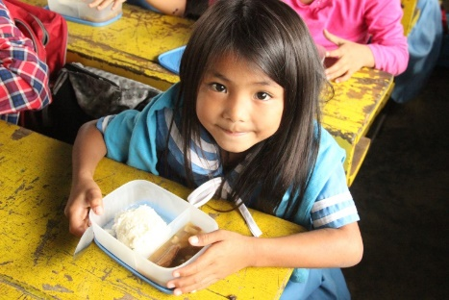

Kusina Ng Kalinga in Communities (Launched in 2020)
Self-rated hunger averaged 10% for the past 20 years which affects roughly around 2.1 million Filipino families annually. But as of July 2020, this number has gone up to up to 5.2 million, due to the effects of the COVID-19 pandemic. Kusina ng Kalinga established kitchens in the communities to provide at least 1 nutritious meal a day for kids aged 1 to 12 years old for at least 120 days.

Island Group | Number of Kitchens | Total Kids Reached | Total Communities Served
Luzon | 5 | 1556 | 23
Visayas | 2 | 450 | 8
Mindanao | 3 | 650 | 22
Total | 10 | 2,656 | 54
as of July 2020

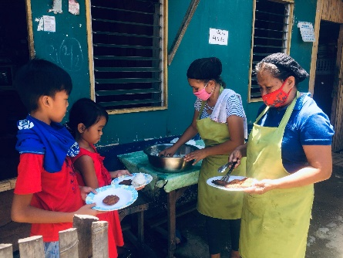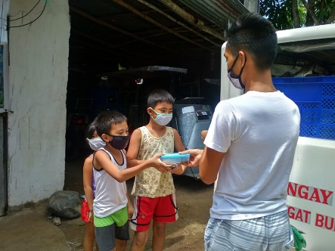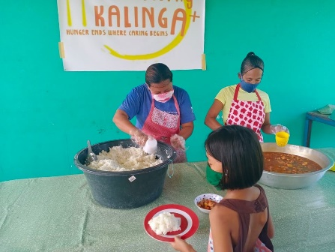

Kusina ng Kalinga Plans for 2020 – 2021

Due to the effects of the COVID-19, hunger became bigger and its grip became tighter. This School Year 2020 – 2021, millions of kids will be studying from their homes and communities. In these unprecedented and uncertain times, we need to make sure that they get all the help we can give. That is why this year, Kusina ng Kalinga will go to where the kids are.

KnK will establish kitchens located at the community level where meals are prepared and served by parent-volunteers for kids ages 1 to 12 years old for at least 120 days. Meals are served to kids in their homes or community centers in partnership with the local government units.

Mechanics:

Feed Children wherever they are
Target beneficiaries per Kitchen | 300 – 500 kids
Target feeding days | 120 days (Monday – Friday feeding)
Program Duration | 24 weeks / 6 months
To feed a child for 120 days | Php 2,400.00 (Php 20.00/kid/day)

Setup and support kitchen operations in priority areas: Php 150,000.00
Repair and renovation of basic infrastructure  (Cost varies for indoor and outdoor kitchen) | Php 30,000.00 to 50,000.00
Purchase of appropriate kitchen equipment, materials, and supplies | Php 40,000.00
Hire and support kitchen | Php 60,000.00

Help us bring food to those who need it the most in this time of pandemic. Join us in the battle against hunger and poverty. We should be able to tell ourselves that no child went hungry under our watch. Hunger ends where caring begins.

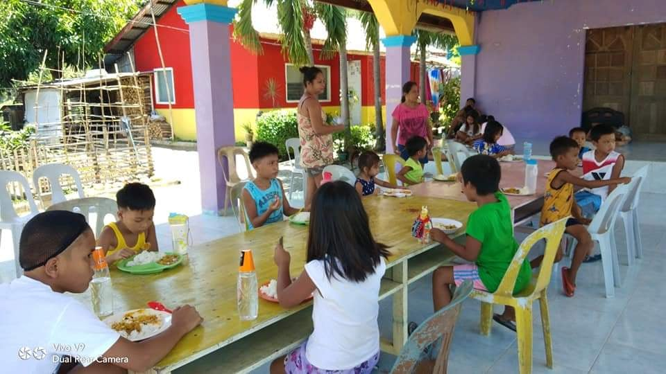

*School Kids in GK Village at San Gabriel, La Union

