Project Name:
Vets on Wheels, Odisha

Project Overview:
The Mobile Veterinary Service (MVS) initiative by the Wildlife Trust of India, in partnership with the Odisha Forest Department, focuses on addressing wildlife emergencies and rising human-wildlife conflict in regions such as Similipal Tiger Reserve and Keonjhar Forest Division. Operating since 2014 and 2019 respectively, these units provide critical on-ground veterinary care, rescue, and rehabilitation for distressed wildlife, particularly Asian elephants affected by conflict-related injuries, while also supporting captive elephant health and training forest staff in safe wildlife handling. Since 2014, the project has attended to 523 cases of wildlife in distress of which 246 (47%) animals were released back into the wild after providing treatment and care. The project’s scope has evolved to increasingly manage human-wildlife conflict incidents, reflecting changing conservation challenges in the region. Its significance lies in improving response to wildlife in conflict situations, reducing wildlife mortality, and strengthening local capacity, thereby contributing to more effective and humane wildlife management in high-conflict landscapes.

Key activities carried out by the Vets on Wheels Odisha project in FY 2025-26:
- Rescue and rehabilitation of distressed wildlife following established protocols.
- Training and capacity building of stakeholders on rescue and rehabilitation of wildlife
- Sensitization of communities on importance of wildlife conservation, wildlife rescue and community engagement in the same.
- Monitoring and management of captive elephant health in respective forest divisions.
- Attending to cases of wildlife mortalities reported from the respective divisions and conducting detailed necropsy and laboratory investigations on the same.
Key achievements of the Vets on Wheels Odisha project in FY 2025-26:
- MVS units in Similipal Tiger Reserve and Keonjhar attended 134 wildlife emergency cases, including 7 injured Asian elephants, reflecting continued field-level engagement in high-conflict landscapes.
- 20 animals (14.9%) were successfully treated and released, contributing to ongoing wildlife rescue and rehabilitation efforts despite increasing complexity of cases.
- The MVS team also collaborated across state lines by helping the Jharkhand Forest Department in dealing with elephant injuries caused by landmines as well as human-tiger conflict situation in Jharkhand and West Bengal.
- The team conducted 04 training and capacity building events for forest department staff, including two mock-drills for the Rapid Response Team (RRT) deployed during wildlife emergencies and human-wildlife conflict situations.
- A specialized training was also conducted for the forest department staff of Sundarban Biosphere Reserve on the use of thermal drones and darting equipment for wildlife rescue.
- The MVS Keonjhar veterinarian provided capacity building training to veterinarians from Odisha and Jharkhand Forest Departments on handling and veterinary management of wildlife emergencies, including the use of darting equipment.
- Community awareness programmes were conducted in villages around Keonjhar and Similipal Tiger Reserve on snakebite management, livestock health, and avoiding conflict with wildlife, improving local preparedness and reporting.

Project Photographs:

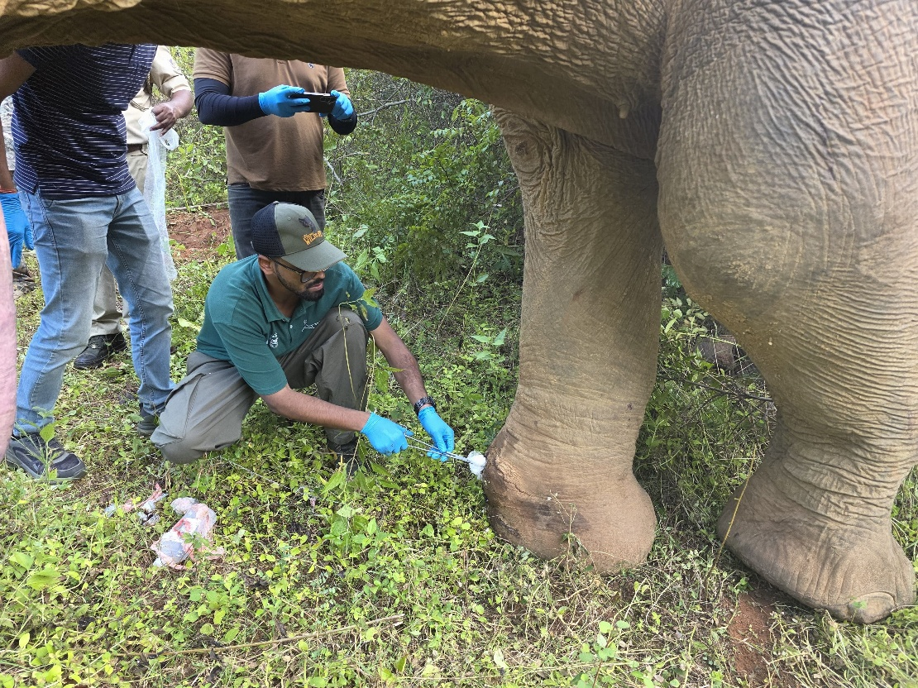
Fig.1: MVS Odisha vets attending an injured Asian elephant | Photo credit: Odisha Forest Department

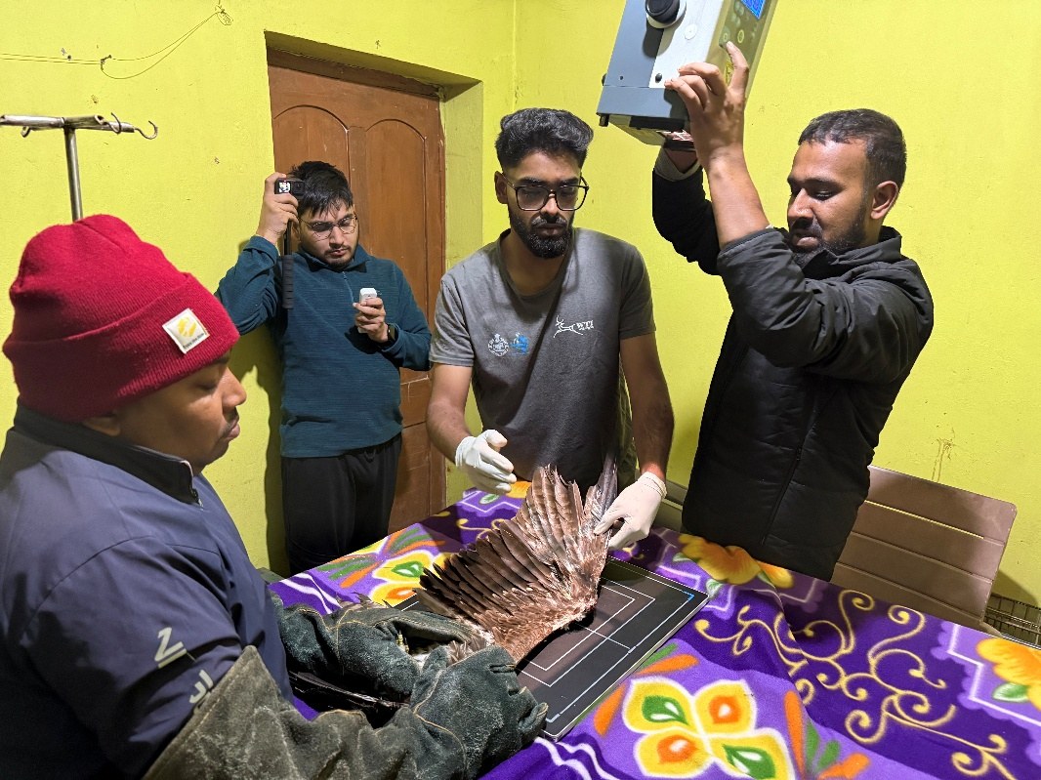
Fig.2: Treatment of a black kite by MVS Odisha vets | Photo credit: WTI

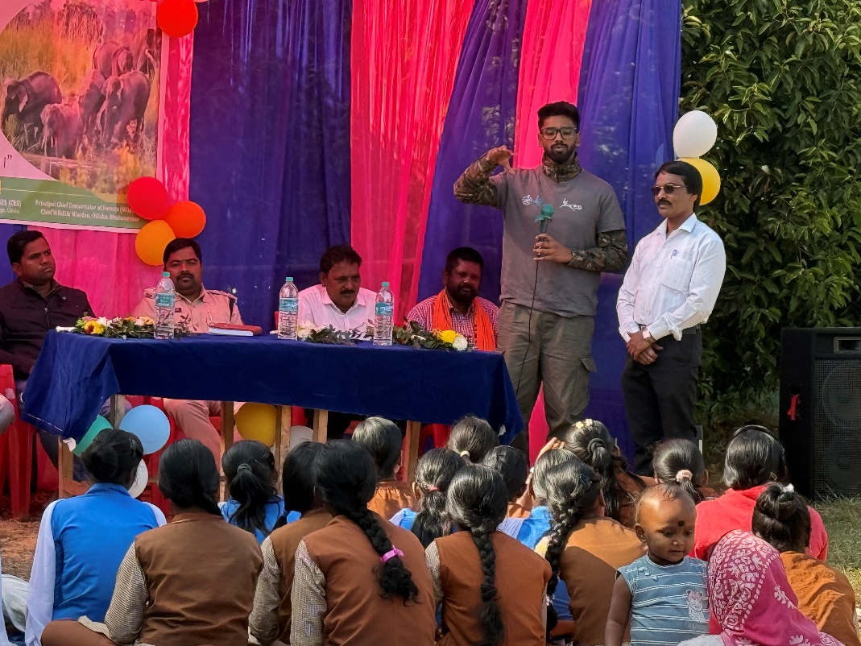
Fig.3: Awareness program conducted by MVS-Similipal vet for local; communities | Photo credit: Odisha Forest Department

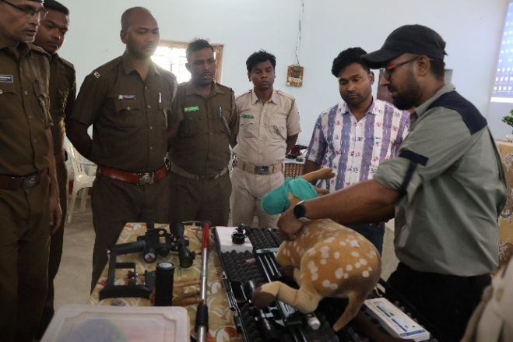
Fig.4: Training on tranquilization and immobilization during wildlife rescues for forest staff by MVS Keonjhar vet | Photo credit: Odisha Forest Department

