IMPACT Project Report- March to May 2016
Project Name: Run an 85-bed child cancer ward in India
Project ID : 19108
Story of a little baby girl who fought a solid tumor
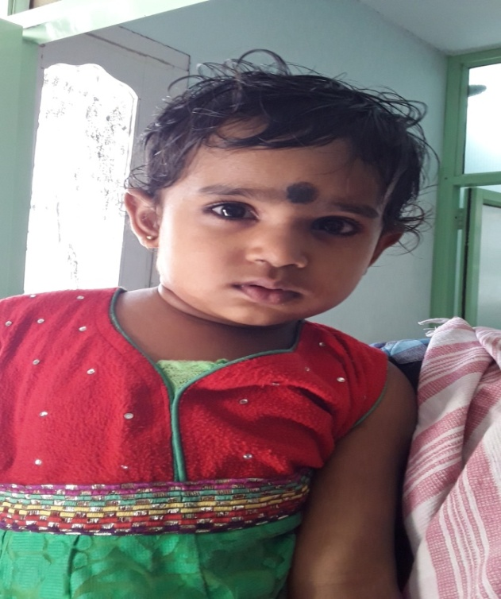
Name : Yamini
Age : 2 years
Diagnosis : Wilim’s Tumor
Place : West Godavari, Andhra Pradesh.

Family History:
Yamini is a two year old child. She hails from West Godavari district of Andhra Pradesh. Yamini’s father is an Auto driver and mother is a house wife. Yamini is the only child to her parents.
Medical History:
Yamini was just 9 months old when she had initial bouts of stomach pain. Her parents showed her to a doctor in a private hospital and took the medicine prescribed by the doctor. This helped in reducing the stomach pain and the child was doing ok. After a few days Yamini’s mother found a tumor in stomach while bathing her. Parents took the child immediately to the private hospital. Doctors suggested getting CT Scan which revealed a tumor near the kidney. Doctors informed the parents and asked them to admit Yamini in Niloufer Hospital in Hyderabad for better treatment.
In Niloufer Hospital Yamini underwent investigations like CT scan, X-ray, CBP, LFT/RFT and other tests. Doctors checked all the reports and then performed a surgery and removed the tumor near the kidney. Biopsy was performed for the tumor. After checking the biopsy report, doctors in Niloufer referred Yamini to MNJ Cancer Hospital for further treatment. Finally they reached the IMPACT children ward in MNJ Cancer Hospital. In MNJ Cancer Hospital medical oncologist examined the patient and suggested all investigations for the final diagnosis. Upon all investigations and after reports pediatric oncology doctors confirmed that Yamini has Wilims tumor.
After confirmation of diagnosis, oncologist explained Yamini’s condition and prognosis and about cancer disease to her parents and immediately started the treatment for Wilims cancer.
Yamini completed chemotherapy successfully with the support of pediatric oncologists, IMPACT nurses and counselors. Now she is under three month observation.
Psycho-Social Issues
In the beginning Yamini’s parents were unable to grapple with the harsh reality regarding their child’s condition. They could not accept that their child has got cancer - a deadly disease. Yamini’s parents had a lot of doubts about the prognosis and were very afraid of the side effects of chemotherapy. Doctors and counselors explained to them about the side effects and disease management.
Yamini’s parents had to shell out a lot of money in private hospitals during the early days of treatment. They had to sell their property in order to pay for the treatment and investigations in private hospitals.
Counselors have given emotional and moral support to Yamini and parents to cope up with the stress and trauma.
Now Yamini is normal and is very active in the ward and her parents are so very grateful to the Oncologist and IMPACT staff because they helped their child complete the chemotherapy successfully with minimal side effects.
Quarterly Status Report
During the period of Mar 2016 to May 2016, a total of 1506 children have been treated for cancer.
Out of which, 120 children were in-patients in the IMPACT ward.
Brief summary of activities
- Transport support
Children benefited from our Transport Support are 72.
- 21children were benefited during the month of March,2016,
- 29 children benefited in the month of April, 2016.
- 22 children got benefited in the Month of May,2016

- Blood Donation Camps
Camps were conducted, one in the month of March and in the month of April, 2016.
- Blood Products collected in March blood camp - 180Units.
- Blood Products collected in April blood camp - 20 Units.
- Total 200 units of blood were collected.
- Blood Products Support
Totally 451 children got benefited with FREE BLOOD.
- 121children got benefited during the month of Mar- 2016.
- 201 children got benefited during the month of Apr -2016
- 129 children got benefited during the month of May -2016.
- Hygiene Program / Support
Hygiene training was imparted to parent/caretakers of children
- Following Hygiene aspects were trained and practices.
- Bed side cleaning.
- Hygiene boxes, Masks and sanitizers were distributed
- Evening Classes
Conducting every day Classes to kids for refreshment and Entertainment program.
- Birthday Celebration
- Academic Classes like Mathematics, English and Telugu.
- Drawing and Painting classes
- Building Blocks and Puzzles
- Video games, watching movies and Cartoon videos
- Medication
Medicines were procured and administered to several needy children.
- 5 children got free medicines in Mar- 2016
- 9 children got free medicines in Apr -2016
- 20 children got free medicines in May- 2016
Medicines administered include the following
- Inj.Tigi 50 mg
- Inj.Ethyal predmoslve 250mg.
- Endoxan 50 Tabs,Lastet Tab.50mg.,
- Tomoxefen 20mg. Methofast 50 mg.
- Syp. Zocovit,Kids care plus
- Inj. Endoxan 500mg.
- Inj.Colistine 10 lakhs(Veils)
- Inj.Clindazine 300 mg
- Volunteering Activities
- Mahesh Kumar Sharada cultural trust visited the IMPACT WARD distributed biscuits for the kids.
- Inner wheel group visited the ward.
- Mr. Krishna and family visited the ward on behalf of Mrs.Anjana Anand.
- Mrs.Dr .C V Vaidehi spent her time with the kids.
- Megha Dinesh distributed ice cream for the kids.
- Mr.Abinandhan from Dell International visited the IMPACT Ward and spend some time with the kids.
- Dell International visited the Ward.
Events during the Quarter
- Birthday celebration of Baby of Kavitha with Leukamia.
- Ugadi celebration in the ward.
- Birthday celebration of Meghana with myeloid leukamia.
- NTT data group visited the IMPACT WARD.
- Birthday celebration of Ayan Khan.
- Dell International visited the IMPACT Ward
- Nurses day celabration in the ward.
- Godavari Polymers representative visited IMPACT Ward
- Movie artist Allari Naresh visited IMPACT Ward and entertained the kids.
- Support Group Meeting for the patient attenders.
- CML meeting in IMPACT Ward .
- Birthday Celebration of patient Laxmi Narayana
- Dhuthi Foundation Awareness Program
- Blood Donation Camp in Vardhaman College
- Blood Donation Camp in Google

