Project Name : Run a 70-bed child cancer ward in India
Project ID : 19108

CASE STUDY AND SUCCESS STORY

- CASE STUDY OF MANIKANTA
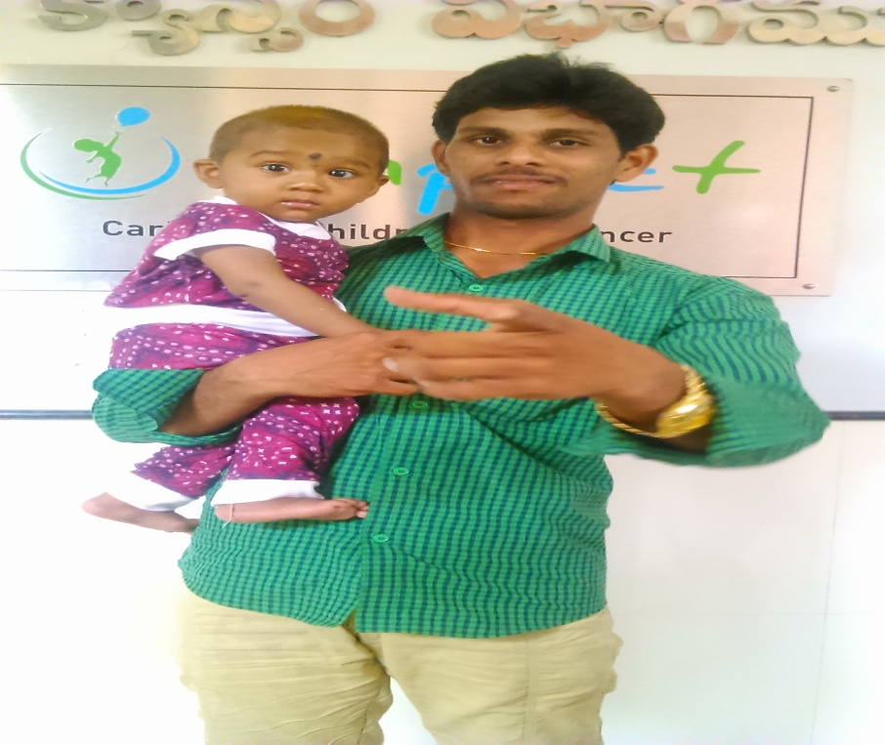

Name : Manikanta
Age : 10 Months
Diagnosis : Acute lymphocytic leukemia (ALL)
Address : 3-361/A, satyavaram, West Godavari Dist.
Family History:
Manikanta is a ten months old child. He is the only son to their parents who hail from west Godavari district. He is born to them after ten years of their marriage. Before he was born his parents had adopted a girl who goes to Anganwadi school. Manikanta’s father is a welder and runs a welding shop. Unfortunately he met with an accident and passed away just two days before Manikanta got admitted in IMPACT/MNJ Cancer Hospital . His mother is a home maker.
Medical History:
Three months back Manikanta developed a unusual swelling in his stomach and became very weak .
His parents took him to to a private Medical Oncology doctor. After doing his blood test they came to know that blood count is low
Then they visited Palakollu Rathna Hospital for blood transfusion. After two days they went to another hospital Tanuku Sathya Hospital for tests . They said blood count is low and referred to Little Star Hospital. Again performed blood tests and informed them that it seems to be Blood cancer and that it has no cure.
Manikanta and his parents then returned home disheartened.
After twenty days he developed cold symptoms for which he was taken to near by town Bhimavaram and got checked into Varma Hospital. On 23rd they were referred to NIMS Hospital in Bhimavaram. It’s on this day Manikanta’s father met with an accident and passed away.
Manikanta’s uncle took the child to NIMS Hospital.
There the doctors Verified the previous reports and referred him to MNJ Cancer Hospital. On 27th March they came to IMPACT / MNJ Cancer Hospital.
BMA test was done and then confirmed that he has blood cancer ALL.

Psycho Social Issues:
- The child was the only son to their entire family. He had born after ten years.
- The child father died in an accident just few days before admitting him in hospital.
- Parents and family is psychologically drained and have undergone mental agony.
- The child was just ten months old when admitted.
- The child’s mother couldn’t cope with the terrible news of her child’s cancer and then the trauma of losing husband suddenly.
- The Family is financially deprived.

PRESENT STATUS OF THE CHILD IS AS BELOW.
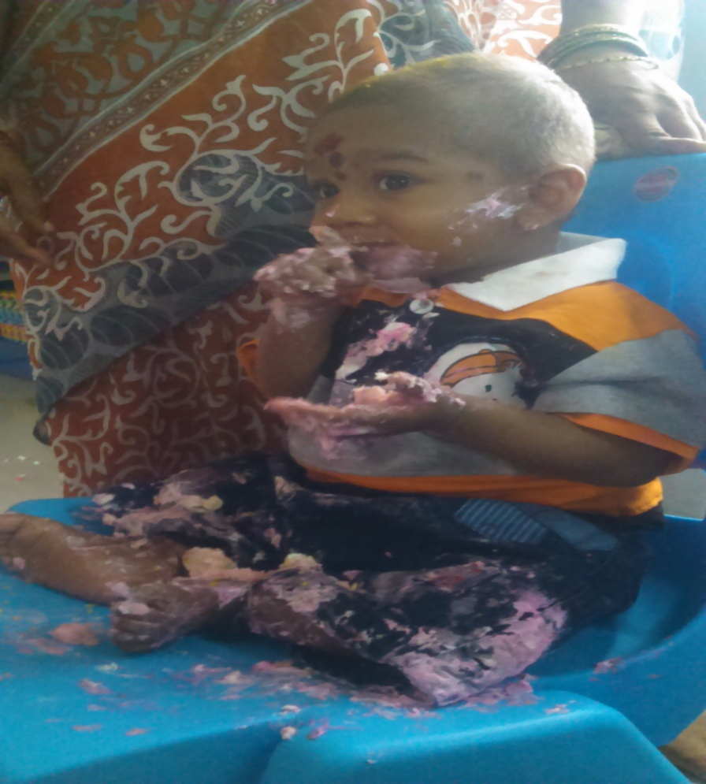
Induction and consolidation is completed successfully.
Child’s first birthday was celebrated by IMPACT in the MNJ Cancer Hospital.

- SUCCESS STORY OF PARVIN
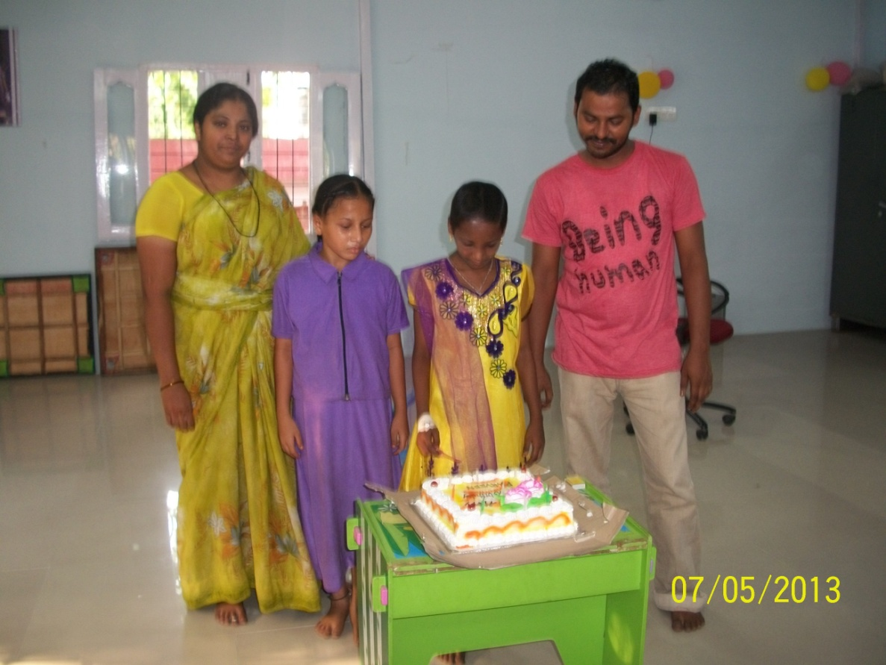

Name : Parvin
Age : 13 years
Diagnosis : Acute promyeloid leukaemia (APML)

Family History:
Parvin is 12 years old girl. She is studying in 3rd class. She has one younger sister. Her father is an auto driver and mother is a beedi worker (Tobacco).
Medical History:
Parvin is very active girl and belongs to a small beautiful family.
One day she developed fever for which her mother gave her paracetamol tablets for reducing the fever. She responded to the tablet and was feeling good for few days. After few days she started bleeding from the mouth. By seeing this her parents got frightened and took her to a private hospital. The doctors in the hospital referred to another super speciality hospital for BMA test. There the doctors by seeing the BMA report confirmed that it is Blood Cancer ALL. And the doctors referred to MNJ Cancer Hospital.
Psycho-Social Issues:
When it got confirmed that Parvin is suffering from Blood Cancer, initially her mother got afraid about the disease and the treatment.
Her mother’s heart filled with deep sorrow was shocked by knowing that her daughter is suffering from Blood Cancer. At that time she was not in position to accept the truth. Doctors in their home town explained to her mother about the disease and treatment. Doctors advised her mother to go to MNJ Cancer Hospital for better treatment. From there they came to MNJ Cancer Hospital. Now Parvin has successfully completed her six months treatment in IMPACT / MNJ.
With these six months of cancer treatment and completion of her monthly checkups, Parvin’s mother is now very confident and hopeful that the child is going to do well in the future. It is expected that after three years Parvin will be mostly cured.
Parvin’s father was not told that she is suffering from cancer because he is a very sensitive person and could not have taken the bad news about his daughter.
FUTURE PLAN :
Parvin is out of danger and she is very happy that she can go back to school and her parents are also very happy to see their daughter cheerful and out of danger.

PROGRAM ACTIVITIES AND REPORT
During the period of June 2015 to May 2015 , a total of 1282 children have been treated for cancer by IMPACT in MNJ.
Out of that, 155 children were in-patients in the IMPACT ward.
Brief summary of activities during June-August 2015
- Transport support
90 children benefited from our Transport Support
o 38 children were benefited during the month of June-2015,
o 30 children benefited in the month of July-2015
o 22 children got benefited in the Month of August-2015
- Blood Donation Camps
Two camps were conducted one in the month of June and the other in the month of July 2015. Total of 400 units of blood was collected.
o Blood Products collected in June blood camp - 310 Units
o Blood Products collected in July blood camp - 90 Units

3. Blood Products Support
- Total of 381 children got benefited with free blood collected from blood camps.
o 175 children got benefited during the month of June-2015
o 146 children got benefited during the month of July -2015
o 60 children got benefited during the month of Aug -2015
4. Hygiene Program / Support
- Hygiene training was imparted to parent/caretakers of children
- Following Hygiene aspects were trained and practices
o Bed side cleaning
o Hygiene boxes, Masks and sanitizers were distributed
5. Medication
- Medicines were procured and administered to several needy children
o 10 children got free medicines in June-2015
o 20 children got free medicines in July-2015
o 06 children got free medicines in Aug-2015

- Medicines administered include the following :
- ( Inj.Tigi 50 mg, Inj.ethyal predmoslve 250mg. Endoxan 50 Tabs,Lastet Tab.50mg.,Tomoxefen 20mg. Methofast 50 mg. Syp. Zocovit,Kids care plusInj. Endoxan 500mg. Inj.Colistinea 10 lakhs(Voils) Inj.Clindazine 300 mgInj.Heptatis-B.)

6. VolunteeringActivities
● International Children’s Day Celebrated by Emcure Lab distributed Fruits to Kids.
● Godavari Polymers donated Injections And Tablets.
● Meghana Group Entertained the Kids.
● Celebrated children birthdays in the ward .
● Srinidhi College Visited the Ward.
● Wills Foundation And Smile Foundation Entertained the Kids in the ward.

EVENTS AND VISITS TO IMPACT WARD
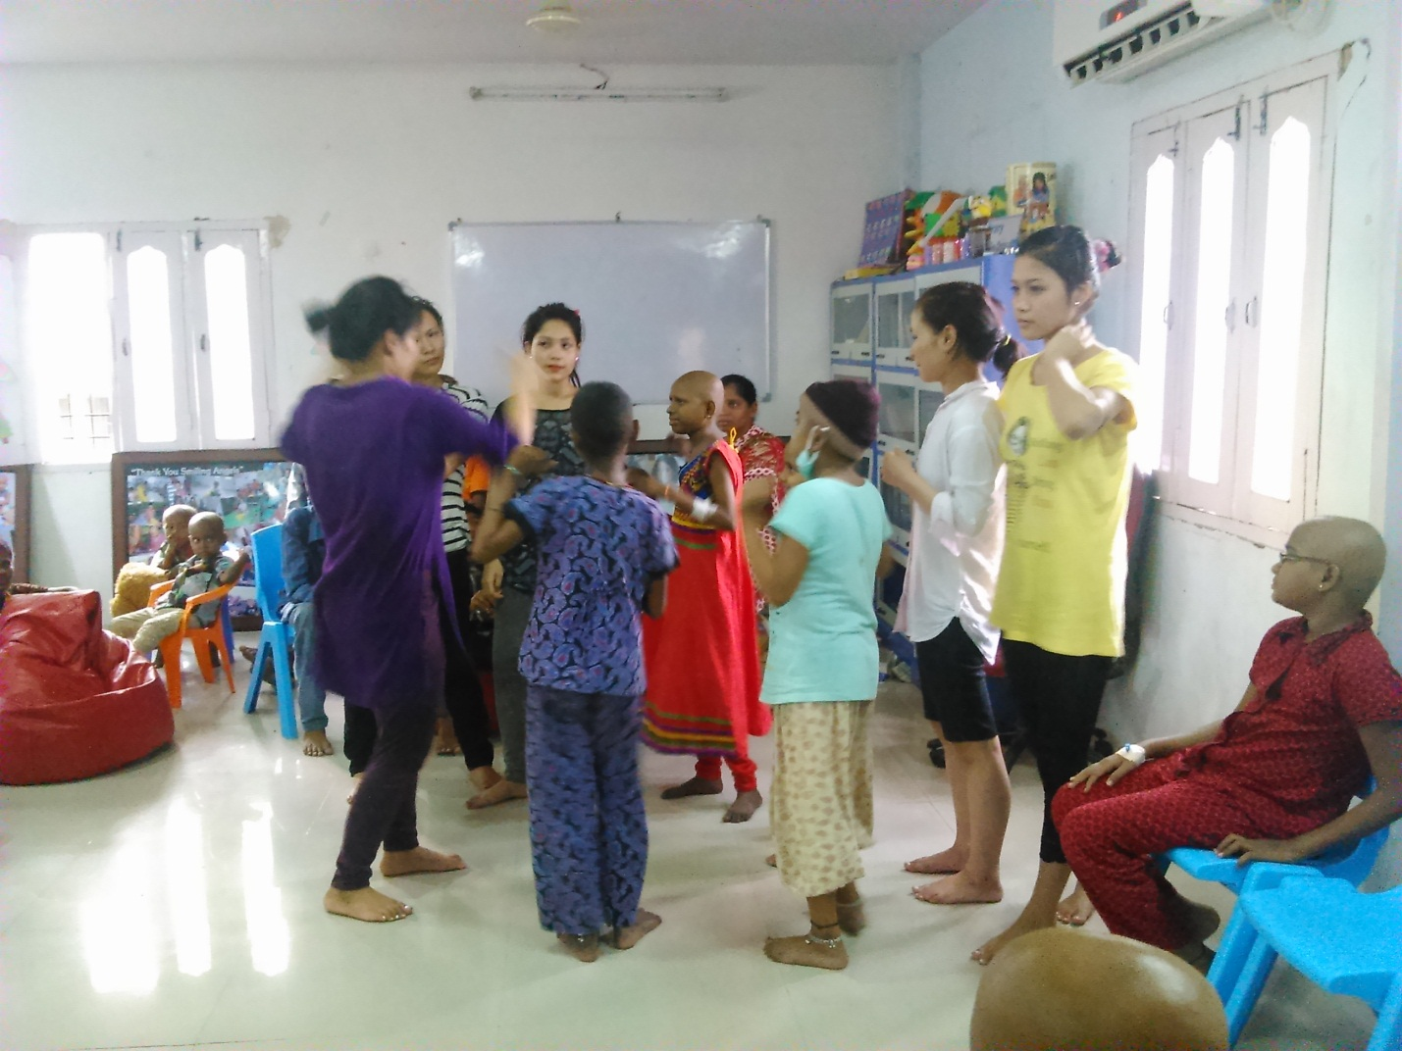
Megha Dinesh Group Visited MNJ And Entertained The Kids.
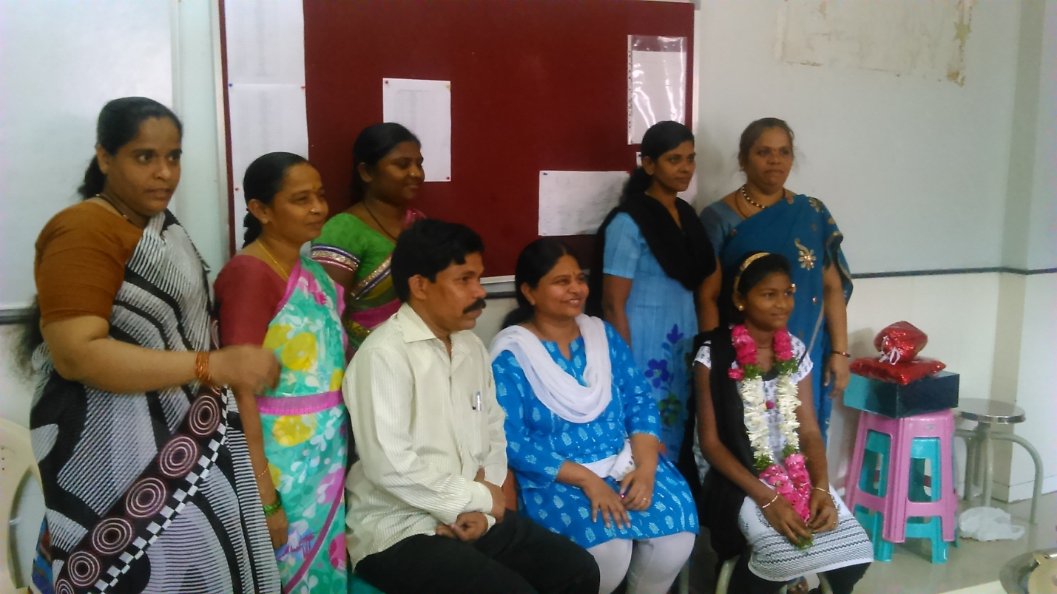
Patient Akhila Birthday Celebrated With IMPACT STAFF

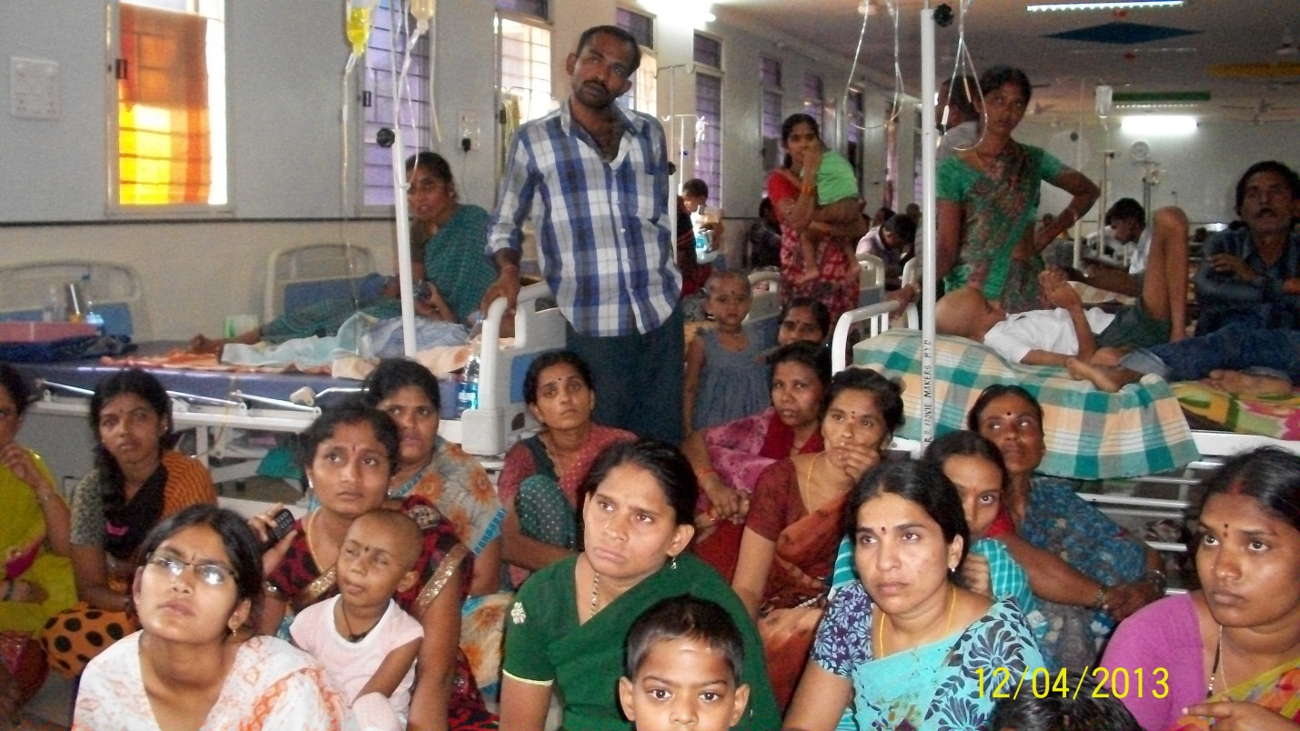
Support Group Meeting In the NATCO Ward For The Attenders.
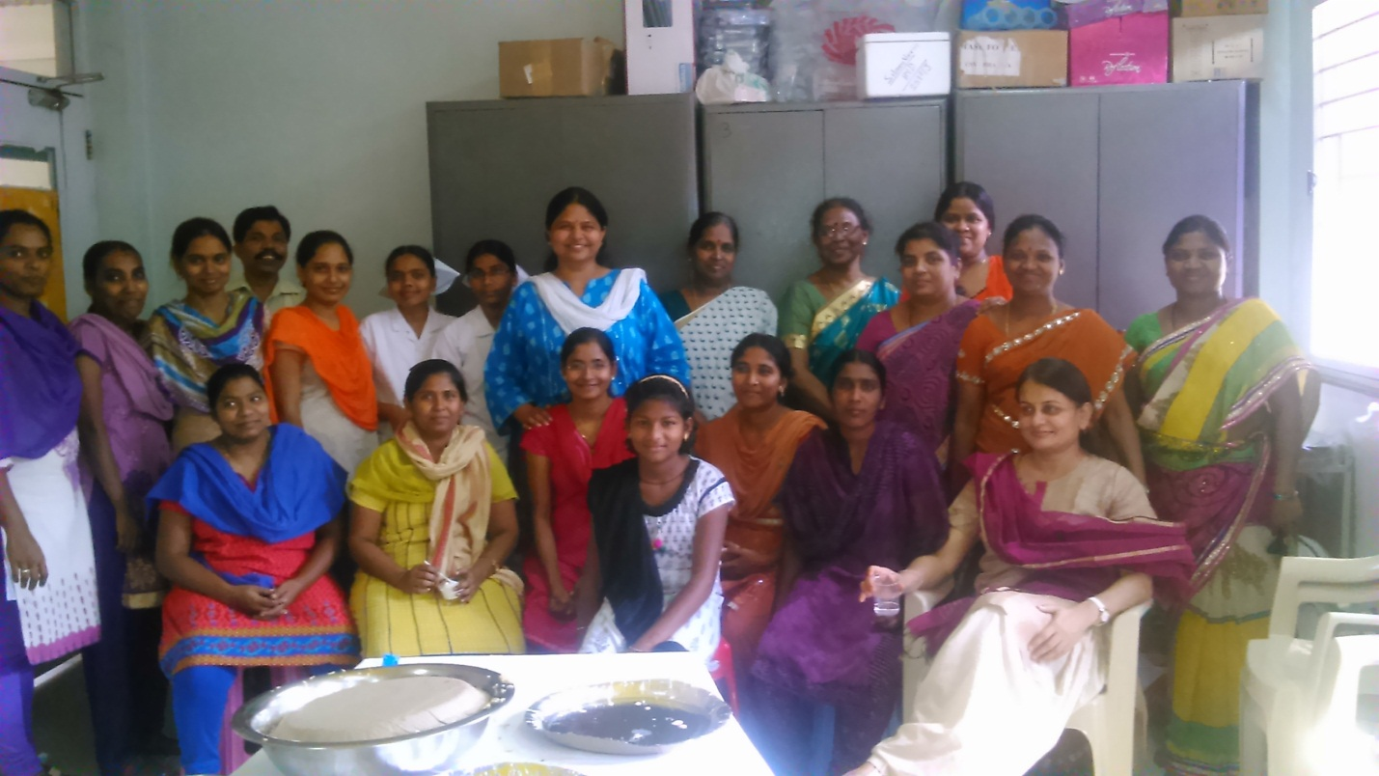
Staff Get Together Along With Kids and Parents In The NATCO WARD
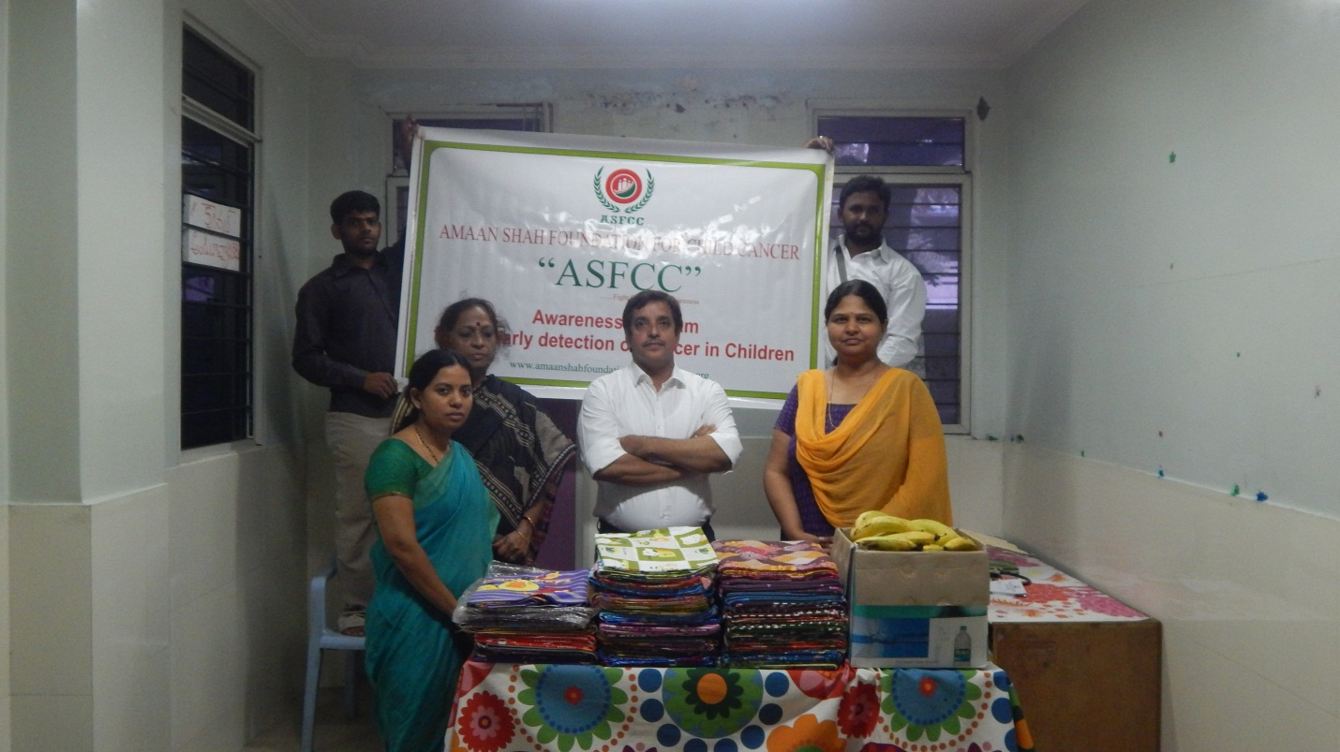
AMAN SHAH FOUNDATION DISTRIBUTED 150 BLANKETS TO IMPACT CHILDERN
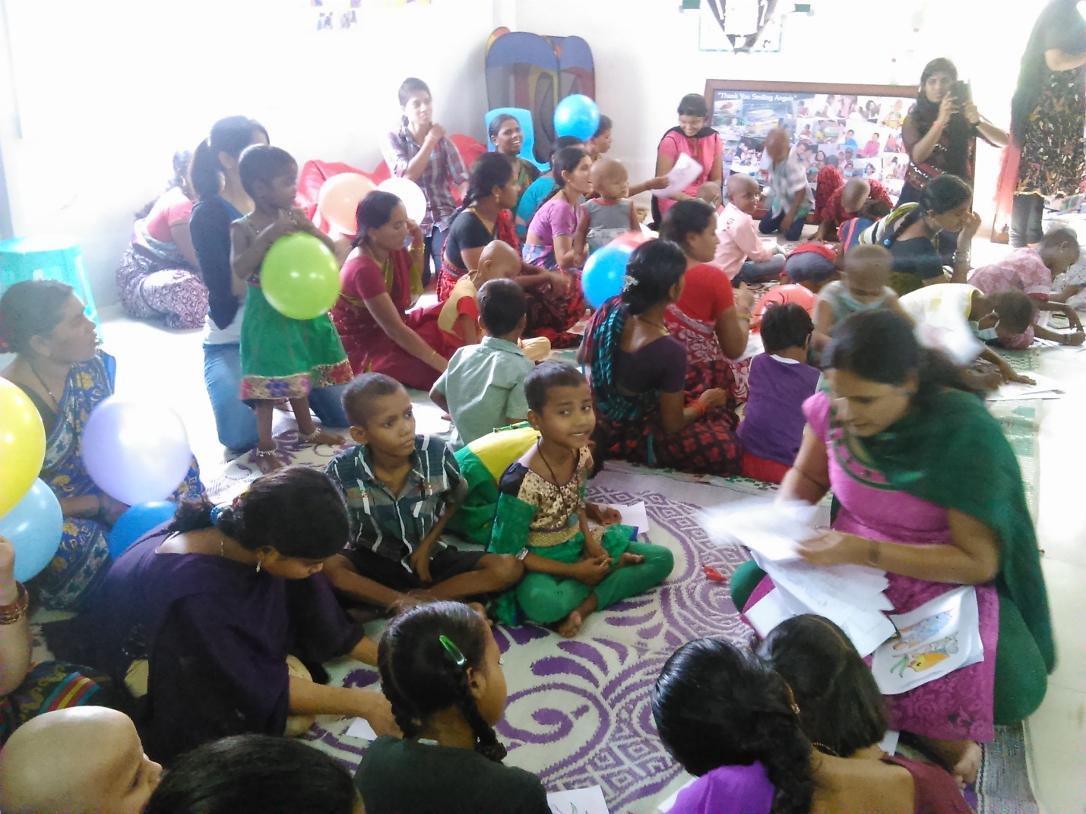
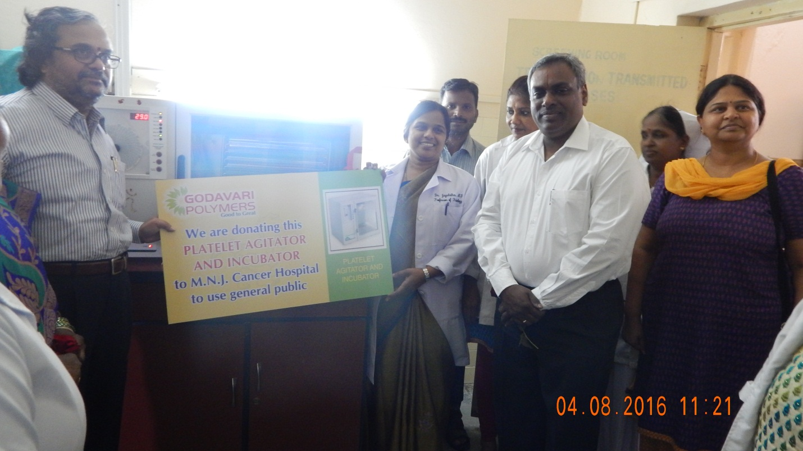
Godavari Polymers Donating Platelet Agitator and Incubator to MNJ Cancer Hospital / IMPACT Child Ward.
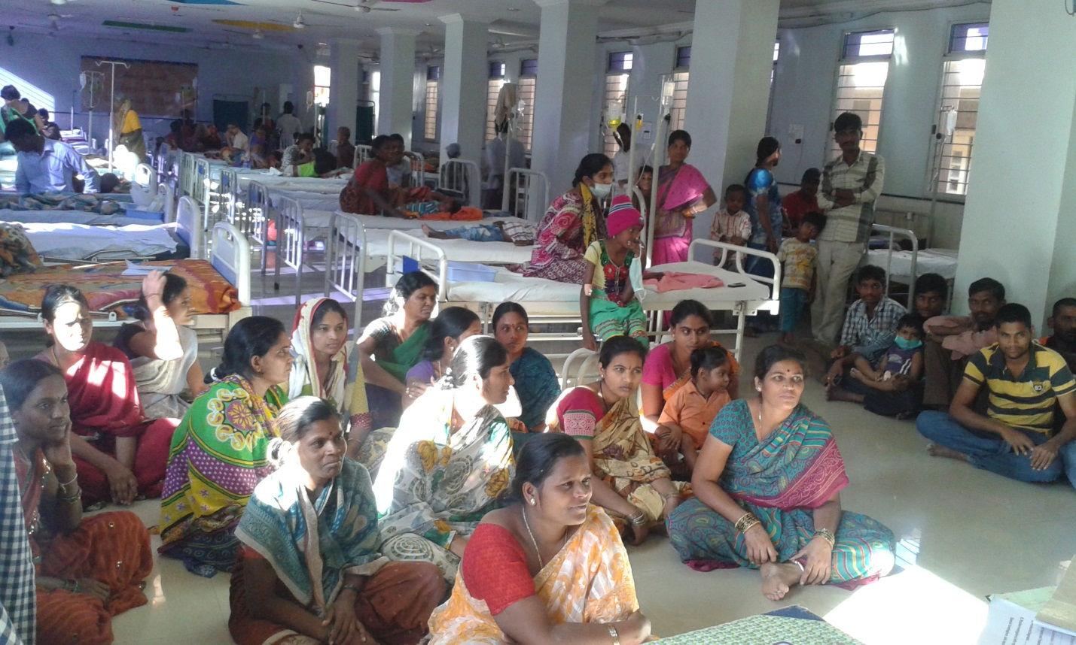
Awareness Program on Cancer By Impact Counselors in IMPACT ward

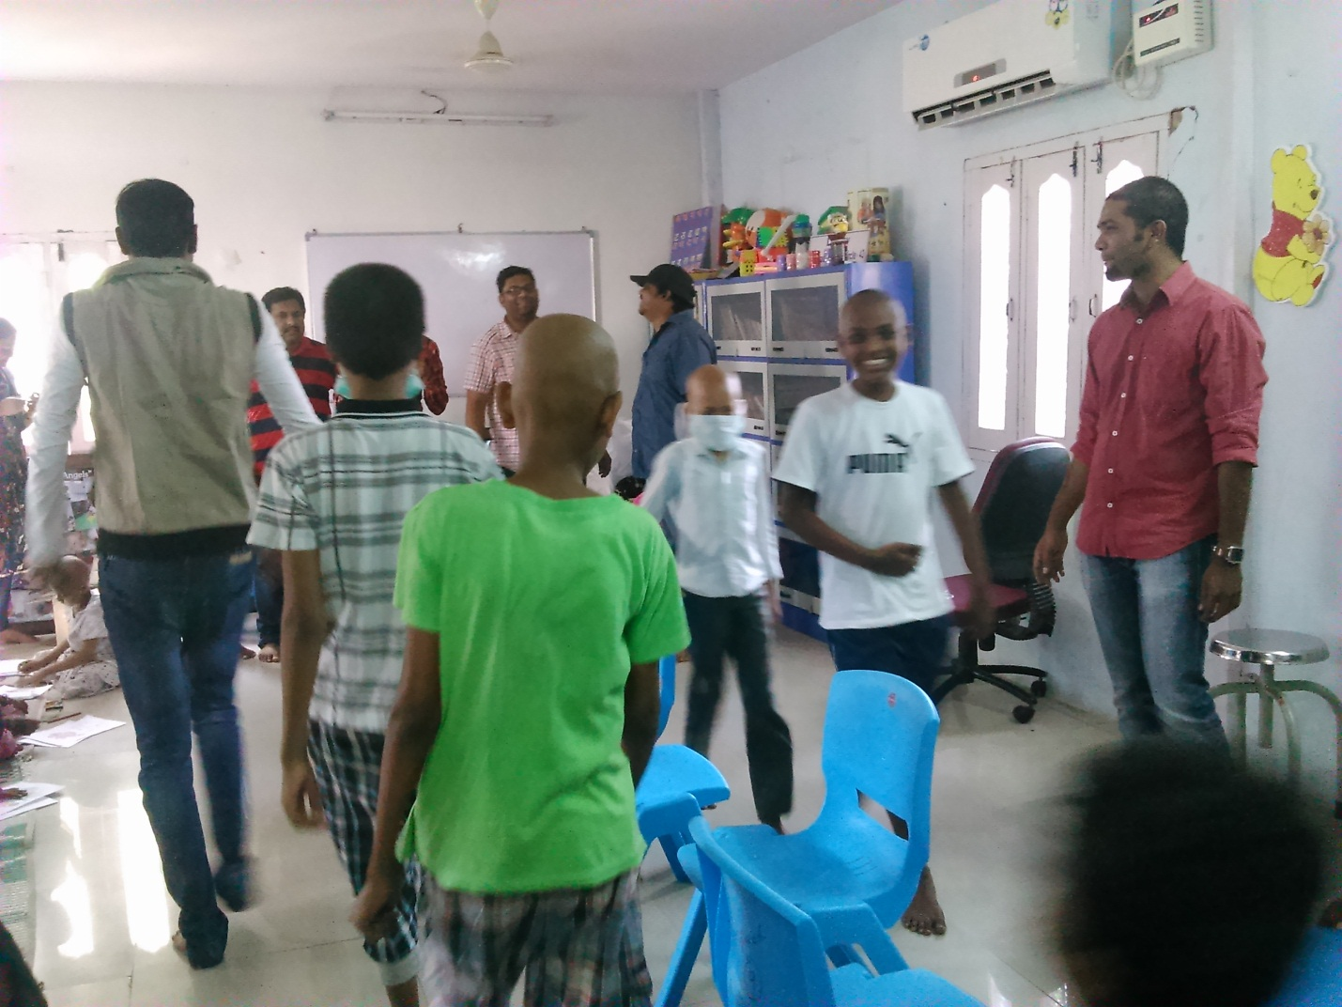
Employees From Madhapur Soft Ware Company Visited Had A Fun Time With Them.

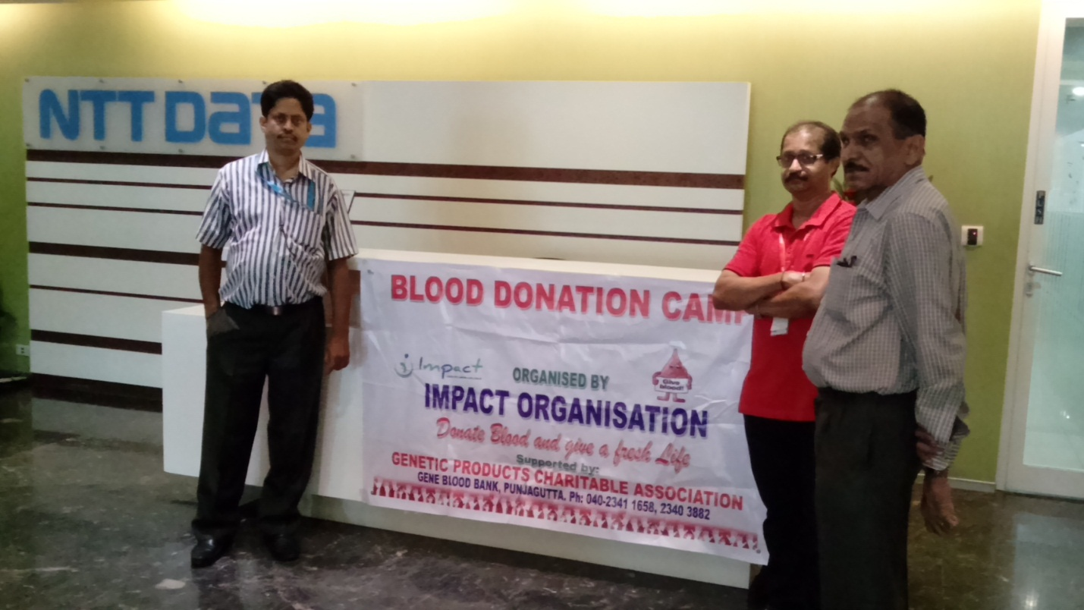
Blood Donation Camp in NTT DATA Divya Shree
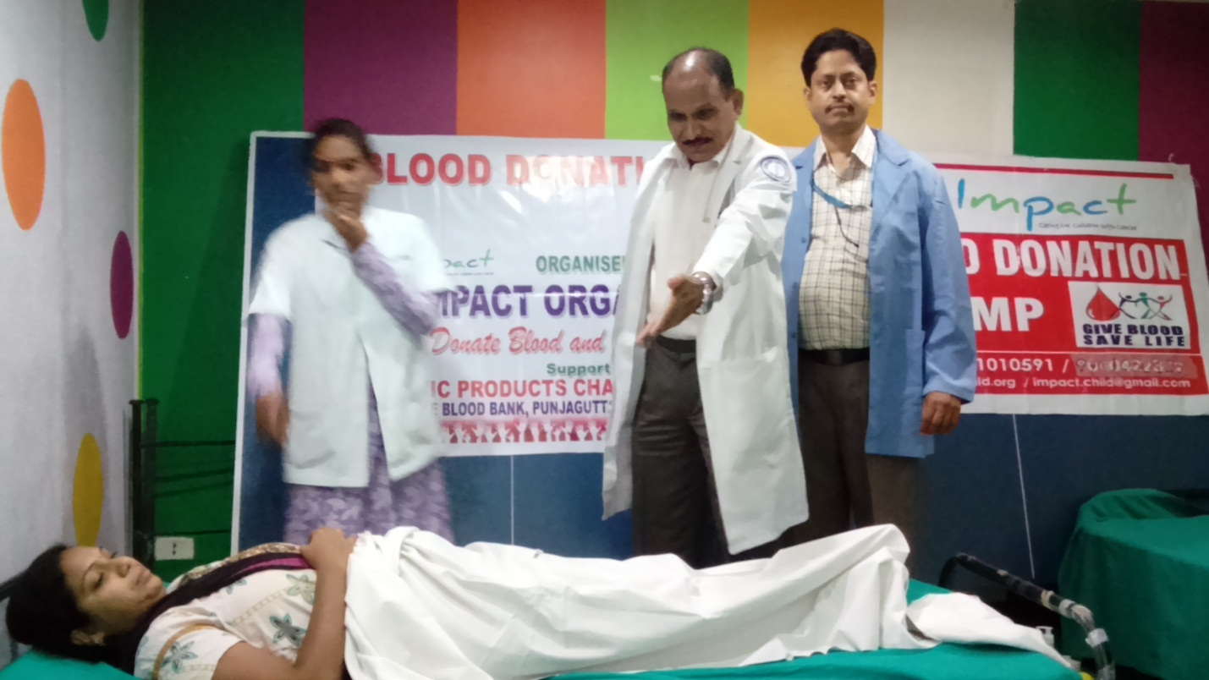
Blood Donation Camp in NTT DATA I-LABS
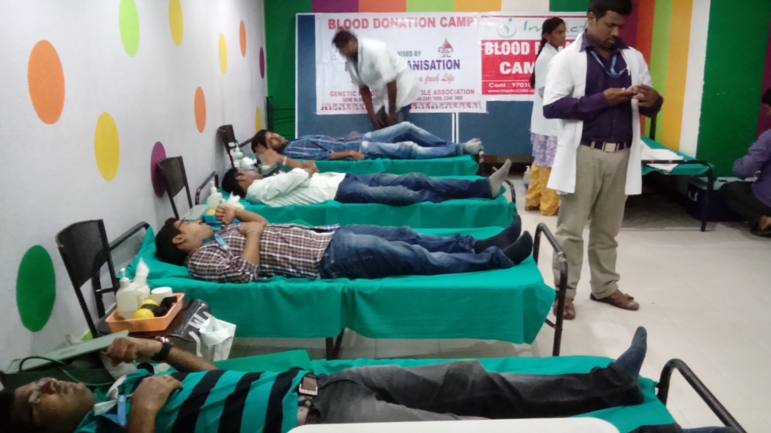
BLOOD DONATION CAMP IN NTT DATA CYBER TOWERS
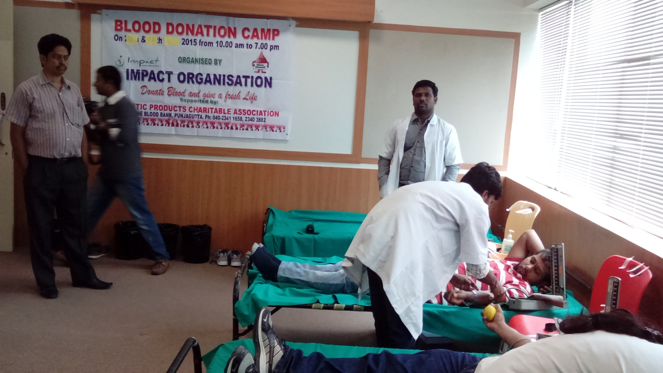
Blood Donation Camp in RYAN , Madhapur
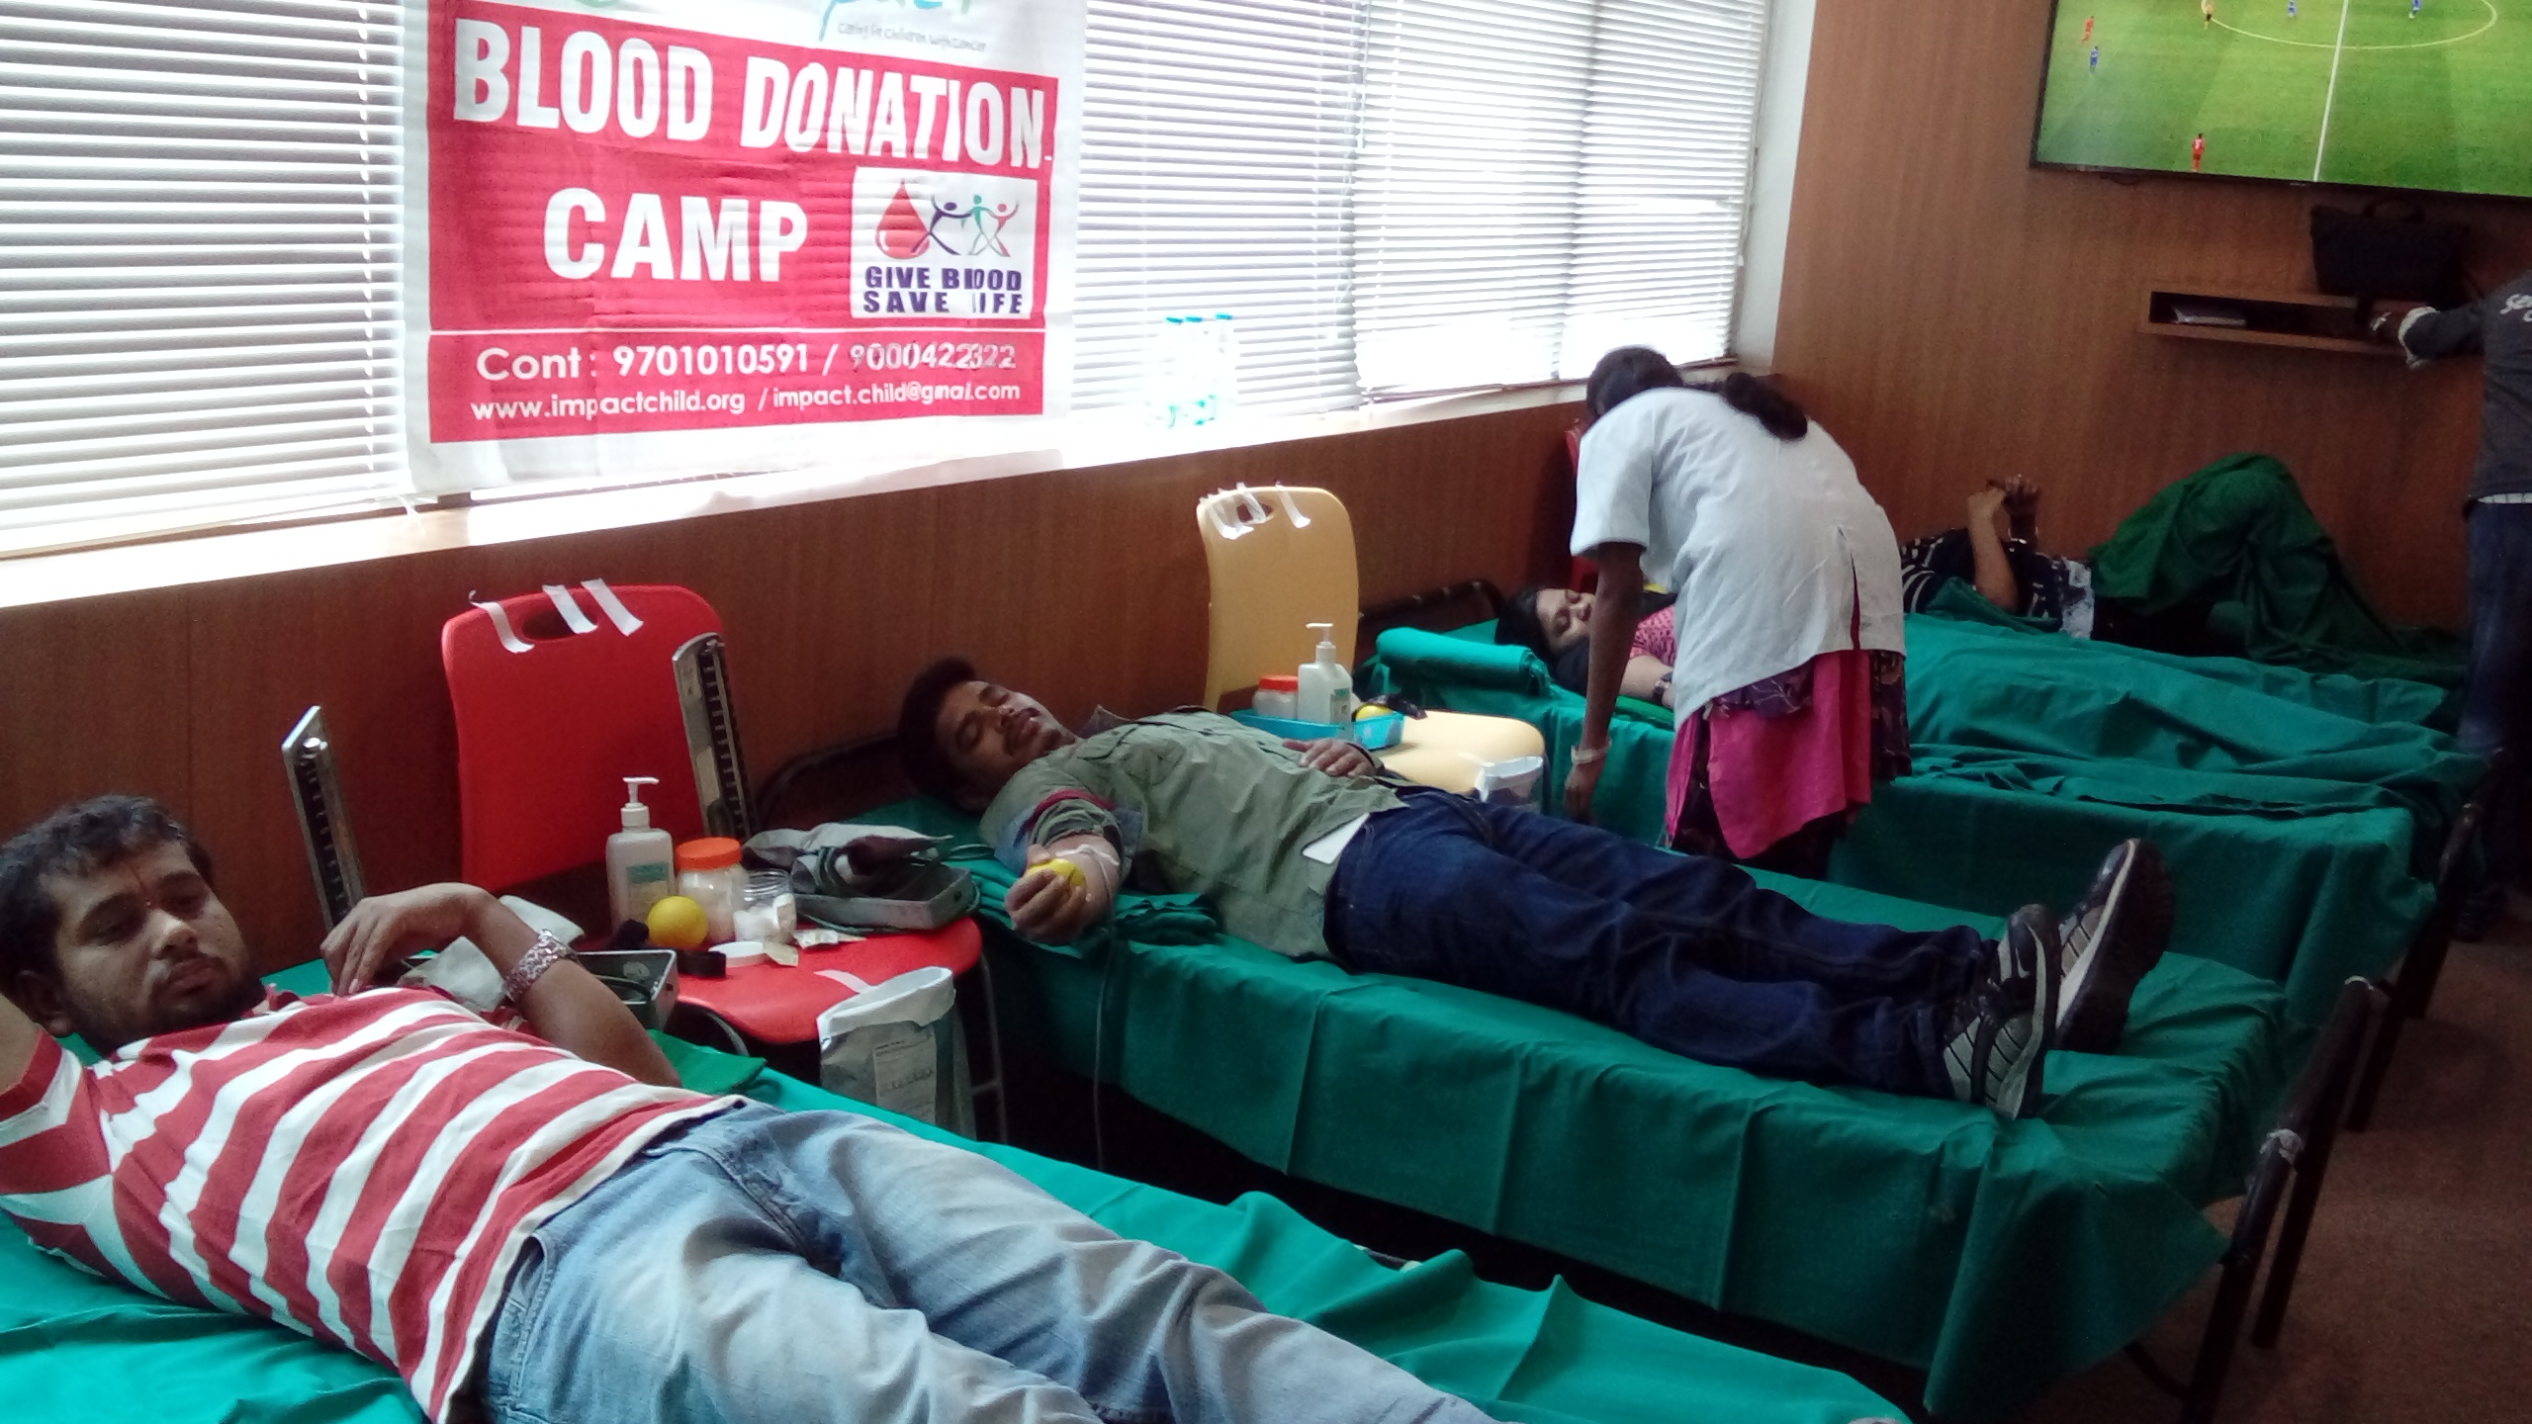
Blood Donation Camp in RYAN , Madhapur

