Annual Report
Building Self Reliant Rural Communities

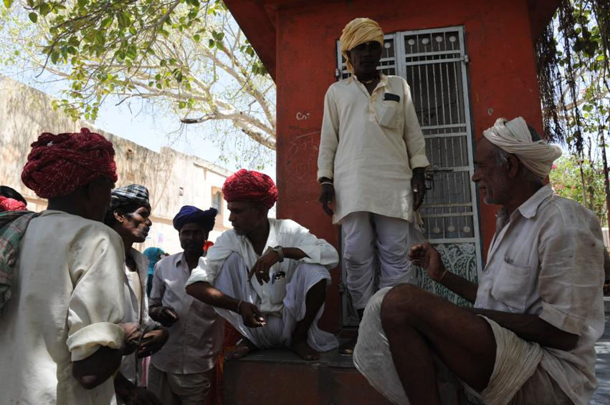

Seva Mandir
Old Fatehpura, Udaipur
313004, Rajasthan
info@sevamandir.org
www.sevamandir.org

Capacity Building Activities carried out between April to July 2011-10-15:
- Training of women members of Gram Vikas Committees (Village Development Committees -GVCs)
A three days training was organized with the 25 women members of GVCs in Jhadol block. The resource person was skilled in conducting such trainings on issues of involving women in decision making processes at the village levels. Women enjoyed participating in this training. They were very shy in the beginning but slowly they opened up and shared their views about various issues they want to discuss in village meetings. The training aims at building women’s confidence of how to engage in discussions at village level meetings and raise their concerns. Many women suggested to organize such trainings for them on a regular basis.

- Training of the Committees for taking responsibilities of development of their own village (Support Peoples Initiative/ SPI):
SPI program aims at empowering villagers by encouraging them to monitor and manage development projects in their villages and take responsibility of some projects financially if they can. They are also encouraged to involve in recruitment and evaluation of village volunteers who are designated to work on various development projects such as rural school, maternal and child health programs, agriculture and preschool program supported by Seva Mandir.
Trainings on SPI also help cultivating necessary skills of self-management amongst the villagers. A total of 8 such trainings were conducted for 250 GVC members.

Village Cohesion Index (VCI):

Every two-three years the grading of Village Groups is done to asses the group’s capability of taking responsibility of development projects. The groups are graded on 4 criteria – including
- Participation of members of Village Institution in the discussion and decision making process,
- Management skills of GVCs in managing the village development projects and common property resources,
- Leadership qualities of GVCs,
- Resource utilization capacity that includes both physical and financial resources.

During this period, 10 workshops for Village Cohesion Index were conducted. A total of 200 Village Institutions have been graded out of total 518 GVCs (Village Development Committees).

Federation building:
The main aim of forming federation (of village development funds across a few villages) is to create a platform that will allow a cluster of Village Institutions to come together and create a bigger democratic space for villages to deal with development issues. Formation of federations of village institutions has been initiated to increase cross learning amongst villages. As a result, it provides people more leveraging power for advocacy. During the period, 3 zone level federations were created. In total now we have 30 zone level federations.

- Gram Vikas Kosh (GVK):
GVK or the Village Development Fund which is built out of people’s contribution serves as an agenda of common interest in village. To grow returns on this village corpus, a significant portion of the fund is kept in the bank as fixed deposit. As on 31st March, there were 620 GVKs with Rs 35 million.
The villagers use the fund for immediate development needs such as reparing the boundary wall of a pastureland/grassland repairing, giving out loans to community for income generation or meeting immediate needs, paying for honorarium to village volunteers who serve for the community, payment of a veterinarian’s fee for cattle’s vaccination, establishing seed bank, buying pest control for farms in villages or purchasing of clothes for children who attend rural schools etc.

