Taking Village Funds to a New Dimension

The institutional landscape in Seva Mandir's work area is characterised by an absence of inclusive, democratic spaces through which citizens can engage in a meaningful, collective process to secure just and dignified outcomes. The Village Institutions Programme of Seva Mandir aims to create the social and political conditions necessary for people to rebuild their solidarity and their institutions to ensure democratic participation of all sections of the society. What is needed are investments not only for building infrastructure but also for capacity building of the poor, and for revitalising the institutional mechanisms to manage resources at the local level; all of which can strengthen the socio-economic status of the rural poor.

Village Development Funds

The Village Development Fund, or Gram Vikas Kosh (GVK), is an innovative concept of Seva Mandir, which aims to foster democratic village institutions through the creation and management of a village level fund, formed from people’s contributions. Gram Vikas Committees (GVC), democratically elected, non-party and non-religiously affiliated citizen associations, hold the funds. The funds serve a dual purpose: a common financial resource in which every villager has a stake, they not only lay the foundations for a secure and autonomous community, but they create a platform for village governance. In the past year, Seva Mandir has helped set up 14 new Village Development Funds, bringing the total to over 585. The total funds saved by these community institutions over the years is now close to Rs 33m an increase of approximately Rs. 2.8m on last year.

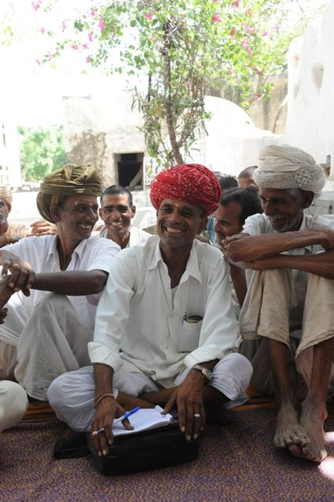
What we do: Trainings, Workshops and Capacity Building

After the initial establishment of the fund, the most important aspect of Seva Mandir’s involvement with a village is workshops and trainings. These are conducted in view of an end goal of complete autonomy and are designed to develop understanding of self-governance within the community, giving villagers the confidence to voice their concerns within the Committee meetings and ultimately to help link village institutions with local government. Moreover, trainings and workshops are held to sensitize village communities towards gender issues and to enhance the capacity of elected women leaders to function effectively. Futhermore, most villages currently outsource their record maintenance, employing costly outsiders to manage their funds. Trainings will be held in order to build up the capacity of communities to manage their own funds: giving one villager basic accountancy training can enable an entire community to be become more self-sufficient and independent.

Some Trainings April 2009 – March 2010

Type of Training |  | Number of Trainings | Number of Village Development Fund Committees | Total Number Participants
Village Development Fund Committee Capacity Building | Newly Elected Committee | 6 | 23 | 187
Village Development Fund Committee Capacity Building | Re-Elected Committee | 14 | 61 | 338
Accountancy Skills |  | 44 | 244 | 435
Women’s Empowerment |  | 20 | 171 | 479 of which 446 women*

* Women often have to be accompanied by men in order to attend trainings in different villages.

Beyond the Financial: Funds and social cohesion

Through its Village Institutions Program, Seva Mandir seeks to empower communities to be able to identify their own development issues, raise them at community and zone level and attempt to solve them independently. The role of the Village Development Fund is crucial in achieving this. Not only does the presence of a financial resource in which everyone has a stake provide a focal point for community discussion and governance, it also enables financial solutions to community problems to be funded communally and independently. For example, when prices for grain increased beyond the means of individual families in one village, it was decided by the Development Fund Committee that grain should be bought in bulk with money from the fund. By buying in bulk, and reducing transportation costs, each family was able to acquire the grain they needed to feed itself. One example out of many, this illustrates the use of the Fund, not only as financial resource, but as focal point for community interaction, and governance towards the common good.

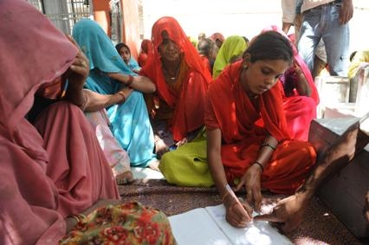
Challenges Ahead: Reaching the Funds’ Full Potential

However, despite its successes, Seva Mandir feels that the funds remain underutilized and are an untapped resource. A project inspired by work conducted by the students of the Yale School of Management, we have begun to explore Federations as a means of exploiting the full economic and social purpose of the village funds. We are looking into pooling funds across villages, low-risk and steady return investments and ways in which new inter-village fund management can improve governance and development projects at individual village level.
Pooling Funds: The Financial and Social Benefits
While the Village Development Funds have historically invested as distinct entities, there are economies of scale that can be achieved in pooling the investments. Pooled funds will enable communities to share associated costs, reducing the burden of banking fees for each fund. Further, the pooled assets will enable a collective fund to access a higher return on securities since it will be considered a bigger player in the market. The shared burden of banking fees and access to higher return securities will help to mitigate the external market conditions that have recently forced rates to drop.
Moreover, we feel that the village funds have not yet reached their full capacity as a financial resource, but also as a locus of community action. Therefore, in pooling the different Village Development Funds together we must find a suitable form which satisfies both social and financial imperatives. However, there are no readily available, pre-conceived, institutional designs which meet our financial, social and legal requirements. We must work with the communities in exploring different solutions to meet our challenge. In order un-tap the full potential of the Village Development Funds, we need to find an institutional form that will allow village communities to retain control and ownership of the fund whilst also being able to invest capital in both in financial markets and land investment opportunities.
With your help, we seek to leverage the money in the funds to reinforce solidarity and support autonomous village development.
The Next Step
In the next year we will provide trainings and workshops to the members of the village fund committees as well as keep up consultations with villages and their leaders. Trainings and consultations are central to the work that we do. We must continue and give communities the leadership skills and confidence to manage bigger funds on a larger scale, together. With your help, we can continue to provide basic accountancy trainings, women-specific confidence building workshops, capacity building trainings and more, and ultimately empower villages and communities to drive their own development.

We will also be seeking professional legal and financial guidance on how best to create an institutional structure that satisfies the needs of the community. Regularising the legal status of a common financial resource is the first step, followed by discussions into different types of low-risk, high-return investments that communities would feel confident engaging in.

