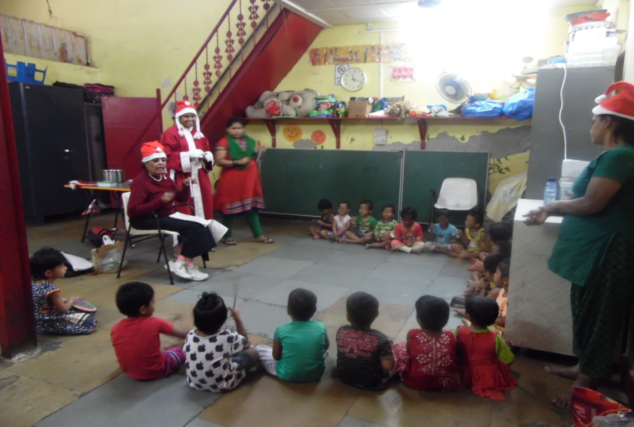CHRISTMAS CELEBRATION

