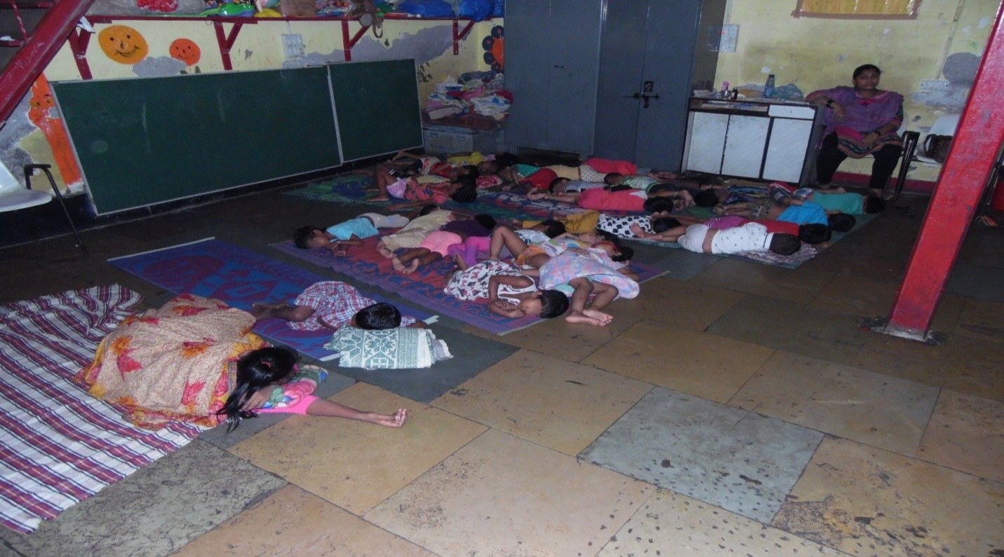SLEEPING HOURS OF TODDLERS

