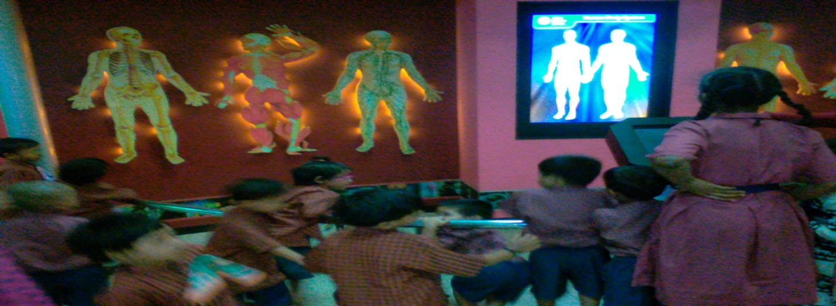VISIT TO NEHRU SCIENCE CENTRE

