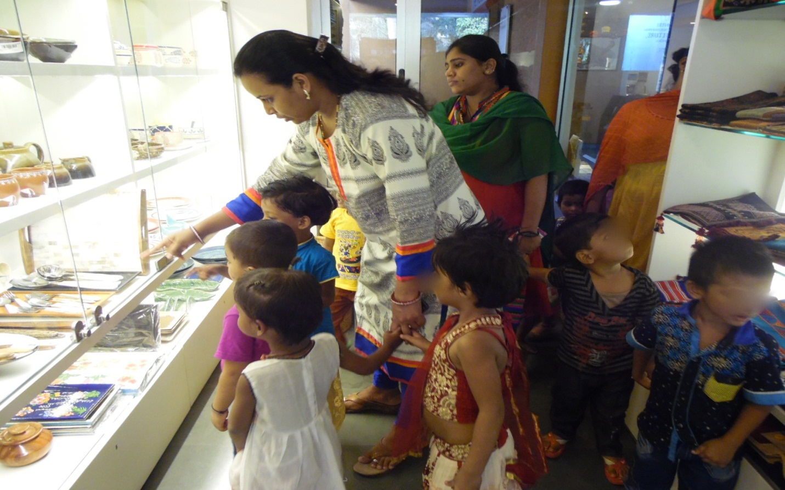UMANG BENEFICIARY’S VISIT TO MEUSEUM

