Enable a Fair Start for High Risk Preschoolers and Their Mothers

Location : Turkey
Theme : Education
Total Budget: $ 210,000 USD
Project Needs : $ 77,000 USD

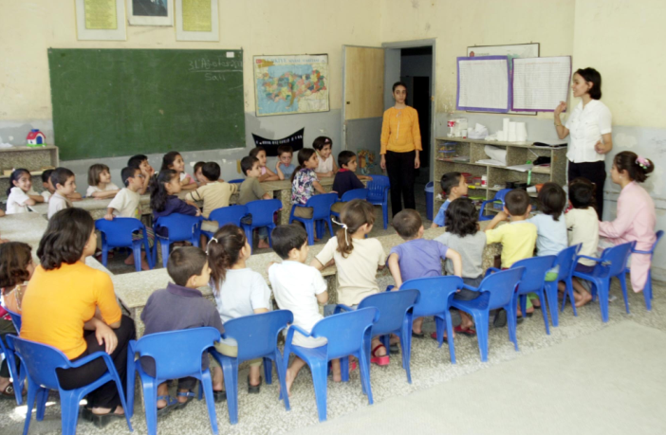

Project Needs and Beneficiaries

The child's cognitive, social, physical and emotional development is almost completed within the first 6 years of life. Compensating for a lack of education and stimulation within these years, later on in life, is almost impossible. Children who do not have access to preschool education have an increased likelihood of being unsuccessful at school, of dropping out and of experiencing social adaptation problems later on in life. Children who live in disadvantaged socio-economic conditions are already at high risk developmentally. Unfortunately, only 32% of preschool aged (for 5-6 age groups) children have access to preschool education in Turkey. Although these children are those most in need of support early on in life, they have the least access to early childhood education. It is therefore most important that these children be provided with a chance to have a 'fair start' in life by being given equal opportunity to access preschool education.

The summer preschool education program is a 10-week program for 5-6 year old children in southeastern Turkey who are about to start school in the fall. The program aims to increase the school-preparedness of preschoolers in this region by supporting their language skills and cognitive development and thereby make their first few years in elementary school more effective. In southeastern Turkey children do not receive preschool training at formal schools and with one out of two women in the region being illiterate, there is also very little home-based education that can prepare these children for school. Therefore, there exists a serious risk to not providing preschool training to children in these disadvantaged communities: including loss of human capital, impeded development, earlier school dropouts that result in increased regional inequalities.

Activities

The preschool education program implemented at the Summer Preschools consists of four modules on children's physical, cognitive, socio-emotional and language development. The modules provide information on how to develop children's self-care skills; support literacy, numeracy and conceptual development; enable the establishment of positive relationships with peers and elders; and self-expression. All of these areas are focused on in order to prepare these children for grade one in the fall. The mothers of these children are offered a training program that consists of information on nutrition, preventive health, health of mothers and children, school readiness and positive mother-child relationships.

The summer preschool program has been developed by AÇEV experts in 2003 and has since then been implemented in 8 provinces reaching more than 4,200 beneficiaries. In 2008, the summer schools project is planned to be implemented in 60 classes in Diyarbakir. As part of the program, participating children's mothers are also provided with complementary “mother support” training. In this set-up, mothers will bring their children to school and also receive training in separate classrooms about child development and education.

The summer preschool program will be run by instructors who are locally selected from graduates of vocational training schools for preschool teachers. Public primary schools of the National Ministry of Education are going to be used as locations for the preschool courses. In these primary schools, AÇEV will furbish the classrooms according to the needs of 5-6 year old preschool children, provide educational materials (books for instructors as well as children’s workbooks) and allocate instructors for the courses. The time period for the summer preschool program will be everyday for 10-weeks starting in June 2008.

At the completion of the 10-week program, the AÇEV program coordinator will follow up on the enrolment of the children in first year of primary school and tries to ensure that all girls as well as boys are enrolled in the first year of schooling. In this way, the program also aims to facilitate the transition into primary school, especially for girls.

Expected Results
As a result of the summer preschool project implementation, AÇEV aims to reach 600 children and 450 mothers in Diyarbakir. (20 children and 15 mothers in 30 summer preschool classes and mother support groups). The evaluation criteria for project success will be the measured increase in children’s verbal and math skills (ii) the improvement in children’s interaction with their peers, ability to play and share with other children and (iii) the enrollment of children, especially girls, in the first year of elementary school.

The lasting impacts of the program are expected threefold: Firstly, the schools in the region will benefit from the program by having an increase in the supply of furbished preschool classes and will have increased internal capacity and resources in terms of equipment, trained staff for delivering early childhood development programs. Secondly, the program is expected to have lasting effects for the children and their families as well as the peace and stability of the region as a whole. The children who attend the program will be more likely to enroll and remain in primary school as they will have fewer problems with understanding the language of instruction. The women, who receive the parallel-running mother support program in the same weeks, will become more knowledgeable about how to communicate with their children and how to provide a safe and nurturing environment for them that ensures their healthy development. Finally, the project will generate employment and develop capacity in the locally hired project team. Over a total of 50 local women are going to be recruited and trained over the course of the action. Some of these women will be in supervisory roles while the rest will assume teaching or support roles. These local women will have increased employability as a result of this solid work experience with and additional training from a credible organization and have increased self confidence and autonomy.

Contact for the Project
Meltem Aran Kazanci - Projects Specialist
Mother Child Education Foundation (AÇEV)
Buyukdere Cad. Stad Han No: 85 Kat: 2 34387 Mecidiyeköy Istanbul TURKIYE
Tel: +9 0212 213 4220 Fax: +9 0212 213 3660 Email: meltem.aran@acev.org

Project Message
With this project children will receive the support necessary to significantly improve their cognitive, linguistic and socio-emotional skills in 10 weeks and as a result they will be better prepared for school and have a higher likelihood of success in school.

Resources
- Project Homepage: http://www.acev.org/english/training/spp.asp
- Reports on ACEV Early Childhood Education Program: http://www.acev.org/english/researches/research.asp

