Project Update on Improving Food security of tribal families

The background of the area:
Seva Mandir’s work area is encircled by the Aravali hills and primarily inhabited by Bhil tribe, which constitutes 68% of the total population. It receives 640 mm rainfall annually, which is highly erratic in terms of onset and distribution. Most of the received rainfall runs-off due to undulating terrain. The region is classified as drought prone. Around 73% of the total geographical area is owned by the State, which includes forestland, village pastures and revenue land. These common lands are highly degraded and contested. On an average, farmers have 1.5 ha of land, out of which roughly half is not a good fit for cultivation while only 16% of the cropped area receives some sort of irrigation.
In this situation, people engaged with agriculture work face a number of challenges. The productivity of natural resources (mainly land and water) has been reduced over time due to inadequate attention to these resources by both the Government and the community. In addition, the overall climatic conditions also affect the agriculture and farming, such as low rainfalls, increase in temperature, frequent and severe droughts and low ground water table. Therefore, on one hand, there is a need to conserve and develop the local natural resources in order to sustain their long-term potential for better agriculture and allied sectors. On the other hand, using appropriate production technologies could help increase agricultural productivity.

Seva Mandir’s response:
Our watershed development, rainwater harvesting and afforestation programs have helped increase the carrying capacity of natural resource base in the region. As a result, the depth and nutrient content of the soil, the availability of moisture in the ground has increased. Building upon this base, the interventions in agriculture (primarily horticulture development), vermin-composting and vegetable cultivation is an attempt to improve farm productivity and food security for tribal farmers in our region.

How it is done in villages:
Agriculture activities are carried out in villages where soil and water conservations measures, water resource development programs have been already undertaken. The village together selects the interested farmers to be associated with agriculture development interventions. The activities are then planned based on the availability of resources. The selected farmers receive relevant trainings from Seva Mandir (in collaboration with agriculture experts) and the village-volunteers provide their guidance and supervision to these farmers.

Activities:

Over the last two years, we have been working with 5000 tribal farmers with activities like horticulture, vegetable cultivation and vermin-composting. Each activity is described in detail below-

- Horticulture development:
Horticulture development provides an opportunity to diversify cropping patterns for farmers. It includes cultivation of various fruit trees on the cultivable land which has an easy access to water. The diversification is helpful in cases where a crop can fail due to low/no rains. The alternative crop (fruit trees) in such cases provides these farmers with another source of income as well as the local consumption of fruits results into better health (vitamins and minerals deficiencies). Besides, cultivating regular crops along with horticulture plants (fruit trees) the farmers are able to utilize their small pieces of lands efficiently.

Horticulture trees are planted in two models – one as dhora (channel) and the other as badi (orchard). Both these models are available for the farmers according to their interest, land use patterns and water availability. In those fields where farmers have water channels for irrigation and farm bunds, they plant tree along with the irrigation channels (dhora) and bunds. This ensures the automatic watering of plants, optimum use of water and helps stabilizing the farm bunds.
In badi (orchard) model - the farmers plant the fruit saplings in equal distance of 8 meters in one particular patch of land and between the gaps they grow their regular, seasonal crops. Both models have their own advantages.

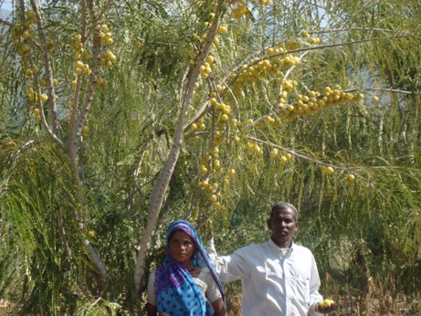
Seva Mandir provides these farmers with saplings (improved variety of Mango, Guava, Aonla, Sapota etc), tree guards and trainings on improved horticulture practices (how to plant saplings, identification of pests, pest control, nurturing the crop etc.).
The farmers contribute a 20% of the total cost for implementation of these activities ensuring their active participation and ownership in the program. (In the photo a family with their Gooseberry (Aonla) tree)

In the last two years, we have supported 591 farmers to adapt horticulture practices. The details of which are as follows:

Year | No. of farmers |  | No. of saplings
Year | Dhora model | Badi model | No. of saplings
2008 | 160 | 31 | 4,740
2009 | 348 | 52 | 5,767
Total | 508 | 83 | 10,507

In most cases, the farmers prefer dhora model (irrigation channel) due to small and fragmented nature of landholdings. In this model, the saplings stand good chances of survival (up to 60%). For the next two years, these trees will be ready for fruition. In the current year i.e. 2010 we will be planting 13,000 saplings with another 650 farmers in all our six blocks.

- Vegetable cultivation:
Vegetable cultivation also helps diversify the cropping pattern. Though farmers do grow some vegetables during monsoon, the quantity is not adequate for their subsistence. However, the vegetable cultivation program is focused and thus ensures the quantity, technique and scale of vegetable production ensuring nutritional security to the families throughout the year. It also helps the farmers earn more income.

There are two models for vegetable cultivation – one is Vegetable Nurseries and the other is Vegetable Gardens.

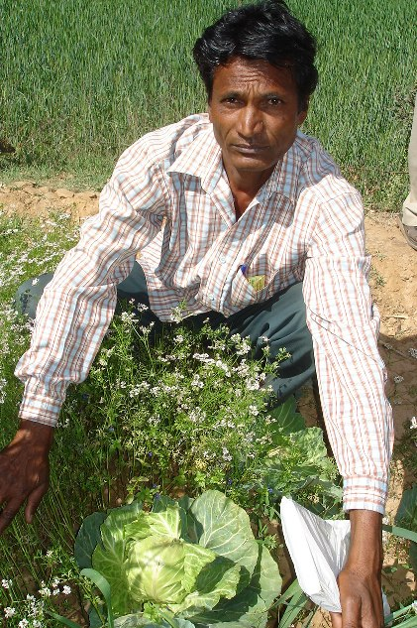
The Vegetable Nursery includes raising nurseries at a farmer’s farm and supplying raised saplings to other farmers for growing these vegetables in their kitchen garden. The first most aim is to increase the household level vegetable consumption. The other is to encourage the production of vegetables at a commercial scale to help farmers earn some cash.
Seva Mandir provides these farmers with good quality seeds, technical support and trainings on vegetable cultivation practices. (In the photo cabbage with coriander)

In the last two years, we have supported 677 families in the vegetable cultivation. The details of which are given below:

Year | Nursery | Individual garden | Total families covered
2008 | 200 | 60 | 180
2009 | 329 | 88 | 497

In the current year i.e. 2010 we will be working with another 500 families under this activity.

A case in point:
In village Kojo ka Guda we are working with 41 farmers, of which we supported 9 farmers with vegetable cultivation program who have access to marginal irrigation. These 9 farmers were given seeds of Okra, Eggplants and Bottle guard. They cultivated these seeds on a piece of land around 0.05 ha. These farmers were able to produce adequate vegetables. After their own consumption they sold the surplus in the local market earning Rs.200 (USD 5) per week for two months. Dholaram and Gangaram from the same village planted vegetables in 0.10 ha of area and earned Rs.750/- (USD 16) per week. The results have boosted confidence and all farmers are very positive about the vegetable cultivation program.

- Vermi-composting:
In our region farmers produce the natural composts by piling up the cow-dung and farm residues to decay on its own. This process is longer and also has the risk of moisture in the air that could affect the decaying. In addition, farmers also use the chemical fertilizers for their crop, which is expensive and affects the soil quality in the long run.

However, the vermi-composting enables the farmers to produce high quality organic manure. It is a technique in which earth worms in a rearing pit convert the cow dung, farm residues and other biodegradable waste into organic manure. Vermin-compost helps reduce farmers’ dependency on chemical fertilizers and is also cheaper. The chemical fertilizers degrade the agriculture land and increase the cost of cultivation in the long run.

The farmers prepare temporary beds for vermin composting and Seva Mandir provides them with necessary technical skills and the earthworms. It takes 30 to 45 days to complete one cycle for composting. Therefore, in a year a farmer is able to complete maximum of 8 cycles. The mice and ants are a big challenge for composting in the temporary beds. Hence, for the past two years, the farmers have been thinking of putting up the permanent beds (cemented structures). One cemented pit costs Rs. 1400 (USD 31) and each farmer contributes 20% towards its total cost. We have been supporting these farmers now with the permanent beds.

So far, the farmers have easily adopted the technique of vermin-compost and have been using it successfully. The crop yield has also been very encouraging, as a result.

A case in point:
Kalulal from village Dhala started vermin-composting three years ago. Initially he was doing the composting in a temporary bed nearby his farm. The mice and ants were a challenge for him for the composting in the temporary bed so he decided to build permanent pits. With support from Seva Mandir he built cemented pits in 2008 and ever since he has been successfully composting the cow dung and other biodegradable waste. He produces enough manure as well as is also selling the vermin-cast (seeds of earthworms) to his neighbors farmers.

In the last two years, we have supported 128 farmers with temporary beds and 235 farmers with permanent beds. From 2009 onwards we are supporting only permanent composting beds. In 2010, we will be supporting additional 400 farmers.

Overall, we are working with 5000 farmers to improve their food and income security with a variety of programs and activities. Our village volunteers are closely in touch with farmers to provide on-spot support, guidance and technical skills. This way we have been able to create a cadre of local resource persons who are becoming experts of agriculture programs.

