Vegetable cultivation at the local level: Food Security
Mid Year Report 2011
Submitted to
Global Giving
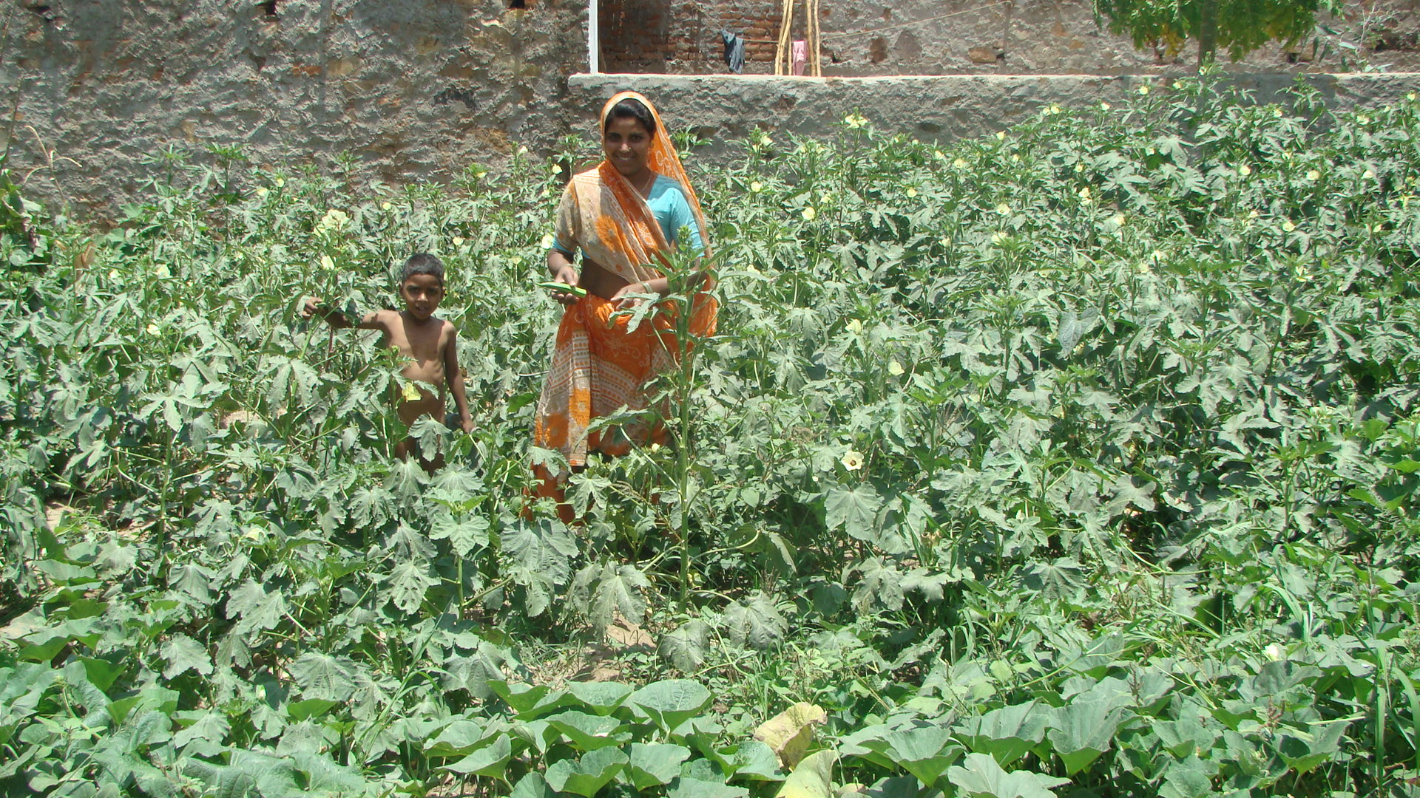

SEVA MANDIR
Udaipur Rajasthan, India
info@sevamandir.org
www.sevamandir.org

Progress from April to September

During the period under report more than 442 farmers cultivated vegetables in summer (zaid) and winter (Kharif) seasons. The table below details their earnings from various vegetables they have grown and sold during the reporting period. Fortunately, the monsoon too, was very favorable this year. The women have also taken a keen interest in growing various vegetables. On one hand, farmers have kept a part of their produce for their own subsistence and surplus was sold in the market to earn a bit of cash. It has been very encouraging for these farmers to be able to produce plenty of food.
Vegetable cultivation activities
S. No. | Block | No of farmers | Villages covered | Remarks
1 | Badgaon | 68 | Kadia, Peepad | Farmers grew bottle guard, ridge guard, okra, cluster bean, chilly and coriander etc. Total value of the produce reported to be INR 339,572/- (USD 6,792).
2 | Girwa | 84 | Kegara and Helpia (35) | 186,000/- (USD 3,720) earn by farmers from Gavar (pods), Okra, Squash, Tinda, Mung (Lentils)
3 | Jhadol | 186 | Kitawaton Ka vas Mornia, Birothi, Som, Umariy, Dhala Suali, Bhamti, Morania, and Adkalia | Vegetable cultivation being followed on wadi model.  90 farmers grew kharif vegetable and summer Mung and earned total 80,956/- (USD 1,619) and income of 42 farmers of summer Mung in Adkaliya village and earned 120,000/- (USD 2,400)
4 | Kherwara | 69 | Samited, Ranawara, Beda | In Babri - Gadunia, 22 women cultivated Egg Plan, Tomatoes, Onion, Okra, and Cluster Beans. They produced 3,440 kg vegetables out of which they sold 1,321 kg. Women earned Rs. 26,420 (USD 528) by selling vegetable @ Rs.20/- per kg.
5 | Kotra | 8 | Wasela, Patherpadi, Rajpur, | Farmers cultivated Egg Plant and earned 8,000/- (USD 160)
6 | Kumbhalgarh | 27 | Gawar, Majera, Sukhar, Antalia, Sevantri, Thurawad (clusters) | 9 Farmers grew bottle Gourd, Ridge Gourd, Bitter Gourd, Cucumber (kheera), Egg Plant, Tomatoes, Coriander, Okra, Cluster Bean, Yam , Chilly and earned INR 45,000/- (USD 900)

Case of Village Peepad
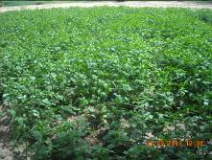
Some farmers in village Peepad were enrolled for vegetable cultivation program of Seva Mandir. Some other farmers also had shown interest after seeing the program’s success. They decided to grow vegetables on their farms too. The 37 farmers out of 42 got requested for good quality seeds of Cluster Beans. With Seva Mandir’s help 3 farmers who were representing the entire group (42 farmers) went to Udaipur City in order to explore various types of seeds available for the Cluster Beans. After close research the farmers selected the “Sarit Soumya 700” variety. It was bought and distributed to selected farmers (39 who showed interest in growing cluster beans).

Seeds | No. of Farmers | Amount (in Kgs) | Production (in Kgs) | Amount (in Rs)
Cluster beans | 39 | 43 | 13,300 | 236,800
Lady Finger | 16 | 9 | 900 | 7,350
Pumpkin | 27 | 1-35 | - | -
Ridge Guard | 37 | 1-85 | - | -
Coriander | 33 | 39-5 | 5,500 | 71,100
Chilly | 30 | 2-45 | - | -
Tomato | 17 | 0-9 | - | -
Moong | 4 | 8 | 50 | -

As per the details given in the table above farming of cluster beans was done in total of 21.5 bighas of land. In the beginning of the produce farmers didn’t receive fair price of the same but later on, as the produced increased due to good rain farmer’s fetched good amount on selling the same. Total of 13,300 of cluster beans was produced from 21.5 bighas of land. The rate of the produce ranged from Rs 10 – Rs 25 stabilizing the price at an average of Rs 18 per kilos. Total income of the benefitted farmers was more than Rs 236,800. Apart from cluster beans, the farmers also had grown other vegetables like Ridge Guard, chilies, coriander, pumpkin, lady finger, tomato, moong (Green gram) etc and had earnings of around Rs 711, 00 in an average from this. The other families of the village along with the beneficiaries were benefited by the produce of green vegetables.

Challenges
Pest and diseases are a major challenge in vegetable production. The pests and diseases impact adversely on overall production and the quality of produce. Seva Mandir’s focus is on promoting organic manure. We encourage farmers to reduce the consumption of agro-chemicals and pesticides. Though in this region, mostly farmers use traditional manure however for the last decade or two, the use of artificial chemical based manure has been in vogue. This may increase in the generations to come. Therefore, Seva Mandir is promoting use of organic compost in order to overcome pests and diseases. These practices become even more critical in areas such as ours where farmers have very little access to land and water.

