Vegetable cultivation at the local level: Food Security

Mid Year Report 2010
Submitted to
Global Giving

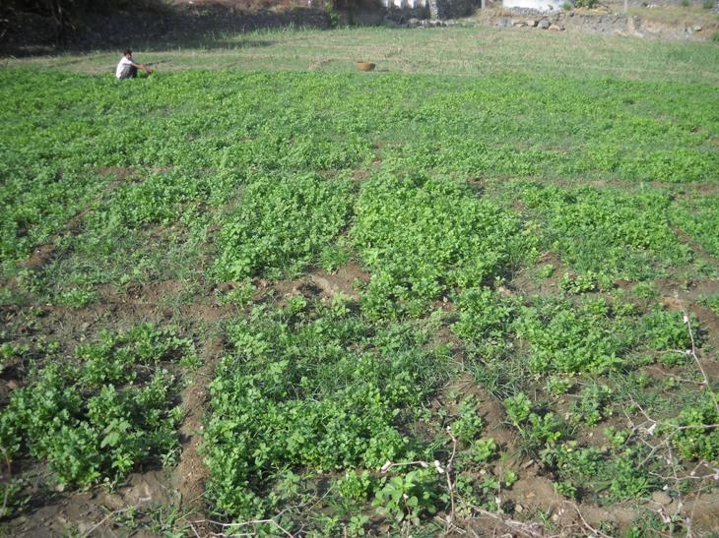

SEVA MANDIR
Udaipur Rajasthan, India
info@sevamandir.org
www.sevamandir.org

Introduction
Most of the farmers in Seva Mandir`s area of operation are producer consumers. Due to scarce and degraded resources the farmers are not able to produce sufficient food for themselves. Also the diet of local farmers lacks vital nutritional components. Through its agriculture interventions, Seva Mandir is trying to enhance production of cultivation of vegetable crops to address the problem of wide spread malnourishment and also enhancing local livelihoods.
We have observed that with little encouragement and support, farmers can produce vegetables all round the year. In recent years, we have observed high demand of vegetables across all seasons. This means better returns on all the vegetable crops all round the year. Vegetables can be cultivated on small plots of land with very little inputs. With the same idea, we are encouraging our groups of farmers to grow vegetables on both small and medium scale.
In small scale initiative we promote vegetable nurseries. A number of farmers pick healthy vegetable saplings from the nurseries. For the medium scale production, the farmers are trained to grow vegetables on an intensive and professional way, called as sabji-wadi technique (Vegetable Field).

Progress from April to September 2010 and emerging trends

During the period under report more than 648 farmers cultivated vegetables in summer (zaid) and Kharif seasons. The results of vegetable cultivation have been encouraging. Farmers received both nutritional and income generation benefits from this venture. Looking to a vast potential of vegetable cultivation in the area, we are gearing up for expansion.

S. No | Block | No of farmers | Villages covered | Remarks
1 | Badgaon | 65 | Kadia, Peepad and Semal | Farmers grew bottle guard, ridge guard, okra, cluster bean, chilly etc. Total value of the produce reported to be Rs.1,25,125 (USD 2780).
2 | Girwa | NA | Helpia and Kojon ka Guda, | Three farmers earned Rs. 2000 to 5000 (USD 45 to 111) by selling vegetables
3 | Jhadol | 91 | Kitawaton ka was, Mornia, Birothi, Som, Suali, Bhamti, Pargiapada and Adkalia | Vegetable cultivation being followed on wadi model. It has provided ample vegetable for self consumption and sale.
4 | Kherwara | NA | Babri-Gadunia, Samited, Ranawara, Beda and Sagwara | In Babri- Gadunia, 22 women cultivated brinjal, tomato, onion, okra and cluster bean. They produced 3440 kg vegetables out of which they sold 1321 kg. Women earned Rs.26,420 (USD 587) by selling vegetable @ Rs.20/- per kg.
5 | Kotra | 2 | Wasela | Farmers cultivated chilly and okra
6 | Kumbhalgarh | 80 | Gawar, Majera, Sukhar, Antalia, Sevantri, Thurawad ( clusters) | Farmers grew bottle guard, ridge guard, bitter guard, kheera, brinjal, tomato, coriander, okra, cluster bean, Yam ,chilly etc. Farmers earned Rs.700 to 5000 (USD 16 to 111) through sale of vegetables.

Challenges
Pest and diseases are a major challenge in vegetable production. The pest and disease attacks not only reduce the production, but also reduce the quality of produced vegetables. In our initiative, we intend to reduce the consumption of agro-chemicals and pesticides. We therefore are promoting use of organic ways to overcome pests and diseases.
Future goals
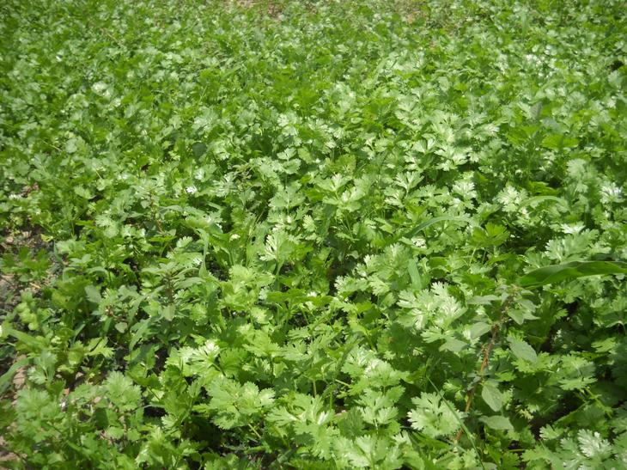
Looking to a vast potential of vegetable cultivation in the area, we are gearing up for expansion of vegetable cultivation in our area of operation. We have already made preparation to support farmers in upcoming winter season to take up vegetable cultivation on a large scale.

Story of vegetable cultivator Dalu Bai

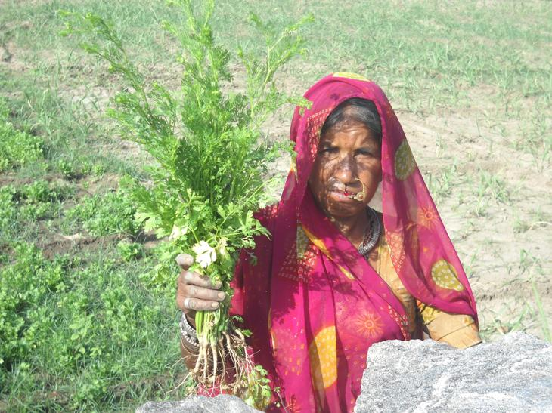
Dalu Bai and her husband Chagan are resident of village Majera of block Kumbhalharh. They are very happy and proud farmers because they underwent a training and cultivated coriander in the summer last year. Dalu Bai and her husband used to cultivate mainly the field crops for subsistence, such as Maize or Wheat if there was enough water. Dalu Bai in one of the meetings conducted by the CIG (Common Interest group) learnt more about the vegetable cultivation. Earlier, she and her family didn’t know that it could be possible in their region as well. A technical training on vegetable cultivation organized and supported by Seva Mandir helped them know more about the various aspects of vegetable cultivation. After the training Dalu Bai was provided with one kg of coriander seeds. She and her husband sowed the seeds on 0.1 hectare of their land. Dalu Bai was able to produce 400 kg of coriander leaves. She sold her produce in the vegetable market of Udaipur and Rajsamand for Rs. 55 per kg. In the end, she earned Rs.22,000/- (USD 489). She and her family is so very happy at this income. The photo above is of Dalu Bai with her Coriander crop.

Story of Haring Ram:
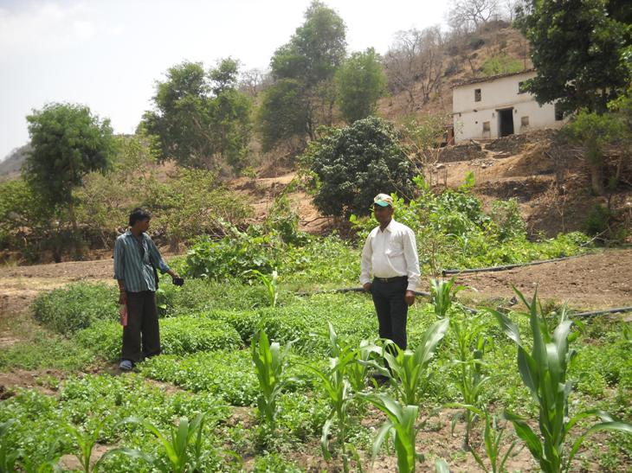
Haring Ram is small farmers of village Majera in block Kumbhalgarh. He was trained to raise improved nursery of tomato in the summer season. He was also provided with 10 grams of seeds for an improved variety of tomato. Haring Ram successfully grown healthy plants of tomato in his nursery. He sold 350 raised tomato plants to his fellow farmers and earned Rs. 350 (USD 8) for it. He also harvested a good crop of tomato from his own field. He sold the tomatoes in the local market and earned Rs.2000 (USD 45). All in all, Haring Ram earned Rs.2350 through this micro farm enterprise.

