Improving Food Security
Annual Report 2011-2012

Submitted to
Global Giving

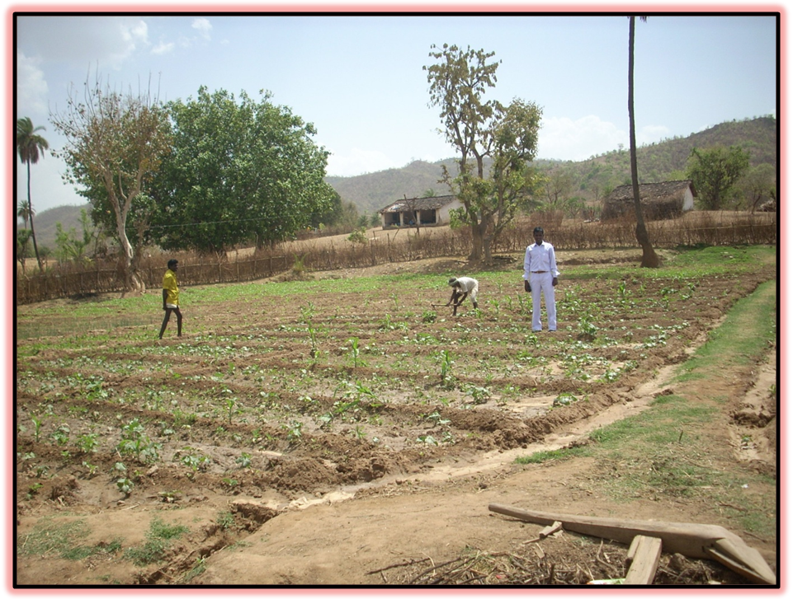

SEVA MANDIR

Udaipur Rajasthan, India

info@sevamandir.org
www.sevamandir.org

The project aims to help improve productivity of farm based income of farmers in Udaipur, Rajasthan through sustainable approach. During the reporting period, we reached out to 5,000 households based in 28 selected village clusters of Rajasthan.

The improved natural resources here mean that activities that were carried out in the past which helped increased the overall productivity of land, soil and water. The focus was to build on the results achieved in the past. The various agricultural activities include the following efforts -

Baseline data and information of the selected households have been collected for creating a data base. Through database, we track project progress and outcome. Following activities were taken up with the selected households in the period under report.

Horticulture:
Horticulture plantation aims to diversify farming systems for providing alternative source of livelihood and nutrition to the farm households. Also, the project encourages tree based cropping system which is recommended in hilly terrain of Rajasthan.

During the reporting period, 624 farmers planted 16,727 fruit saplings. The planted saplings included fruit species of mango, aonla (goose berries), guava, lemon and sapota (cheeku). Details are provided below in a table:

S. No. | Block | No of farmers | No of plants | Villages Covered
1 | Badgaon | 18 | 340 | Peepad and Chali
2 | Girwa | 30 | 560 | Helpia, Amba ka vela,Kegra, Shishvi and Kemri
3 | Jhadol | 151 | 1276 | Kitawaton ka was, Mornia, Birothi, Som and Adkalia,Dhala,Bhamti,Dob ,Navej and Atwal
4 | Kherwara | 300 | 12,000 | Under wadi project in 12 village.
5 | Kotra | 65 | 1972 | Koldara, Hansreta, Nakola, Meri, Patherpadi, , Mahad, wasela,Chikala,Rajpur,Dhari,godamari
6 | Kumbhalgarh | 60 | 579 | Riched,Charbhuja Gawar, Majera, Sukhar, ( clusters)
 | Total | 624 | 16,727

Vegetable cultivation:
Traditionally, use of vegetable is very low in the diet of tribal people of Rajasthan, contributes major reason behind malnourishment and susceptibility to various diseases amongst the local population. To overcome from this issue, we encourage our farmers to produce vegetables in small scale and large scale, throughout the year. In small scale, we promote vegetable nurseries and from these nurseries, farmers pick healthy vegetable saplings for farming. In the medium scale endeavor, farmers are trained to grow vegetables on an intensive and professional way following sabji-wadi technique.

During the reporting period, more than 1,044 farmers cultivated vegetables in summer (zaid) and winter (kharif) seasons. Details are provided in the table give below:

S. No. | Block | No of farmers | Remarks
1 | Badgaon | 152 | Farmers grew bottle guard, ridge guard, okra, cluster bean, chilly and coriander etc. Total value of the produce reported to be Rs 339,572/- (USD 7546).
2 | Girwa | 136 | 186,000/- earn by farmers from gavar, Bhindi, loki, tinda, Mung
3 | Jhadol | 359 | Vegetable cultivation being followed on wadi model.90 farmers grow kharif vegetable and summer mung and earn total 80956/- and income of 42 farmers of summer mung in Adkaliya and earn 120,000/- (USD 2,667) in Dhala,Umariya,Bhirothi ,Som and pargiypada villages farmers earn more then 175,000/- (USD 3,889) from the sell of vegetable.
4 | Kherwara | 159 | In Babri- Gadunia, 22 women cultivated brinjal, tomato, onion, okra and cluster bean. They produced 3,440 kg vegetables out of which they sold 1,321 kg. Women earned Rs. 26,420 (USD 587) by selling vegetable @ Rs.20/- (USD 0.44) per kg.
5 | Kotra | 47 | Farmers cultivated Brinjial and earn 8,000/- (USD 178)
6 | Kumbhalgarh | 82 | 29 Farmers grew bottle guard, ridge guard, bitter guard, kheera, brinjal, tomato, coriander, okra, cluster bean, Yam ,chilly and earn 77,560/- (USD 1,723)
 | TOTAL | 1044

The results of vegetable cultivation have been encouraging. This venture helps farmers to reap both nutritional and income benefits and therefore, we are planning to expand this project.

Vermicomposting:
In our operating area, it is very important to add fully decomposed organic matter to the soil for maintaining its physical, chemical and biological health. Farmers do not have enough farm yards manure (FYM), hence they put FYM once in three years in their fields.

During the reporting period, we have supported 327 farmers to construct beds for following vermicomposting to enable farmers to convert their farm waste and animal refuse into highly productive manure. Details are provided in the table given below:

S. No. | Block | No of farmers | Remarks
1 | Badgaon | 13
2 | Girwa | 129 | 38 tons vemicompost was produced from three villages and 5 farmers sold it and earned 29,160/- (USD 648)
3 | Jhadol | 33 | In all most all villages vermicomposting is now an established activity.
4 | Kherwara | 70 | 25 beds ready in Babari-Gaduniya and production of compost 2,130 Kg.and verma sell of 2,400/- (USD 53)
5 | Kotra | 51
6 | Kumbhalgarh | 31 | 56 Quintal vermicompost produce and sold by farmers and they earned 2,800/- (USD 62)
 | Total | 327

Crop Productivity Improvement Programme:
The main objective of this activity was to improve the productivity of local field crops by participatory selection of locally suitable appropriate varieties suitable for local agro ecology. Seed of such new variety is provided to the farmers for field testing and if it turns up suitable then it is multiplied in the village. During the reporting period, 1,019 farmers were covered in the Kharif season and 1,867 in the Rabi season under this activity last year.

S. No. | Blocks | No of farmers | Seeds provided in Quintal | No of villages | Crops covered
1 | Badgaon | 114 | 643 | 3 | Maize,Til,Black gram,wheat
2 | Girwa | 300 | 1776 | 10 | Maize and black gram,wheat
3 | Jhadol | 732 | 15802 | 10 | Maize, black gram, sesame, cowpea, pigeon pea,wheat,Gram
4 | Kherwara | 250 | 3000 | 10 | Black gram,Maize,Tuaar,wheat,Gram
5 | Kotra | 694 | 5200 | 12 | Pigeon pea, sesame, blackgram,Maize,wheat,Gram,Pigon pea
6 | Kumbhalgarh | 350 | 580 | 19 | Maize, green gram, black gram and cluster bean,wheat
 | TOTAL | 2,240 | 27,001 | 54

Seed Banks:
To ensure availability of good quality seed of such varieties in the village, we have promoted the concept of seed banks in the villages. Seed banks have emerged as a very important community driven activity under which selected farmers test the new composite varieties on their fields and share their experiences with the group in village meetings. They return a pre decided quantity of seed in the local seed banks. The deposited seed is issued to other farmers for further multiplication

During the reporting period, seed banks were functional in 60 villages. Also, we have provided Sudan Grass in Helpia village of 10 farmers in summer season and farmers profit near about Rs. 100,000/- (USD 2,222)

S. No. | Block | Village
1 | Girwa | 8
2 | Jhadol | 10
3 | Badgoan | 6
4 | Kherwara | 7
5 | Kotra | 10
6 | Kumbalguargh | 19
 | Total | 60

