Weekly Report from the VIDYA Schools and Communities
October 16 to October 22, 2016

Weekly Report from the VIDYA Schools
VIDYA SCHOOL, GURGAON
14th October 2016:- Following activities took place:-
- Students from both sections of class IX went to the Aero-planet Museum with KPMG volunteers accompanied by 2 teachers, Ms. Arundhati and Ms Sunita Mohanty. The students saw the dummy aeroplane and did various activities on how to board the aeroplane and to escape if there is an emergency.
- Pre-primary classes (Nursery & KG) had a yoga session. It was conducted by Ms Ayushi Punj, class teacher of Nursery A).
- Aavishkar quiz was held in the school dining hall, where the students from class IV to class XI participated.
15th October 2016:- Following activities took place:-
- Pre- primary students conducted the morning assembly on Dusshera.
- Students of class I saw a movie, Delhi Safari in Audio Visual Laboratory.
- An inter-house Cricket tournament was held, where the students from classes VI to XII participated and Team Creators won the match by beating Dreamers.
17th October 2016:- Following activities took place:-
- Students of class III, observed different plants around the school campus and noted their shape, colour, texture etc. This activity was a part of their lesson on surroundings.
- Art Competition was organised for primary and middle school by Pragyata Foundation.
- Students of Eco Heritage Club made paper bags in club activity.
18th October 2016:- Following activities took place:-
- Students of class VI and VII visited Heritage School to view the history through Pottery with Ms Anamika and Ms Sunita Mohanty. The Indus Valley civilization was presented through varieties of pottery of those times. Students learnt a lot and mentioned that they had also created a number of similar things which could not be preserved due to paucity of space.
- Mehndi stalls were put up by middle and senior classes’ girls. They applied mehndi to the teachers on the occasion of Karwa chauth. They were paid based on the details of the design. This was done to encourage the girls to earn a little money for themselves and their families.
- Class I students understood the concept of trees and had their class in the ground while observing the trees. This was helpful in understanding every aspect of the tree. They also observed the nests built by the bird and the types of barks that the trees have.
- Class I students made a fish by sticking bindis on the body of the fish. An outline drawing of the fish was provided to the students.
- Class VI students had a session with “Seekh Lo”. The organization works towards creating awareness among students about living a healthy life and taking care of their bodies. The students learnt about the importance of muscles, joints and bones.
19th October 2016:- The school worked till 01:00 p.m. on the occasion of Karwa-chauth. The sports teacher Mr Jitin Rohilla was nominated as the referee in the Table Tennis tournament organised by CBSE held in SD Adarsh Vidyalaya. This event went on for three days from 15th October to 18th October, 2016.
20th October 2016:- Following activities took place:-
- 14 students from junior and senior classes have left for Jind in Haryana to participate in the CBSE Cluster -15 athletics meet for along with sports teachers Mr Jitin Rohilla and Mr Jitender.
- Classes Nursery-A, KG- A, I-A went for excursion to the Rail museum.
- Class I-B performed an activity with balloons.
- Class III-B students did an activity on multiplication by using hundreds kit in Math Laboratory.

`

BAL VIHAR
- Week began with regular morning assembly and prayers.
- Students of class V presented a weekly assembly on the topic – Save Earth.
- Students discussed about global warming, causes of pollution and measures to be taken to save our beautiful earth and also enacted play related to the topic - Say No to Crackers.
- On 22nd October, I Term Results were declared. The PTM was a great success. 98% of the parents attended the meeting; special interaction with class II parents was done by class teacher and Head Mistress.
- Class I students learnt ascending order by flashcards.
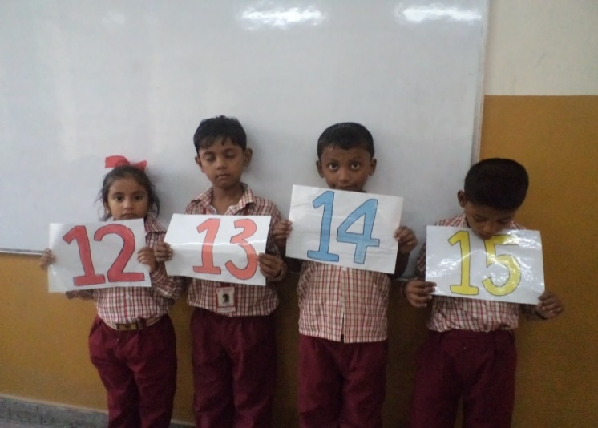

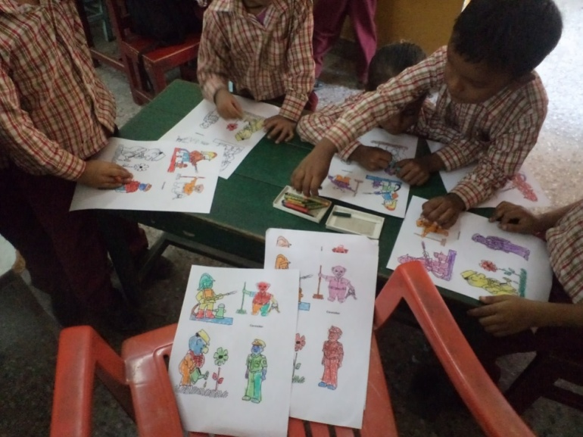
- Students were taught about various professions in our day today life and their importance.

Special PTM of class II PTM on 22nd October
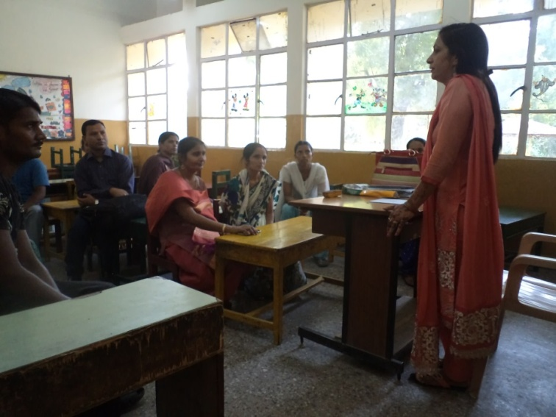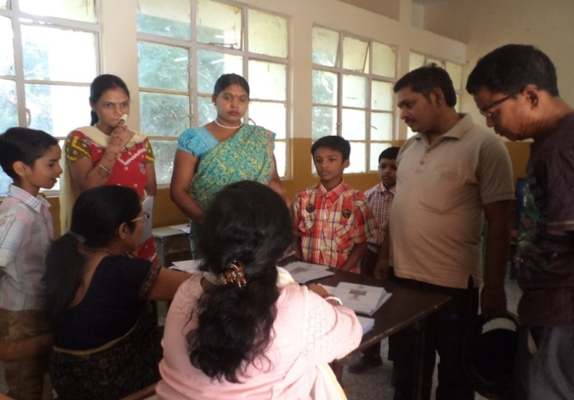

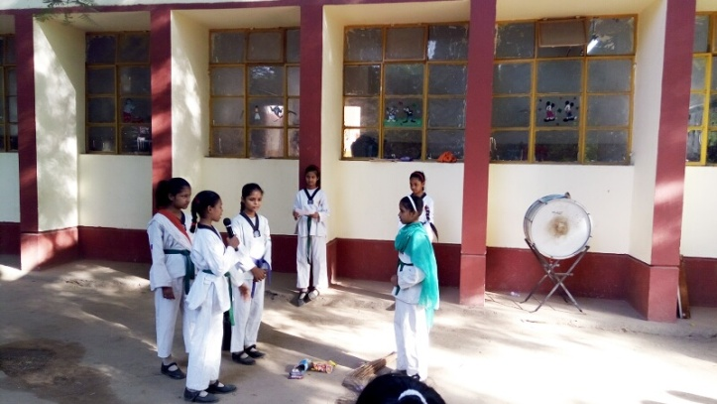
Morning Assembly by Class V
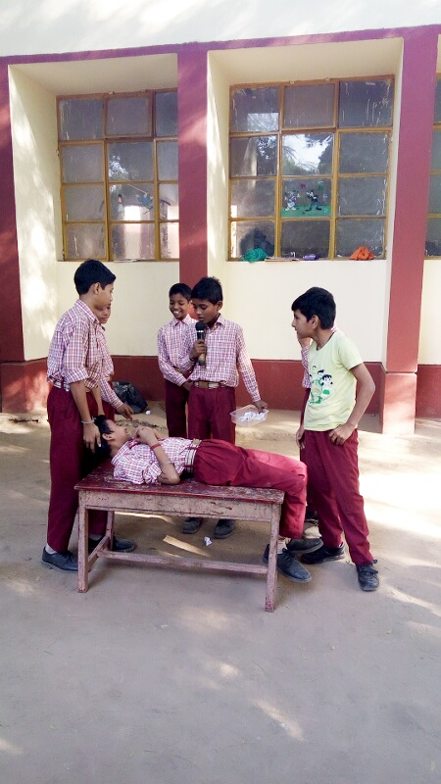

VIDYA PTS SCHOOL
Scholastic: This week was full of fun as well as academic activities, as students started coming regularly after Dusshera holidays.
- Class Nursery students did activities on recognition of parts of plants and pot.
- Students of class 1 & 2 did ‘h’ letter words & colour recognition concept.
- In Hindi Aa ki matra was revised in classes 1 & 2.
- Remedial classes continued this week as well.
- On 22nd Oct, Ist Term results were declared. 71% of the parents attended the meeting; Report cards, along with diyas & candles decorated by students, were given to parents.

Co-Scholastic:
- Music basti took their sessions on Tuesday & Saturday with class 2. The activities included, playing rhythm games that gave them knowledge on rhythm as a component of music.
- Students of classes 1 & 2 had remedial session with volunteers Charu & Aditi on Saturday on alphabet revision & three letter words.
- On 20th of October all the classes from 1-5 did art & craft activities of Diya & candle decorations with Dheeraj.
- Poushali took story telling session with class 3, 4 & 5.
- Education initiatives took second round of assessments of Hindi.
- Les transformations an organization helping to frame curriculam, demonstrated topics in English & Maths. The classes were observed by regular teachers & curriculum was discussed.
- Julia, a volunteer continued remedial classes with weak students.
Volunteers at PTS in October month:
- Julia - Remedial Teaching & art & craft activities.
- Charu & Aditi – Remedial Teaching
- Poushali : Story telling

Sharing some of the pictures:
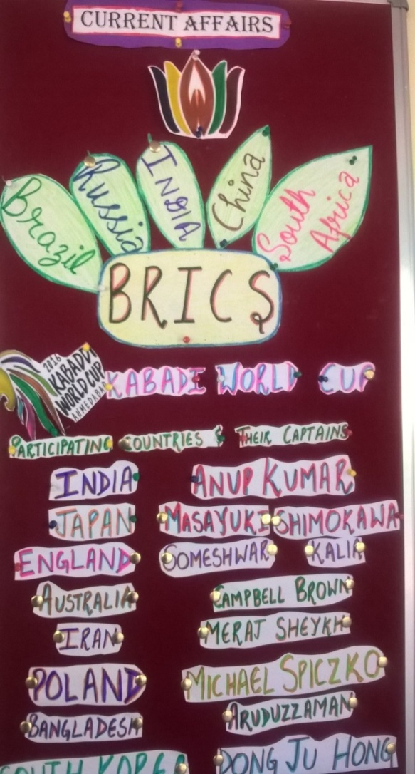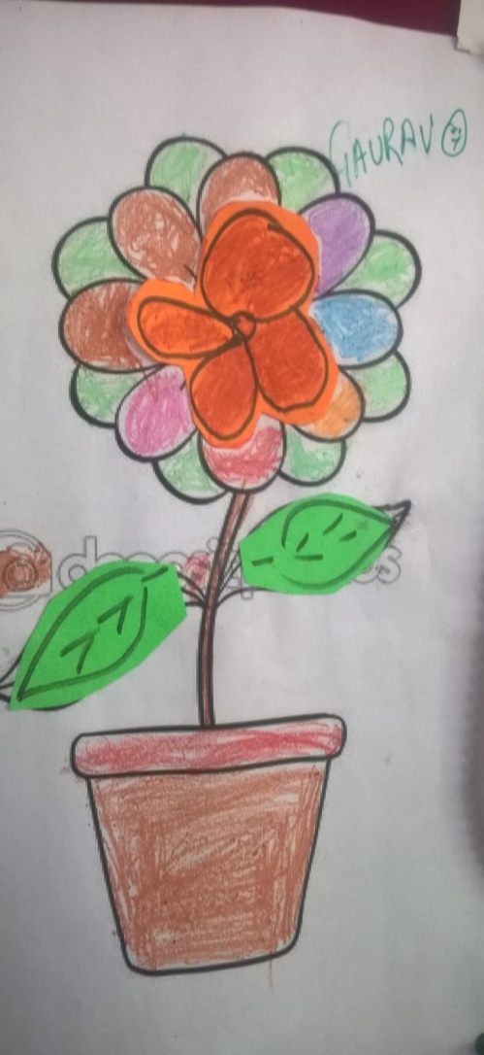
Sports update Flower & pot
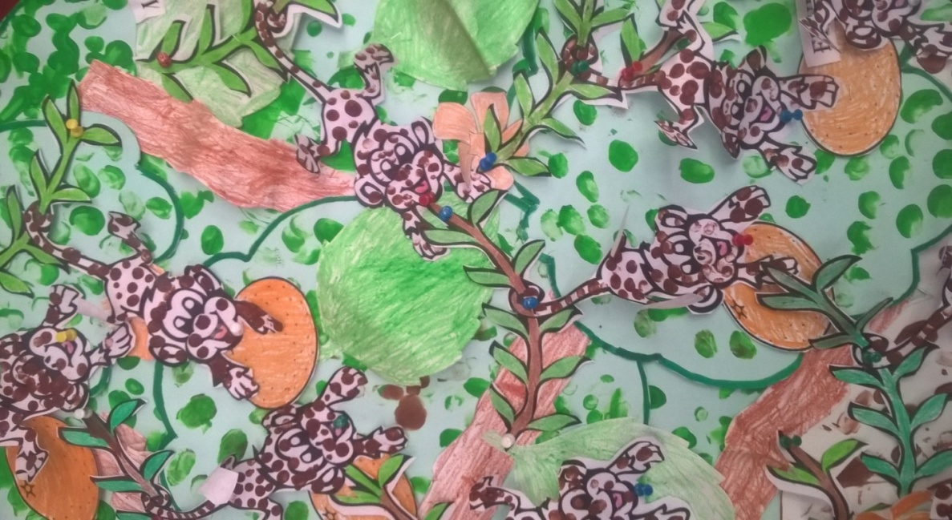
Tip painting & colour concept on display
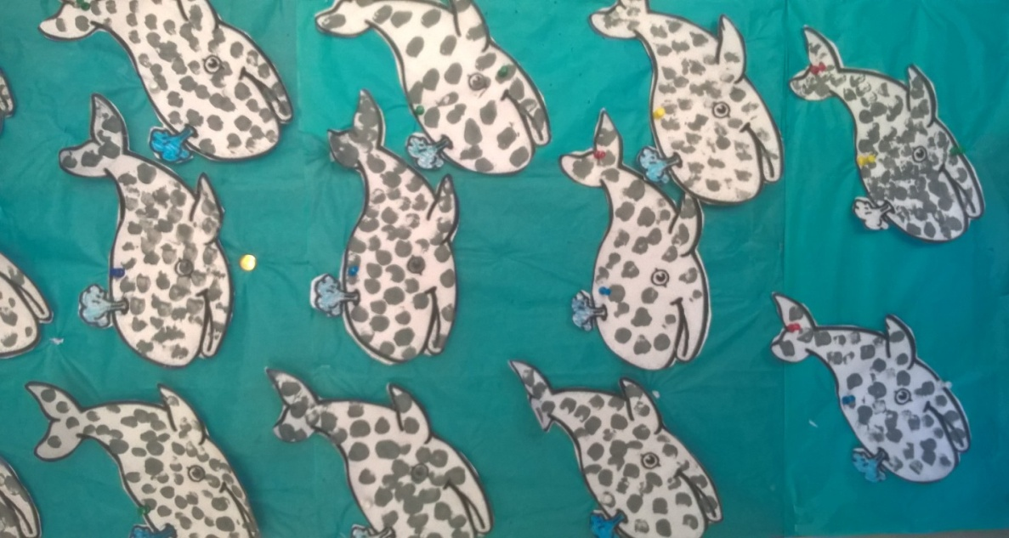

Diya & Candle Decoration
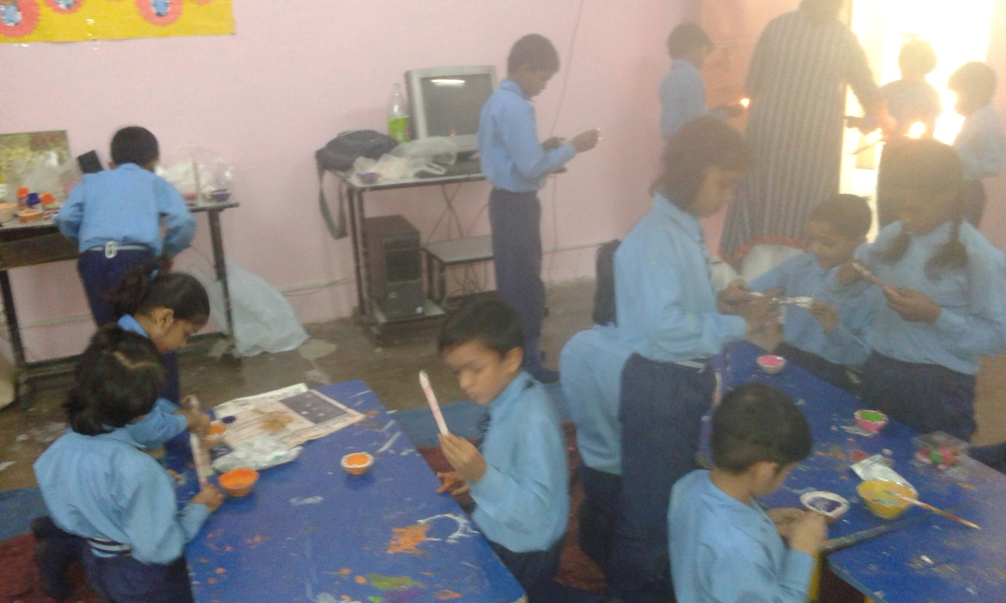
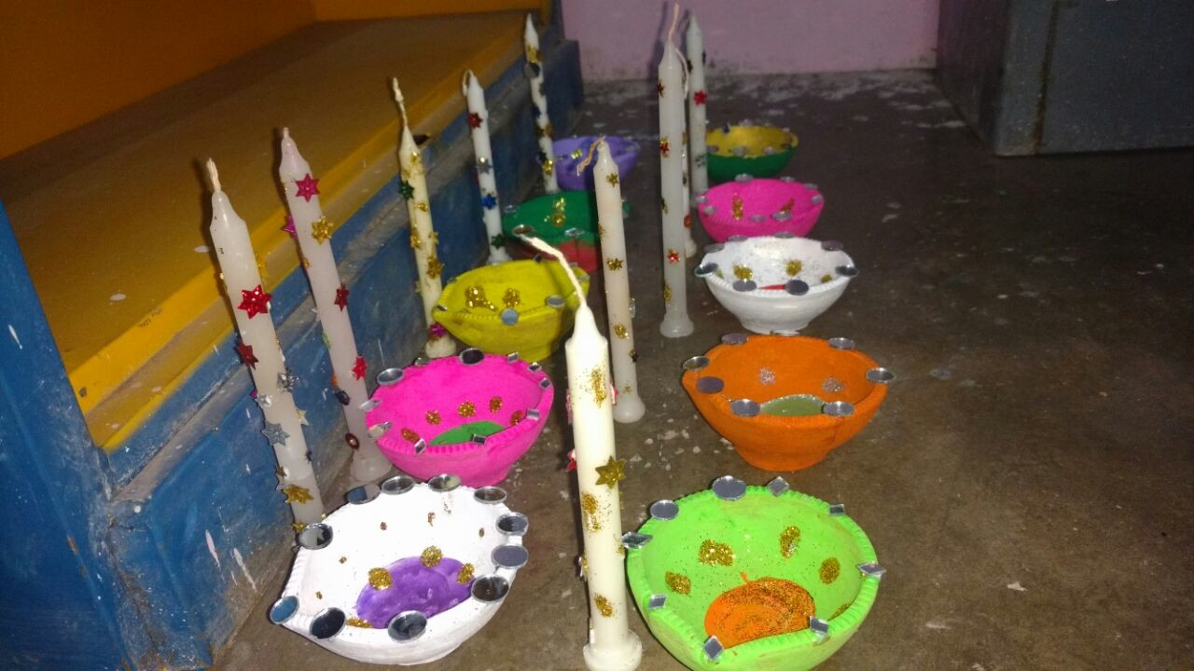
Dot Painting
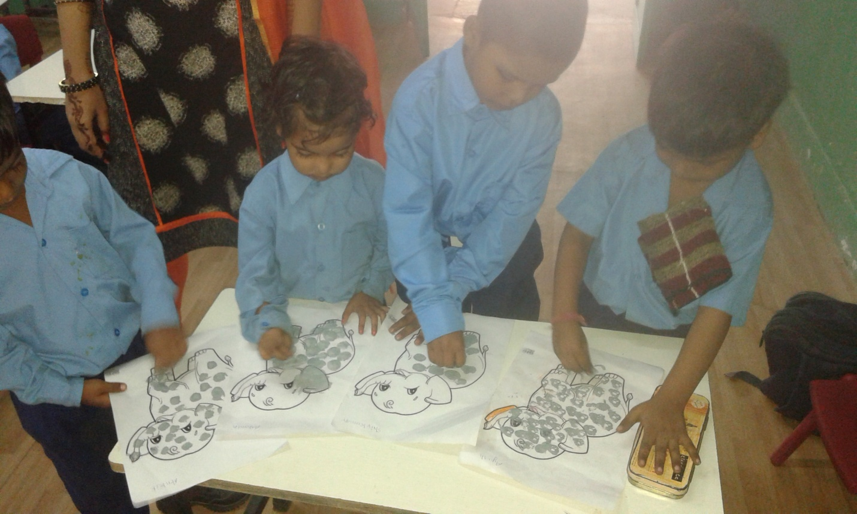

Delhi Community Weekly Report
Region: Delhi
Period: 16-22 Oct’16

VIDYA Mandira Women’s Program
Program 1
Computer
Duration: Aug’16-Nov’16
Timing: 12:00 noon to 1:00 pm
No. of batches: 1 batch
No. of students: 12 (one dropout)
Name of the teacher: Bharti
(This program is supported by NIIT Foundation).
Our motive: To provide an opportunity to the needy women of weaker section of society to become independent.
Computer Theory : Ms-Word :-
- Home Tab: Paragraph group
- Alignments(left, right, center, justify)
- Bullets & numbering
- Table border
Program 2
English Class
Duration: Aug’16-Nov’16
Timing: 11:00 am to 12:00 noon
No. of shifts: 1
No. of students: 12 (one Dropout)
Name of teachers: Deepti & Shailja
(This program is supported by Federal Mogul)
Our motive: To empower the women and make them confident through group activities and spoken English.
Activity:
- Quiz competition
- Book reading
- Newspaper reading
Planning for the next week:
- Skit –Diwali festival
- Unseen comprehension

Pappankalan Community Development Project:
Program 1
Computer Learning & Resource center:
Duration: 4 months (July 2016 to Oct 2016)
No. of batches: 2 (two hours for each batch)
No. of students: 27 (16 boys & 11 girls)
Name of the teacher: Mr. Mangal Singh
This week, we have covered the following topics:
- Salary sheet design
- Mark sheet design
Our motive: We try to empower the children from underprivileged communities through computer classes.

Program 2
Beyond School Program
Duration: Academic year (April 2016 to March 2017)
No. of shifts: 2 shifts (morning & afternoon)
No. of students: 69 (31 in morning & 38 in afternoon)
Name of teachers: Mrs. Renu Knuajia, Mrs. Sunita Singh & Mrs. Sarabhjit Kaur
In this week, we have covered the following topics:
Class |  | English | Hindi | Math | Science
1st |  | Revision of work done earlier | Revision of work done earlier | Revision of work done earlier | --------
2nd |  | Puppy and I(poem)  Sounds of animals | Jhabarjhabarbaalowla(Kavita)  Four letter words  AA ki matra | 100-1 reverse counting  2-5 tables | --------
3rd |  | Phonetic sound O  Words with sound O  Draw pictures | Practice of reading and writing four letter words  AA aur EE ki matra | 100-1 reverse counting  2-7 tables | --------
4th |  | Singular & plural(Es)  Noun | Chand se gappein (kavita)  Practice of reading and writing four letter words,  Ek vachan aur Bhu vachan | Tables 2 to 13  Addition & subtraction  Number names 1 to 30(Hindi & English) | Chapter: Fulwaari (continued)  Picture work related to chapter
5th | Singular & plural(Es)  Noun  Opposite words |  | Practice of reading and writing four letter words  Match words with pictures.  AA ,EE aur OO ki matra  Ek vachan aur Bhu vachan | Counting 100 to 200  Tables 2 to 13  Addition and subtraction  Division | Names of wild and domestic animals with their sounds
6th | Focused on reading  (short stories, to improve reading skills of the students) |  | Panchtantra stories  Questions and answers related to the stories | Factor tree  Tables 5to 15 | Chapter: Air (importance of Air)  Picture work
7th | Chapter : Golu grows nose  Difficult words,  Write names of animals from the chapter |  | Chapter : Kancha  Question/Answers | Triangle and it’s properties  Types of triangles,  sides, angles and vertices. | Chapter:  Soil  Types of soil

Cutting & Tailoring
Duration: 6 months (July 2016 to December 2016)
No. of batches: 2 (2 hours for each batch)
No. of students: 30 (15 +15)
Name of the teacher: Mrs. Seema Chouhan
Activities:
- Revised simple and pleated skirt
- Conversational English
Our motive: To empower the community women with a skill to be independent, so that they can also financially help their families and live better lives.
Volunteer:
Annie, Haleigh (CCS volunteer) taught conversational English to the women’s group. Erika, on the other hand, did their health checkups.
Ruchika Dhawan(Life skills coach) visited our center and had an introductory session with the women’s group.
Challenges and solution: To cope with the new students as they are not able to read and write according to their classes. We are taking 25 minutes of extra class for these students.

VIDYA IIT NSS Centre
Program 1

NIOS
Duration: July’16-Apr’17
Timing: 2:30 pm to 5:30 pm
No. of batches: 2 (X & XII)
No. of students: 45
Name of teachers: Umesh Pal, Jyoti and Manju
(This program is supported by Federal Mogul).
Our motive: To provide an opportunity to the dropout youth to complete their education and achieve their goals in life.
Activity:

Class 10th |  | Class 12th
Subject | No. of lessons completed | Subject | No. of lessons completed
Hindi | Bharat ki bahadur betiyan | Hindi | Bihari Ke padd
English | The Shoe Shine | English | A case of Suspicion
Data Entry | Mail merge ( Practical) | Data Entry | Basics of spreadsheet
Home Science | Food groups | Home Science | Aahar-Poshan
Social Science | ----- | Pol. Science | Directive principal of state policy
Business Study | Parivahan swayein | Business Study | ----

- A sports class is conducted twice a week, for half an hour.

Program 2
Remedial Classes
Duration: April-Mar’17
Timing: 3:00 pm to 5:30 pm
No. of shifts: 1
No. of students: 28
Name of the teacher: Only volunteers
(This program is supported by NSS Volunteers)
Our motive: To support the children with their home works and prepare them for the exams.
Activity:
- NSS volunteers helped the student to revise what was taught in the school.
- They also organized an origami workshop for the remedial student at VIDYA IIT NSS centre on 20 Oct’16. The theme of the workshop was “Diwali”.

Program 3

Adult Education program
Duration: April 16-Mar’17
Timing: 2:30 pm to 5:30 pm
No. of shifts: 1
No. of students: 30
Name of the teacher: Mrs. Lalita along with one volunteer
(This program is supported by Federal Mogul)
Our motive: To make them literate and empowered so that they can lead their lives.
Activity:
- English: Three letter words like rat, mat, fun, sun etc.,
- Hindi: kirmichkigand and kathinshabd,
- Math: Addition, multiplication and subtraction
Volunteer: Students from I.I.T. campus and LSR were placed in the VIDYA IIT NSS centre.

Planning for the next week: Preparation for Diwali Celebration

VIDYA USHA Silai Centre:
Program 1
Computer Learning & Resource center:
Duration: 6 months (August to January, 2016)
No. of batches: 2 (one hour for each batch)
No. of students: 16 (2 ladies & 14 girls)
Name of the teacher: Ms.Vandana Mehra
This week, we have covered the following topics:

Link
- Revision of hyper link and bookmark
- Cross reference
- Revise all
Our motive
We try to empower the children in underprivileged communities through computer classes.

Program 2
English class
Duration: September 2016 to February 2017
No. of shifts: 2 shifts (morning & afternoon)
No. of students: 16 (8 morning & 8 afternoon)
Name of the teacher: Miss.Vandana Mehra

(THIS PROGRAME IS SUPPORTAED BY FEDERAL MOGUL)
This week, we have covered the following topics:
Batch | Activity | Feedback
1st Batch | Basic class  - Writing words  - Daily spelling words  - Revision of  Advance class  - Clock time  - Vowels (with simple sentences)
2nd Batch | - Number names (with oral practice)  - Name of the months  - Name of the days

Program 2:

Sewing Class
Duration: 6 months (September 2016 to February 2016)
No. of batches: 2 (two hours for each batch)
No. of students: 16 (8 +8)
Name of the teacher: Mrs. Gitanjali
This week, we have covered the following topics:
WEEKS | Activity | Feedback
1ST Batch | - Practice of all stitches  - Hook  - Kai  - Batan taka  - Theory class  - Repairing of machine  - Introduction of color contrast  - Definition of colors  - Seasoning colors  - What are the natural, hot and cold colors?
2nd Batch | - Practices of all stitches  - Hook  - Aai  - Batan taka  - Theory class  - Repairing of machine  - Introduction of color contrast  - Definition of colors  - Seasoning colors  - What are the natural, hot and cold colors?

- Planning for the next week: Regular classes will be conducted as usual.
Okhla Education Project:
Program 1
Computer center
Duration: 6 months (July 2016 to December 2016)
No. of batches: 6 (one hour for each batch)
No. of students: 96 (62 boys & 34 girls)
Name of the teacher: Ms. Preeti pal
(This program is supported by Fena Foundation).
In this week, we have covered these topics:
References
- Mailing
- Review
- Recap
- IT Session: Introduction of internet and its history, search engine
Our motive: We try to empower the children in underprivileged communities through computer classes.

Program 2
Beyond School Program
Duration: Academic year (April 2016 to March 2017)
No. of shifts: 4 (morning boys & evening girls)
No. of students: 189
Name of teachers: Mrs. Yashmeen Bano and Ms Arpita Pandey
(This program is supported by Fena Foundation & the Monsoon Accessories Trust).
In this week, we have covered the following topics:
Class | English | Hindi | Math
1st | - Tell them about different fruit names with their pictures | - Phalo ke naam | - Exercise on smallest number
2nd | - Practice on Dia critic marker and reading of word using specific Dia critic marker | - Animals names | - Addition and subtraction
3rd | L-8 A little fish Story | L-7 (Tiptipva) | Len-den ka khel
4th | L-7 ( WHY) | L-7 ( Daan ka hisab) | L-6 ( Kabadi wala)
5th | Lesson-9 (The lazy frog))  Activity : word meaning, Q/A session, drawing, book activity | L-9,(Ek maa ki bebasi)  Activity: reading, Q/A session, word meaning | L-7 ( Patterns)

Beyond School Program helps in improving the quality of education

Program 3
Library Program
Duration: Academic year (April 2016 to March 2017)
No. of shifts: 2 shifts (morning & evening)
No. of students: 189
Name of the teacher: Ms. Sonia Verma
(This program is supported by Fena Foundation).
This week, we have covered the following activities:
Regular activities: Reading session, role play, storytelling, story narration, poem recitation, painting, art & craft and audio visual sessions.
Class | Story/Poem Name | Special Activity | Related activity
1st and 2nd | Phool | Children made colorful flowers with papers | A video was shown to them to make them familiar with the different types of flowers
3rd | Kachua aur Khargosh | Drawing activity
4th | Macho Machli | Children made fish pot on drawing sheet. | Video session
5th | We are all animals | Drawing activity
Our library program fosters confidence and personal development through diverse, interactive lessons. It helps to promote reading habit among children.
Program 4
Dance Classes
Duration: Academic year (April 2016 to March 2017)
No. of shifts: 2 (morning & evening)
No. of students: 52 (17 boys & 35 girls, all beyond school children)
Name of the teacher: Ms. Amita Bharanger
(This program is supported by the Monsoon Accessories Trust)
Activity: Students did practice on songs ‘Shivaya’ and ‘Ramleela’ for Diwali celebration

Program 5
Evening Computer class
Duration: June 16- Nov 16
No. of batches: 3
No. of students: 35
Name of the teacher: Mr. Nakul
(This program is supported by Fractal Analytics)
- Component of Tally course

Planning for the next week: Preparation for Diwali and will be organizing related activity Celebration.

