VIDYA is a not-for-profit organisation devoted to educating, empowering and transforming the lives of less privileged.

Twinkle Twinkle Little Stars, Shankar’s Spell!

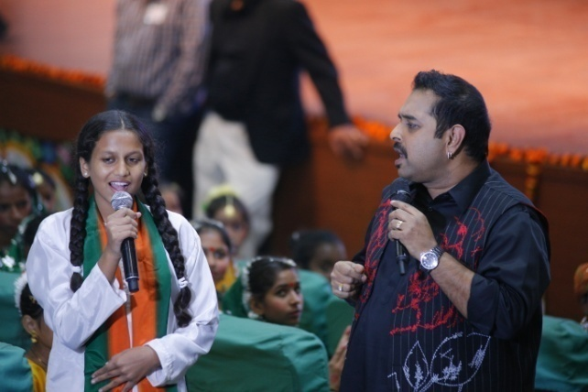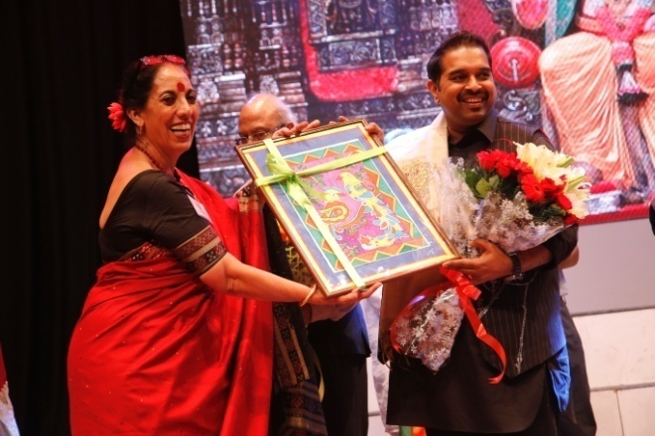

What a grand finale of VIDYA’S 30 years’ journey! Renowned singer, musician, composer and a friend of VIDYA, Shankar Mahadevan facilitated commemoration of 30 years with a musical magic. Benevolent, boisterous and ‘breathless’, Shankar takes away your breath with his melodies. The FICCI auditorium reverberated with his soulful songs as he took the stage by storm. This great musical evening on November 6, , was organized in collaboration with the Shankar Mahadevan Academy that brings music education online and reaches schools, corporate and centres around the world. The VIDYA students are now members of this Academy. The entire VIDYA family, well wishers and sponsors were present…spellbound when the auditorium went pitch dark with just the candle like lights glimmering as the song came alive. The experience was mesmerizing.

The VIDYA School is a flagship programme and an educational institution with a difference. It is here that the children of nearby slums are encouraged to achieve their potential in academics, creativity, physical and emotional development. This English medium school recognized by the Haryana government and affiliated to Central Board of Secondary Education (CBSE), Delhi is a boon for almost 1070 underprivileged children.
- Microsoft Session with Ms. Suman Chawla

Ms. Suman Chawla from Microsoft conducted a session with teachers. They were instructed how to work on “One Note”., to create their own ids on “Educators Network.com” a site especially created for teachers where they can interact with teachers all over the world and share their views, lesson plans, thoughts, interesting ideas etc.

- Class 7th students perform in Innovate 21st century competition
On 18th January, 2016 some children of class 7th participated in an innovative competition organized by Think Station. Children were given task from their daily lives in which they had to use their ingenuity and creativity to solve problems given to them.
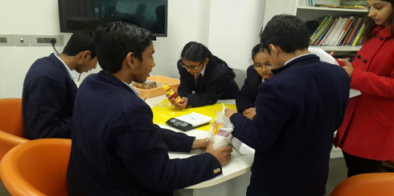

- Inter House girls Basket ball competition
On 20th Jan’ 2016 an Inter House Basketball competition was held at our school. Despite of the cold weather and chilly winds, the girls from classes VIII – XI passionately took part in the competition.
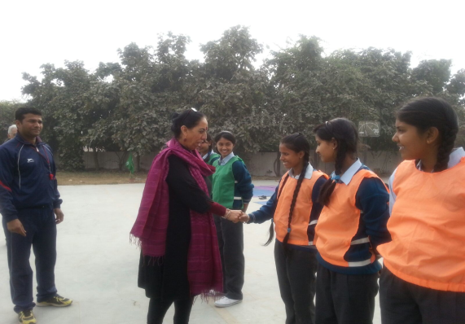

- Junior wing library Inauguration by KPMG
On 27th January, 2016 the Junior Wing of the library was inaugurated by KPMG. After the inauguration a story telling session was also organized for classes 1st and 2nd. Sweets and chocolates were distributed.

- Workshop

A workshop on Mind and Memory was conducted by Mr. Anant Kasibhatla. Teachers were taught that there is nothing like “forgetting” rather there are some hindrances which slow their memory and the measures they can take to remove these barriers. Ms. Kamal conducted a session with teachers on Self Motivation.
- AON HEWITT’S CEO classes
Mr. Yashpal CEO of AON HEWITT comes to Vidya and teaches Physics to the children of classes 10th and 11th

VIDYA Mandira Women’s Programme

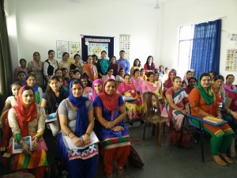

- The VIDYA-Mandira Women’s Programme is now reaching the final stage for which it was designed and conceptualized. The objective of programme was to empower women and the first batch of women has started learning driving. Out of 14 women, 7 have been selected for on the road driving. The women are very enthusiastic and keen learners. The remaining women are eagerly waiting for their turn to start learning driving.
- Students of Lady Shriram College organized a painting competition. There was a follow up of the dental checkup by Rotary Club Delhi South. Children were guided on ways to keep teeth and gums clean & healthy
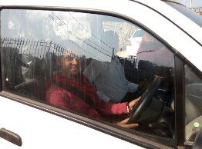
VIDYA Bal Vihar, Delhi
- Students of Lady Shriram College organized a painting competition. There was a follow up of the dental checkup by Rotary Club Delhi South. Children were guided on ways to keep teeth and gums clean & healthy
- Medical – An eye camp was organized on 10th& 11th February by Fortis Foundation in partnership with PNBHFL.

- Workshop – Three teachers of Bal Vihar attended a workshop titled: Sex education and relationship management in classroom through stories, conducted by Mr Ameen Haque founder of Storywallah.

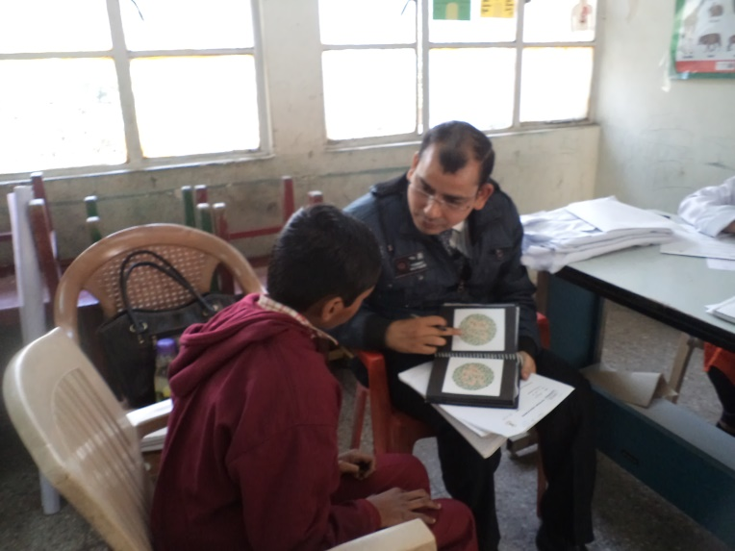

- The last month of the academic year ended with final exams. 284 Students appeared in final exam.
- 276 were promoted to next class and 158 students scored above average marks. PTM was held on 19th March to declare the result. Parents were given yearly assessment report and students of 5th standard were guided admission to other schools. 98% parents attended the PTM.

- Proud moment for Vidya All the hard work and effort bore fruit when Vidya signed an agreement with SDMC on 29th Feb. 2016, to run a primary school at PTS Colony South Delhi from 1st April 2016. The new branch will commence with classes Nursery, I & II. We all have a new role and responsibility to make this school a role model for government.
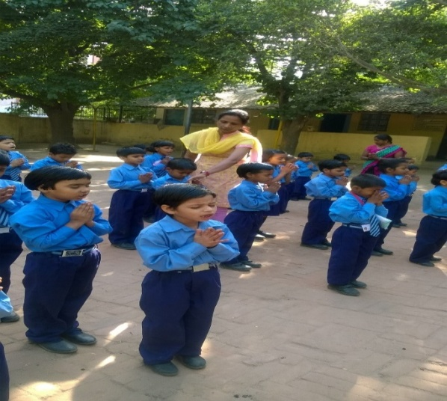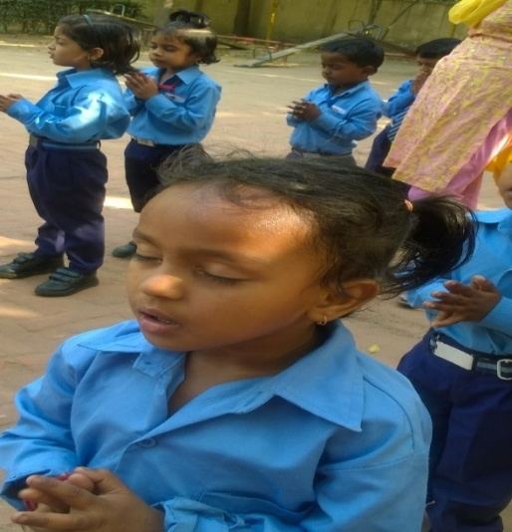
Community Update, Delhi
- Shanti Art in Action Project (4 to 15 January) in Okhla centre

VIDYA was honored to host three artists from the United States of America. Max recycles waste material to create instruments to make beautiful music, Karla teaches Samba dance, and Joel creates gorgeous paintings on the walls of the school yard and encourages the children to depict their feelings by painting into the art he creates. Topics in the wall art include girls’ safety and child rights.
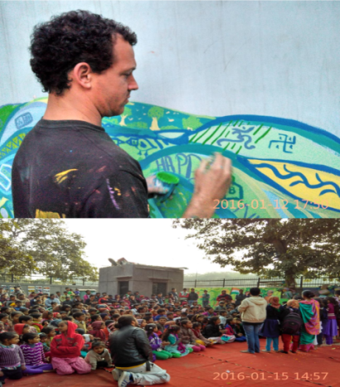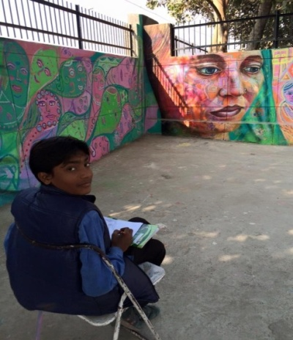
- Eye Camp (20 Feb 16): an eye camp was organized by Satya Sai sewa samiti for the kids of our centre and their parents. 263 people benefited.
- Cancer Patients Aid Association organised a health camp at the Munirka centre on 15 January. They did health check - ups of the ladies and the children of the community. 70 children and 20 ladies were checked by a team of 10 gynecologists’ pediatricians and assistants. They advised the children to make it a habit to deworm every 3 months.
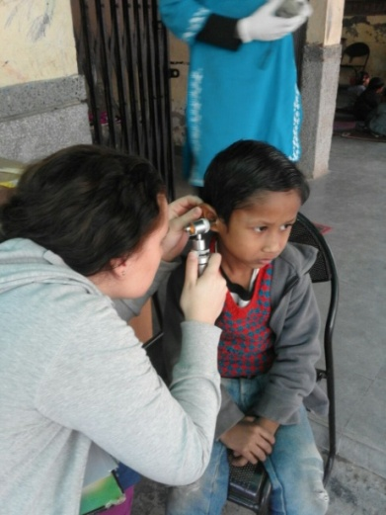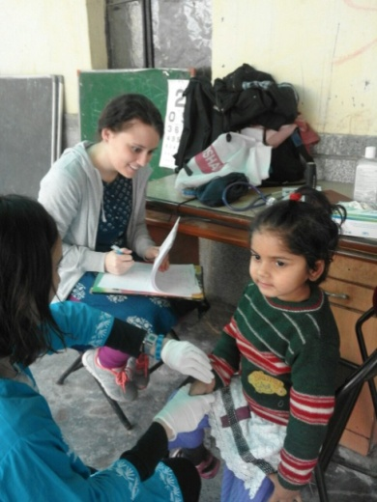

- VIDYA USHA SIlai Centre: VIDYA started a women’s skill centre with support from Federal Mogul in the Motilal Nehru camp after conducting a need assessment. The program will bring significant change in the lives of the women of Munirka and Motilal Nehru camp of Delhi. The program was formally inaugurated on 9th Feb 16 by Mrs. Hardeep in the presence of EB member of VIDYA. 27 women enrolled in the program to get professional training in stitching and tailoring from USHA. A structured curriculum will enable learners to become proficient at the end of 6 months. USHA will do an evaluation and certify the successful candidate. On completion these women can work as trainers, work from home, take up jobs or start a micro enterprise.

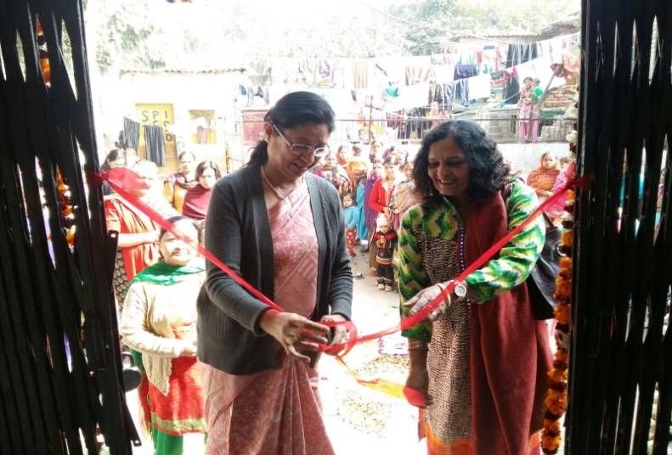

- International Women’s Day was celebrated on 8th March 2016. The function was attended by some known dignitaries from industry and media. Dr. Simi Malhotra(academics, media and culture), Lieutenant Governor of Delhi, Mr. Vinod Hans, Managing Director Federal Mogul, Mrs. Hardeep Vilku, CSR Co-ordinator Federal Mogul, Mr. Ashish Mathur, Assistant General Manager IDTRLP Maruti Suzuki India Ltd, Ms Neeti Tyagi, ICRA and Ms Navneet Kapoor, ITC Fortune.

On women empowerment day 15 senior students visited Jesus and Marry College. They made posters with catchy slogans highlighting women’s importance.
- IIT-NSS: 43 children of VIDYA IIT Centre visited the “Inspire 2015”. This is 5th National Level exhibition & Project competition organized by the Department of Science & Technology. This event was organized in IIT D campus. Children got an opportunity to learn about methods and ideas. They visited the stalls of different participants and interacted with the exhibitors.
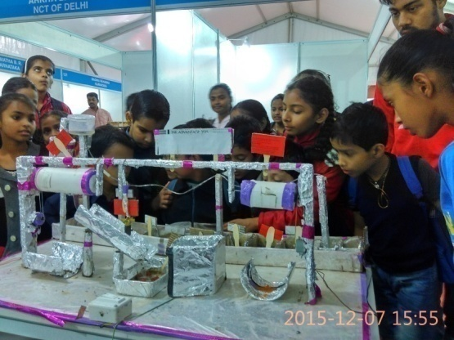

In PAPPANKALAN
- The sewing ladies made cups and socks for the children

- Awareness session on Hepatitis: On 19^{th of} February we conducted a health awareness session on Hepatitis. 45 people received information how the disease spreads, its symptoms, precaution, prevention and information about the treatment of Hepatitis.

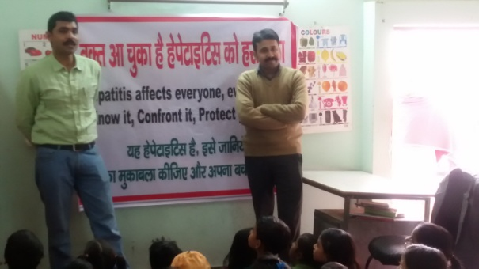
- Exam Preparation:
Preparation and revision of all the subjects was conducted as in March students have final exams in their regular school as well as in our center. In the month of March children were busy preparing and appearing in the final exams in their regular school.
- On the 22nd we celebrated World Water Day by conducting an awareness session on importance of clean water and need to save water.
- Festival of colors Holi was celebrated by conducting rangoli competition. Children presented a small skit depicting the story behind the Holi festival.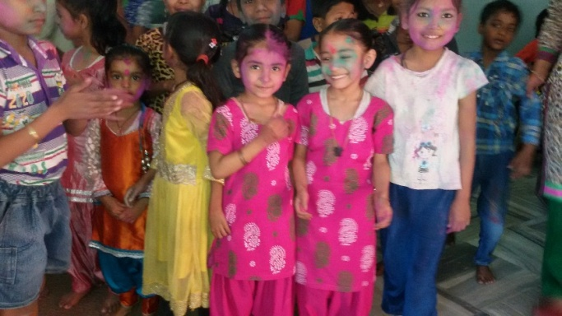

- Bridge Course Okhla and Gurgaon
Revision and Pre board examination have been held and some students have done well in all subjects. Mughal Fedral team visited our center on 8th March (Women’s Internation day)Mrs. Harpreet and Mr. Amit interacted with the children. Self Defence training was organized by GE for the girls. Mughal Fedral team interacted with the children

