“Integrating social and economic values through sports
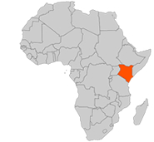
by creating a proactive health environment.”

Vijana Amani Pamoja was founded in 2002 and operates in Eastleigh, Nairobi. Growing up there involves constantly facing challenges such as HIV/AIDS, drug abuse and unemployment.
Nairobi, Kenya

VAP provides an opportunity for the area’s youth to participate in training, sports and peer education through several programs.

OBJECTIVES

- Provide a fun, memorable and interactive learning experience.
- Provide in-depth and factual information about HIV/AIDS.
- Provide a favourable sports environment.
- Respond to social challenges through sports in the community.
- Enhance life skills through sports.

In 2004 VAP trainers and peer educators underwent a 5-day course with Grassrootsoccer (www.grassrootsoccer.org) on teaching the HIV/AIDS prevention curriculum. Since receiving their training VAP members have delivered this interactive curriculum to 2,500 students in 3 schools. Due to the initial success of these projects and subsequent increased demand from schools for this innovative prevention methodology, VAP is now seeking additional funding to scale up its projects.

Support VAP - place your donation at

https://www.globalgiving.com/ac/spplen1.html
CURRENT PROGRAMS
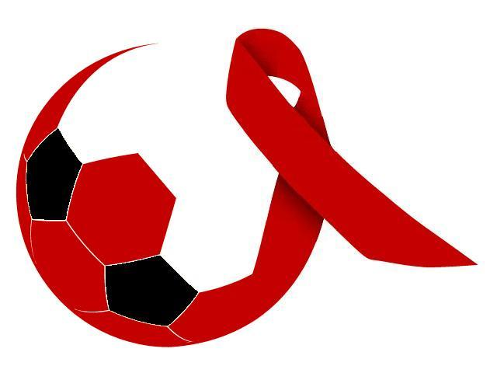
GRASS ROOT SOCCER
Using the power of soccer to fight HIV/AIDS

A soccer themed curriculum is used to empower the youth to prevent HIV/AIDS through discussions about decision making and healthy choices. The GRS curriculum is a series of activities that explore issues related to HIV/AIDS, providing the skills to lead healthy lives. It requires active participation and creates a safe (team based) environment in which participant can share their feelings, beliefs and ideas about HIV/AIDS. It is delivered primarily as an after school program in schools and community centres.

Coaches take their teams through 15 sessions that each contains a set topic with one or two short activities. One such session, “My Supporters”, focuses on how everyone needs supporters in life. The group is arranged in small circles. One person at a time stands in the middle leaning against the others, who support him or her with their hands. The group will then discuss stigma against people living with HIV/AIDS and the importance of social support.

A graduation ceremony is held for participants who complete all sessions. Families and friends are invited to witness a certificate being awarded to all graduating students.

MREMBO GIRLS PROGRAM

The primary goal is to reach out to the disadvantaged and marginalized young women and girls in the Majengo slum area. Many young girls lack information on how to tackle issues relating to their reproductive health. As a result many end up in compromising situations leading to early pregnancies, HIV and sexually transmitted diseases, school drop outs etc. The Mrembo program, meaning “beautiful” in Swahili, seeks to build, unveil and restore the inner beauty of young women through a series of educative sports activities.

One of the sessions in the program is called “Life Choices”. The girls will first dribble a ball through a set of cones. Next, each cone will represent a challenge in life, and there will be a penalty of 5 sit-ups for hitting a cone. The session is concluded with a round of discussions about the similarities between soccer and life - in both one must make the right decisions and deal with challenges and consequences. The coordinator will assist the discussion by bringing up choices and challenges faced growing up.

The Mrembo program was launched in August 2008.

GAME ON! YOUTH SPORTS

Millions of Kenyan children lack the opportunity to reap the physical and emotional benefits of taking part in quality sports programs. The Game On! school plan introduces children in the primary grade 1-3 to the skills development necessary to participate and enjoy sports activities. Children in grade 4-8 are introduced to the rules and skills requirements for a number of specific sports as determined by the local community.

The Game On! Youth Sports program operates by training grass root soccer coaches from the community as well as P.E teachers on introducing proper sports skills to young children. The goal is promoting the value sports can bring to the overall child development.

Parents of the participants are all aware of the coaches who are handling their kids and also know where their kids are training. Furthermore, parents are supporting their kids to achieve their fullest sports potential by meeting with their coaches and allowing their kids to attend training sessions on time and reporting back on time. Generally, Game On! Youth sports, has been an eye opener to many youth sports coaches, participants and the community.

In July 2008, Game On! Kenya in conjunction with Kenya American Sports Coaches conducted a two day girls’ soccer clinic at the Makongeni Youth centre. A total of 300 girls from 12 youth centres accompanied by their coaches came together.

TRAUMA RECOVERY

The Trauma Recovery project aims to help in the recovery and personal development of children and youth affected by the hostilities in Kenya. The need for such a project was evident by the aftermath of the 2007 post-election violence. Nationwide, over 1000 people died during the skirmishes and over 3000 families were rendered homeless. In Mathare slum over 300 people died and more than 1200 families were rendered homeless. In Kiambiu slum, over 100 people died and more than 600 families were rendered homeless. In Kibera slum over 700 people died and more than 800 families were rendered homeless.

Research shows that traumatized people achieve better outcomes when they have strong connections to people who care about them; friends and mentors who understand the challenges they face. The concept of using sports as an educational tool is quickly emerging, and is internationally recognized as an effective means of reaching traumatized youth with proper advice and support.

In August 2008 a group of 4 VAP mentors arranged a drama and play at St. John High school and Makongeni secondary school.
NAIROBI, KENYA



Nairobi is the capital city of Kenya, with an estimated urban population of between 3 and 4 million people.

There are a wide variety of standards of living in Nairobi. Most wealthy Kenyans live in Nairobi, but most Nairobians are poor. Half its population is estimated to live in slums, which cover around 5% of the city area.

Nairobi has experienced some of the highest growth rates of any city in Africa (~7%), despite being the youngest large city in the region. It’s estimated that Nairobi’s population will reach 5 million in 2015.

CONTACT US

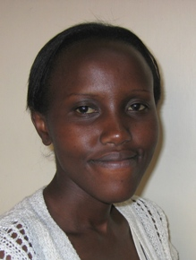
Nancy Waweru
Assistant Executive Director
Phone: +254 721 681 897
E-mail: nancywaweru@yahoo.com

Nancy Waweru (1980) has played soccer for many years. Nancy played for her school in the finals of Kenya secondary sports Association in 2001 and clinched the title. She has also coached vap under 14 girls team, known as Mrembo FC. Additionally, Nancy holds a degree in sociology and has attended several youth leadership trainings and been awarded several certificates including counselling, life skills etc. As a result of her involvement in youth activities and a vast experience in youth leadership, Nancy decided to transform the lives of youth through VAP. Nancy heads the financial control department and the HIV Biology education for VAP peer educators for GRS HIV prevention program.

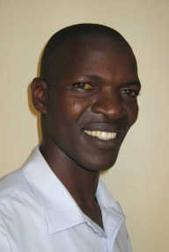
Enouce Ndeche
C.E.O/ Founder of Vijana Amani Pamoja
Phone: +254 723 954 556
E-mail: endeche@yahoo.com

Enouce Ndeche (1979) has played soccer all his life and has previously coached VAP under 12's, 14's and 16's. During his tenures as VAP youth coach, he has received praise for his ability to impress skills such as sporting, environmental and life skills on his players and the youth around Nairobi.

He is currently the head coach of VAP’s under 23 team which features in Kenya's Super League. Enouce holds a Diploma in project management and computer engineering as well as other international diplomas in sports and development (sports pedagogy) and local certificates for life skills. He’s passionately involved in the VAP project, and brings to the organization years of experience working with the youth of Nairobi. Enouce heads the fundraising and marketing portfolio for VAP.

