Dignitaries of Bubak Welfare Society;

President;
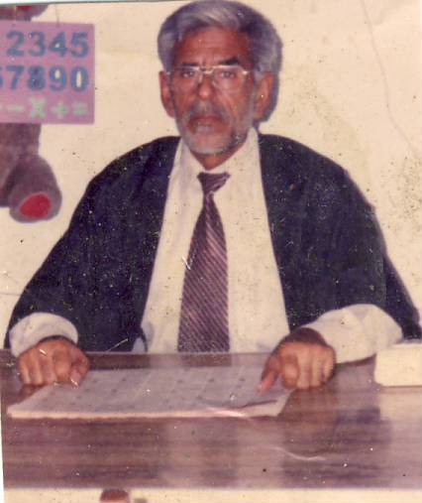
Prof. Ghulam Sarwar Bubak has served in the Federal Government Education Department Islamabad as a teacher. In the Education Department of Nigeria, Borno State as Principal Officer. In the Attefaq Academy Model Town Lahore, as Principal. In the Minhajul Quraan Lahore, as Controller. In Faisalabad Grammar School, as Vice Principal and worked as Tutor for Graduate / Post Graduate programes, of Allama Iqbal Open University.

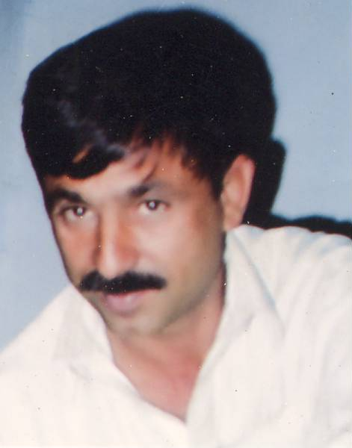

General Secretary;
Rafiqul Hassan Bubak; Equipped with Foreign Education. Graduated from University of Punjab. A renown farmer, social worker and a resource person. Highly interested in Computer implications.

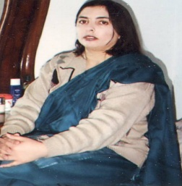

Senior Vice President;
Madam Salma Bubak is senior vice president of the Society. She is M.A. M.Ed and because of her foreign education, she is ever planning for the betterment of the School Staff and the students. She is always busy with the teachers to instruct them how to become a good teacher.

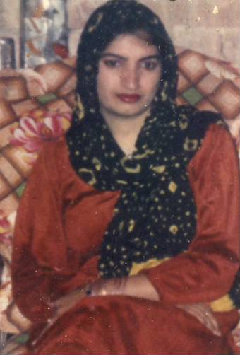

Vice President;
Madam Khalida is M.A.M.Ed. Has got a long experience of teaching and administration in T.N.T Model School Haripur. She is the in-charge of Discipline and administration in the Schools of Bubak Welfare Society.

Secretary Finance;
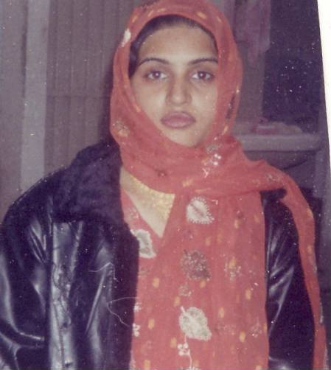
Madam Ayesha Hassan is M.A. L,L.B. She has been working in the Revenue Department but she resigned from there and joined Legal Practice. She is very popular Lawyer and is always fighting for the oppressed class of the women.

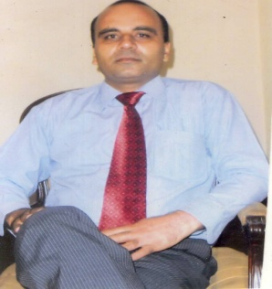
Legal Advisor;

Muhammad Shamshad Malhi Advocate is a renown lawyer. He is a very good Social Worker. His clients are mostly from the poor and the middle class. He has always guided our Society how to take legal action on disputed programs

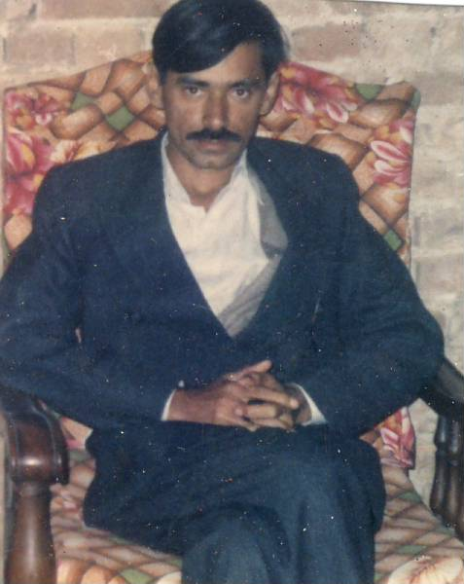

Secretary Information;

Mr. Tamjul ul Hassan is an advocate. Very much interested in social activities. He is a good planner and is running an estate project. He is an expert in agricultural farming in Cholistan Desert.

Advisory Council.

It consists of 10 to 12 senior members of the Society who always discuss and guide on the merits and demarks of planned projects and make audit of the Society’s Budget and expenditure.

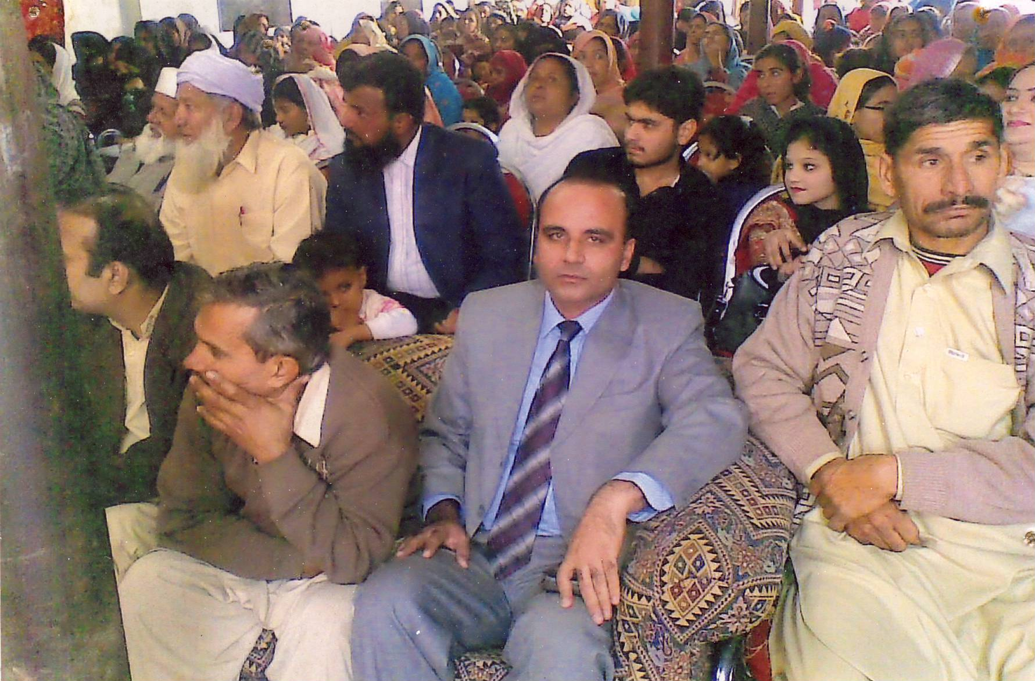

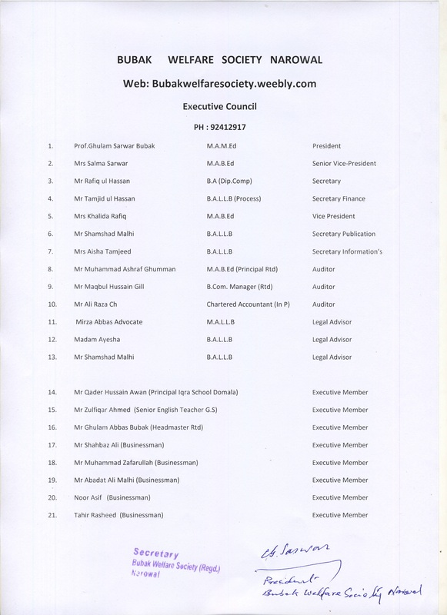

Bubak Welfare Society Registered Narowal
Ph;0542, 412917

Organization; The name of the organization is Bubak Welfare Society which is registered as non-profit organizations under Act XXI of 1860 dated 6-6-2004 at Narowal . And registered under the Voluntary Social Welfare Agencies Act 1961 (XLVIof 1961) date 21-7-2006 at Narowal. Punjab, Pakistan.
E Mail Address; Bubakwelferesociety@gmail.com
Website; Bubakwelfaresociety.weebly.com
Head Office ; Bubak House Eid Gah Road Narowal Punjab Pakistan.
Bubak Nomenclature:

Bubak, is an East European Family name, originated from ancient Bubal family of Eastern Europe which gave birth to Bubak, Budak and Babak tribes in Eastern Europe. Presently there are many welfare organizations in the name of Bubak, Budak and Babak working in Europe, America and other countries of the world.

Bubak; local History.

Historically, in India, during the reign of Sultan Qutab-ud-din Aebec, Ameer Ali Bubak was the Governor (Subedar) of Malwa State of India. In Sialkot pargana(Ditrict) of Jammu State, Hindu Jat Bajwa tribes created Law and Order problems and Ameer Ali Bubak of Malwa state was asked to reach the troublesome area and help fighting against the miscreants. So he via Lahore came to Sialkot Pargana and on his way camped at a place which is presently known as Babakwal . He recruited a large army of local tribes and reached Rayyia Khas, near Narowal. Here Bajwa tribes blocked his way for more than one year. During his stay Amir married a Goraya woman and after the defeat of Bajwa militants, during his advancement, he camped near a village Kapurwal present Bubak Marali, where his Gorayya wife gave birth to a male baby who was named as “Rah-Neik Nov” meaning lucky child born on the way. Later miss-spelt as ‘ Ranoknov’, The child and mother were camped there and for their safety Garayya commanders were appointed as attorneys on them and were allotted nearby areas which were named after the names of the Gorayya commanders as, Luttar Gorayya, Nanar,Gorayya, Bhatti Gorraya, Data Gorayyia, Acal Gorayya , Rayyia Gorayya etc Child Ranokanov was adapted by his maternal in- laws of Rayyia Gorayya . Amir Bubak ,after vacating the area from the Bajwa Hindu Tribes, appointed Zafaryov as commander of that area and went back to Malwa. Zafaryov is the founder of present Zafarwal Town. He built a Fort at that place whose remains are still present near Village Bubak Matar He clustered anti Bajwa Solehr Tribes in that area and established peace and security in the Sialkot Pargana which was the part of old Jammu state.

Bubak Welfare Society:
Prof Ghulam Sawar Bubak, B.Sc, M.A (English) is the founder of Bubak Welfare Society registered Narowal. He has been serving with the Europeans during his foreign service and has deeply been influenced by their commitment towards humanity. Having been inspired by the Bubak N.G.Os around the world, he too decided to establish a non-profit-organization in the name of Bubak Welfare Society. It was established in 1999 and was registered in 2004.

Aims and Objectives:
- Main aim of Bubak Welfare Society, is to rear the children of Middle class families, in such a way, that they could compete with the children of the Elite families. The society aims to Establish Educational Institution for the middle class community, providing Quality Education
- Society aims at providing health facilities on the same pattern

3 Society aims at keeping itself liberal and detached of
Religious, ethnic or Sectarian proliferation.

4 Bubak Society is more interested in the betterment of the
female cadre which is highly suppressed in our poor
countries.

- Co-education is a blessing for the Nation if it is well
Planned. Students are polished and disciplined to behave
as friends. Female are encouraged to compete

6 English as medium of instruction need to be stressed upon if we really want to live in the modern world. Our Bubak Society wishes to affiliate our education system with the foreign advanced institutions.

7. Bubak Welfare Society is interested to introduce practical subjects in our institutions so that students could avail job opportunities after they finish their education.

8 Our Bubak Society wishes to establish health units, Job centers, commune centers and advisory councils.

9. Our Society is against the gender dominance therefore we wish to pay more stress on female education and joint education.

10. Poverty alleviation, child protection and religious harmony in a backward, narrow minded and illiterate society is the main concern to be addressed.

Society Membership:
Any person who has the inspiration of doing something to improve, or to impair the disorder in our community, can member himself or herself with the Bubak society, Society believes in the supremacy of human ethics, which is common in all religions and all communities.

Donations / Subscriptions:
Anybody who wishes to donate for the betterment of the society is highly commended. The members of the society make monthly subscriptions directly or indirectly through monthly school fee of their children.

Society Account:
Society maintains its account in the National Bank of Pakistan Jamman Chandowal Branch Narowal, and is operated jointly by the president and General Secretary of the society.
Executive Council:
Senior members of the society constitute an Executive Council who is responsible for policy making, planning and administration.
Projects:
Bubak society, with the consent of its Executive Council can initiate any project in the field of Education, health and public welfare.

Society Employment:
Society Employment is governed by Government rules, Allowances and Salary of Summer Vacations in case of teaching staff is conditioned with the satisfactory performance. Confirmation in service is also attached with good performance. After 3 years successful service an employee could be confirmed.

Termination From Service;
Termination from service, in the case of a temporary employee needs fortnight notice or reimbursement of salary from either side. In the case of a confirmed employee one month notice or one month’s salary reimbursement from either side is required.

Honorary Service:
Society members or retired Govt Servants are employed against honorary positions. They are entitled to all benefits according to the society rules.

Audit of Record:
Society record including accounts and finances are audited once a year by the Audit Committee and are presented in the General Meeting.

Salary:
Salary is paid according to basic Government scales. Allowances are mandatory with the society provisions and availability of funds.

Vacation Salary:
Vacations Salary is conditioned with 6 months service period before vacations and satisfactory performance of the employee. It is paid in installments after the vacations.

Annual Increment:
With successful completion of one year service, increment becomes due and is paid in the month of September.

Casual Leave:
One leave in a month is allowed. More than one, leaves are deducted against salary and non availed leave of an employee is credited to the salary.

Projects; Bubak welfare Society intends to expand its activities in the fields
of Education, Health improvement, Poverty alleviation
and Gender-harmony..

- Bubak Higher Secondary School (English Medium ) in force
- Bubak Girls High School ( English Medium ) in force
3 Bubak Kids Nursery ( English Medium ) in force
4 Bubak Health Unit in line
5 Bubak Technical Workshop in line
6 Bubak Job unit in line
7 Bubak Foreign Education centre (O’ level, A’ level ) in progress
8 Bubak Public Library in line
9 Bubak Mobile Schooling with films etc in line
10 Bubak resource centre in line

BUBAK HIGER SECONDARY SCHOOL NAROWAL
( Affiliated with Gujranawala Board )
Ph. No: 0542-412917

A Non-Profit Project of Bubak Welfare Society Narowal

Establishment ;
The school was established in 1999 and it is successfully covering its educational journey year after year making 100% first division goal marks in the Board Examinations.
Building :
Presently school is running in a four storey spacious building. Very soon with the completion of new campuses boys and girls shall be accommodated in the separate blocks.
Medium:
It is an English Medium institution.
Admission:
Admission is made on merit. The children from the middle class families are encouraged. Admission is made to Play Group, Nursery ,class 9 and class 11 on the start of new Education year.
Admission Fee :
Existing Admission Donation for Primary section is Rs.1000/= for Middle Section is Rs 1500/= and for High and Higher Secondary Section, it is Rs 2000/=
Donation Fee/ Subscription:
Existing subscription fee for Primary Section is Rs 600/= per month, for Middle Section it is Rs 800/= per month and for High and Higher Secondary Section it is Rs. 1000 /= per month.
Late payment Fine :
Fee must be deposited on or before 10th of every month. After that Rs 10 per day is charged as late fee fine and on 20th (after noon), name is struck off from the school roll.
Absence from School :
As the school is a Science School, absenting from school is highly discouraged and Rs 20/= per day are charged as fine so that parents become conscious of their children’s punctuality.

Expulsion from School :
A student is liable to be expelled from school if his / her fees is unpaid by the 20th of the month, or if he / she is absent from school for 7 days or more, or if he is proved miscreant, trouble maker, rude to the teachers or been involved in the breach of school rules. If any Metric student is expelled from school, he /she can not sit in the Board Examination

Penalties :
Deliberately breaking or damaging the school property is a serious offence which is heavily punishable.

School Uniform :
School Uniform is compulsory for every student. Gray trousers, white shirts, black boots, white socks school tie and school badge is the uniform for boys and for girls, white scarf , gray shirt , white shalwar, black shoes and white socks is the school uniform.

Assemblies :
There are two assemblies in the school, one at the beginning of the school and the other at the closing of school. Presence in the assembly is important, because we do, collective teaching of, Al Quraan and spoken English in the morning and afternoon assemblies. Al Quraan and Assembly work papers, are part of our Internal Examination system.

Proctorial Board :
Proctorial Board consists of very descent boys and girls from every class in the senior section. The teacher incharge of the board is made the chief proctor. From amongst the proctors Head boy and Head girl are nominated, by the school management.
Proctor duties :
Proctorial Board is responsible to help maintaining Law & order, discipline , cleanliness, ethnics cohesion, health , functions etc.
First Aid :
For minor physical problems, first aid is available in the school. For serious cases the students are escorted to the hospital.
Examinations :
Monthly tests are conducted every month in the last week of the month and student’s files are sent to the parents along with students answer sheets. At the completion of every term, term tests are conducted to evaluate the student’s term progress. Annual Exams are conducted in the first week or second week of March. It is the responsibility of the parents to see, check and sign the student files. Mostly the students sign themselves for their parents and deceive their parents and their teachers.
Annual Function :
Annual function is usually arranged in the month of September or October, in which parents members of the society, old students and honorable guests are invited. Students are awarded prizes and certificates for their distinctive performance in different fields of Education.

Co-curricular Activities :

Debates, speeches, dramas, plays minor games, magic shows are arranged by the respective incharges, to provide the students, the chances of exploring and exposing their hidden qualities.
School leaving certificate :
If the school dues are clear school certificate can be asked at any time, not by the students but only by the parents. Class 9 to 12 can not ask for school leaving certificate. They need migration certificate.
Migration Certificate :
Board students, class 9 to class 12 can not be issued school leaving certificate. They need to deposit migration fees to the Board account and seek migration to a school at least 6 KM away from the parents school.
Movement / Disposition Register:
Students are not allowed to leave the school without permission and endorsement in the movement register. Small children can not be handed over to the strangers. Only the parents need to collect them. If any child is collected before, off time, it needs endorsement in the disposition register.

Day duty :
In every section of the school Day master / Day mistress are responsible for controlling the activities of the students, especially before morning Assembly, during break hours, and school time. Day master / Day mistress need to come to school half an hour earlier and leave the school half an hour later after closing time.
Student Fund :
Present rate of student fund for primary section is Rs.20/=, for high section, it is Rs.40. Student fund is deposited with the class in-charge and finally collected by the in-charge teacher of the Proctors Board. Student fund can be used for student’s welfare programs, heaters, coolers, medicines, chalks, stationery, charts, boards, clocks, dusters etc. are provided out of student fund. Student Fund register must be maintained by the Teacher In-charge.
School Badge and School Tie :
School badge is compulsory for all students, School tie is compulsory for boys only. It is the schools badge which helps locating and identifying a missing child, especially for the young children.
Handkerchief / Bib :
It is very important for young children to be equipped with handkerchief and bib, so that the teacher could keep them neat and fresh looking.
Lunch box :
It is very important, that the parents supply their children with Lunch box and Water bottle so that the young children could be saved of contamination diseases.
Ornaments / Mobile Phones:
Gold ornaments and mobile phones are not allowed in the school. If such things are found with the students, these could be confiscated.
Cycle / Motor Cycle locks :
Students are not allowed to park their cycles and motor cycles without lock. It is easy to carry away any cycle / motor cycle on the road side, if not locked properly.
Prohibited Drugs / Cigarettes / Narcotics:
Unless prescribed by the Doctor , no student is allowed to bring prohibited drugs in the school. If any student is found with narcotics or cigarettes, he/she must be expelled form the school without any excuse.
School Canteen :
School Canteen is supposed to keep all items needed by the students and sell them on market rates. Day Master / Day Mistress are bound to check the prices and quality. If some thing substandard is found, it could be destroyer or removed.
Visitors Book :
Visitors are expected to express their views on the school activities and performance and record their views in the visitor’s book.
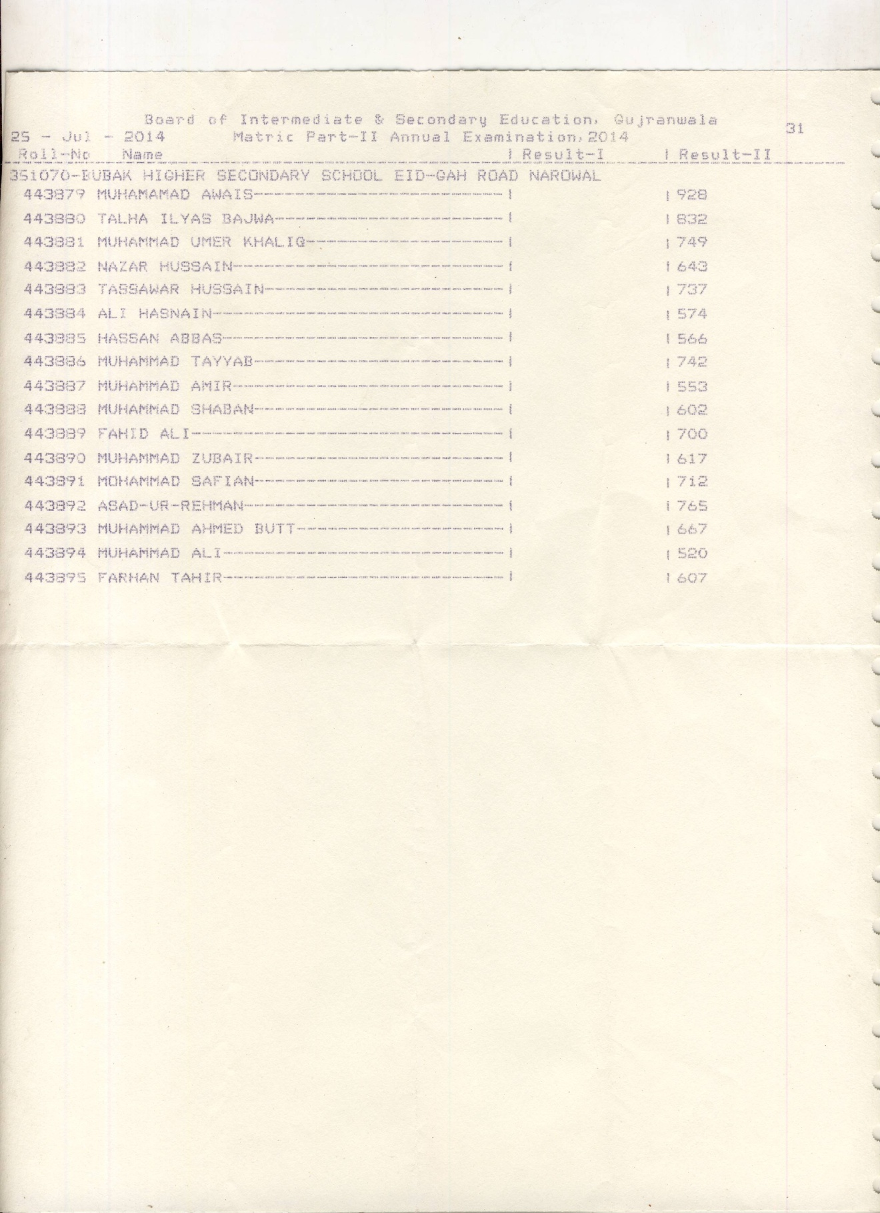

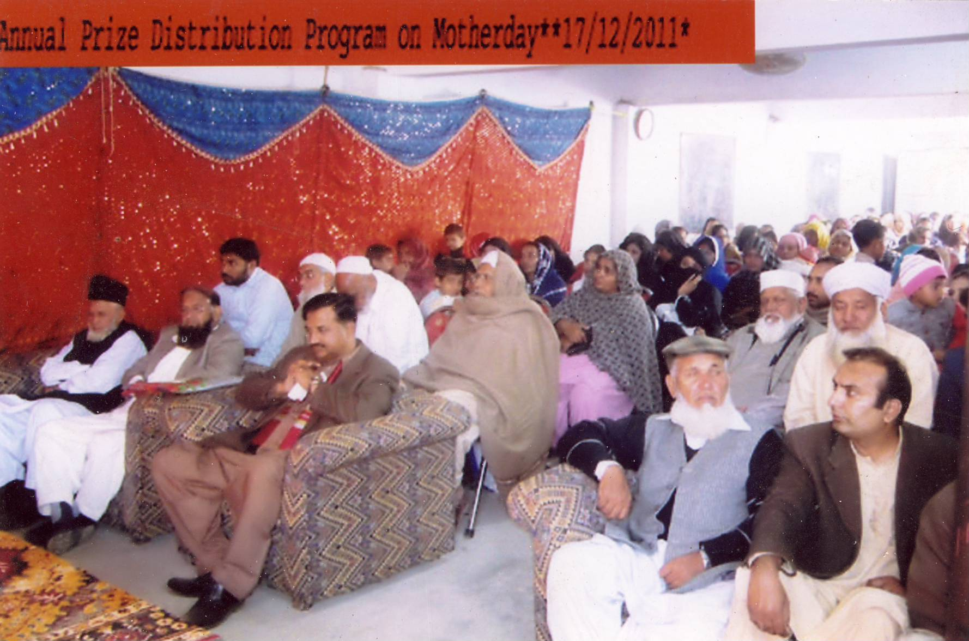
Annual School Function, with the District Nazim Col. Javed Safdar Kahlon

Proposal: Bubak International School Narowal

Background of District Narowal:-
District Narowal is a backward area situated on the Indian/Kashmir border. Education rate is not very low but the population of the area is very poor. A few national quality schools present in the district, are very costly. There is no International school in this district.
Importance of International School:
At least one International school is required in the District Narowal. Where at least 30% students must be admitted from the 80% poor majority of the area including minorities who will be granted scholarships to complete their International Education. Rest of the 70% students shall be admitted from the comfortable population, who will pay full fee to meet the expenses as far as possible. Unless we uplift our poor majority, we cannot discourage fundamentalism. Our National system of Education, no doubt is good but it encourages religious supremacy. Compulsory religious syllabus and ban on Co-education is a great hindrance for liberalism. International donors who wish to promote liberalism in religious state like Pakistan, must encourage International Schools for the poor at least one in a district. Presently, there are a few International syllabus schools in Pakistan which are very costly and are run on commercial bases. Only the children of rich people are studying there who are already a liberal class. The poor class who are the main source of Mulla-ism (clergy-ism) can only be attracted to liberal International syllabus by offering full fee concession/scholarships. Once new trend is created, no hurdle can block the way to promote liberalism.
Scope:
Only for a year or so, reluctance of the people may become a problem. Once the school is established, 1/3 of students with poor background can be accommodated against 2/3 of majority students who will afford full fee. After 3 to 4 years the school will start bearing its own burden. International donors only need to help established such schools. The names of such schools can be adopted in the name of the donors like American International Bubak School etc. The Aid like USAID in Pakistan in spite of its huge bulk, is not visible because it is going to invisible power centers. Nobody knows, how, where and who is spending the money and for what purpose. Abstract planning means to encourage corruption in the society
How to complete Such Projects:
Bubak Welfare Society is bearing the expenses of the old projects itself. With the new projects, we need to purchase new plots for the building, then to construct building on them and then to encourage and attract the low income population with Scholarships for the children of the poor. Different steps which we can plan to accomplish our goals, could be to complete the projects step by step first to purchase the plots then to start the building with class rooms and then to start the classes on slow and steady phenomena. If there are some strong funders, the project can be completed in one step only.
Estimated Expenses:

Size 16 feet X 26 feet plus veranda 10 feet:
Estimated Cost of 1 Class room Rs.671400 $ 6714
Numbers of Class rooms = 15
Estimated Cost of 15 rooms = 15 X 671400=Rs. 10071000 15 X 6714 = $ 100710
Scholarships = 100
Estimated Amount of 100 Scholarships = Rs.100 X 5000 X 12 = Rs.6000000 $.60000

Bubak Welfare Society has decided to open a quality school for the children of the poor/middleclass community where ‘A’ Grader students of the poor/middleclass parents shall be admitted for the overseas syllabus like ‘O’ level ‘A’ level etc. We will need philanthropic organization to help us towards scholarships for the poor, transport buses, computers and other unforeseen expenses.
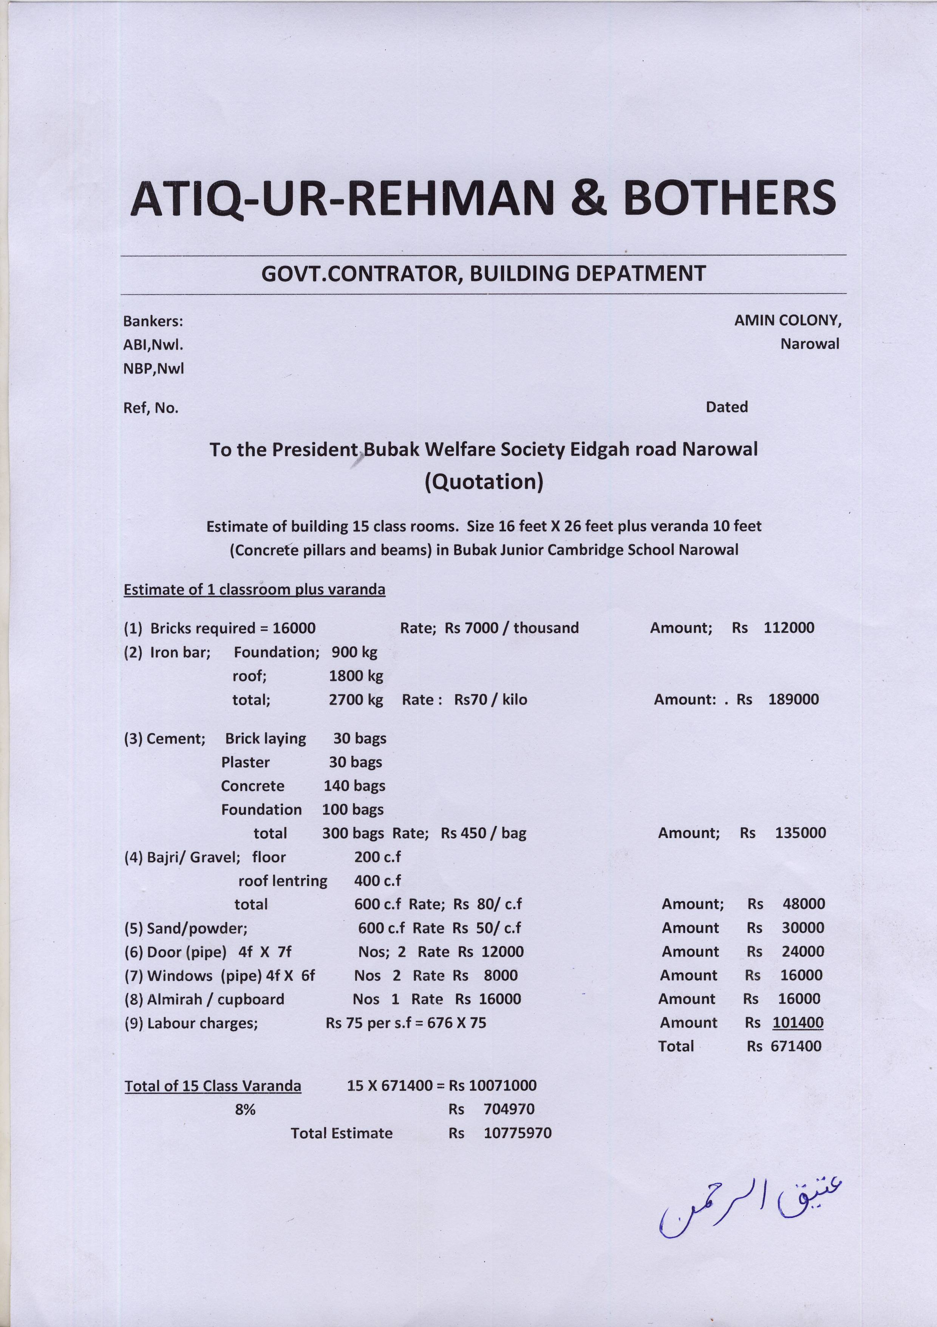Pakistan in the Present circumstances

About Prof, Bubak: -
Prof, Ghulam Sarwar Bubak, president of Bubak Welfare Society Narowal would like to submit that he belongs to a lower middle class family. His father was not an educated person he made a great sacrifice to get him admitted to a Missionary Murray College Sialkot to complete his B.Sc and then to Missionary Garden Colleg Rawalpindi, to do his M.A in English. These colleges molded his personality into a liberal Education lover. He started his Service with Federal Government Islamabad. Later he was selected by the Federal Public Service Commission of Nigeria as an Education Officer. There he learnt a lot from his Senior British Colleagues. He was earning around 1000 sterling a month. His stay in Africa and Europe changed him into a liberal Social Worker. After coming back to his country towards the late last country. He found, Pakistan, an entirely changed country, immersed in corruption and Lawlessness. In order to pay tribute to his deceased father, he decided to open a liberal English medium, Gender free and non religious School in the poor locality. In those days, it was, strongly condemned because it was a new idea. He continued and ultimately succeeded to attract his people. Then he organized Bubak Welfare Society from amongst his liberal minded educated people and got it registered with the Government. Here after, Bubak Welfare Society Narowal was handed over the change of Bubak School System because he wanted to provide to this school System, a permanent footing. Bubak Welfare Society Narowal introduced monthly fee equivalent to one day’s wages of a laborer. Presently our Bubak Schools are very successful and are giving 100% results. Our Bubak Welfare Society Narowal wishes to start more liberal International Schools and in order to meet the expenses; it has decided to approach the International donors.
Real Challenges In Pakistan.
1 - Corruption: - First and foremost challenge is the supremacy of corruption in Pakistan. Our rulers, our Government machinery, our justice system and our religious domain have all become corrupt. Powerful countries, like America, Europe, Japan, Canada, China, India etc must encourage Rule of Law, Corruption elimination, Poverty alleviation, Liberal Education and Religious harmony in Pakistan. If world leaders really wish to make Pakistan corruption free country, they must discourage politicians in Pakistan, to hide their money in any country in the world.
2 - Ill Education: - Our Education System has completely collapsed. In Pakistan, teachers and lectures, wish to enjoy salaries without teaching. They only wish to make extra money through private tuitions and academies. On the other hand Private Schools and Colleges are very costly. They try to make good results by unlawful means and encourage the cramming habits among the students instead of, imparting quality Education. Our Education system is over shadowed by religious dominance. Sectarian Institution are funded by Ushar and Zakat to attract the poor majority towards free education in Religious Schools.

3 - Lack of Health Facilities: -
Our country itself has become a diseased country. Every new disease emerges from Pakistan. Public Sector has completely collapsed. Every doctor is receiving handsome salary in Pakistan and every doctor has opened his private clinic. They pay no heed to their duty in hospital and are found busy in their clinics, during duty hours. Voluntary hospitals even, are miserable. Medicines are being sold in the market. The poor majority of people is completely ignored. Hunger, disease and helplessness is their only fate.

4 – Poverty: -
Poverty rate in Pakistan is more than 80% and it is increasing on. Poor majority cannot afford to educate their children. Children of the poor can only read in free clergy schools where they learn Mulla-ism and help sectarian propagation. With the increase in devaluation, our country has reached to the collapsing stage. Presently, suicide rate in Pakistan is increasing on to an alarming stage.

5- Agriculture: - With the increased prices of commodities, the farmers have reached to a miserable position. Electricity bills have gone very high. Seeds fertilizers, medicines, insecticides, water pumps, diesel etc have gone out of the farmer’s reach In addition to that heavy rains, disasters and unfavorable circumstances have adversely affected our agriculture. Expenses are high, produce is low. Only middle man and the Mill owners are enjoying the benefits.

6 – Sanitation: - If our atmosphere is dusty and smoking, our water is unclean and our food is poisonous, how can we defend ourselves against diseases. At present in Pakistan whatever we eat is poisonous, whatever we drink is polluted and where ever we breathe, is suffocating. Local Government system does not suit to the nature of our rulers. With the collapse of our Local Government system, our sanitation system has also collapsed.

7 – Poor Planning: -
Our Government’s poor planning is running after, to make money. They make a road, in order to break it. Our Railways, PIA, Steel Mills etc have all been made to collapse. Our Education System has collapsed, health system collapsed, Agriculture system collapsed and above all Government system has also collapsed.

Possible Remedies
Pakistan has reached to a stage of no return. Immediate steps need to be taken.

- Police force must be purified. The only cure for that is, to recruit District Police officers, provincial and Federal IG.s, Anti Corruption officers etc from abroad on contract bases for about 10 years.
- In judiciary District session judges. High court and Supreme Court, chief justices and Accountability Chiefs, need to be borrowed from abroad.
- Maximum wealth limit need to be fixed.
- Pakistani citizens residing in Pakistan must be banned to keep their Account/money in other countries.
- In elections, 80% seats must be allotted to poor population. Only 20% seats should be allotted to rich community.
- Educational institutions must be non-religious and gender free.
- People in the Public Service must be banned to seek beneficial offices/practices during Government Service.
- Poor students must be encouraged to quality education by awarding poverty scholarships.
- Doctors in the Government hospitals must be banned to do private practice during Government service.
- Farmers must be allotted barren lands to make cultivation and maximum subsidies must be provided to the farmers.

President Bubak Welfare Society Narowal
Prof, Ghulam Sarwar Bubak

Bubak Welfare Society Narowal
Web: Bubakwelfaresociety.weebly.com

PROJECT 1 : - Quality Education/Scholarships for the Poor Youth

Purpose: - In Pakistan more than 70% people are living below the poverty line. A person, who is earning less than 15000 rupees a month, cannot afford to teach his children in a good school. If he wishes to teach his children, he gets the only chance of free education schools, religious Schools, or fundamentalist Institutions’. He cannot dream of a quality school for his children. Our Bubak Welfare Society believes that poor and lower Middle class community youth needs to be uplifted. Philanthropic organizations can do that in two ways. (1) By opening quality education schools themselves, or by funding quality Education Schools (2) By funding the smaller N.G.Os who could arrange reasonable scholarship facilities for capable youth from the poor majority. Our Bubak welfare Society has opened its own quality Education schools for the lower middle class youth and to make the uplift program more effective, we are starting Quality Education Scholarships for the youth belonging to low income families.
Scope: - Bubak Welfare Society is a small N.G.O registered under social welfare ordinance No XLVI of 1971. We work in different fields like Education, youth Scholarships (Male/Female), women independence, health care and water pumps/lavatories in the rural primary schools etc. Our main focus is on Education for the poor. A capable child of a poor family can complete his metric, ‘O’ Level ‘A’ Level, F.sc If he can avail a reasonable scholarship. We wish to arrange at least 1000 scholarships.
Capability: - For award of scholarships. The youth need to belong to a family whose monthly income is less than Rs 15000 a month.
2- The child keeps ‘A’ grade status in the class examination or in the board examination.
3- He may get admission in any quality school anywhere but his origin must be District Narowal.
4- Scholarships shall be awarded on merit by the selection committee.
5- Scholarship shall be awarded through Bank cheque after every three months term.
6- Mal Practice or corruption may lead to dangerous consequence.
Funding requirement. To start with, Bubak Welfare Society needs an amount of
Rs.5000 X1000 X12=Rs 60000000 per/Annum = $ 600000 Per/Anum
Fund Raising: - Bubak Welfare Society expects that philanthropic international funding organizations who wish to alleviate poverty from Pakistan and wish to spread non-religious and gender free international quality education will surely help us because poverty can never be alleviated without Proper Education. Ill-Education leads to fundamentalism and terrorism.
Project 2: Laptops :
We expect that the International Donors dealing in IT equipments/computers shall be pleased to help the students from a backward/poor family background who cannot afford to buy such equipments for the enhancement of their education. If our Bubak Welfare Society could afford it will like to grant computer help to the other schools who do not have the resources to afford the expenses.
Project 3: Class rooms in Small Schools: -
In order to take part in Universal Education system, Bubak Welfare Society needs to encourage the small schools in the backward area, with provision of class room facilities,toilets and water facilities. School buildings attract students and the parents to send their children to the school. A school in the open air or in the religious places gives the impression of a clergy school.
Project 4: Bubak International School for the poor youth:-
Bubak Welfare Society is about to construct Bubak International School with International syllabus like ‘O’ level ‘A’ level. Its building may cost up to $100000. British Council Lahore Pakistan has already approved it and wishes us to start the program as early as possible. The society will initiate the classes in a rented building as soon as it succeeds to arrange youth scholarships for the girls and boys.

President: Bubak Welfare Society
Prof, Ghulam Sarwar Bubak
