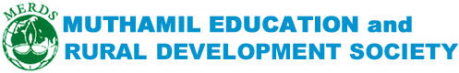
Working Together to empower rural community 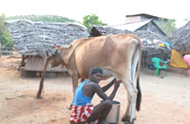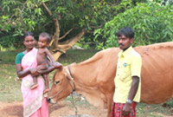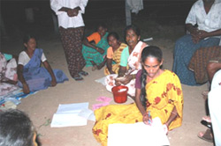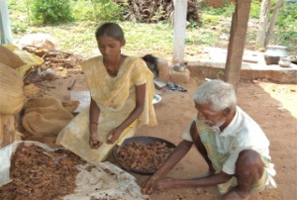
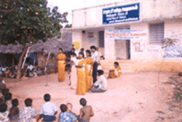
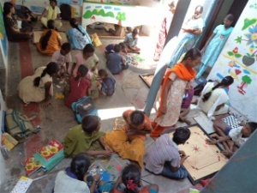
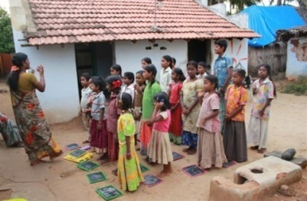
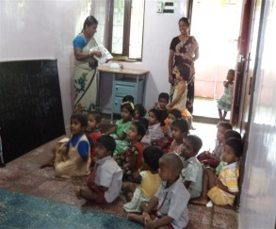
INTRODUCTION
MERDS is a Non-Profit voluntary service organization working for the development of rural people and children in Tamil Nadu, India for more than a decade.
VISION
The Organization is committed to improve the socio –Economic Development of the down-trodden masses of Natham Block, Dindigul District of Tamil Nadu, India.
MISSION
It Strive work for the development of rural poor women, children and educated unemployed youth. It also tries to create a sustainable mechanism at micro level to build a society based on equity and social justice.
SOME ACHIEVEMENTS
MERDS
INVITING PARTNERSHIPS
MERDS has legacy of collaboration and welcomes more to explore and discuss such possibilities further, please get in touch with us. We will be more than happy to discuss alternatives such as technical as financial collaborations, internships, volunteering, capacity building, and many more.
OUR CONTACT DETAILS
MERDS
2/146, East Street, Uluppagudi post, Natham Taluk, Dindigul District, Tamil Nadu, India, 624 401, Mob: 09159989958, Phone: 04544-244207, Email: merds36@yahoo.com, merds36@rediff.com www.merds.org.in

