Immunization Program
Mid Year Report 2011-2012
Submitted to
Global Giving

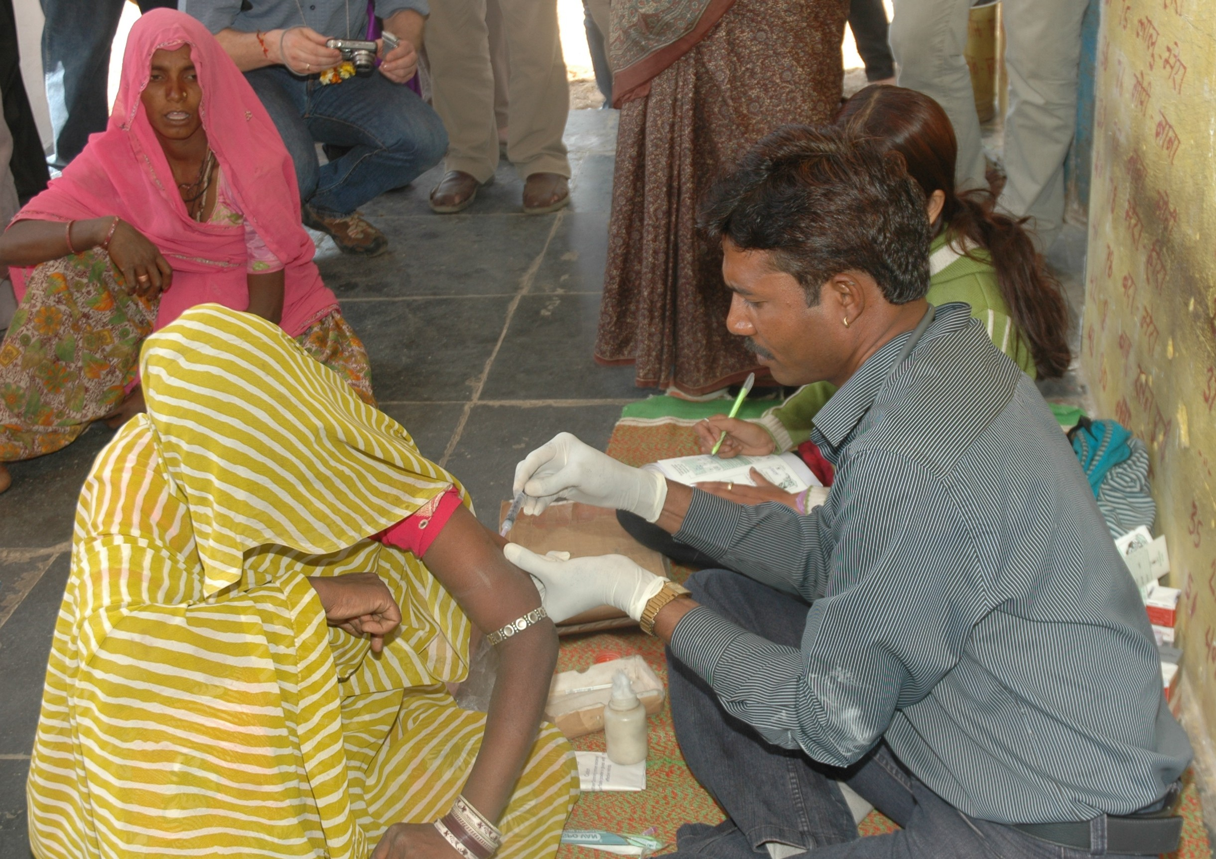

SEVA MANDIR
Udaipur Rajasthan, India
info@sevamandir.org
www.sevamandir.org

Immunization Camps

Immunization for Tribal children and Young mothers aims at improving the immunization status of children and pregnant women in those remote areas which are not reached out by the government health service providers. The services provided in Seva Mandir run camps include immunization of children, antenatal checkups and vaccines for pregnant women and treatment for minor childhood illness.

Immunization camps were being carried out in 125 hamlets across all five blocks of Udaipur District, Rajasthan. Previously, immunization camps were conducted in 68 locations and out of which four locations were dropped during this reporting period because Government’s MCHN days (Indian Government’s package for routine immunization to the community, involves Maternal, Child and Nutritional components) were started in these locations. Immunization camps were initiated in 61 new locations across the five blocks of Udaipur during the month of June and July, 2011. The new sites were decided on the basis of the proposal put forth by the village development committees and after collection of complete information on the status of immunization services at those locations.

During the reporting period, out of the targeted 607 camps, 545 camps were held. Total of 90% camps were held against 96.8% in the previous reporting period. One of the major reasons for cancellation of camps was poor weather conditions and inaccessible roads during the monsoon.

Total 62 camps were cancelled due to reasons as mentioned below:

Reasons for camp cancellation | Number of camps cancelled
Unavailability of nurse | 7
Heavy rains and bad roads | 24
Replacement for nurse/assistant could not be arranged | 10
Vaccine not supplied from government department | 8

During the reporting period, the camps registered a total of 683 children in 539 camps for vaccination. The table below gives the number of children received different vaccines during the reporting period from April 2011 to September 2011:

Types of Vaccination provided | No. of Children
Number of children received BCG shots | 394
Number of children received DPT / OPV (1st dose) | 461
Number of children received DPT / OPV (2nd dose) | 336
Number of children received DPT / OPV (3rd dose) | 207
Number of children received Measles vaccine | 351

Apart from the routine vaccination provided in immunization camps, 978 children were given treatment for diseases such as fever, cough, cold, measles, eye or ear infection, diarrhea and skin infection.

These camps also reached out to pregnant women for antenatal care. As per the available data, the camps reached out to 937 pregnant women for antenatal checkups and immunizations. A total of 749 women received one shot of tetanus toxoid and 583 women received both the shots of tetanus toxoid. These women also received ante natal checkups which included blood pressure and weight check, hemoglobin and urine test and physical check up for identifying risk symptoms. The women were also counseled based on the test results and were referred for institutional care where needed. In the previous reporting period, most of the women availed only two antenatal check ups at the camps but during this reporting period stress was also given in counseling women for third antenatal care. Total 123 women received 3rd antenatal check ups in the camps.

New Intervention

Immunization in Pre-school centres
During this reporting period, immunization for the Balwadi (Seva Mandir’s rural pre-schools for rural and tribal kids from 1 to 5 years old) children was initiated in the month of July, 2011 with a new dedicated team. Flock of people were hired for each block and given responsibilities of conducting immunization at Balwadis and few camps at hamlet level. It took lots of efforts in planning the work schedule of block Immunization teams so that the Balwadis as well as the camps could be covered simultaneously within a minimum time period. The teams were given list of children with their immunization status which was collected during the base lines survey conducted before. For each Balwadi, a review visit is fixed by the team and conducted once in every three months. The Balwadi Sanchalikas were informed about the planned schedule. Each immunization schedule was decided after consulting a senior pediatrician. A child over the age of one year who had not received even a single shot was given measles and DPT in the first month, followed by BCG and DPT in the second month and the last dose of DPT in the third month. Also, oral polio drops were provided in each month.

During the reporting period, immunization at 31 Balwadis was successfully completed wherein total 393 children received immunization in all the five blocks of Udaipur District, Rajasthan. However, we were not able to meet with our target due to delay in starting the intervention. Delay occurred because of unavailability of nurses and when the project was initiated, many of the Balwadis (pre-school) did not get the information of the immunization days. Later, this problem was sorted out through repeated dissemination of information to the Balwadi’s Sanchalikas (instructor) regarding the immunization days.

