GlobalGiving Project Update: “Immunization for Tribal Children and Young Mothers”

Background:
In India, 1 in every 14 children dies before the age of five, and child mortality rates are significantly higher in impoverished, rural locales. Many children are dying of vaccine preventable diseases, such as measles, polio, tetanus, and tuberculosis that have long been eradicated in much of the world. While immunization is proven to be a very cost-effective way to reduce child mortality, immunization coverage in much of India remains relatively low. According to statistics collected by the Indian government, 44% of the country’s children are fully immunized. Wide disparities in incidence of immunization coverage exist across and within states, with state-level rates ranging from 81% of children fully immunized in Tamil Nadu to as little as 21% in Nagaland.
In Rajasthan, the state in which Seva Mandir has long been working, only 27% of children have completed the full course of vaccines; the state ranks among the worst in the country when it comes to immunization coverage, with only two other states having lower rates. In addition, very low incidences of antenatal care visits and tetanus vaccinations by pregnant women contribute to the high rate of maternal mortality. Seva Mandir seeks to reach the most disadvantaged and vulnerable populations; we work in the Udaipur district of Rajasthan, one of the most impoverished areas of the country, where indicators of health are typically very low. A survey of health status in Seva Mandir’s catchment area, undertaken in 2003-04 in conjuncture with the MIT-based Abdul Latif Jameel Poverty Action Lab (J-PAL), found only 2.66% of area children ages 0-5 to be fully immunized. Through its innovative immunization program, Seva Mandir is working to increase immunization coverage at drastic levels and to make childhood and maternal immunization the normative behavior in these communities.

Barriers to Immunization:
A number of challenges exist to providing the children and mothers in India with complete immunization against disease. A lack of demand for immunizations coupled with an unreliable supply of basic health services account for most of these barriers. Concerning the weak demand, there is often insufficient awareness on the importance of vaccines. In addition, parents are often deterred by the opportunity cost in the form of lost time and wages in taking their children to be immunized. Complete immunization of one child requires at least five trips to the health center, and antenatal care for pregnant women requires multiple visits as well. These numerous days without wages can be very difficult for a family. On the supply side, although the government provides vaccines free of charge in India, staff shortages and high levels of absenteeism of health workers make health centers and immunization camps unreliable. When camps are repeatedly not held at the regularly scheduled times and health centers are closed when they should be open, local people often deem it not worth their time to travel, sometimes very long distances, in an attempt to avail of these services. In the Udaipur district, the hilly terrain and scattered population in rural and tribal areas makes it difficult for people to reach health centers, and, therefore, these challenges are even more acute.

Seva Mandir’s Innovative Approach to Immunization:
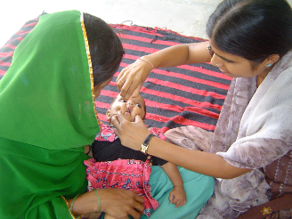
From mid-2004 to early 2007, Seva Mandir and the MIT’s J-PAL conducted an extensive research involving 1640 children across 134 villages to test the effectiveness of different interventions in increasing vaccine take up. We found that ensuring the regularity of camps by holding them at a fixed time and date each month in a central and accessible location and boosting demand for immunizations by providing parents with a small non-financial incentive, in the form of lentils and utensils set, leads to a drastic increase in the rates of child immunization. These interventions resulted in almost 38% of children receiving the full course of immunization, compared to just over 6% in control villages where the interventions were not undertaken.

Our resulting approach to immunization is based on the two key principles learned from our research: ensuring a regularity of services and encouraging demand result in significantly higher rates of immunization. Seva Mandir’s immunization camps are conducted by mobile teams at fixed times and dates. The mobile teams are monitored using data and time stamped photographs and their compensation is linked to their performance. To encourage demand for child immunization, parents receive 1 kg of lentils for each vaccine their child receives and a utensils set when the child’s immunization is complete.

The Evolution of our Immunization Program:
Seva Mandir has been holding mobile immunization camps since April 2007. We are currently conducting camps in 68 hamlets (a hamlet is a group of households, similar to a small village) across our area of work. A camp is held one day per month in each hamlet.
For example - over a period of 12 months from April 2009 - March 2010 a total of 779 camps were conducted. This represents 97% of scheduled camps (3% were not held due to heavy rains which made areas inaccessible).
During all the three years from April 2007 to March 2010 a total of 6512 children and 4317 pregnant women registered at these camps. The vaccines administered are shown in the following tables.
Although the focus of the camps is immunization, other maternal and child health services have been added to take advantage of the rare occasions when woman and children in these areas have access to doctors and trained health care workers. In addition to receiving TT vaccinations, pregnant women are also given comprehensive antenatal care (ANC) checkups, which include tests for hemoglobin levels, urine analyses, and measurements of blood pressure and weight. The nurses provide counseling and referral services to the women based on these diagnoses.

Vaccine Coverage of Children from 2007 to 2010
Year | Children Registered | BCG | DPT1  /Polio 1 | DPT2  /Polio 2 | DPT3  /Polio 3 | Measles | Booster | Complete  Imm
2007-08 | 2223 | 2016 | 1994 | 1698 | 1397 | 1062 | 12 | 1551
2008-09 | 2244 | 1454 | 1493 | 1312 | 1184 | 977 | 10 | 1365
2009-2010 | 2045 | 1260 | 1256 | 1046 | 963 | 863 | 22 | 827

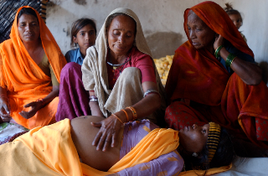
The medical staffs at the camps have, since October 2009, also been providing treatment and referrals for childhood illnesses. They treat common, but often deadly, diseases including diarrhea, pneumonia, bronchitis, scabies, malnutrition, and ear and eye infections.

Vaccine Coverage of Pregnant Women from 2007 to 2010
Year | Women Registered | TT1 | TT2 | Complete Immunization
2007-2008 | 1504 | 1419 | 1039 | 1199
2008-2009 | 1403 | 1178 | 986 | 1061
2009-2010 | 1410 | 1250 | 887 | 903

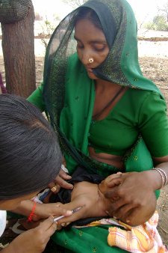
Much Success, but a Long Way to Go:
Since they were started in mid-2007, the immunization camps run by Seva Mandir have vaccinated children against deadly diseases as well as supplied antenatal vaccinations and check ups to pregnant women. Our work has shown that even in very hard to reach, resource poor areas, immunizations can successfully be provided to mothers and children. Yet there are still so many children in our region who remain unvaccinated and therefore very vulnerable to disease and early death. Currently we are working to continue running our 68 monthly camps, as well as establish camps in additional villages to reach more and more mothers and children. The objective of our camps is to ensure that no child or mother die from a disease that could be prevented by a simple shot. In the long run, we seek to build an acceptance of vaccinations, thereby making child and maternal immunization the normative behavior in these communities.

DLHS-3, 2007-2008
NFHS-3, 2005-2006
NFHS-3, 2005-2006

