A note by North from Canada on Immunization Camps (February 2011)

The Seva Mandir Immunization camps aim to increase immunization rate in the Udaipur area. They are held monthly across the blocks to make immunizations accessible for local people. The first time that I went to the field was about two weeks after I started volunteering at Seva Mandir. I woke up at the crack of dawn to eat breakfast and get to work in order to catch the jeep to the village of Keli in the Girwa block. I was going just as an observer, so that I would feel comfortable travelling alone to the field later in my work in the Health Office. It was a beautiful, cool, sunny morning in Udaipur, as most morning are in October. The jeep ride was through gorgeous hills. I spent some of it learning about the camps from Devrani, the Health-in-Charge of Girwa block, and the rest of the time napping against the window.
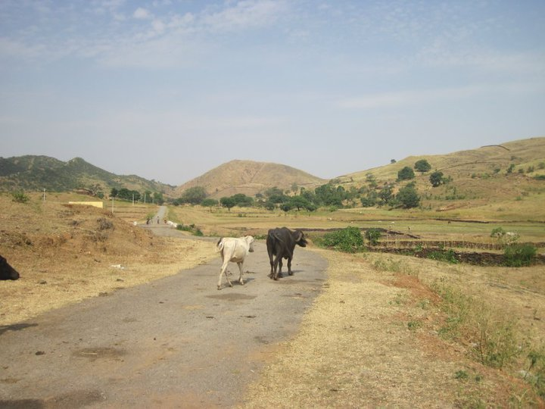
The village of Keli, Girwa Block
We had arrived in the village of Keli when the paved road ended in the middle of a grassy valley between rolling hills. It was quiet and pretty deserted. There were a bunch of cows and a few people in the distance, and birds singing in the gentle breeze. We walked up a gentle hill to a small one-room building with a patio were we met Neelam, the nurse, and Govind the para-health worker, who were sitting inside on carpets on the floor. Govind pulled out a hefty medical bag and Devrani and I went through a checklist of all the things that were supposed to be available for the immunization camp. Everything was in order. The village’s Traditional Birth Attendant (TBA) arrived with about ten women and their babies. There was also one very tiny and very pregnant lady. Neelam and Govind went through the babies one by one, checking their immunization cards and entries in the records from previous camps in order to give the babies the immunizations that they needed.
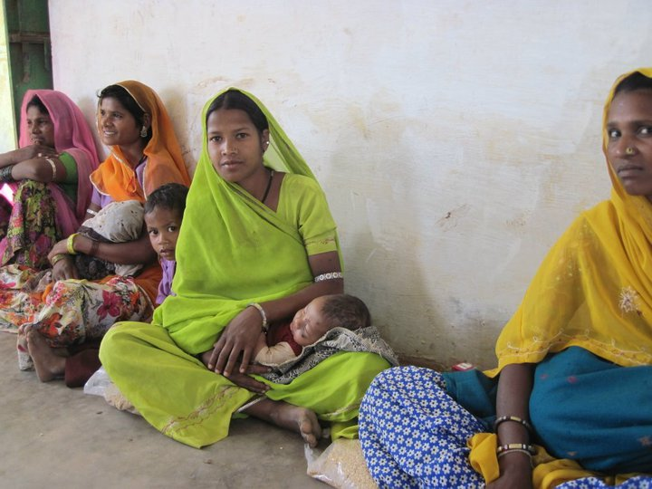
Women wait to have their children immunized.

This camp was part of an incentives program being tested by Seva Mandir, so each child who got immunized when I was there received one kilo of lentils for his or her family, and each family that got their child immunized with the full course of five immunizations received a set of plates. Neelam gave some pain medication to each mother in case their child remained in a lot of pain after the immunizations. She also gave medication and nutritional imformation for children who were sick or underweight. The one pregnant lady was quite anemic and underweight, so Neelam gave her some advice about how to get more iron in her diet.

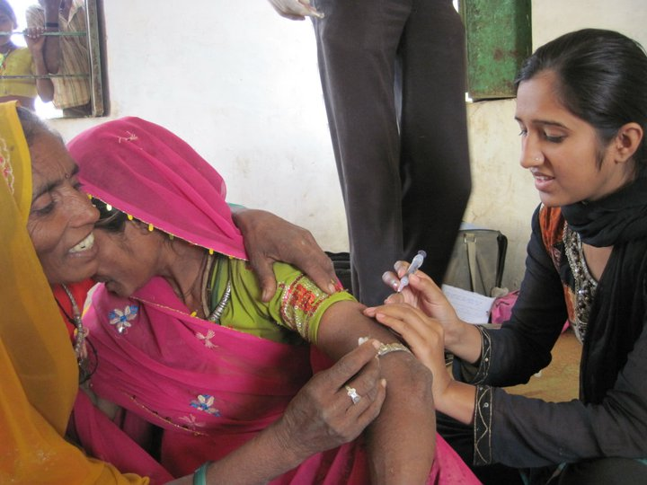
The nurse, Neelam, is giving an injection to a pregnant woman, who is being comforted by the village’s Traditional Birth Attendant (TBA).

At the end of the camp, Devrani, the Health Program Incharge of the respective block talked to all the women about general good health practices for taking care of their children, especially about good breastfeeding practices. Then the women went home and Devrani, Neelam, Govind and I pulled out our very similar looking lunches in tiffin containers, and shared each others vegetables with the chappatis we had each brought from home. Devrani also brought awesome roasted peanuts. Before saying goodbye, Devrani took a picture of the TBA, Neelam and Govind in front of camp sign in order to record their attendance. As we drove back over the bumpy roads back to the city, I reflected that for the first time in my life, I had really seen public health in action.

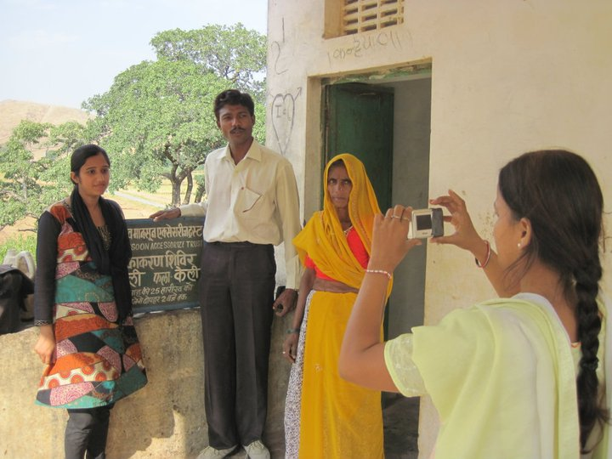
Photo to record attendance

-------------------------------------------------------------------------------
Two stories from the field –
Reaching to the remotest – Bedadhar village
Bedadhar is one of the remotest villages in our work area where the health service providers reach very rarely. Many women like Mangi, remained deprived of the ante natal care during pregnancy due to the unavailability of health services within closer proximity. The Immunization Camp initiated in late 2008 has been a boon for these women bringing maternal health care specially ante-natal care within their easy reach
Mangi Bai, resident of village Beradhar had suffered severe tetanus seizures during her first pregnancy and therefore had to be rushed to primary health centre, where she survived a near fatal loss due to unavailability and negligence towards pre-natal precautions. She had not received tetanus toxoid shot during her first pregnancy and therefore suffered.
During her second pregnancy she came to know about Seva Mandir’s Immunization Camp and visited the camp for ante-natal check up twice during her pregnancy. This time she got two tetanus shots on time due to which she had successfully escaped complications during her second delivery.

Deu’s Story
Deu wife of Pema is 24 years old and lives in the village Amba Ka Vela. This village fares low in terms of health facilities for its residents and thus Seva Mandir started the immunization camp in April 2007 which caters to the pregnant women and the children. Deu came to the immunization camp during her second pregnancy for ante natal check up. The blood test done during the ante natal check up revealed that her heamoglobin level was very low. The nurse at the immunization camp advised her to consult a doctor immediately as otherwise it would prove to be dangerous for her as well as the child. However, she did not give importance to the advice and never went to the doctor. She came to the camp in next month for the second round of antenatal check ups and the nurse again counseled her to consult a doctor. This time the nurse also spoke to her family member for taking her to the nearest public health center at Kurabar. Her family members then took her to the health center at Kurabar from where she was further referred to the district hospital in Udaipur. Deu was given blood transfusion at the district hospital. Deu gave a pre-matured birth in seventh month of her pregnancy. It was a still birth, but the doctors were able to save her life. She had become very weak after the delivery but has gradually regained her strength. The immunization team’s timely advice and appropriate counseling saved her life and this experience has also proved to be a learning experience for Deu for her future pregnancy.

.

