Annual Report 2010-11

Submitted to

Global Giving

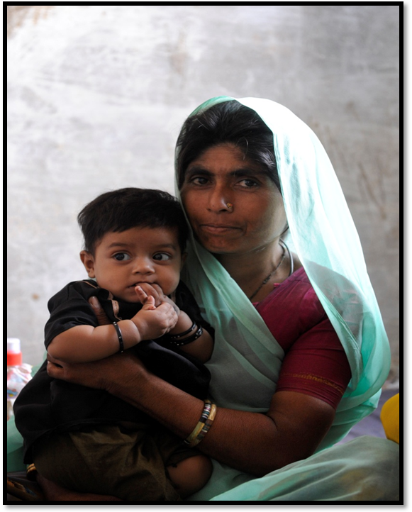

SEVA MANDIR

Udaipur Rajasthan, India

info@sevamandir.org

www.sevamandir.org
Introduction

Improving the Immunization Status in Rural and Tribal Areas of Udaipur District

Seva Mandir’s project on Improving the Immunization Status in Rural and Tribal Areas of Udaipur District aims to improve the immunization status of children and pregnant women in those remote areas which are not covered by the government health service providers. Camps are conducted on a fixed date and at fixed place by mobile immunization teams. These teams are monitored using date and time stamped photographs.
To encourage demand for immunization in the community incentives are given in the form of lentils (1 kilogram) for every shot a child receives and a set of utensil after complete immunization. Services provided in these camps include immunization of children, antenatal checkups and vaccines for pregnant women, and treatment for childhood illnesses.

a) Regularity of Immunization Camps
Immunization camps are currently being run in 68 locations. During the reporting period, 790 camps were conducted against the target of 816 camps, which means 96.8% of camps were held against 95% in research period and 97% in previous year.
A total of 26 camps had to be cancelled due to various reasons such as festivals, monsoon, unavailability of ANMs and some local conflicts. One of the major reasons for the lesser number of camps held in the reporting year as compared to the camps held in the previous year was unavailability of nurses. During the reporting period, three nurses left and it took a lot of time to find appropriate replacements as most of the nurses got absorbed in government services.

b) Immunization of Children
During the period 2010-2011 1,236 children were registered in the camps. The details of each shots of vaccine received by the children are as follows:

Number of children received BCG shots | 914
Number of children received DPT / OPV (1st dose) | 970
Number of children received DPT / OPV (2nd dose) | 862
Number of children received DPT / OPV (3rd dose) | 807
Number of children received Measles vaccine | 776

Antenatal Care of Pregnant Women
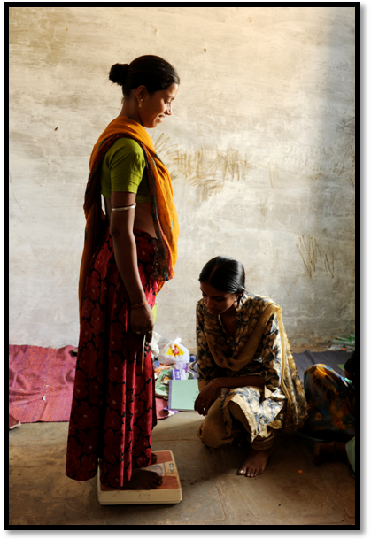

Antenatal Check up at Immunization Camp
Camps also provide antenatal check ups and immunization for expectant mothers. During the reporting period, the camps reached out to a total of 1,449 women. The antenatal checkups include a hemoglobin test, a urine test for checking risk factors such as eclampsia, a blood pressure and weight check, and a routine physical examination. The women were counseled on care they should take during pregnancy. A total of 1,387 women received first dose of tetanus toxoid and 1,123 women received complete dose of tetanus toxoid.

d) Improving the Camps
During the reporting period, efforts were made for improving the qualitative aspects of immunization camps and updating the MIS (monitoring information system). Arrangements were made to improve and ensure the cold chain maintenance of the vaccines. It includes fixing thermometers – to check the temperature of the refrigerators used for storing the vaccines; developing a system for maintaining temperature records; orienting teams about the correct procedure for storing vaccines in refrigerators; and providing immunization teams with canvas bags for transporting the vaccines, to avoid the melting of icepacks.
Under the MIS system, we also introduced separate rosters for recording antenatal checkups and for recording the services provided to ill children. We streamlined the previous formats that had been used for reporting to Block and Head Offices. In consultation with the Computer Unit, we added the antenatal and child illness records to our existing immunization database. We will now be able to generate data on the number of women receiving complete antenatal care at the camps.

e) Future Plans

In the coming year, in addition to continue with the current activities efforts will also be made to ensure that camps are run efficiently and regularly. Also, new camps will be initiated in the next year based on the demand from the villages (remotely located and where there is a lack of basic health facilities in their vicinity). Therefore, a new team has been appointed in each block which will cover the new camps proposed by the villages.
Last year, a baseline survey was conducted to assess the immunization status of all the children aged 1-5 years in all Balwadis (pre-school cum daycare centres supported by Seva Mandir) in all the 5 blocks. The results revealed very low complete immunization rates (19%). Given the criticality of immunization to children’s health, it was felt that concentrated efforts are required to ensure complete immunization of children attending Balwadis. Therefore, Seva Mandir has begun from June 2011 immunization for children at 196 Balwadis.

Stories of Immunization Camps from the field
Story 1

Seva Mandir has been conducting immunization camps in Undithal village on the 14th of every month, which are attended by many women and children. Undithal also has a Traditional Birth Attendant (TBA) and a Balsakhi (children’s pal) who create awareness about immunization and motivate women to come to the camps. The Balsakhi came into contact with a two month old child, Mangi Lal, who was extremely malnourished and weighed only 1.5kgs. The Balsakhi counseled Mangi Lal’s mother about exclusive breastfeeding and the need for immunization. The mother was not aware of the immunization camp. She also hesitated to go. After much persuasion the mother agreed to take her child at the camp. The immunization team spoke to the mother and explained in detail about the importance of each shot and the deadly diseases that it saves the child from. The mother was very happy to learn about these shots and agreed to get her child immunized.

Story 2

Vanki Devi is 22 years old and lives in Bedadhar, a very remote village. It is difficult for the inhabitants to access healthcare facilities as often there is no transportation available. During her first pregnancy, Vanki and her family were unaware about immunization for expecting mothers. Therefore, she never received any tetanus shots.
At the time of her delivery Vanki had a seizure attack and there was swelling in her whole body. She was taken to the nearest private hospital in Gujarat (Kher) where a caesarean section was performed. The family incurred a total cost of Rs.12,000/- (USD 267) for the entire treatment.
During her second delivery Vanki came in contact with the village TBA, who counseled her about immunization and accompanied her to the Seva Mandir Camp on the 25th. Vanki received complete ante natal care and tetanus shots. As a result, she delivered a baby without any complications.

