Shiksha Kendras - Half Yearly Report

April 2011 to September 2011

Submitted to

Global Giving

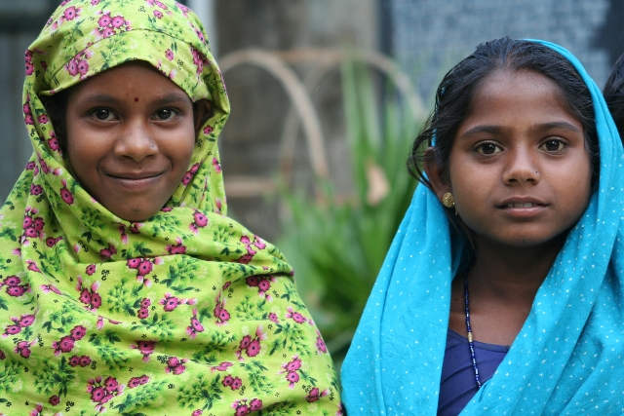
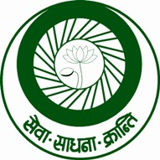

SEVA MANDIR

Udaipur Rajasthan, India

info@sevamandir.org

www.sevamandir.org

Introduction

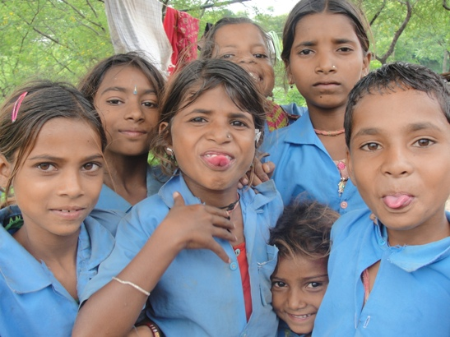
Seva Mandir works with village communities to establish Shiksha Kendras (SKs formerly also known as Non Formal Education Centre/NFEs) in remote villages with the aim of providing access to education to out-of-school children between the ages of 6 to 14 years. The SK is run for six hours every day and two subjects covered are math and language (Hindi). There is also a considerable emphasis on teaching environment to these kids. Efforts are made to connect their leanings with their own experience of natural environ. It takes a child 3-5 years to graduate from the SKs with the level equivalent to class 3. However in most cases the children after graduating from a SK are admitted to class 6 in government schools. The ability acquired at these SKs help children to sail further in their studies at the Government Schools.

The Instructors:

The village community selects the instructors who are from within the villages. With constant investments and trainings programs, Seva Mandir has created a cadre of instructors who use interactive, child centric pedagogy and help promoting community participation in children’s education at the village level. An annual training is conducted for all the SK instructors. It focuses on enhancing teachers' capacity for classroom interaction. During the training the same pedagogy is used that a teacher uses at the SK. These trainings also offer a platform of mutual interaction and learning for the instructors. Most teachers at SKs are not academically trained to teach and their respective qualifications also vary. Thus, there is a need for improving their competence so that they can become independent instructors. In addition to trainings the Certification Course is also conducted. It provides the teachers with required guidance and discipline for a continuing source of learning. Vidya Bhavan Society (an Udaipur based charity has an extensive experience in the field of education) helps us conduct this course. It is a unique course in the country.

The Curriculum and Learning Environment:

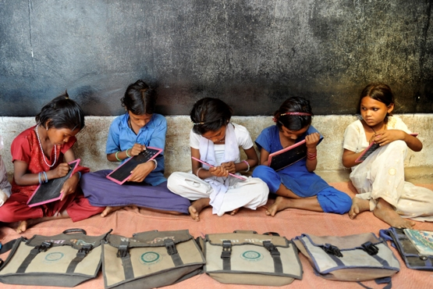
One of the key underlying principles of Seva Mandir's SKs is that all children are uniquely endowed and therefore their pace of education has to be facilitated accordingly. Therefore, the teachers are trained to allow each child to learn as per his/her own pace and in their own ways. There is no strict curriculum followed at the SKs. This is done so as to enable the child and the teacher to have their pace of learning and engaging. However, there are a set of guidelines on how to teach and to what learning abilities a teacher can strive to teach.

The use of interesting learning material, emphasis on helping children to think, interact, question and form concepts on their own as well as creating a joyful and stimulating learning environment for children are some key features of a Shiksha Kendra. The assessments of these children’s performance have been indicating an increased retention in schools and an improved learning ability.

The Community Participation:

The other important dimension of these SKs is strengthening community ownership and their contribution to education. The communities monitor the regular functioning and performance of teachers and schools. Every student pays a token fee of Rs. 100 every year, which is deposited in the village’s common fund (Village Development Fund). The village community together with the instructor decides to utilize the collected fee for meeting the immediate demands of children attending the SK, for example – buying uniforms or lunch boxes or flip flops for children. If required the communities pay for the additional cost for obtaining these items. Some village communities have taken up the responsibility of paying for the teacher at SK from the interest earned on their Village Development Fund. The village communities have gradually been including the issues concerning their children and education in their meetings. This has happened due to the fact that these SKs also serve as platforms of engaging communities for social change and deliberation on issues in education and children.

Evaluation and Assessment of SKs:

There are three ways of assessing the SKs –
a) Through regular monitoring and classroom observation;
b) Through bi-annual evaluation of children at the SKs and
c) Camera Monitoring.

The education program staff and field staff (Block and Zone level) make regular visits to SKs. They are required to fill out a monitoring-form available at the SK to capture specific measures such as the participation of children, use of learning material, black board and the books, the level of interaction between the teacher, children and parents, classroom activities etc. The data collected is helpful in improving the program.

Every year two evaluations (half yearly and yearly) are conducted at the SKs. The standard test papers help us track the learning abilities of children. Please find more details on this in following pages in section Annual Evaluation 2011.

At each SK there is a date and time tamper proof camera. The instructor is required to take two pictures at the beginning and at the end of school every day. The pictures should have the instructor, the location of school and the children present that day. The payments to the teachers are done on the basis of number of days he/she opened the SK. The camera monitoring is helpful in ensuring the teacher’s regularity at the centre. Seva Mandir was awarded ICT Digital Learning Award in 2006 for its innovation and the use of technology in its SK program.

The trainings and regular meetings with the instructors is an additional tool for us to monitor their performance and aptitude for teaching.

Current Status of SKs

Currently 178 SKs are reaching out to 5,749 children, 43% of which are girls, in the five rural blocks in which Seva Mandir works.

Table 1: Block wise details - the number of SKs, teachers and enrollment of teachers

Block | No. of Rural Schools/ SKs |  |  | Enrollment of children
Block | March 2011 | September 2011 | Teachers | June 2011
 |  |  |  | Boys | Girls | Total
Kotra | 54 | 55 | 66 | 1,312 | 680 | 1,992
Jhadol | 46 | 43 | 47 | 749 | 609 | 1,358
Kherwada | 41 | 36 | 38 | 528 | 499 | 1,027
Girwa | 26 | 23 | 27 | 436 | 398 | 834
Badgaon | 21 | 21 | 22 | 272 | 266 | 538
Total | 188 | 178 | 200 | 3,297 | 2,452 | 5,749

During the 2010-2011 year 1,879 new children (44% of girls) were enrolled in these SKs. Most of these new enrollments were in Kotra Block (one of the remotest blocks of Seva Mandir).

Table 2: Block wise details- new enrollment in 2010-2011

Block | No. of Children
Block | Girls | Boys | Total
Kotra | 215 | 399 | 614
Jhadol | 210 | 203 | 413
Kherwada | 187 | 203 | 390
Girwa | 136 | 151 | 287
Badgaon | 96 | 79 | 175
Total | 844 | 1,035 | 1,879

Annual Evaluation – 2011

To measure the performance of children standardized tests are conducted twice a year. During the reporting period a yearly evaluation was conducted in March - April 2011. In the annual examination a total of 3,548 students, appeared in the exams. Their level wise distribution is given below:

Table 3: Students’ learning levels (annual exam –March – April 2011 scores)

Block | Level 0 | Level 1 | Level 2 | Level 3 | Total
Kotra | 54 | 887 | 302 | 253 | 1,496
Jhadol | 13 | 195 | 74 | 46 | 328
Kherwara | 14 | 342 | 138 | 174 | 668
Girwa | 29 | 396 | 95 | 156 | 676
Badgaon | 9 | 229 | 67 | 55 | 360
Total* | 119 (3%) | 2,049 (58%) | 676 (19%) | 684 (19%) | 3,548

* Percentages listed are of total students.

This year 19% of students scored level 3, 19% of students scored level 2, 57% of students scored level 1 and 3% of students scored level 0.

Mainstreaming

Once the students of the SKs have the initial foundation of reading, writing and mathematical abilities, they are encouraged to enroll in government schools (roughly the equivalent of class 3, however like the SK model defines, and the individual level of each child are determined by the instructor).
This year in July – August 2011, a total of 1,178 children (approximately 20% ) from five blocks got enrolled in government schools. Generally students are either admitted in class 4 or 5, but some children were admitted to class 6 after graduating from the SKs. In the last 6 months 1,178 students from SKs were enrolled in government schools.

Table 4: Number of children by gender and block admitted into government schools

Block | Boys | Girls | Total
Kotra | 218 | 87 | 305
Jhadol | 207 | 135 | 342
Kherwada | 149 | 118 | 267
Girwa | 78 | 62 | 140
Badgaon | 91 | 33 | 124
Total | 743 | 435 | 1,178

Community Participation

Strengthening community contribution and ownership of education is another key dimension of Seva Mandir’s work. Democratically elected village committees have the responsibility of monitoring and evaluating the centers and the work of the instructor and paying the instructor’s monthly stipend. In fact, some committees have taken up the responsibility of paying the stipend of the instructor from interest earned on their own village development fund.

Parents are also invited to participate in two-monthly parents' meetings where they can interact with instructor and learn about what happens in the centers. Every student pays a token fee (Shiksha Shulks, waived for children from families with economic constraints), which are deposited in a village development fund. The village community together with the instructor and children decide how to spend the fee. Usually they buy things of utility such as lunch boxes, flip-flops, uniforms etc. For this the village provides the funds for the shortfall. Through these mechanisms, the SK centers contribute to overall community development.

It is significant to note that over the years these communities have now begun to include issues of education in their discussions. The involvement of parents and community around the dialogues on education communities are gradually acquiring greater awareness about quality education and coming forward in claiming demands concerning the standards in government schools.

Certification Course

The certification course has been offered to the instructors of SK’s since 2003. This year the course has completed. When the course started this year a total of 228 instructors (104 in Level 1, 65 in Level 2, 59 in Level 3) were enrolled with 3 levels depending on their experience and abilities. During the course, 39 instructors dropped out for various reasons. Out of the 189, 167 instructors appeared in the final evaluations and 63% instructors completed the certification course.

Table 6: Level 1 certificate course results by block as of end of course in March 2011.

Block | Enrolled | Left | Absent | Pass | Fail
Kotra | 37 | 6 | 8 | 8 | 15
Jhadol | 17 | 1 | 2 | 8 | 6
Kherwada | 16 | 5 | - | 10 | 1
Girwa | 19 | 1 | 4 | 12 | 2
Badgaon | 15 | 5 | 2 | 5 | 3
Total | 104 | 18 | 16 | 43 | 27

Table 7: Level 2 certificate course results by block as of end of course in March 2011.

Block | Enrolled | Left | Absent | Pass | Fail
Kotra | 19 | 5 | - | 8 | 6
Jhadol | 20 | 1 | - | 10 | 9
Kherwada | 12 | 2 | - | 9 | 1
Girwa | 6 | 2 | 1 | - | 3
Badgaon | 8 | 3 | 1 | 2 | 2
Total | 65 | 13 | 2 | 29 | 21

Capacity building of teachers

Since most SK instructors have schooling till 8th or 9th standard, various trainings were conducted regularly to build their capacities. It is a significant way to engage with the instructors as it allows the instructors to learn new things and endorse their motivation.

Instructor Meetings

After the Completion of the Certificate course in March 2011 it was decided to hold at least one instructor meeting every quarter. The aim of these meetings is to track the progress made by the SKs, children and the instructors. It was also useful to identity and address problems faced by the instructors.

The challenges faced by instructors are concerned mostly of classroom interactions. The solutions were sought through peer group discussions on involving the parents in PTMs (parent teacher monthly meetings) and the timely collection of Shiksha Shulk (fee). The instructors were asked to engage parents to orient them about the significance of parent-teacher meetings and monitoring their children’s performances.

Parent Teacher Meeting

In an effort to further deepen relationship between the SKs and the parents, Parent-Teacher Meetings were organized in all the SKs once per quarter. The meetings enabled the parents to get acquainted with the progress of their children. It also allowed the parents to interact with the instructors. During the reporting period, on an average two PTMs were held at all the SKs across 4 blocks except Kherwada. In Kherwada on an average only one meeting was held.
In these meetings several issues were discussed and resolved. These issues include Shiksha Shulk, enrollment/ attendance of children, cleanliness of children, teaching patterns, parent’s role etc.

Pravesh Utsav: Enrollment Festival

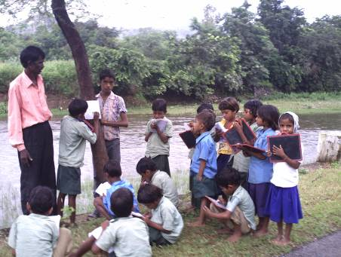
Pravesh Utsav (Enrollment Drive) is a traditional way of celebrating and encouraging the enrollment of out-of-school children. The Pravesh Utsav was celebrated at all the centers in Kotra, Badgaon and Jhadol block. Students of the SKs organized rallies in their hamlets encouraging out of school children to join schools. The new students were welcomed with jaggery, tilak and the tying of laccha (a traditional wrist band). In some places students of the SKs celebrated the Pravesh Utsav together with the government schools. In Jhadol block along with the enrollment festival, a farewell ceremony of children graduating from the SKs was also organized. The villagers, parents, teachers and fellow students blessed the children for a bright and progressive future.

Independence Day (15th August)

Each year, Independence Day is celebrated in most of the centers by hoisting the national flag and hosting of a cultural programme. In most places, the village committee and other residents of the villages participate in the celebration. Celebrating national festivals in the SKs provides children an opportunity to interact with others. Also, children participate in many cultural activities which instill encouragement, enhance their social development and allow them to showcase their talents.

English Language Teaching

Based on the learning from the pilot of introducing English language teaching and the feedback received from the instructors the English language teaching has been up scaled in the SKs in all the blocks. Several trainings have been organized. These trainings focused on including various activities such as rhymes with hand movements (to help retain the meaning of the words), day to day commands, and the verbs. Instructors are also given with the written material and worksheets to practice in order to keep them in touch with the language until the next training takes place. The flash cards for English words are designed to be distributed during the instructor meetings.

In Girwa block along with the English teaching, teaching Environmental Science has also been introduced. We have received a positive feedback from the students and the teacher for introducing English and Environmental Science at the SKs. During the second phase of the initiative, the Environment Science will be up scaled to all the blocks.

Camera Monitoring

Seva Mandir started an action research in August 2003 to address the issues of absenteeism across the SKs. It was done using a tamper proof camera, through which an instructor is required to take two photographs at the beginning and the end of the school day. The instructors either receives an incentive payments for opening the centre for more than the minimum number of days (valid days) in a month or receives a disincentive payment for opening the centre for less the minimum number of days in a month. A valid day is defined as a day where the opening and closing pictures are separated by at least five hours and where the number of children in both the pictures is at least eight. The research done in a randomized treatment control design showed a significant reduction in absenteeism across the treatment centers and also an improvement in children’s learning levels.

The digital camera monitoring programme in all SKs was up scaled in January 2010. This year the instructors are more comfortable in handling and managing the cameras, pictures and associated time lines. These cameras have helped to a great extent in checking instructor’s absenteeism and also helped in improving the monitoring mechanism of SKs and closing those centers where instructors were often irregular resulting in poor performance of center. Currently all the 178 SKs are camera equipped.

To identify the progress of a child we have categorized four levels of their learning from 0 to 4. The levels are roughly equivalent to government classes. Level 0 is when a child enters the NFE and can barely read or write. Level 1 is where she can read and write small words and does simple counting and can identify some numbers. When a learner can start reading, and understanding simple sentences and writing small / incomplete sentences, in Mathematics can do basic counting and simple operations like addition and subtraction with small numbers, she is placed in Level 2. At level 3 a learner can read and understand simple texts and articulate themselves by writing a group of sentences and in Mathematics understands concepts of multiplication, division, etc.

