Sarathi Model: Girls Resource Centre

Enhancing Space and Building Future of Adolescent Girls

- About Organization
Sarathi Development Foundation is a professionally
Outreach and Impact

- 90000 girls in age group of 10-19 years are impacted through girls resource centers , adolescent girls groups, Integrated village/slum planning, capacity building processes, and convergence with government service providers .
- 1080 children including adolescent girls are capacitated on participation, communication and documentation skills on advocacy using media platforms and resources.
- 300000 families are reached and impacted on education, health, nutrition, education, water & sanitation and hygiene.
- 8000 volunteers, 600 women self help groups, 600 mothers groups, 1500 adolescent girls groups are developed and
- Provided training and field support to more than 70,000 to service providers.
- 1200 villages and slums have been facilitated to formulate, implement and monitor their own action plans based on children, adolescent girls, women needs in particular and community as whole in general.

- action plans clearly

managed social organization working with a vision towards empowerment of people especially children, adolescents and women belonging to socially and economically marginalised communities. It believes in their potential to identify their issues, devise mechanisms and prepare road map for the impact they wish to achieve. Our community based models tell us that they themselves catalyze impact and inspires others for the same and when equipped with knowledge, skills, opportunities and enabling environment. Our main strategies are community based programming, adolescent girl’s resource centres, social change catalysts, community groups & forums, capacity building and mainstreaming with public service delivery systems. Our team of more than 300 full time persons including community facilitators, coordinators, trainers, researchers and managers facilitates planning, implementation, monitoring and evaluation of programmes in Uttar Pradesh, Haryana and Madhya Pradesh states in India.

2.0 Project Summary
Project addresses vulnerabilities of adolescent girls, are living with in social, cultural and economic settings in slum areas. Their conditioning in given environment, social behaviours, imposed constraints, gender inequality, early marriages, poverty, lack of opportunities such as participation, decision making, expression affect them severely. 50% girls become brides before attaining legal age of 18 years affecting their life pattern and often ending their education. The project focuses on empowerment of 5000 adolescent girls in age group of 10- 19 years through 10 Girls Resource Centres covering 100 slums of Lucknow district in Uttar Pradesh state of India. They are most disadvantaged girls in terms of school dropouts, poverty and deprivations in various forms such as basic services & facilities. It will provide learning platforms, self awareness and actualization abilities, education, reproductive and sexual health knowledge, healthy behavioural practices, life skills and enterprise education using participatory learning approach and curriculum developed for adolescent girls living in slums. These trained girls will act as social change agents at community level to change the mindsets, behaviours and environment affecting their life, choices and future. Girls Resource Centre has been evolved as a part of our model strategies under the Saloni Model (An Integrated Adolescent Girls Project) in social, cultural and economic settings in 400 slums of Lucknow. Thus proposed project carries proven processes and results is a part of initiatives to contribute in enhancing space and building future of adolescent girls in slums.

3.0 Adolescent Girls Vulnerabilities
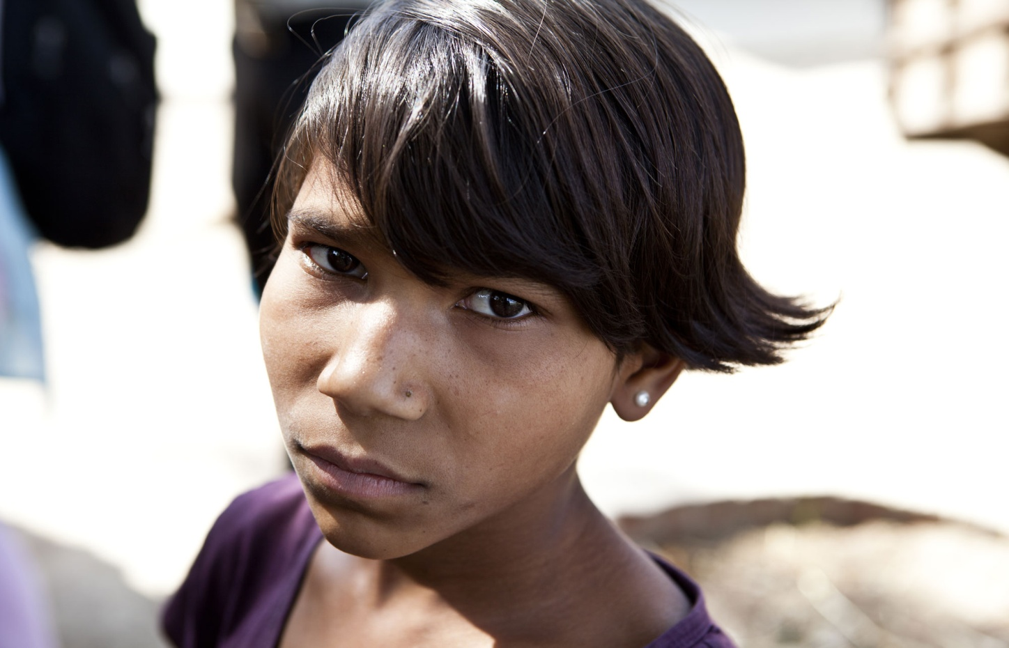
Status of adolescent girls, representing more than 10% of the total population, is an area of concern particularly in slums across the India. They are severely affected by gender discrimination, early marriage, social behaviours, poverty and inadequate opportunities. 50% girls become brides before attaining legal age of 18 years. It affects their life pattern often ending their education and placing a burden on them to start a family at this formative stage of life. 55.8% of the adolescent girls in the age group of 15-19 are anaemic compared to 30% adolescent boys in the same group.72% girls married before age of marriage received no education. 14% are pregnant during adolescence and up to 70% of these pregnant girls suffer complications during pregnancy or delivery, including death during delivery. This situation guides us to work for adolescent girls with an inclusive approach to engage girls, their families, community, government, entrepreneurs, credit institutions and development agencies in order to create holistic and sustainable impact on indicators related to them.

Problems | Solutions
- 50 % of girls become brides before their age of 18 years at their formative stage.  - Gender inequality affects their life pattern leading to burdens and poor quality of life.  - 55 % girls are anemic affecting their growth and development.  - 88% are not using safe menstrual hygiene management practices.  - 23% of girls drop out of school due lack of adequate knowledge about menstrual hygiene management.  - 72% girls married before age of marriage received no education.  - 14% are pregnant during adolescence.  - 70% of these pregnant girls suffer complications during pregnancy or delivery, including death during delivery. | - Identifying issues and providing information, counseling and support to address them.  - Engaging girls, parents, community members and service providers in building right perspective about girls.  - Equipping adolescent girls with appropriate knowledge, skills, abilities, attitude and behaviors.  - Providing knowledge and supporting girls to access government services and schemes related to them.,  - Building confidence among adolescent girls for participation, expression and communication.  - Prepares adolescent girls for actions and self advocacy on the issues related to them, their families and community.  - Facilitates access to basic services such as health, education, nutrition and hygiene.  - Provides a platform for identifying their needs and devising mechanisms to address them.  - Build environment positive behaviors towards girls at family, community and service providers’ levels.  - Developing peer education systems” Girl to Girl” on behavioral and other issues such as education, nutrition, uptake of services early marriage.
4.0 Project Strategy
Ten Girls Resource Centres will be set up and managed by with active participation of adolescent girls, parents and community members in the given social, cultural and economic settings in 100 slums. The centre will be operational for 8 hours to equip the girls with knowledge, skills, self awareness, abilities and opportunities essentially required to address their issues affecting them and build a better future for them. Each of the ten centres will have one counsellor to provide information, counselling, support to adolescent girls to identify and address their issues.

Counsellors will conduct two four hour sessions in morning and evening covering 25-30 girls in each session. The most vulnerable girls in the community, typically those who have dropped out or have never attended school, will attend the CRC sessions. Counsellors will use innovative tools like thematic songs, flash cards, special games and pocket charts to deliver content on healthcare, sexual and reproductive health, sanitation, life skills, confidence building and livelihood development amongst them. Thematic specialists, media resource persons, entrepreneurs and service providers will also participate and facilitate sessions to enrich learning processes among adolescent girls.

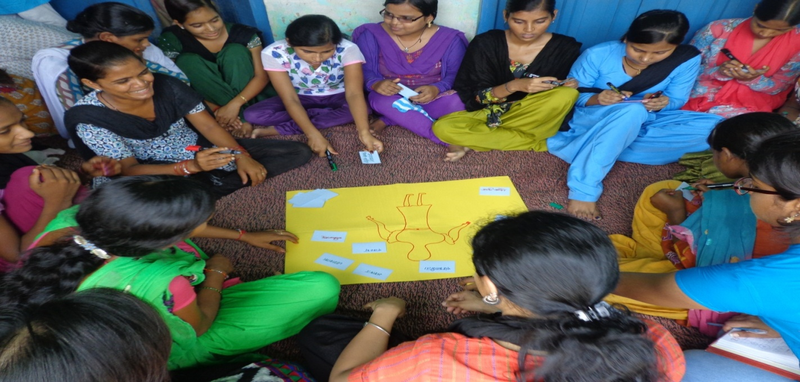

5.0 Outreach and Impact
Project will focus on overall empowerment of adolescent girls living with deprivations and constraints in terms of opportunities, basic services, poverty, education, rights, environment, early marriage and violence. It will benefit 5000 adolescent girls, their families and communities. The following indicators will be adopted to measure the impact on adolescent girls covered under the project.
- Adolescent girls are equipped with abilities and skills required for effective participation, expression and communication.
- Adolescent Girls and their parents are well informed about the services such as health, nutrition, education, hygiene, water, sanitation, skill development, banking available.
- Adolescent girls are well aware of communication tools, forums and platforms for self and collective advocacy on their issues and concerns.
- Adolescent girls have accurate knowledge about hygienic practices such as menstrual hygiene management, hand wash at critical timings.
- Positive attitudes and behaviours towards girls education, mobility, equal opportunities and delaying the age of marriage.
- Adolescent girls are aware of basic reproductive and sexual healthcare practices.
- Adolescent girls are married after the legal age of 18 years and completing their education.
- Adolescent girls have knowledge on family budget preparation and basic financial management.

6.0 Funding Support
Funding support of USD 20,000 will enable us to bring change among 5000 most disadvantaged girl living in 100 slums. Per girl cost is USD 4.
Sarathi Development Foundation
Organization: Non Profit I Sector: Health, Education, Nutrition, Water & Sanitation, Livelihood
Head Office: 3/382, Vishwas Khand Gomti Nagar, Lucknow-226010, Uttar Pradesh, INDIA. Phone: 0522 2309998, 4009600, 7408441450, Email: akhilesh.tewari@rediffmail.com Web:www.sarathidevfo.org Region of Impact: Uttar Pradesh and Madhya Pradesh
Partnership: Unicef, Catholic Relief Services, Dasra, Find Your Feet, Water Aid, Family Health International, NABARD, Government I Annual Budget: Rs 400 Lac
Staff Strength: 300 (Full time staff) 127 (Community Resource Persons)

I Website: www.sarathidevfo.org

