EVERYDAY GANDHIS PROJECT REPORT OCTOBER, 2014

Ebola Awareness in October 2014

On October 10, 2014, the FGPs received the amount of five hundred USD to donate to Ebola preventive materials such as chloride, tide-soap, and fossil buckets. Several items were taken off to be shared with our neighbors who believe that the disease exists and have no means of getting it themselves, including a tea and coffee shop run by a Fulani [an ethnic group common in West Africa], where people gather to drink tea, coffee, atiyea, watch television and have conversation. During the presentation, another Fulani, a businessman, requested a bucket for his coffee and teashop too.

Moreover, on October 13, 2014, the FGPs based in Monrovia made a donation to the NYAAE Organization to empower them in their community sanitization against the Ebola Disease. We were able to donate four cartons of chloride, three cartons of tide-soap, two cartons of hand soap and twenty fossil buckets. During the presentation we asked for partnership and cooperation in dealing with issues that will save and foster peace and stability in Liberia, which include peace tournaments, workshops on topics like HIV/AIDS, conflict management, teenage pregnancy, self-esteem and permaculture. They were very excited about the partnership and every aspect possible to promote peace and stability in our communities across the county.
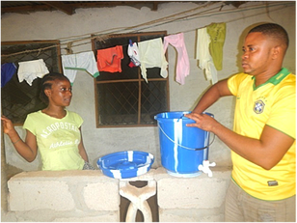
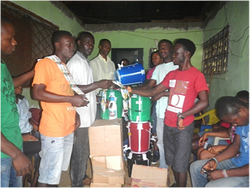

Akoi Mawolo started the presentation with a short overview of everyday gandhis work in Liberia and further said, “Let the materials be used for their intended purpose.” While we were there, I observed the need to break into groups of four, where each group may target populated places, providing them with a bucket, chloride, tide-soap and hand soap. Many thanks and appreciations were given to everyday gandhis for providing preventive materials for their community in this crucial time.

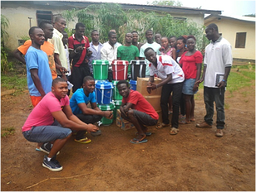
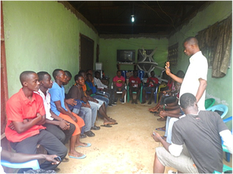

We ended with a decision to have our second workshop at the beginning of December on the above listed topics. We look forward to your support in implementing this great idea of having another workshop to empower and brighten the minds of the youth in our new community.

To conclude, the FGPs want to say many big thanks and appreciations to everyday gandhis staff and donors who are working tirelessly to see that Liberia overcomes this disaster, and not forgetting all of our trainers for helping us to discover our gifted talents that we are using to change the lives of others.

-Ezekiel Mavalo, FGP, everyday gandhis, Liberia

MONROVIA CLINIC DONATIONS, 2014
On October 17, 2014, we donated some Ebola preventative materials to four clinics plus two individuals who treat patients at home-Esther Sawo and Ma Agatha. Our first stop was at the Faith Clinic in Paynesville’s Red Light where we donated one non-contact infrared thermometer, two cartons of soap, two cartons of chloride, chlorine, one hundred pairs of examination gloves, two hundred pairs of surgical gloves, flood mapper, few hand sanitizer, two dozens of tissue, three large bottles of hand sanitizer, three bottles of antiseptic, three laboratory spectacles, and a complete set of PPE and nose masks.

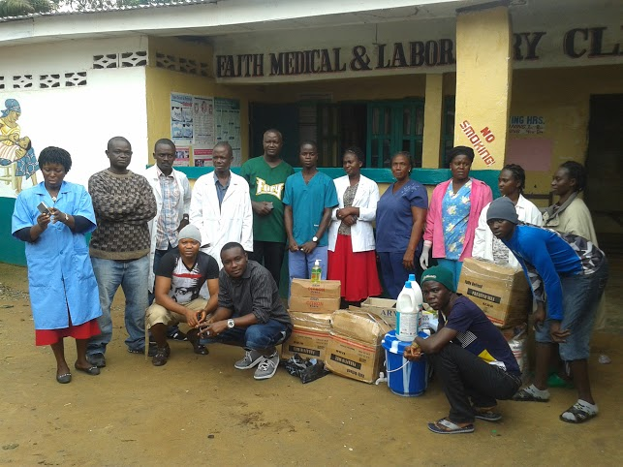

We headed on to Chickensoup Factory Community, home to about thirty thousand inhabitants. We decided to supply two clinics there: the Stanko Clinic and the Robert H. Ferguson Clinic. The Stanko Clinic is a private clinic that is helping the community to treat non-Ebola patients with normal sickness and delivery. At the Stanko Clinic we donated the following materials: three cartons of chloride, one floor mapper, two non-conta ct infrared thermometers, two cartons of top-soap, three large bottles of antiseptic, hand sanitizer, dozens of tissue, fossil buckets, one hundred and fifty pairs of surgical gloves, one hundred pairs of examination gloves, three complete set of PPE, three delivery boots and three laboratory spectacles.

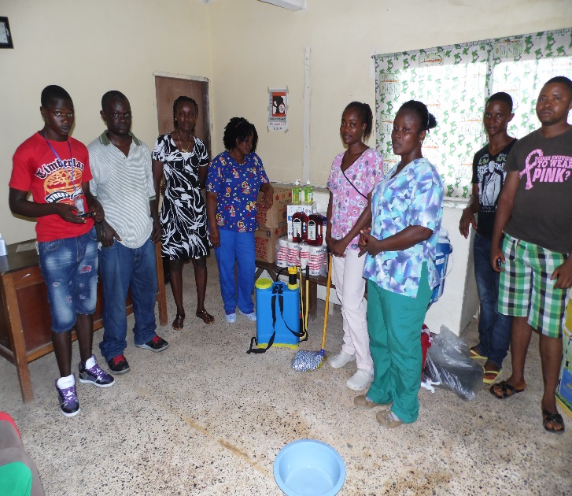
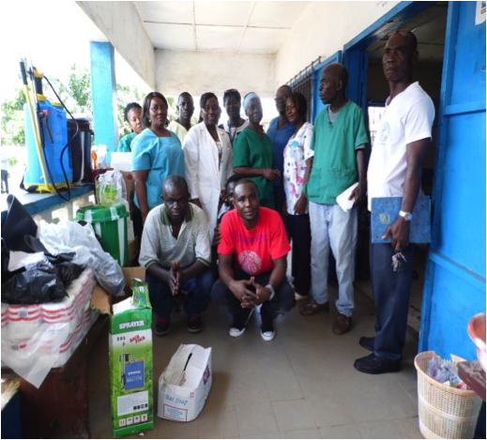

On our way back from Stanko, we made a stop at a government-run clinic called Robert H. Ferguson. The health workers at this clinic were happy and excited to receive us, and were dancing and singing praises to God and to everyday gandhis for donating such Ebola preventive materials. The spokeswoman told us that we were the first NGO to donate to their clinic, even though some NGO had been there for an assessment, but never returned. They were most happy about the thermometers and the chloride because the thermometer from the government was damaged and the last chloride bottle was finished the day we arrived. However, we donated the following items: three cartons of chloride, one hundred and fifty pairs of surgical gloves, a hundred pairs of examination gloves, two cartons of soap, two pairs of delivery boots, three large bottles of hand sanitizer, three large bottles of antiseptic, two fossil buckets, two dozens of tissue, two pairs of PPE, chlorine, one spraying can, one floor mapper and three laboratory spectacles.
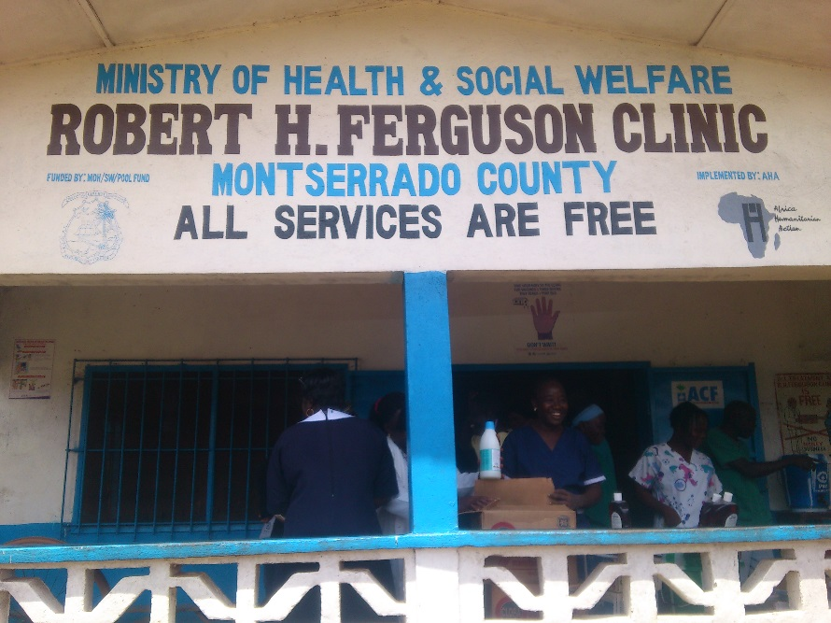

From the Chickensoup Factory Community, we headed to Chocolate City Health Center. They were very happy to receive supplies for the first time since the Ebola issue started in Liberia. They said the government is focusing more on the Ebola centers than local clinics like them, which is not good for the community as they were almost completely out of the materials we donated. The materials donated included: two hundred and fifty pair of surgical gloves, three cartons of chlorides, three cartons of soap, two cartons of tide-soap, one spraying can, four fossil buckets, five rain boots, four hand sanitizers, several dozens of tissue, one black plastic of chlorine and five Dettol bottles. The staff of Chocolate City gives many thanks and appreciations to the organization, especially to Ma C for helping Liberia in this critical time. They went as far as saying, “you and the everyday gandhis family will always be remembered for such kind help.”

We also made an individual donation to a health worker called Ma Agatha. She is a nurse at Chocolate City Health Center who also treats patients at home when they are rushed over to her place. The items included one thermometer, one carton of top-soap, seven bottles of chloride, surgical and examination gloves as well as delivery boots.
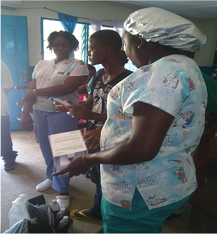
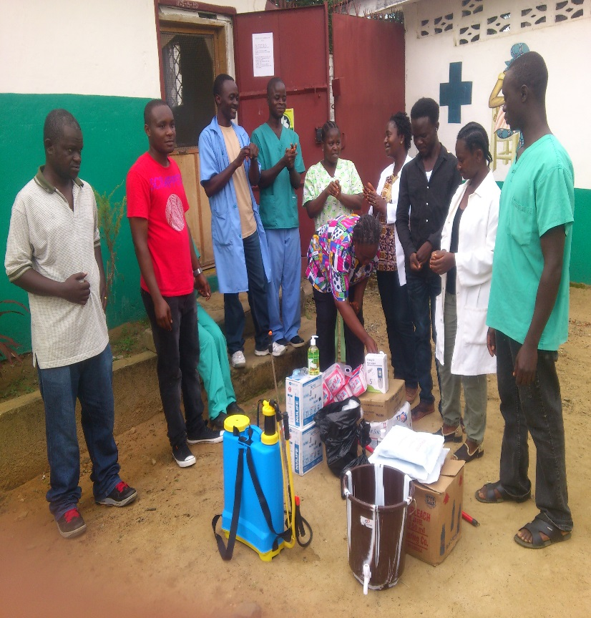

On our way back from Chocolate City, we stopped to distribute supplies to another local nurse, Ester Sawo at her community drug store. We first drove to Ma Esther to present her materials. In a short interview with her, she said at her drug store that she regularly received patients such as pregnant women for delivery and other illnesses. She also said at the time that she had refused patients due to a lack of preventive materials. Therefore, we saw the need to give her supplies including a fossil bucket, tide-soap, a hundred pairs of surgical gloves, two large bottles of hand sanitizer, a half carton of chloride, two cartons of soap, and one chlorine spraying can. Mr. Sawo and his wife gave many thanks and appreciations for remembering them in this critical situation.
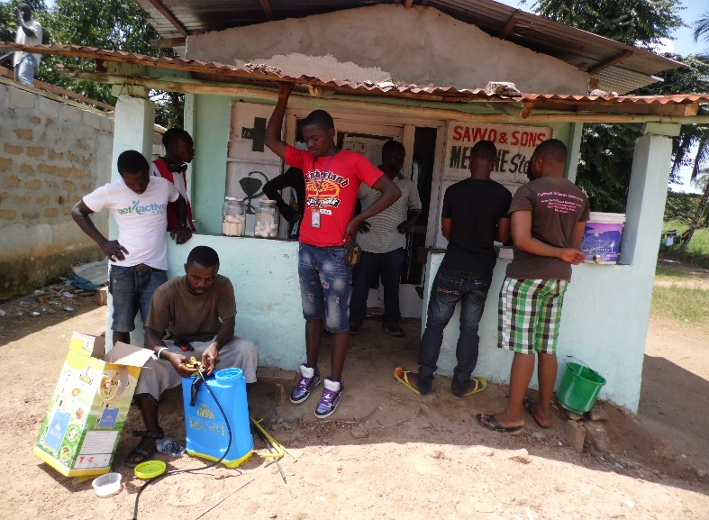

To continue our work, we distributed a few additional buckets, chloride, top-soap and spraying cans to some public toilets and other households in the community that lacked hand-washing materials.
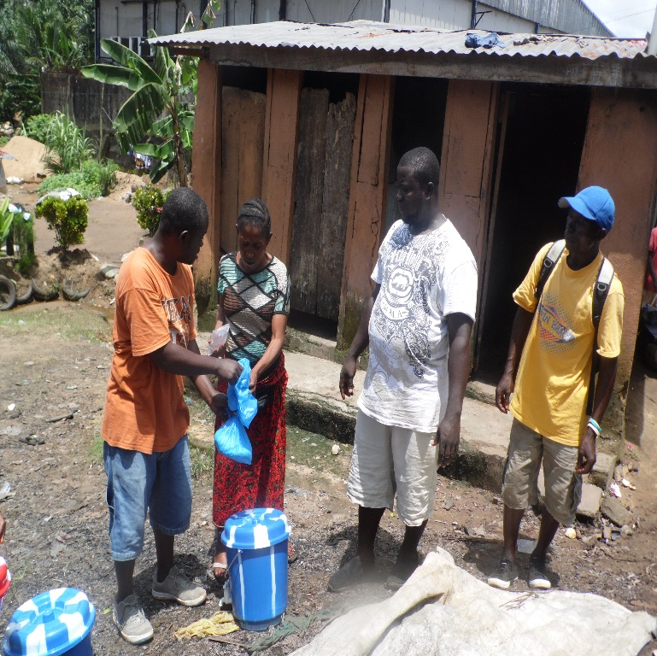
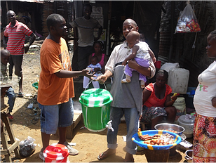

In conclusion, all of the clinics and individuals who received donated items from everyday gandhis give many big thanks and appreciations to both the Liberia team and the United States team for working diligently to support them.

-Mulbah Richards, Youth Coordinator, everyday gandhis, Liberia

VOINJAMA CLINIC DONATIONS, OCTOBER 2014

The donations of medical drugs and ICE materials were done to the below listed clinics on October 17 – 18, 2014 along with the clinical supervisor of Lofa county.

- Fassawolu Clinic, Kolahun District
- Shelloe Clinic, Foya District
- Bolahun Clinic, Kolahun District and
- David Salma Clinic, Voinjama district

The communities were excited for the donations and words of appreciation were over emphasized by the head of the various clinics who said the donation was timely.

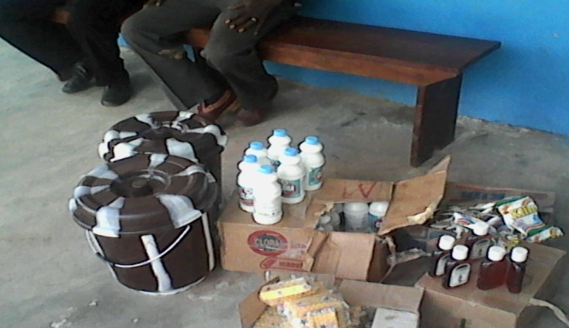
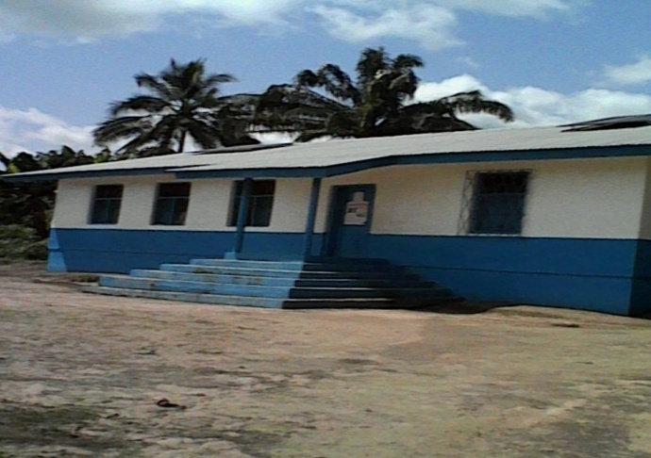
IE materials for Shelloe Clinic View of Shelloe Clinic

Shelloe Clinic ICE materials donation
No | Material | Quantity | Unite price | Amount
1 | Tire-soap | 2 cartons | 18.00 | 36.00
2 | Cholora | 1 carton | 33.00 | 33.00
3 | Delton | 1carton | 49.00 | 49.00
4 | Soap | 2 Cartons | 20.00 | 40.00
5 | Hand washing bucket | 2 | 15.00 | 30.00
6 | Hand grove | 3 boxes | 8.00 | 24.00
 | Total |  |  | 214.00

Bolahun Clinic ICE materials donation Bolahun Clinic
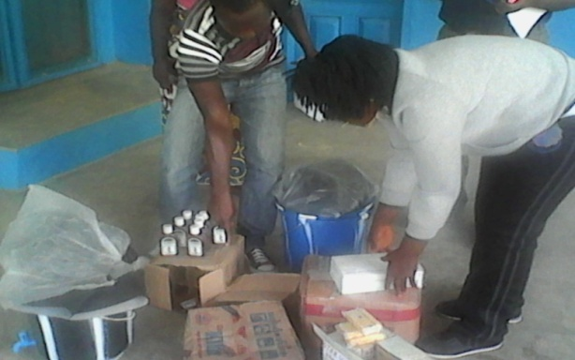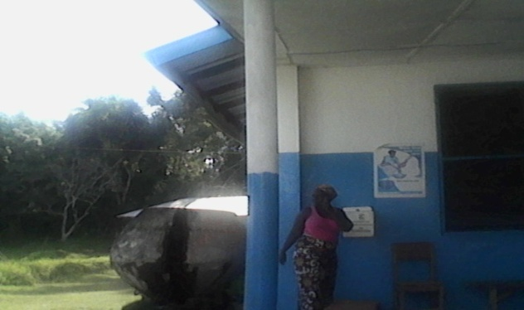

Bolahun Health Center ICE donation, Kolahun District
No | Material | Quantity | Unite price | Amount
1 | Rain boot | 3 | 15.00 | 45.00
2 | Hand washing bucket | 2 | 15.00 | 30.00
3 | Hand grove | 2 cartons | 8.00 | 16.00
4 | Cholora | 2 cartons | 33.00 | 66.00
5 | Delton | 2 cartons | 49.00 | 98.00
6 | Soap | 2 cartons | 20.00 | 40.00
 | Total |  |  | 295.00

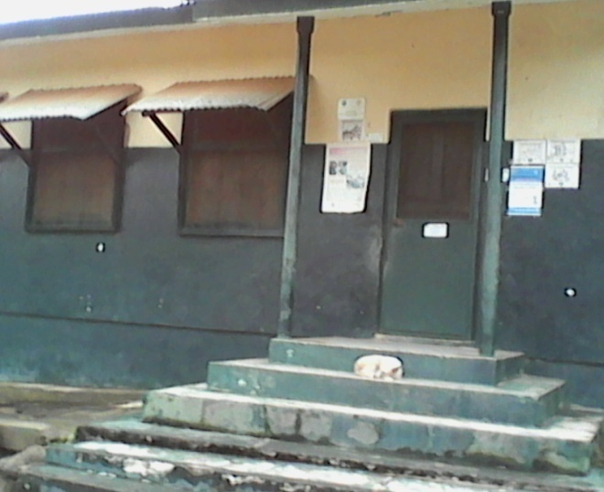
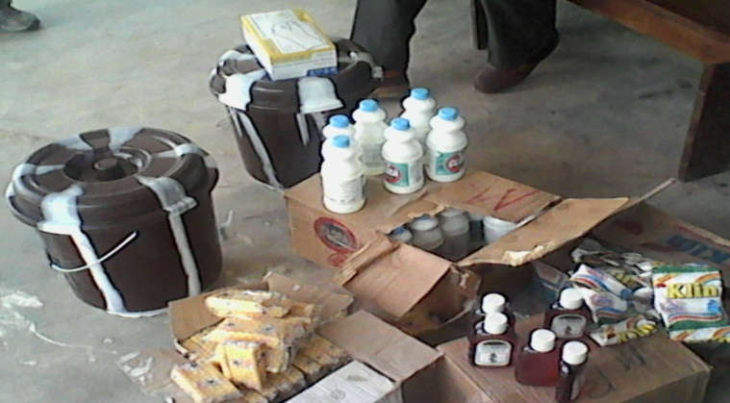
David Selma Town Clinic donations David Selma Town Clinic

David Selma Town Clinic Ice donation
No | Material | Quantity | Unite Price | Amount
1 | Hand grove | 2 box | 8.00 | 16.00
2 | Tire-soap | 1 carton | 18.00 | 18.00
3 | Cholora | 1 carton | 33.00 | 33.00
4 | Delton | 1 carton | 49.00 | 49.00
5 | Rain boot | 2 | 15.00 | 30.00
6 | Soap | 2 cartons | 20.00 | 40.00
7 | Hand washing bucket | 2 | 15.00 | 30.00
8 | White sheet | 1 ring | 6.00 | 6.00
 | Total |  |  | 222.00

Drugs donation to Fassawolu Clinic Fassawolu Clinic
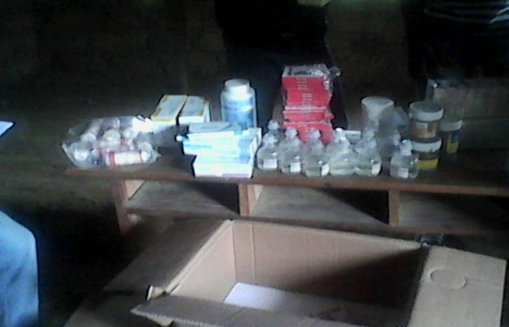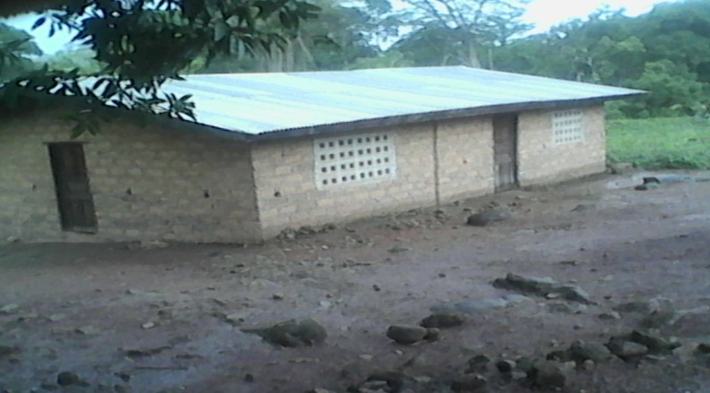

Fassawolu clinic/ Kolahun District
No | Materials | Quantity | Unite price | Amount
1 | Ceftriaxone 1g vait | 2 gross | 18.00 | 36.00
2 | Paracetamol 500mg | 1 cans | 18.00 | 18.00
3 | cloxucllin (500mg)cps | 1 box | 88.00 | 88.00
4 | Act Adult | 2 boxes | 18.00 | 36.00
5 | Act unfort | 2 boxes | 11.00 | 22.00
6 | Acyclouir 250 mg | 1 can | 41.00 | 41.00
7 | Dextrose 50% | 12 pc | 2.00 | 24.00
8 | Ntenolol 50mg | 2 gross | 35.00 | 70.00
9 | ASA | 1 can | 18.00 | 18.00
10 | Rbuprofen | 1 gross | 24.00 | 24. 00
11 | Traimadul 100 mg cup | 3 Amp | 12.00 | 36. 00
12 | Plaster Adhasuce forpe | 1 box | 24.00 | 24. 00
13 | Vitamin B complex | 2 can | 12.00 | 24.00
14 | Multivitamin | 1 can | 12.00 | 12.00
15 | Guaze bon adge | 1 plastic | 29.00 | 29.00
16 | Penecillince (250 mg) | 1 can | 70.00 | 70.00
 | Total |  |  | 572.00

Summary

Shelloe Clinic---------------------------------214.00
Bolahun Clinic------------------------------- 295.00
David Salma Town Clinic------------------222.00
Fassawolu Clinic----------------------------572.00
Transport-------------------------------------150.00

Total-----------------------------------------$ 1453.00
-Lasana Kamara, Project Coordinator, everyday gandhis, Liberia

