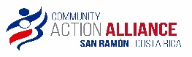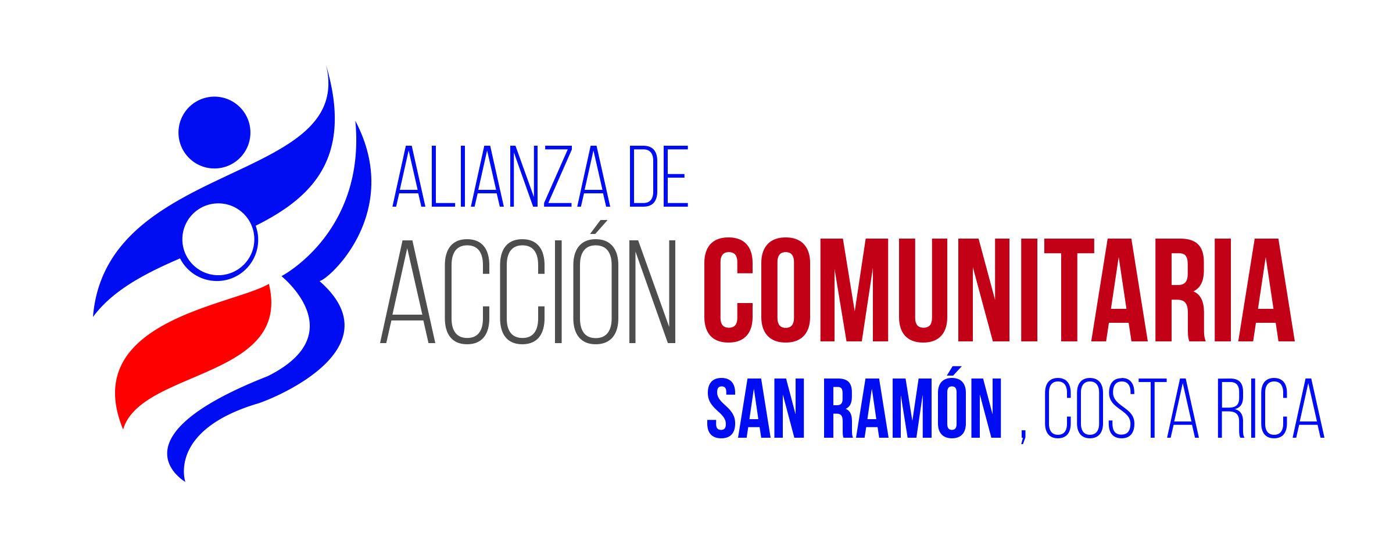

**CAA Education Scholarship Program-Class Year 2024 Objectives**

**CAA Education Committee Objectives for Class of 2024: First Term is late January; Second Term is late July.**

1. Recruit additional high school age students to fill the 3 vacated-by-graduation, and loss of 2 students due to failing/dropped out of school. Target is 24 students. Most of last year’s additions worked by day, H.S. at night.
2. Continue with 2 University Social Worker Program Interns on scholarship, with NJN taking her first year in the lead role, and AEM assuming a mentoring and support role for at least 7-8 months.
3. Continue to provide extra awards (voucher for books-supplies) for last year graduates & selected Academic Excellence students (GPA above 89: 1 @ 89 GPA, 2@ 98 GPA).
4. Continue to support basic uniforms, school supplies, and shoes through voucher program for all students.
5. Continue previous tutoring initiatives including:
   * Continue to offer tutoring: English as second language—individual students matched with native English speaking local volunteers, opportunities to participate in CAA’s English Conversation Club, and offer online access to ESL programs-Duolingo etc.
   * Continue to offer tutoring as made available by the University of Costa Rica Occident-Math Dept.
     + Continue to support transportation needs of rural students into San Ramon as needed.
   * New Initiative – Support digital learning/implement laptop computer loan program: For selected students, up to 10, provide basic laptop and Office program instruction in January, and distribute loaner laptops to those students that can take advantage of them.
     + UCR instructors lined up to offer the basic instruction over a 4- day course.
     + Selected Ed. Committee members will be on point to assist students with computer issues/familiarity, and resolve any defective laptop issues (our donated U.S. laptops are at least 7 years old).
     + A local business volunteer donated/installed enterprise level MS Office apps for our 10 computers at no cost to CAA.
6. Continue vocational and university planning orientation sessions for students and parents in March each year. The goal is to make sure parents/students know the timelines for application for university/vocational schools in the area and are aware of requisites for financial assistance/deadlines.
7. Continue to provide University Entrance Exam Prep Courses: For most 2024 graduating and selected prior year graduates, fund private 10 - week University Entrance Exam Prep courses to give our students the best opportunity to qualify for a public university slot. Revised upward based on projected GPA levels, we will fund 6 participants.
8. Continue to fund the cost of the university entrance exams for each academically eligible graduating student and selected past year graduates (second try). Note: January Update - had 1 university acceptance of the 3 graduates from 2023, and 2 re-try university acceptances from class year 2022 graduates.
9. Continue to provide vision exams and glasses to all students in need – anticipate 6-10.
10. Continue to provide selected extreme poverty families with food assistance, as needed- likely needed monthly or bi-monthly.
11. Continue to provide psychological counseling support as needed—as many as 30-40% could need help; an increasing need post Covid.
12. Continue to provide social worker support services, mentoring, problem solving assistance as needed.
13. Continue to support the academic goals of our 2 full-time University of Costa Rica Social Worker career/law career students (working with CAA in a work-study scholarship mode) who will work directly with our students/families, under the direction of CAA’s volunteer licensed social worker.
14. Maintain funding flexibility to deal with new challenges – including support for cell phone data plans to allow adequate internet connectivity for students in more remote areas. Some of our students living in rural agricultural areas need help finding locations served by adequate cell signal strength suitable for internet research for assignments, and for the interactive language learning applications we loaded on the laptops.
15. Running Total H.S. Graduates: 30 as of Class of 2023; anticipate 6 - 9 more eligible for graduation end of 2024.
16. Running Total University studies: At least 10 students have gone on to private or public university studies.

**Funding:** Raise funds of $25,000-$27,000 and organize events as necessary to achieve the objectives above; note that the declining US Dollar to CR Colon has hit us hard over the past 2 years—a 25+% decline in purchasing power.

**Plan forward** to obtain another 9-10 laptops for Class of 2025; either through donated laptops, or through direct purchase of refurbished used laptops. We anticipate that 30-40% of the existing model years 2016-17donated laptops will be unusable sometime in 2025, and we will need extra laptops**.**

**Identify ways to better track H. S. graduated students** moving into vocational or university studies - to gain insight on challenges/successes**.**

*CAA Education Committee; San Ramon de Alajuela, Costa Rica*

[*https://www.actionalliancecr.com/*](https://www.actionalliancecr.com/)

