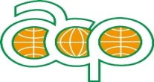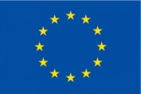
Culture Works Connect
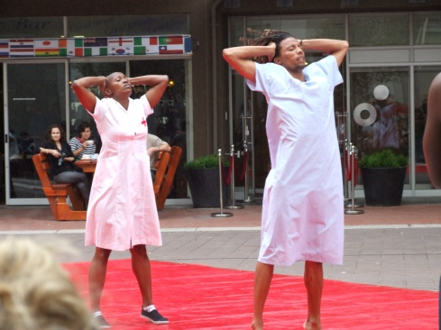
Culture Works Connect is a project linking the creative businesses in Africa, Caribbean and Pacific funded under the EU ACP+ Culture programme. It runs for three years from 2014- 2017. There are four parts to the programme which, at its heart, aims to build stronger more sustainable creative businesses that are able to access world markets and develop collaborations. It aims to overcome one of the major barriers to international working which is the need for good accessible information on what exists and how to contact them.
The first part is process of mapping and surveying the creative businesses. We build on the existing initiatives of mapping and provide the sector with access and training to be able to promote themselves through the World Cultures Connect on line platform. This is a searchable database of the cultural sector worldwide.
The second part is a training exercise that involves the appointment and training of a “link” person in each region responsible for the marketing, promotion and moderation of the platform.
The third part is a programme of targeted and tailored workshop training packages that are co-designed by the creative businesses themselves in response to a needs analysis that we undertake on line. This allows us to match the needs with the training. The outcome is a bespoke programme that will build the skills of the sector as well as giving them access to contacts worldwide.
The final part is an opportunity for some of the participants in the workshops to meet together at a final networking event in the UK where the experience of the programme can be shared. In addition, a one week work placement in a UK organisation can be organised. The results of the programme and future initiatives can then be discussed at the International Producers’ breakfast event at the Edinburgh International Festival in August 2016.
We have raised over 80% of the funding needed – Euros 400,000 and are short of a small amount to run the programme, around Euros 50,000. We estimate to enable 2,000 small businesses access to the global platform and over 100 businesses would be trained and enabled to work internationally bringing more wealth into their communities.
The programme is being led by Visiting Arts, who have a 30 year history of working with and connecting artists across the world. The three partners are:
Ministry of Arts and Multiculturalism Trinidad and Tobago; The Africa Centre, Cape Town, South Africa; The Pacific Arts and Culture Foundation, Suva, Fiji

