NYOF’s Nutritional Rehabilitation Homes

From January 1, 2006 to August 31, 2006, 129 children were restored to health at the NRH (75 boys and 54 girls) and their mothers trained in the principles of nutrition and childcare. The cost per mother/child pair was $264.78. Eighty-six percent of the children were under five years of age.

The health problems of the mother and child were addressed during their stay at the homes, so that both mother and child were in good health when they were discharged. Our field workers are in the process of following up to assure that the children have maintained normal weight and health and that the mothers are teaching other mothers in the village what they learned at NRH. The field staff performed 98 first follow-up visits, 90-second follow-up visits, and 96 third follow-up visits during the first eight months of the year. This necessitates visits to remote villages in hard-to-reach areas, sometimes requiring a very long walk from the nearest road.

Immunization program: The large majority of children who come to the NRH from rural villages have not been vaccinated. They and the mothers who come with them and who are pregnant receive DPT, tetanus, and measles vaccinations. In addition, due to the generosity of a donor in the United Kingdom, the children at the NRH are also vaccinated against hepatitis B, mumps, and rubella.

The British Embassy’s Charity day: Each year, the British Embassy in Kathmandu chooses a local charity as a volunteer project for their staff. This year, they chose the NRH. They painted six of the rooms in bright colors, provided toys, and donated carpets for the playroom and the nurse’s room. While they were working on improving the building, some of the embassy staff took the mothers and children to the zoo – an amazing experience for these remote villagers who had not imagined such a place existed.

Again, we include a few “before” and “after” pictures of children who
were restored to health at the NRH this year.

Ram Bahadur at admission Ram Bahadur 31 days later

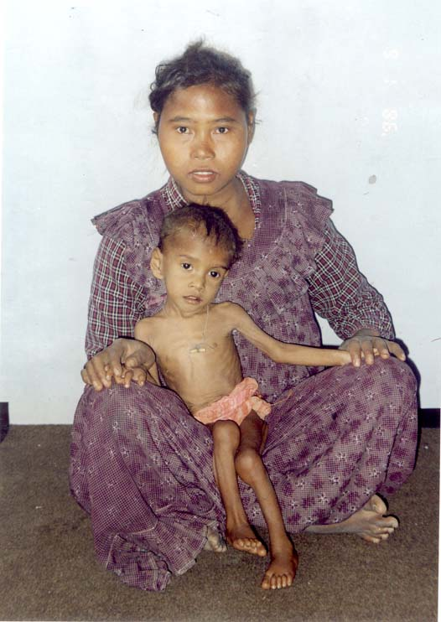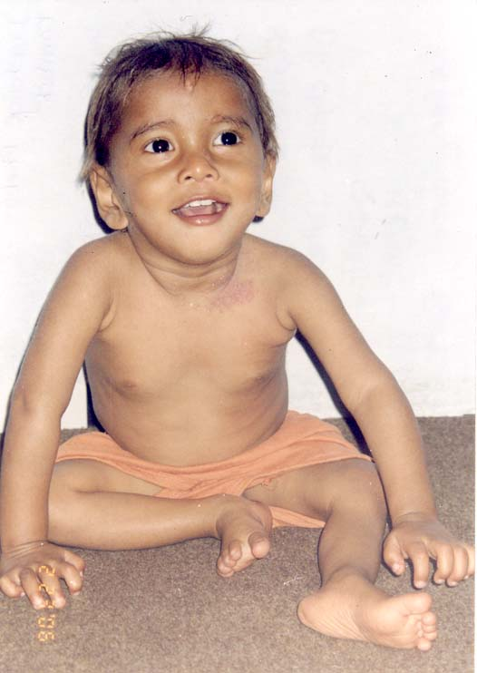

Kamlesh Tharu at admission Kamlesh Tharu 55 days later

