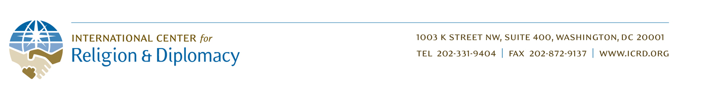

ICRD - Yemen Project: 9th Quarter Report 2017
By Rebecca Cataldi - Program Manager

Final Report on Program Activities
ICRD is pleased to share with you this final summary report on our program to empower Yemeni citizens to resolve local conflicts and address critical needs in their communities, providing an alternative to militant groups. These efforts have focused on training religious and community leaders in conflict resolution (CR) and countering violent extremism (CVE), and facilitating trainee-led community projects. The program provides Yemeni civil society actors with the opportunity to build skills in internationally-practiced CR and CVE methods, which they can then adapt and integrate with local methods as appropriate and according to local contexts.

The impact of this work continues to grow. Project activities and follow-on initiatives have now engaged over 1400 Yemeni participants to date, in nine governorates and the capital of Sana’a. Trainees have used the skills that they gained to resolve local conflicts, train others in their communities, and initiate sustainable projects. Yemeni civil society organizations have been strengthened and empowered to sustain these efforts. They have created new training resources based on what they have learned, raised their own funds to continue the work, and built new relationships and credibility within their communities.

While all the training topics have been well-received by trainees, three in particular—active listening, conflict analysis, and countering violent extremism—were especially embraced by participants and incorporated into subsequent activities. Participants have expressed that, as a result of the CVE training, they have felt motivated and empowered to work against violent extremism, conscious of their critical role as part of a broader community.

Trainees have initiated numerous follow-on projects to address critical issues. For instance, one group of trainees facilitated a community project to address a water conflict in the governorate of Abyan. In addition to providing resources and greater security for the area (e.g. eliminating the need for long and dangerous trips to gather water), the project empowered the community to work together in addressing local issues. This activity strengthened the community bonds and self-sufficiency, increasing its resilience to violent extremism and leading community members to agree not to join a militant group or to allow such a group to return to the village.

A replicable model has been created to empower Yemeni citizens to resolve conflicts, transfer skills, and provide a credible alternative to Al-Qaeda and other militants. This model includes locally-designed training manuals and other resources, and mechanisms for knowledge- and skill-transfer within Yemeni communities.

ICRD is deeply grateful for your support for our efforts, which has been critical in making the program a success. We are now working to significantly expand these efforts to other governorates and constituencies across the country. We invite you to visit our website at www.icrd.org to receive future updates on these efforts—including a more detailed white paper about our methodology and lessons learned through this program which will be published in the near future—and to donate directly to the expansion of these efforts. Thank you again for what you are doing for the Yemeni people.

