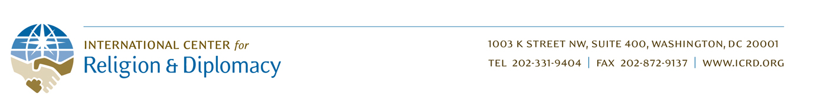

ICRD - Yemen Project: 3rd Quarter Report 2015
By Rebecca Cataldi - Program Manager

Yemen continues to suffer widespread humanitarian devastation due to the current military conflict. Many programs in Yemen have been scaled back, have closed down, or remain stalled in light of logistical obstacles, security risks, and funding freezes from nervous donors.

However, ICRD remains committed to supporting Yemenis and empowering them to more effectively resolve conflicts which contribute to so much human suffering. We have been constantly monitoring the situation on the ground in Yemen, and adapting our program design in preparation for when we can implement the first training workshop on conflict resolution and countering violent extremism (CVE) skills. Recently, some flights began operating between Yemen and Jordan, increasing the possibility that we will be able to bring the Yemeni trainees to Jordan for the first program in the coming months.

In the meantime, we are working with our local partner DASO on how we can best adapt the training content, structure, and participants to new realities in Yemen in light of the current conflict and new needs. This may involve the inclusion of DASO Peace Committee members from various regions, in addition to core DASO HQ staff, in the first training, which would expand the geographic impact of the program and deepen the knowledge transfer to various grassroots communities.

In this context, ICRD will continue to develop and refine the training curriculum to the needs of these communities. The Arabic translation of our CVE film Back from the Brink is also near completion, and will be used during the CVE portion of the training as well as made available to DASO and its Peace Committees for use in their own community initiatives.

In addition to the added costs of moving the training to Jordan, the conflict in Yemen has led to skyrocketing costs of fuel and other resources. We continue to seek funding support to meet these new costs to facilitate our program activities. We are deeply grateful for the generous support to date from the Global Giving community, and hope you will consider making another donation to support moving the training to a safer location in Jordan. Your support will be critical to enable us to meet our remaining funding goal of $13,587.

We are determined not to abandon the Yemenis in their time of greatest need, despite the risks and challenges. Conflict resolution capacity is now needed in Yemen perhaps more than ever before. By supporting this program, you will be helping to empower these brave Yemenis to work against violence and hatred in their communities and to offer a better path to the future. Thank you for your support.

