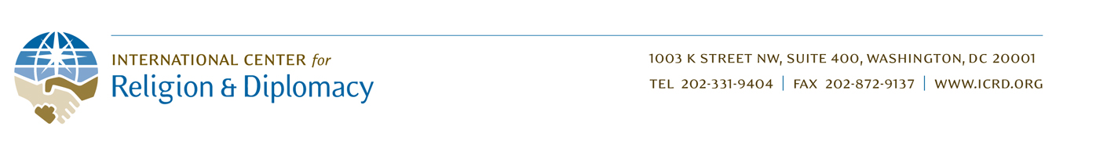

ICRD - Yemen Project: 2nd Quarter Report 2015
By Rebecca Cataldi - Program Manager

Overview:
The outbreak of widespread military conflict in Yemen this spring has caused tremendous suffering throughout the country, exacerbating an already-unstable situation. Many international organizations working to aid the Yemeni people have scaled back or closed down their programs in light of security risks and freezes of funding from nervous donors.

However, in this time of extraordinary need, ICRD remains committed to supporting the Yemeni people—many of whom risk their lives every day to find peaceful ways to deal with conflict, create social and political change, and counter violent extremism. Our indigenous partner will not abandon the local communities its staff and members hail from, and it remains committed to working with us to serve the Yemeni people. Its recent decisions to include its President and Founder among the trainees in ICRD’s upcoming conflict resolution program and to cover the cost of travel for additional male escorts to ensure that its female staff can travel abroad for this training, are indicative of the importance DASO places on its work with ICRD, and the need for programs such as this.

Activities:
Thus, despite the current difficulties involved in operating in Yemen, ICRD is continuing the project with the following recent and current activities:

- ICRD conducted an extensive assessment of various countries to determine suitability as alternative locations to hold the first training for the Yemeni peacemakers, evaluating factors such as cost, security, ease of visa procurement, and ease of in-country travel. Currently, ICRD believes Jordan to be the best location for holding this training, and is continuing to consult with local partners to monitor developments. Initial logistical arrangements for holding the training there have been made; however, timing will depend on factors such as when the Yemeni airports reopen to allow the trainees to travel out of the country.

- ICRD is continuing to develop and refine the training curriculum in order to adapt it to new conflict realities on the ground in Yemen. The final training manual will not only be used to conduct this first training, but will also form the basis of a second training manual on conflict resolution and countering violent extremism (CVE) that will be given to our partner following the training. This manual will serve as a resource for them to integrate with their own methods as they prepare to train the thousands of local peacebuilders in their nationwide network.

- ICRD is currently overseeing the translation into Arabic of Back from the Brink, our educational film on countering violent extremism, in order for it to be incorporated into the Yemeni training and made available to our partner as a CVE tool to use in its subsequent activities in Yemen. (The English version of the film is viewable for free on our website at: http://icrd.org/countering-violent-extremism/).

Moving the training to Jordan entails additional costs, particularly travel and accommodations for the participants. We are deeply grateful for the generous support to date from the Global Giving community, and hope you will consider making another donation to support moving the training to a safer location in Jordan. Your support will be critical to enable us to meet our remaining funding goal of $13,587.

We must not abandon the Yemenis in their time of greatest need as so many others in the international community are perceived to have done. Conflict resolution capacity is now needed in Yemen perhaps more than ever before. By supporting this program, you will be helping to empower these brave Yemenis to work against violence and hatred in their communities and to offer a better path to the future. Thank you for your support.

