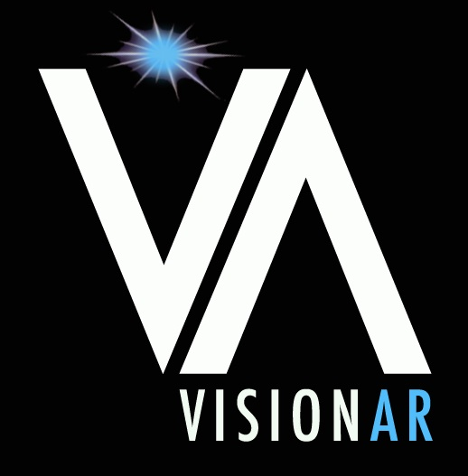 VISIONAR SCHOLARSHIPS – JULY 2018 UPDATE

Last month, I had the chance to visit with VISIONAR students during a short trip to Argentina. Five of the ten students currently receiving scholarships (Emilia, Florencia, Micaela, Jesica, and Luana) were able to join our VISIONAR management team for a low-key dinner and lots of conversation.

It is always a pleasure to meet with VISIONAR students and not only hear about their progress, but also see for myself how these ambitious and resilient young people bloom into well educated adults ready to take on the world. It is exciting, inspiring and humbling, all at once. I hope that everyone reading this letter and contributing to VISIONAR feels reassured that your support is helping to change these kids’ lives. I can attest to that.

When I speak with our students, I always hear about their coursework, their grades, their challenges and their successes. But there is more about their experiences that I find admirable. I can summarize it in three points:

- Aiming high. It is a pleasure to see that VISIONAR students are driven to set high standards for themselves. For instance, Maria Paula is complementing her Psychology coursework with additional training as a Personal Therapist to assist mental health patients in their home environment. Not satisfied with the local trainer, she sought and found nationally acclaimed trainers and was able to take courses from them, “to ensure I have the highest level of training possible in this field”.

- Community matters. Jesica and her classmates took the initiative to introduce high school students from all schools in the San Francisco area to the fields of Electrical engineering, Robotics, and to university life. Jesica’s team invited schools to participate in Robotics workshops that culminated in several competitions. Intrigued high school students (and their teachers) attended sessions first to learn how to build robots, and later to participate in robot races. The first time they set up this first-of-a-kind workshop, in 2017, they had 40 high school participants. This year, 160 students signed up! (and all showed up!). I congratulate Jesica and her team for achieving this amazing level of engagement from a demographic that was not yet aware of the opportunities the university system offers.

- Helping each other. A few VISIONAR students share the same major (for instance, both Luana and Micaela are studying Chemical Engineering, both Emilia and Maria Paula are majoring in Psychology), and it is great to see their teamwork and mutual support (senior students helping their juniors with assignments, contacts, even part-time jobs at the university). They give each other advice. They care about each other and want to see their peers succeed.

I hope you enjoyed reading these highlights. If you have questions about VISIONAR students, or questions for any specific student, I would be more than happy to channel your queries.

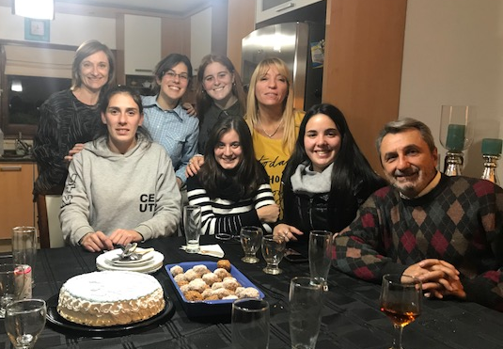

Top (Left to Right): Gabriela (VISIONAR), Maria Paula (student, Psychology), Emilia (student, Pyschology), Marcela (VISIONAR)
Bottom (Left to Right): Jesica (student Electric Engineering/robotics), Micaela (student Chemical Engineering), Luana (student, Chemical Engineering), Victor (VISIONAR)

Please consider supporting one VISIONAR student through the school year, which represents USD $1,000 in today’s exchange rate. This amount helps pay for university fees, school supplies, books and transportation. As always, any amount is deeply appreciated and welcome.

You may make your donation at: https://www.globalgiving.org/projects/support-education-in-argentina/

Thank you for your support!

Gabriela

