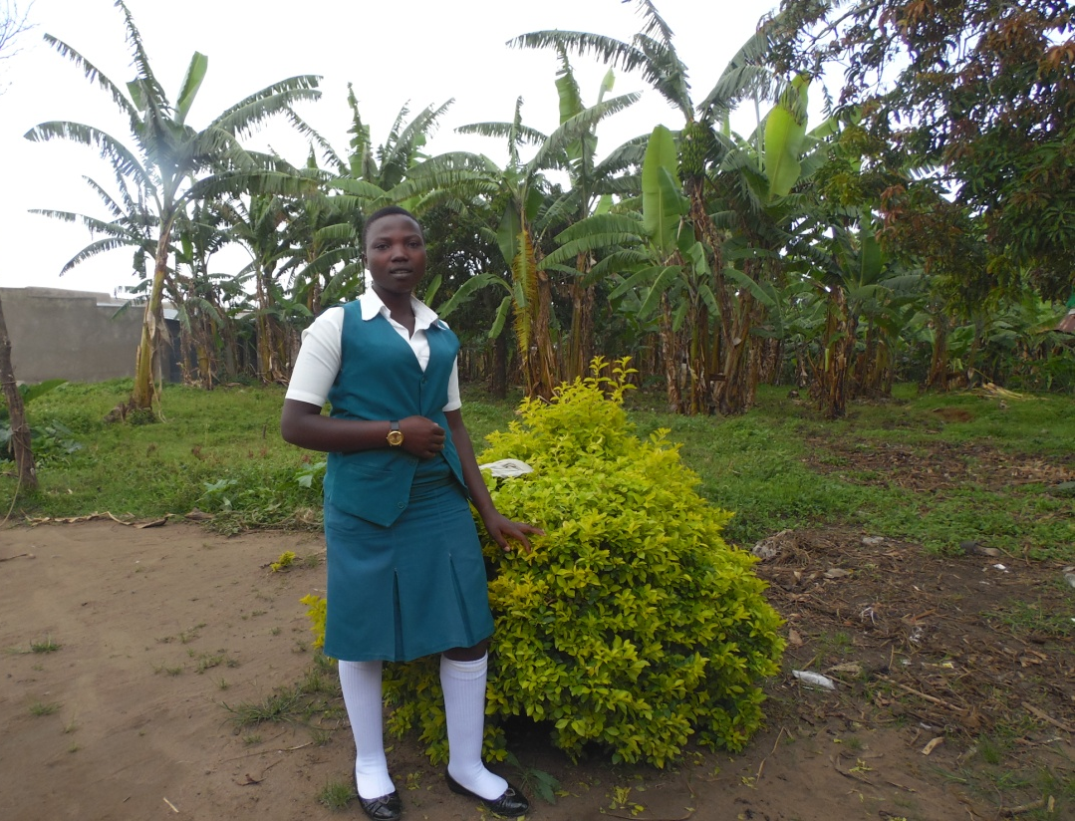
Kabugho Mable
Age 17
Class S4
School Bukuuku secondary school.
Jfcu gave her a goat in 2015 when she was in p7 at Kibyo Primary school. Kabugho comes from a needy family; her parents are all alive but peasants. The goat given to her has motivated her to stay in school. ‘’When my parents are not able to pay fees or buy scholastic materials I sell one of my goats and therefore continue to go to school’’ says Kabugho. The goat currently has one kid which she hopes to sell in third term since she will need money to sit for her final examinations and finally join a nursing school. ‘’I want to become a nurse and help my young siblings’’ says Kabugho.
However the money sold from the goat is not enough to cater for all the needs, for example it cannot be used to pay fees and buy scholastic materials at the same time.(A kid is sold at 80000=) There fore sometimes she is chased from school due to unpaid dues and this affects her performance.
Kabugho pays 120000= per term.

Sibanza Doreen
16yrs
S3
Moons Vocational
She received a goat from JFCU in 2015 however it died after giving birth to one kid in 2018. She sold the kid when she was joining s1. This money helped her buy scholastic materials and uniform.
Doreen says ever since the kid was sold she has been struggling to get fees and scholastic materials since her parents are poor.
‘’I sometimes miss school to do casual jobs to get money and when I don’t get any one to offer me the casual job I first sit at home for sometime until when my parents also struggle to get some money. This affects my performance in class.’’ says Doreen
Doreen wants to be a teacher to teach other people help her parents and her siblings. She pays 220000= per term.

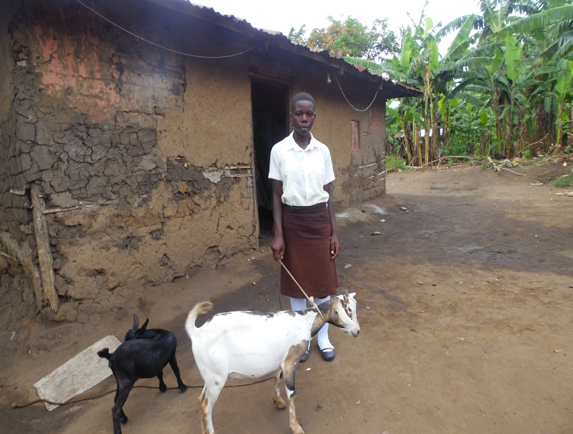
Thungu Eveline
16 yrs
S2
Moons vocation and Scondary School
Jfcu gave her a goat in 2015
Thungu Eveline received a goat in 2015 from JFCU. She comes from a poor family and she lost her father, the mother is a peasant and struggles so hard to get fees.
Before she was given a goat the parents used to pay half fees at school and they would chase her back home to pick fees four times a term. The goat she received gives birth to a kid every six months.
When she was joining S1 she sold one kid at 80000= and bought a uniform.
‘’Am the 5th born among 8 children, all of them have dropped out of school due to lack of school fees. Am very lucky that I have a goat which has helped me to continue with school. Every term I sell a kid and pay for my fees and scholastic materials in addition to my mothers contribution’’ Says Eveline.
She says,’’ However sometimes my mother is not able to get money and the money I sell from the kids is very little. I pay 220000= a term ‘
she didn’t attend second term 2018 coz she didn’t have school fees, long distance from home (up in the mountains ) to school she takes 2 hours from home to school.
She wants to become a doctor to get money and help her siblings

