REPORT FOR THE LIVE PUBLIC DIALOGUE WITH POLITICAL CANDIDATES

ON

ENDING CHILD MARRIAGES IN BUTALEJA DISTRICT

HELD AT BUTALEJA
DISTRICT HEAD QUARTERS

SUPPORTED BY THE

JOY FOR CHILDREN UGANDA

About Joy for Children:
Joy for Children Uganda is a non – profit children’s rights Centre and non-government organization dedicated to working with children, families and communities to respond to the plight of vulnerable children in Uganda. Through human-rights-based initiatives designed to meet the needs of children, JFCU addresses issues that have plagued war-ravaged Uganda such as; violence against children, including neglect, abuse, exploitation and child labor, child marriage, poor education and illiteracy, familial conflict, poverty, poor health due to HIV/AIDS, malaria and malnutrition, Sub-standard sanitation, water and food security. In 2014, JFCU reached over 55,000 children and their families in Eastern, Central and Rwenzori region in Uganda. 3,000 children and their families were reached directly through designed programmes and 100,000 children and their families benefited indirectly on the organization programmes.
Child Marriages in Butaleja district:
Uganda is one of the worst African countries with high rates of child marriages/child brides. Its eleventh in Africa with 46% of underage girls below the age of 18 years forced or lured in marriages. According to UNFPA, the prevalence of child marriages is highest in the Northern region at 59%, followed by Western region at 58%, Eastern Uganda at 52% with Kampala having the lowest rate at 21%.
Butaleja district is one of the top 5 worst districts in Uganda contributing to the highest rates of child marriages/brides in the Eastern region at 46% Most of these girls drop out of school due reasons like poverty, poor performance in class, etc to go into marriages. (UNFPA 2013).
Early marriages and the resultant pregnancies are the biggest causes of deaths in 15-19year old girls accounting to 20% of maternal deaths in Uganda, those who survive pregnancies suffer lasting complications like fistula and disability, (UNICEF-2014). Ending child marriages in Africa especially Uganda requires the efforts and commitments of every stake holders, including parliamentarians, district leaders, religious leaders, academia, private sector, etc.
What happened?
On 12th February 2016 at 2:00 pm, Joy for Children Uganda and Butaleja district local government held the first ever live public dialogue with political candidates on child marriages in Butaleja district.
The dialogue brought together political candidates for the seats of Members of Parliament in Butaleja District (MP- candidates from Bunyole East, West and women MPs), District chairperson candidates, religious leaders, academia, district leaders, traditional leaders, and community members among others. Hence 100 people attended the dialogue including police and children.

Objectives of public dialogue:
This dialogue was organizes mainly to address two objectives which included;
- To generate and document commitments, political will and strategies proposed by candidates towards ending child marriages and teenage pregnancies in Butaleja district once elected in their respective political positions.
- To sensitize the community and create awareness about the dangers of child marriages and teenage pregnancies to both the individual families and the community at large.
Methodology:
A week prior the day of the dialogue, we held a planning and security meeting with the district security, Resident district commissioner, office of the CAO, office of gender and child protection, representatives of the candidates among others, at the district headquarters. The aim of this meeting was to harmoniously plan for the event, rectify on the child marriage questions, plan for security since it was a season of political climax and distribute roles and responsibilities to every stakeholder.
The dialogue was conducted mainly in Lunyole (the local language) as the language of communication which enabled equal participation by all members. The Assistant Chief Administrative officer was the moderator of the dialogue assisted by a member from civil society organization. Each candidate was given maximum of 10 Minutes to make their submissions/views and 5 minutes to respond to questions related to child marriages. In order to keep the dialogue focused, any question to a particular candidate was asked through the moderators.
The dialogue was broadcasted LIVE on Open Gate FM radio station which was chosen because of its wide coverage in the region and the most accessible and listened to by the majority community members in Butaleja district.
Official opening by the Resident District Commission (R.D.C)
He began his opening remarks by welcoming everybody to the debate and thanked them for committing their time to this noble cause.
He also thanked Joy for Children Uganda for organizing the first live dialogue on child marriages in the district and vowed to continue working together to put an end on child marriages.
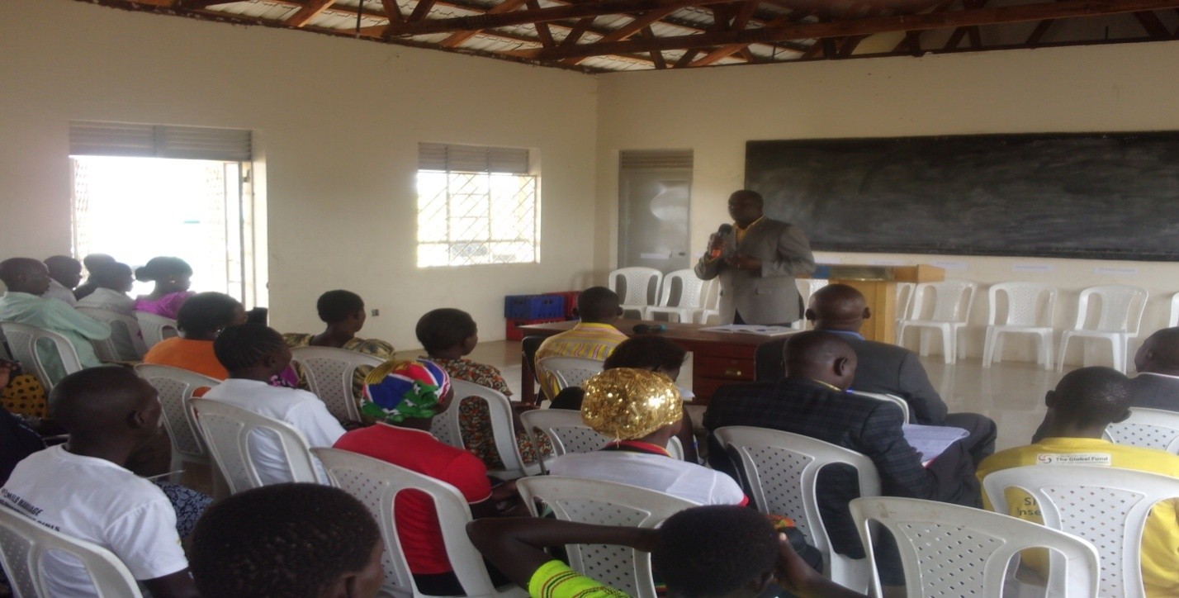
He warned members present to stop voting candidates because they look good, buy salt during campaigns, which he called bad practice but advised them to vote leaders who have good developmental plans, like developing the education system of their district, have good plans to promote health for all the people, and protecting children among others. He added that issues of child marriages need to be addressed from the grass root level and there is need to involve parents and teachers. He humbly asked everybody to support these kinds of activities and always take part in talking to community members about the dangers of child marriages.

The R.D.C giving opening remarks.

Outcome of the dialogue:
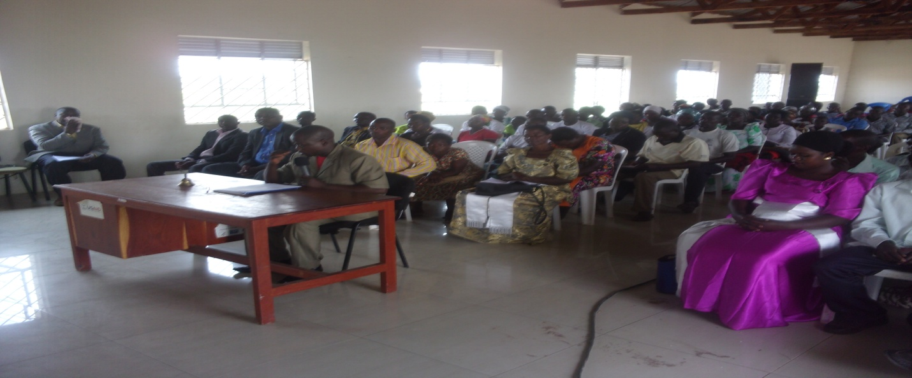
Though it was a season of political climax when every candidate was in his final steps of concluding the campaigns, majority of the candidates attended the dialogue to share his plans on ending child marriages in Butaleja district. Out of the 15 candidate who were invited to the dialogue, 13 of them attended with apology from Hon. Wangolo Jacob from Bunyole West who had gone to the offices of electro commission in Kampala and Hon Betty Hamba who had gone to attend a burial of her relative and was caught up on time.

A lot of issues were discussed and the candidates were at a task on explaining what their plans are, what, with who and how they will implement programs that will reduce the rate of child marriages in Butaleja district. Each candidate gave his plans and how he will do it however, we compiled most of the cross cutting suggestions and committments.
- They committed themselves to support and strengthen by-laws passed by both district councils and parliament to protect children.
- To engage, support and encourage mobilization and sensitization of parents of the danger of early childhood marriages and teenage pregnancies. (“I want to start holding meetings with parents to discuss on this matter every monthly with support from partners and stake holders” said Waya Richard Local Council V candidate.)
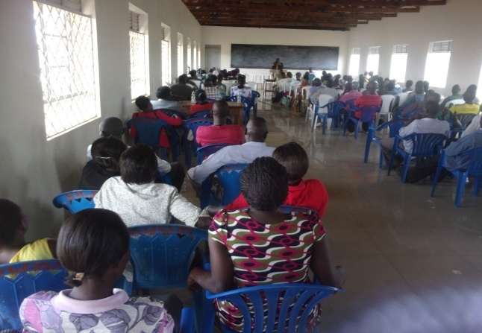
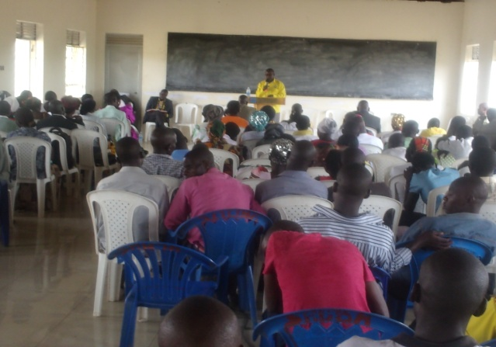
- Most of them committed themselves to supporting and encouraging sexual education among the victims of teenage pregnancies, co-ordinate with other organizations and religious leaders to hold school out reaches to discuss with students openly.

- Committed to fight poverty among the women especially child mothers through encouraging opening of saving groups extended up to village level, this will be strengthened by empowering these groups on the saving skills for sustainability, encourage commercial farming especially products that take shorter periods to mature like vegetable and encourage farming of food security.
- Support and encourage victims of teenage pregnancies to remain school, encourage and support civic education in schools were teacher, children and parents which will enable them learn their obligations and responsibilities.
- Creating a conducive environment in school for teacher and learner through providing enough space for learning and construction of staff quarters to reduce on the distance teachers move to reach schools.
- Strengthening model school and support capacity building of teachers, Parents Teachers Association (PTA) and School Management Committee (SMCs) on management and administrative strategies of schools, attitude management for teacher and collective mobilization of children to go to schools by parents, teachers and stakeholders, this motivate them and therefore solve the problem of poor performances in
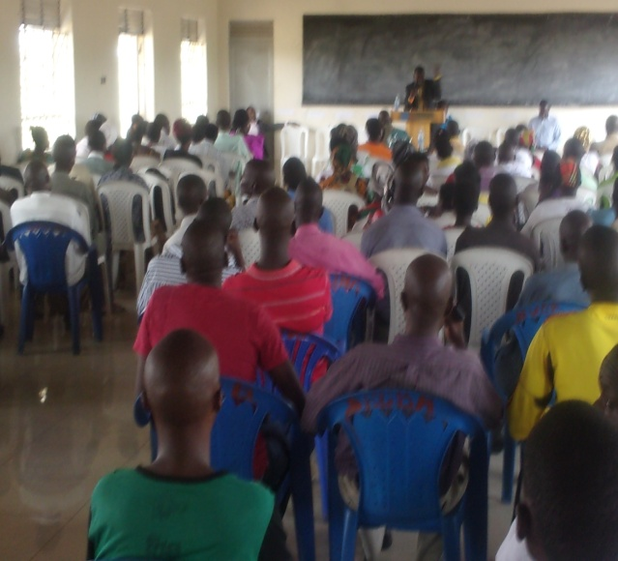
- Support capacity building of health workers, construction of houses for health workers and attitude change mostly towards young mothers and the patient group as a whole.

- Rehabilitating the available sources of water, co-ordinate with government to boost and increase the sector budget, co-ordination, mobilization and empowering communities on good sanitation and hygiene and
- Promote and support of community tours to the neighborhood to learn the best practices.
- Empowering and supporting youth groups to start up income generating project that can support their wellbeing like break laying, poetry and pig farming, this will help reduce on the level of idealness among the youths and in the long run help solve the question of poverty eradication among the people Butaleja.
- Ensure close and proper monitoring of government programs and services and empower communities to fully participate in planning and implementation of programs, this will ensure sustainability and good governance.
- In ensuring good accountability, candidates pledged to support and encourage public accountability fora where leaders shall be demanded accountability of government resources by community members, this will help curb down the level of corruption which is a major detractor of growth, development and cause of poverty in the district.
Recommendations and Conclusion:
Public dialogues are very good platforms for both candidates and community members because they give opportunity and chance to both parties to listen to each other, think about each other and there make a decision that benefits each other, Hence a learning opportunity for these two groups of people. All in all the activity went on well as planned
The Chief Administrative Officer (CAO) thanked the candidates and stake holders for sacrificing their time and he therefore declared the meeting closed.

