1/28/2016
DELAY MARRIAGE PROMOTE EDUCATION FOR UGANDAN GIRLS
JANUARY 2016
Child Marriage in Uganda
Uganda falls among the 15 worst African countries with high numbers of child bribes. Nearly half (46%) of girls are married by 18, and 12% are married by age 15. If we are to enable the adolescent girls of this and the next generation to live up to their potential, we must end the practice of child marriage and support married girls to be all that they can be.

Joy for Children –Uganda with funding from Global Giving (online crowd funding platform) is implementing a project dubbed; Delay Marriage, Promote Schooling for Girls in Uganda aimed at eradicate the harmful practice of child marriage. The project activities include; dissemination of learning materials, assist local leaders to develop action plans to end child marriage, conduct community dialogues and raising awareness, changing behavior and empowering communities with the Knowledge and tools needed to resist child marriage. Promote the effective implementation of strong laws and policies with a bearing on children especially the girl child and promote the fulfilment of their human rights.

Child Marriage in Butaleja District

Butaleja district is located in the eastern part of the country and its ranked third in Uganda as having the highest number of teenage mothers and child marriages. It’s a social norm for girls to get married when they reach puberty and also regarded abnormal for a boy to turn 18 before becoming a father. When this happens, the family members and the community begin to think that the boy has a problem and start discussions on how to help him including getting him a young girl. Butaleja is made of a big number of young boys and girls and it’s also believed to have young grandmothers as young as 24 years of age. There are a number of causes of child marriage in this region which include poverty, cultural beliefs and peer group influence.

Joy for Children Uganda carried out a number of activities in the District in an effort to encourage community to delay marriage of their children and instead send them to school.

Action plan with Butaleja District Leaders
As part of the project activities, an engagement meeting with the district leaders was held with purposes of developing an action plan to end child marriages in the area and get commitments from the district officials and departments towards the end child marriage campaign. During the dialogue with the district leaders a number of issues were discussed which included clear definitions of child marriage, cause and solutions to child marriage in Butaleja district as a whole.
The Chief Administrative Officer mentioned that Butaleja District is one of those districts in the country that has the highest number of child mothers and also children dropping out of school before completing their primary Seven. He mentioned that when a case is identified and reported to the police, the parent’s connive with the parents of the boy, and through bribery, the case is dismissed.

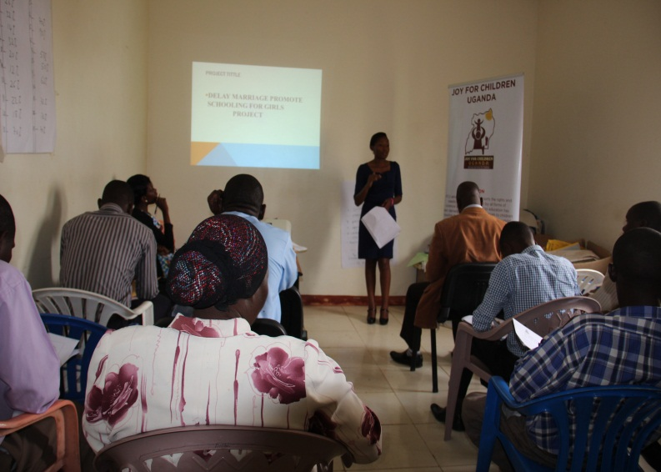
The Resident District Commissioner (RDC) thanked Joy for Children Uganda for the initiative, accepting to come to Butaleja and also lobbying funds for the project. He said government appreciates every effort that is brought to support the community. He mentioned that Butaleja District is faced with a high number of school drop outs between Primary Six and Primary Seven. He applauded Joy for Children Uganda for targeting schools and also emphasized reaching out to those out of school and majority leaving in rural areas. He mentioned that rural communities have attitude problems because they look at a girl child as a source of wealth.
In this he (RDC) emphasized to support the Girl Child not to get married, keep in school and retain them in school in order to delay marriage.

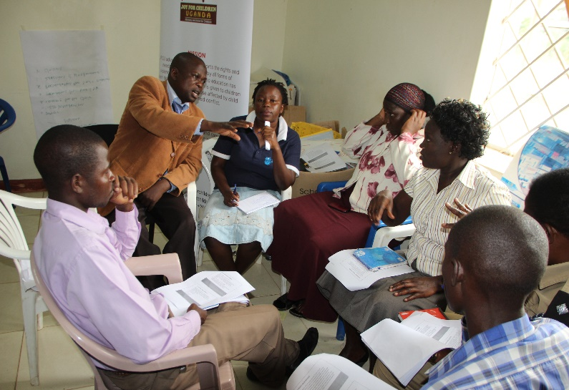

ACTION PLAN DEVELOPMENT AND DISTRICT LEADERS COMMITIMENTS
The finance officer mentioned that leaders should not look at Non-Government Organizations as sources of funds for the problems that are faced in the area. He urged that Government should work hand in hand with the organizations. He made commitment of saving a percentage of the district revenues handling child marriage cases in the district.
The religious leader of Butaleja district Sheik Mukawa Swaibu made a commitment to talk about child marriage and how it can be reduced in Butaleja during their prayer time.
The District Police Commander of Butaleja made a commitment to work with the organization and also handle child marriage cases without tolerating any bribery from the community so that the issue is solved.
The Rev. George Kyampwine also made a commitment to preach the gospel of ending child marriage in Butaleja during church masses and after the mass so that the community gets to know that child marriage is a bad for the community.

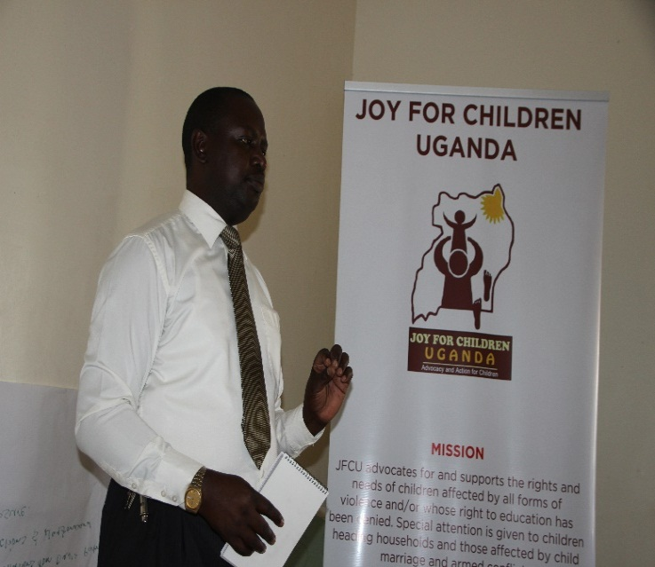
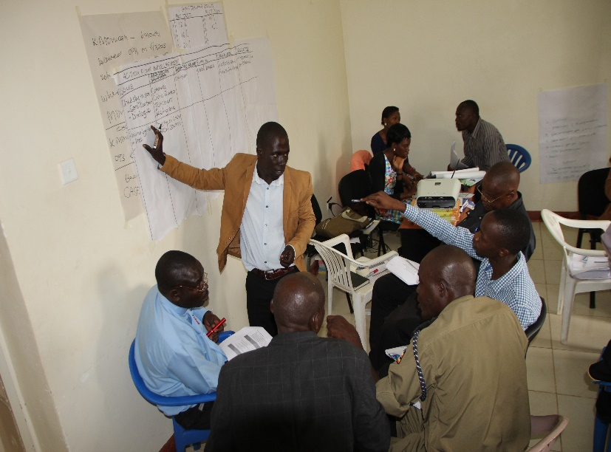

RECOMMENDATIONS MADE BY LEADERS
Joy for Children Uganda to Network with the civil society Organizations in Butaleja district since it’s a big issue in the area and can only be solved when organizations work together through sharing of information of what works to end child marriage.
Involve religious leaders in community dialogues to spread out the message of child marriage in the community since they have a chance of interacting with different types of people

Joy for Children Uganda to work with the district youth leaders to carryout sensitization in schools and the rural areas to end child marriage.

Joy for Children Uganda urged to form an umbrella organization in Butaleja district to accelerate efforts to end child marriage.
The Education department was also advised to network with other stakeholders to keep children in school and learning.

MEETING WITH THE COMMUNITY GROUPS
Joy for Children Uganda held a community meeting with men and women from different villages of Bukaire, Nakawa, namawa and Ntindato to seek their views and perception about child marriage. Members turned up for the meeting and were eager to discuss issues related to child marriage and how they can get involved ending it in the district. Communities in Butaleja acknowledge that child marriage is an issue that has affected them greatly and yet it is still widely practiced.
From the discussion, the community thinks is persistent because of a number of reasons that include among others; ignorance of community members about the consequences of child marriages, poverty, love for money since most parents exchange their daughters for some little money and a goat. Some parents said that some girls lure the boys and men into the act and requested that Joy for Children should organize guidance and counseling sessions for girls and boys / men.
Long distance to and from school is another issues raised by the community as the cause for girls getting to into marriage at an early age. Many children can not sustain waking long distance and eventually drop out, while those who continue are often given a ride by motorcyclists (boda boda) who in turn ask for favors thus resulting in child marriage.
“It’s hard to raise up a child now days especially those living near the village towns”, mentioned the Chairman. He said children escape from homes without the notice of their parents to go and watch films and join dance groups where most men and boys find them and lure them into marriage. Some parents give money to their children to go to disco especially on big days like Christmas and Idd day.
The Chairman added that poverty in families is alarming, parents send their children to school without anything like exercise books, lunch and transport when such children reach at school and find men who can give them some money and also provide them with basic needs like pads they accept and run away from home with such men.
Similarly, one of the mothers in the group mentioned that poverty is a very big issue in their area and even if they try to start up small businesses, it’s hard to get money that will take care of the family.
Mothers complained of the negligence of their husbands. “Our husbands do not want to own up their roles and responsibilities”, mentioned Sara a member of the community. She said when men get some little money all they think about is marrying another wife and yet they already have one and children, they neglect the home leaving it under the care of the mother which makes it hard to get all children requirements like scholastic materials, pads among others thus girls run away from home into marriage hoping that marriage will be better than homes.
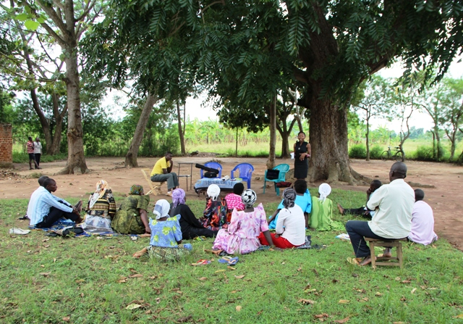
Meeting with community groups of men and women in Bukaire Village.

COMMUNITY RESOLUTIONS / COMMITIMENTS TO END CHILD MARRIAGE
A number of resolutions were made to end child marriage by community members that attended the child marriage dialogues among others included,
- Commitment to come up with bi-laws that will compel all parents to take their children to school and also make parenting a community responsibility where by all parents in the communities will be concerned with the welfare of the neighbor’s child, this can include disciplining the girl if she is found loitering on the road during school time, working together to rescue married girls and hold parents who want to marry off their children before 18 years accountable (Take them to police)

- Decision to arrest both girl and boy’s parents in case of any child marriage case in the community.
- Members committed to start up saving groups and come up with income generating activities so that they can provide for their children rather than sending them into marriage. In addition the women groups requested for goats from Joy for Children which they can rear and use the money that comes out to support their children in school.
- The members suggested and urged families to avoid violence in the homes becauseas a result children who are mistreated end up getting married because they think that when they get married they would have sorted there issues.
- Villages to form a committee that will be spear head the campaign to end child marriage in their areas of residence. Inaddition, the members requested to be supported so that they can carry out their work well. They requested for at least a bicycle to ease their transportation and boots in case they have to carry out a rescue operation at night.

After the commitments the community requested that Joy for Children should continue making community sensitizations to help solve this issue in the community. The community members were so happy that the organization had agreed to work with them because most people in the area are not educated and ignorant about child marriage.

DIALOGUE MEETING WITH THE YOUNG BOYS AND GIRLS
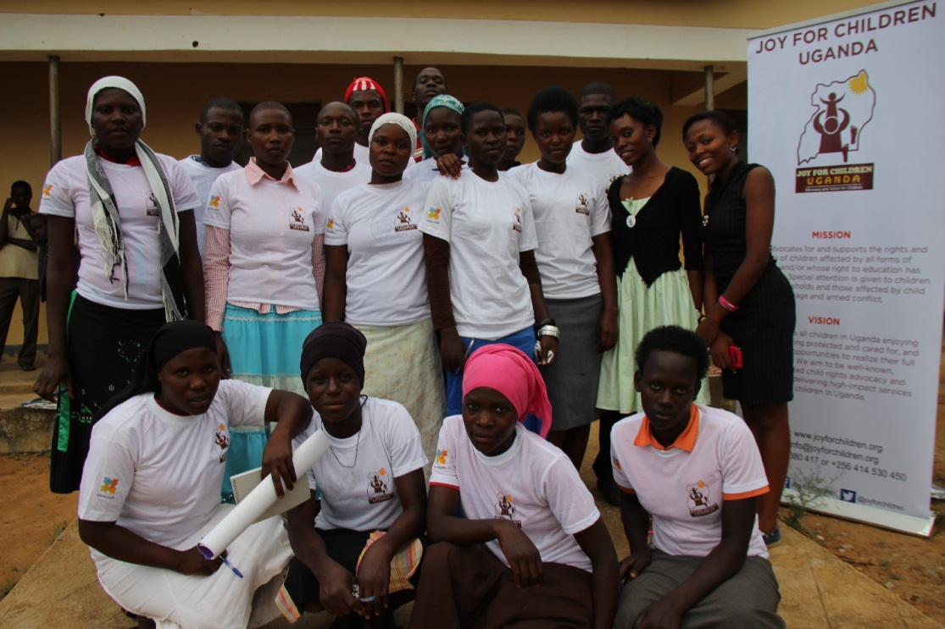
A group photo with the youth group in Butaleja
A meeting was held in Kachonga village with young boys and girls between the age of 18 to 24 years of age to understand whether the teenagers understand child marriage and how it affects the life of young people and what innervations they think can help to end child marriage in their community. Moses one of the teenagers mentioned that child marriage is one when people marry before the age of 18 years according to the constitution of Uganda.

Causes of Child Marriage as mentioned by the youth
Poor family background was mentioned by the youth as a cause of child marriage in the area. Parents look at their children as a source of wealth through marrying them at an early age so that they can be given bride price.
Lack of enough schools in the area in which girls have to move long distances to schools without transport. This is where the meet men who will provide them with transport and will make them pay through sleeping with them hence getting pregnant and the end result is getting married.
Ignorance is also one of the causes of child marriage in this area that was mentioned by the youth because some parents think educating a girl child is not important after all her end result will be getting married and have children and keep at her husband’s home.
Cultural beliefs in the region where by once a girls reaches her puberty stage its believed that she is ready for marriage and hence parents will not hesitate to marry her off. Also boys get married when still young especially after circumcision and start having children.
Divorce in families is also another cause of child marriage in the region because parents separate and mothers are left with the responsibilities of taking care of a big family which they cannot afford. In this the mothers will let their girls get married so that they can reduce the burden of basic needs at home.
Bad peer group ,influence from the youths who encourage their fellow youth girls to join them in marriage.
Ignorance of the parents is another cause of Child marriage because some parents look at their girls as a source of wealth. In this they tend to encourage their girls to get married before the age of 18 years such that they can enjoy the pride price that is associated with the marriage.
What the youth think can be done
The youth think that carrying out sensitizations in the communities where they live about child marriage and its dangers can reduce cases of child marriage.
The youth also pointed out the issue of advocating for more schools in Bataleja since their limited number of schools for them to attend and yet those that are in Butaleja are long distance schools which are not easily accessed by the girls. They requested that the government should consider building more schools in the district so that they number of children going to school can also increase thus reducing child marriage rates in the district.
Formation of youth groups in the village so that they can carry out child marriage sensitizations within the community and in schools. They also agreed to carryout door to door sensitizations concerning issues of child marriage both at school and in their villages..
The youth also encouraged family discussions where by the parents should talk to their children to avoid bad peer groups, encourage them to stay in school so that they can have a bright future and avoid early marriage.
Formation of drama groups by the youth so that they can carry out sensitizations in the community through drama. These drama groups move around communities informing them about the causes and effects of child marriage in Butaleja and how they can be solved or avoided.

Open market Community Dialogue
An open market community dialogue was conducted at Nabbiganda market which was attended by large numbers of people including village leaders like Local Council 1, Police Officer in Charge of Nabigganda Village, Market leader of the area, Child Protection Police officers, business men and women , children you and old and the community members at large.
During the dialogue the community was engaged in discussion to identify causes of early marriage in the area in which they mentioned a number of factors which include, family prejudice in which the mother of the girl will inform her daughter that she’s growing old and soon dying so she would like to die when she has seen her grandchildren. They also mentioned that poverty is another cause of child marriage in Butaleja since most parents are poor and cannot take good care of their children so they end up sending them to get married. The community also sited out an issue of poor dressing code by the girls in which they provoke men through dressing in skimpy clothes and very tight clothes.
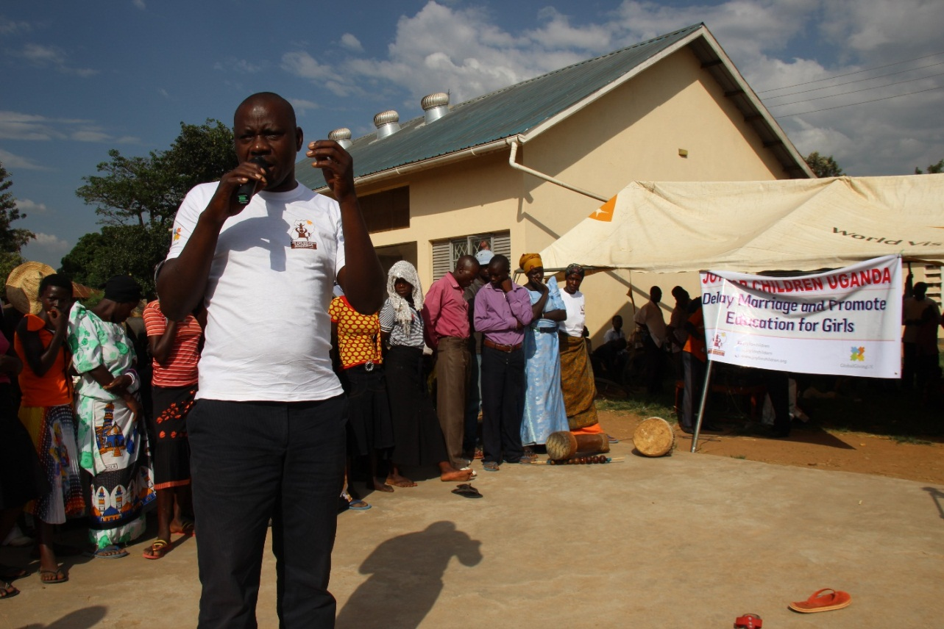
The Market leader of Nabbiganda giving a speech about child marriage in the region.
Poor relationships between the mother and daughter in which the girl cannot confine into her parents and hence end up being a victim of child marriage. Mothers also fail to talk to their daughters when they have reached puberty stage and also parental love in Butaleja and hence a girl will run to someone who will give her attention. A point of income inequality between the men and women in Butaleja is another cause. This is so because men earn more than women in the region and yet they have more than one wife. In this the women have less to provide for their families and hence end up marrying their daughters off.
Poor family planning in the area has led to increased number of school drop outs and early marriages. This is so because when a family has so many children, it may not be possible to attend to all the children and provide basic needs to all of them. This will necessitate a girl child to fend for herself basic needs lie soap, pads since the parents have failed to provide them. The Islamic faith is also a major cause of child marriage in the Butaleja in which they also believe that a girl child should get married before the age of 18 years most especially when she reaches her puberty stage.
Unnecessary sending of children to certain places like bird seeing in the swamps and yet they are lonely places has also contributed to child marriage in the area. Also some parents give money to their children to attend certain events in the area like night clubs which is an exposure of these children to child marriage.

Possible solutions to Child Marriage as sited out during the open market dialogue
Non-Government Organizations like Joy for Children Uganda should continue coming to the Butaleja and sensitize the communities so that child marriage in this area can be reduced. This is so because most people in the rural areas don’t understand what is meant by child marriage.
Parents should stop domestic violence in homes since its one of the factors that cause child marriage. In this they encouraged both parents Father and Mother to work so hard so that they can support their children through provision of school fees and basic needs for a girl child. They are also advised to use family planning so that they are able to control the number of children in the home and also give birth to children they can take good care of.

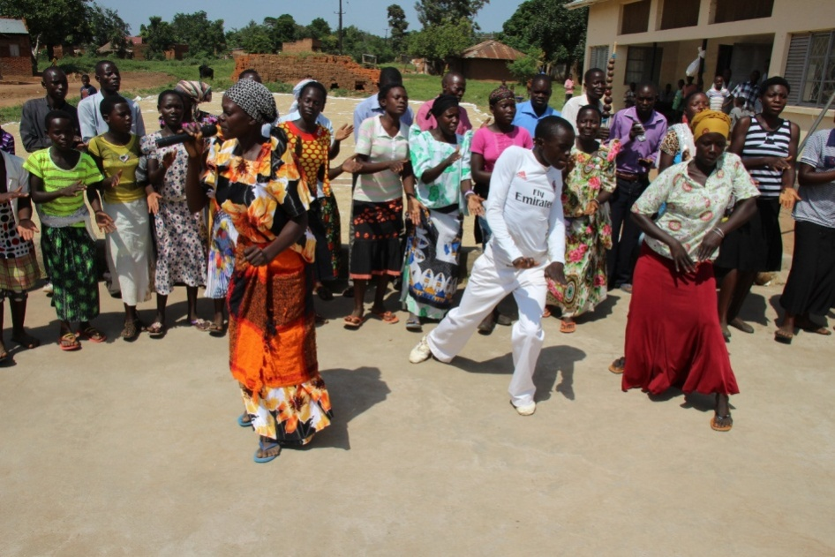
Drama group performances during a community sensitization on child marriages in Butaleja district.
Parents were also urged to conduct guidance and counselling sessions for their girls to bridge the gap between the mother and daughter. This is so some parents have no time for their daughters and hence they end up making certain decisions that end them in Marriage. The police was also encouraged to handle child marriage related cases seriously so that they don’t connive with the parents and dismiss such cases.

