2015
DELAY MARRIAGE, PROMOTE SCHOOLING FOR UGANDAN GIRLS

JOY FOR CHILDREN UGANDA

DELAY MARRIAGE, PROMOTE SCHOOLING FOR UGANDAN GIRLS
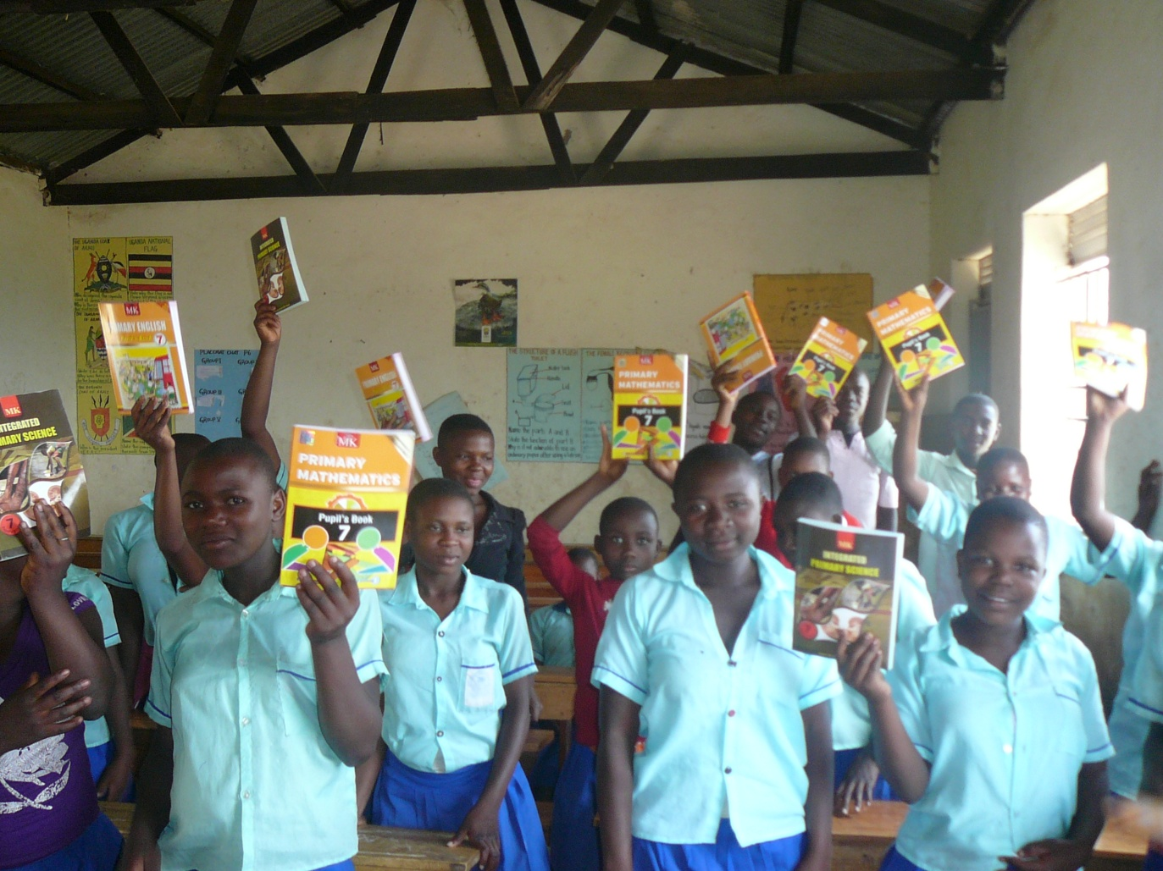
Project activity report

- Introduction
Child marriage, defined as marriage before age 18, devastates the lives of girls, their families and their communities. This harmful practice is most common in poor, rural communities, and its consequences only perpetuate the cycle of poverty.
In Uganda, 54% of women between 20 to 24 years were married before the age of 18 and 12% are married by the age of 15 years. In the district of Kabarole in western Uganda parents marry off their daughters for money and gifts. More often than not, child brides are pulled out of school, depriving them of an education and meaningful work. They suffer health risks associated with early sexual activity and childbearing, leading to high rates of maternal and child mortality as well as sexually transmitted infections, including HIV. And they are more likely to be victims of domestic violence, sexual abuse and social isolation.
Though child marriage is entrenched in tradition and culture, change is possible. Very often, girls and their parents want to delay marriage but lack options. Joy for children Uganda is actively working to discourage the practice by raising awareness of the adverse consequences for girls, running activities that provide girls with viable alternatives to marriage, and demanding more effective enforcement of existing laws that condemn child marriage.
This report highlights activities carried under the project entitled “Delay marriage, promote schooling for Ugandan girls” which is funded by Global Giving UK through the online fundraising. The activities included a meeting with the community leaders and the children of Kibyo and Marhoyoro primary school in Karagura Sub County held on 12th to 13th February 2015. The meeting was held to eradicate harmful practice of child marriage through raising awareness, changing behaviour and empowering communities with the knowledge and tools needed to resist child marriage.
- Visits to schools and distribution of text books
- Kibyo primary school.
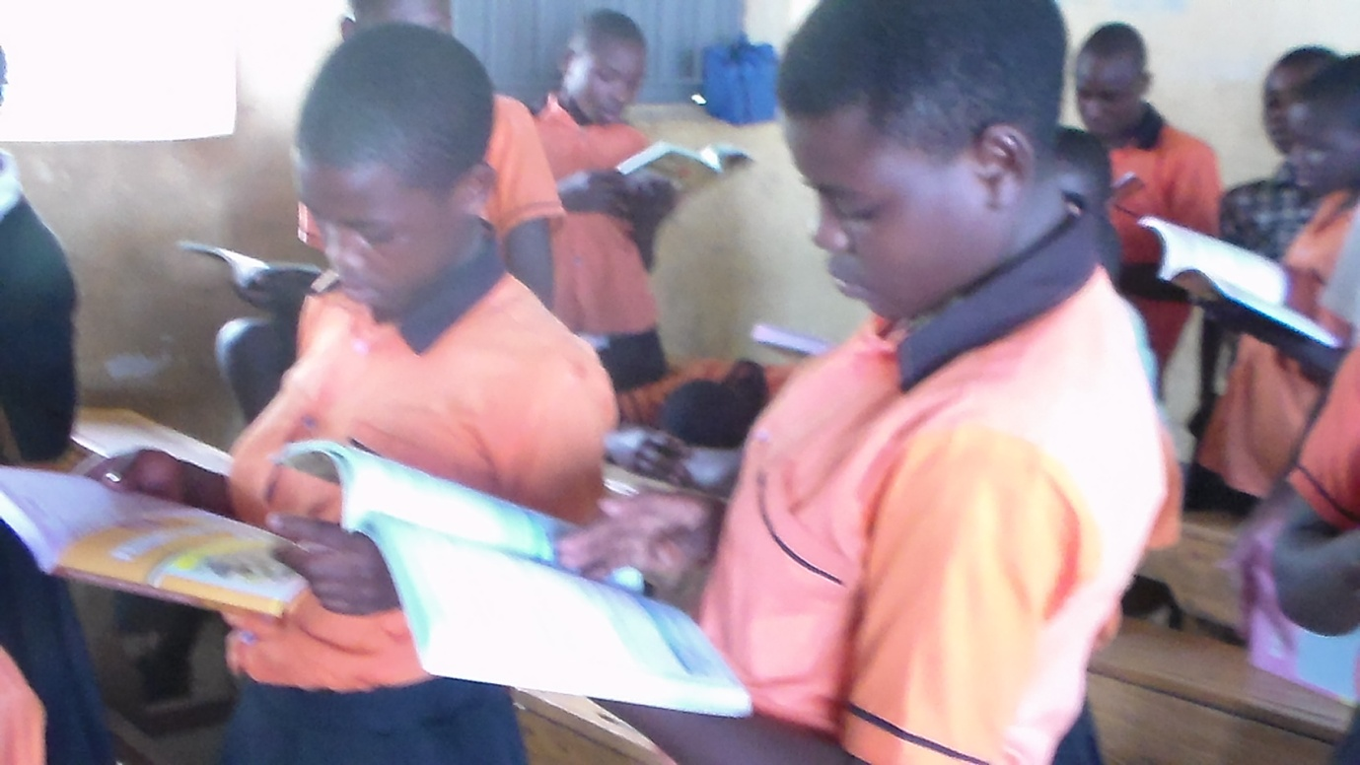
Pupils reading text books they had received from Joy for Children
The Executive Director, Fundraising officer and Project Officer of Joy for Children Uganda went to Kibyo primary school on 12/02/2015 and gave out 30 text books of mathematics, English and science to primary seven and primary six girls.
The girls of Kibyo primary school shared their challenges. Parents do not provide enough scholastic materials, sanitary requirements and they walk long distances to school which affects their performance in class.
The Staff for Joy for Children inspired the girls, to read hard and stay in school, speak English to enhance their confidence, open up to their senior woman whenever they face challenges, look up to their idols and work hard to be like them as well as being assertive.
All primary seven pupils promised to study hard and signed a commitment chart which was displayed in the head teacher’s office.
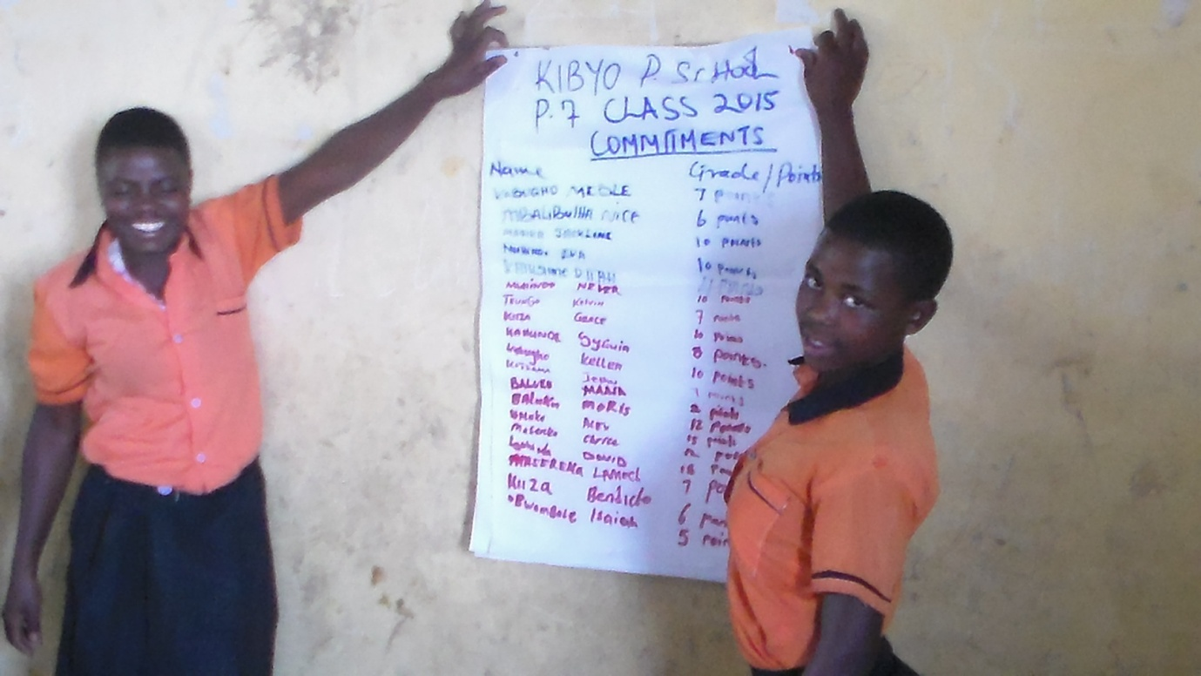
Girls demonstrating a commitment chart for primary seven pupils to pass exams

- Marhyoro primary school.

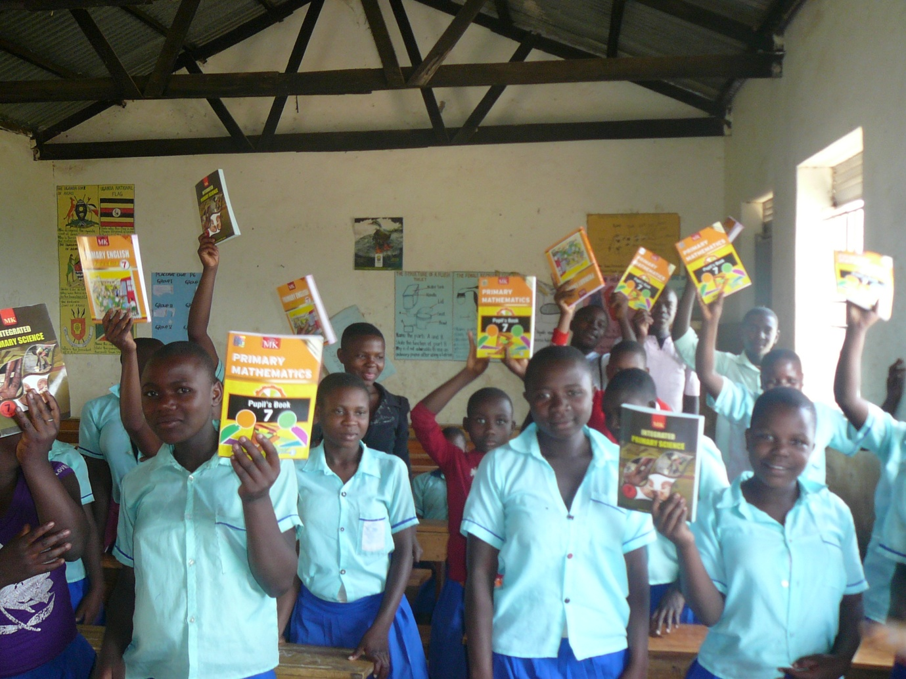
On the 13th/02/2015 the staff visited Mahyoro primary school and issued 30 test books of mathematics, science and English to primary seven and primary six girls.
The girls shared out some of the challenges they face, they include: lack of female teachers at school, parents are not involved in their academic activities, lack of enough class rooms which reduces their time of study, lack of enough scholastic materials and sanitary requirements.
Joy for Children staff advised the girls accordingly on how to go about the challenges they are facing and on how to keep safe in school.
The primary seven girls promised to study hard and signed a commitment chart which was also displayed in the head teacher’s office.
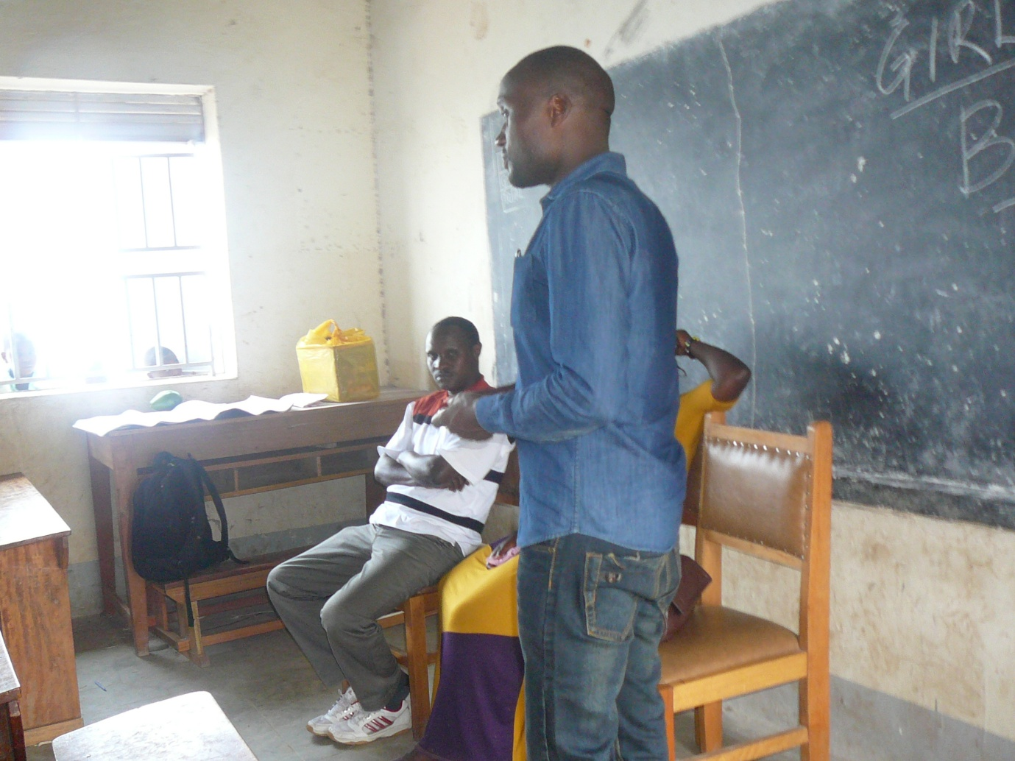
Moses Ntenga, the Executive Director Joy for Children speaking to pupils in Mahyoro primary school
- Planning meeting to end child marriage with the community leaders of Karagura Sub County.
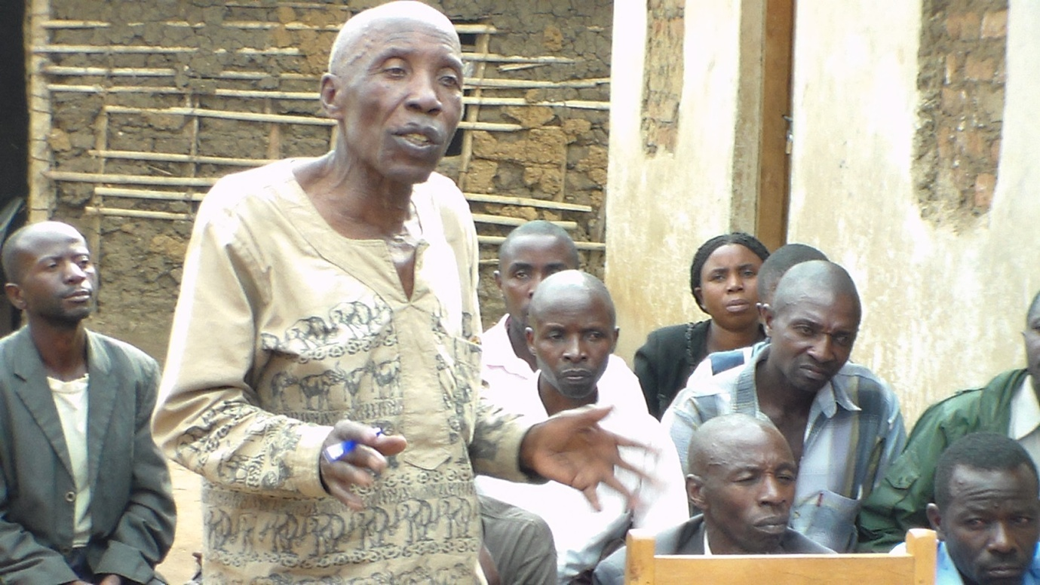
The Local Council 3, chair person at the local leaders’ planning meeting to end child marriage
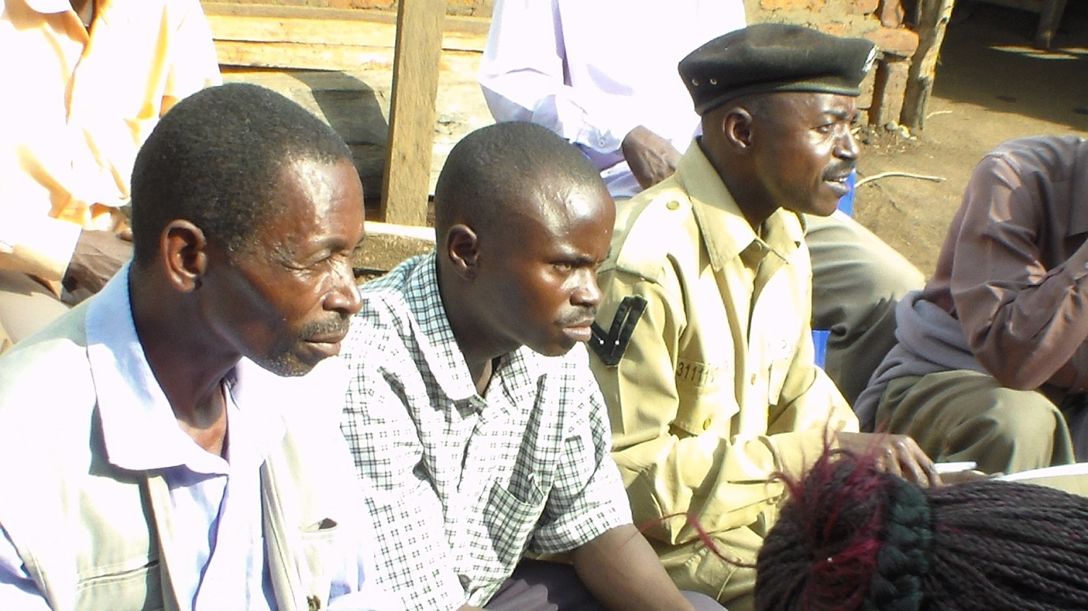
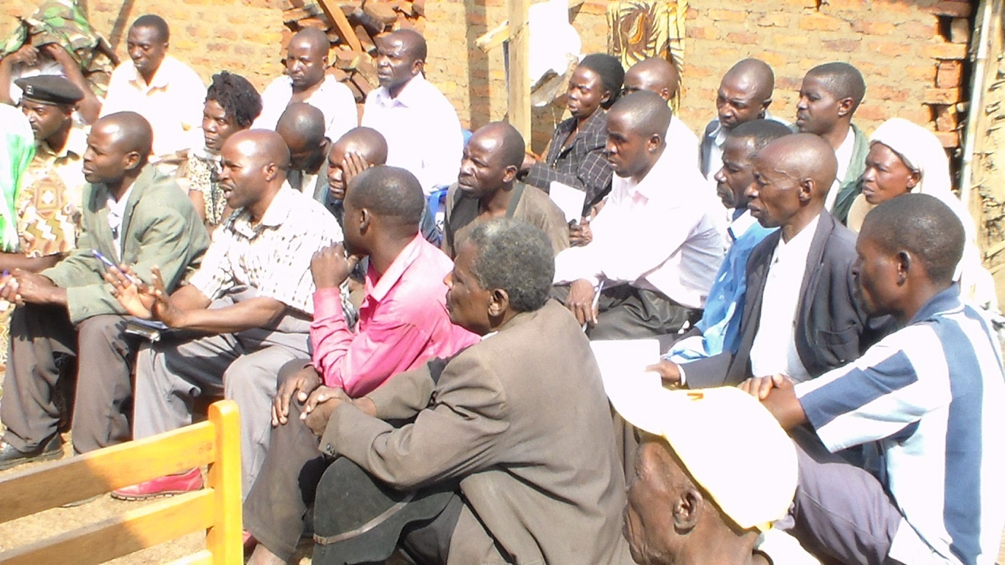

Participants at the planning meeting
The meeting for the leaders was held on 12th/02/2015 and facilitated by Joy for children Uganda. It was attended by 30 participants who included the sub county chief, community development officer, district counsellors, the Lc 3, women councillors at the sub county level, Lc 2 and Lc 1 chairpersons, the schools head teachers and police.
The discussion modified and highlighted the causes of child marriage what has been done before to end child marriage and what can be done to end child marriage.
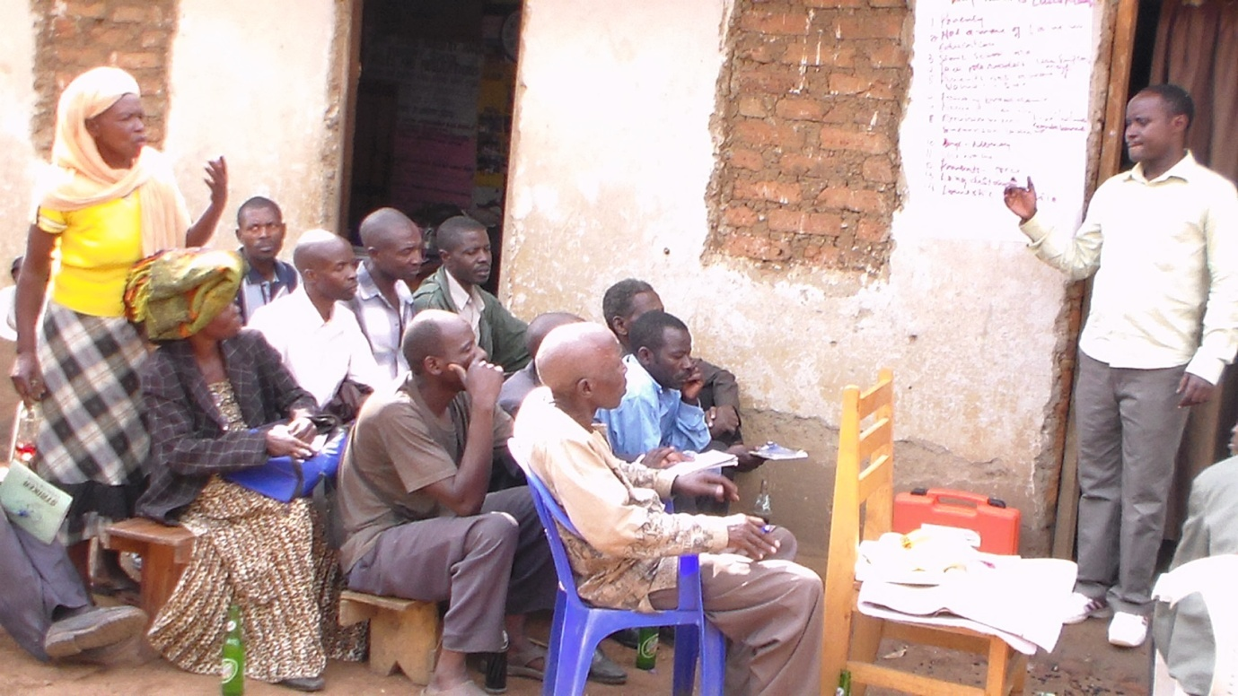
John Aturinde the Fundraising officer of Joy for Children listening to a female local leader on her submission about child marriage
  - The following were identified as Causes of child marriage in Karangura Subcounty
- Poverty is the model problem why there is incresing child marrieges since parents find it a problem taking the responsibiliy of rising and educating the girl child thus marry them off to get the rid burden.
- Family breakdowns where parents live in separate homes living the responsiblity of rising the children is left to one parent
- Lack of awareness about the value of education in the community hence will not be passed on to the children causing lack of interest where the girls will find it an option to married at a young age.
- Girls start school at an older age this causes intimidation by the younger classmates and teachers which makes the school enviroment undesirable for them.
- Lack of role models at school. Girls lack people who can talk to them about sex education.
- A lot of domenstic or house work that hinders them from going to school.
- Unfarvourable enviroment with bad peer groups that influence the girls to have sexual relationships from which unwanted preganancies may result hence causing early marriage.
- Lack of supervision and guidence from the parents.
- Girls are seduced by men who offergifts and money exchange for sex.
- High levels of illiteracy.
- Parent’s influence that forces girls to get married in exchange for material gains and money.
- Schools are out of easy reach with roads which are impassible.
- Lack of birth cerficates which are requirement for joining schools.
2.2 What the leaders resolved to do end child marriage.
- The leaders in the community agred to set a by-law gainst child marriage.
- Mobolise parents for sensitization about the dangers of child marriage.
- Ensure families are self sustaining by helping them to start up small income generating activties like mashroom growing,poultry,and piggery projects.
- Envolve Lc1 chairperson in the regitration of newborns.
- All children of school going age should be in schools with the help of the local leaders.
- Run media programmes on birth registration.
- Present birht cerficates for every child joining primary one.
2.3 Immediate outcomes
- Local leaders agread on the by-law with a penality to both families that marry and marry off their girls to pay 500.000 shillings each as a penality, and also face the local council committe, they agread that the money will be given to a school to meet girl children’s needs in school
- Three radio talk shows were held and so many people responded by calling and asking. questions, appreciating and giving suggestions onhow to end child marriage.
- The staff for Joy for Children creared agood report with the local leaders.
- Alinkage between school administration and the community was created.
- IEC materials were distributed to the leaders and community memebers.
- Conclusion
The interventions by Joy for Children have provided a deeper understanding of the causes and consequences of child marriage. Now, our is focused on how to prevent and ultimately end the practice. We need to also scale up our activities through the Girls Not Brides Uganda Alliance coordinated by Joy for Children to ensure we reach out to wider community.

