**Partner**

**with us**

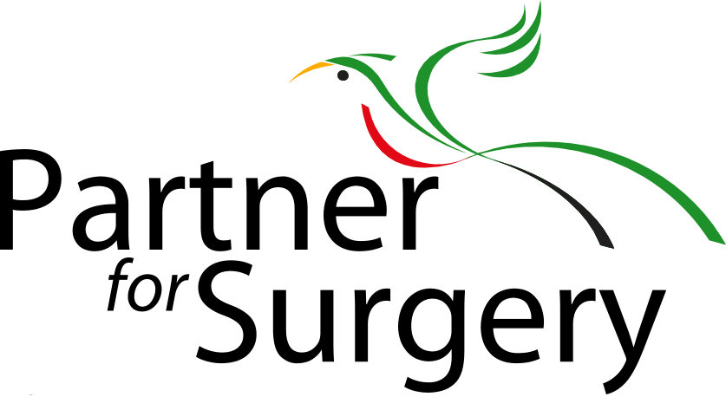

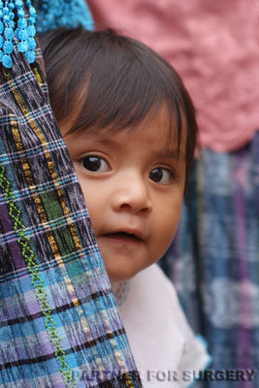 

* Twitter: @pfsguatemala
* Facebook: /partnerforsurgery
* Instagram: /partnerforsurgery
* Web: Partnerforsurgery.org
* YouTube: /partnerforsurgery

Partner for Surgery is a 501(c)(3) non-profit organization. Gifts are **tax-deductible** to the full extent of the law. Visit us at www.partnerforsurgery.org to make a secure online donation. Many companies have a **Matching Gift Program**, and match the donations of their employees. **Our** **EIN # is 54-2034427**.

**Learn more**

**about us**

 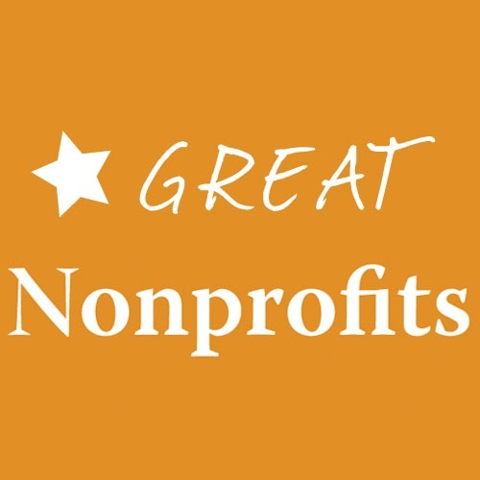 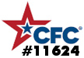

P.O. Box 388, McLean, VA 22101  
703-893-4335  
info@partnerforsurgery.org

* I want to **donate** $__________ to be put to immediate use changing lives
* I can donate **equipment or** **supplies** to support surgical missions
* I want to learn more about **joining a team** in Guatemala
* I want to **host a dinner** to help spread the word
* I want to receive Partner for Surgery’s **newsletter**

**No gift is too small.**

Name _________________________________

Email _________________________________

Phone _________________________________

Address _________________________________

_________________________________

Please make checks payable to **Partner for Surgery.**

Our mailing address is:

P.O. Box 388

McLean, VA 22101

You may also donate securely on our website at **www.PartnerForSurgery.org**.

**You can**

**Change a life Today**

**Lives transformed through medical care**

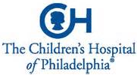 



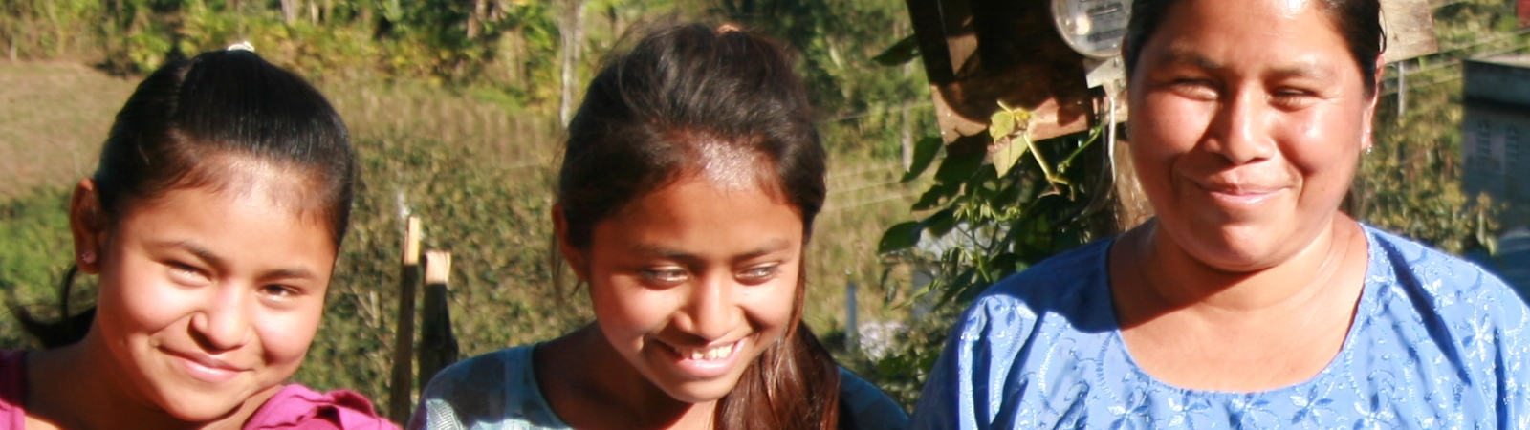

Each year, a growing number of international surgical missions rely on Partner for Surgery to connect them with the **patients most in need**. We operate surgical facilities in collaboration with our Guatemalan sister organization, Asociación Compañero para Cirugía.



We pioneered the use of **Health Promoters** wholive and work in the communities our patients call home and have established basic infrastructure to provide periodic health care. They understand the local language and culture, thereby building the trust our **Mobile Medical Missions** need to deliver compassionate care. We partner with a host of North American surgical teams and:

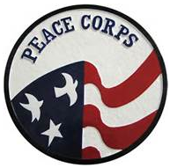  

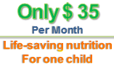

In addition to surgery, we educate and improve health within communities. Many of our cleft **babies are malnourished** due to an inability to nurse, so we developed an **Infant Nutrition Program**. We supply specially designed bottles to the little ones and breast pumps to their mothers. We also offer our patients **a place to stay** in preparation for surgery and during recovery. The photos above show **Jonathan** as a newborn, and then again a few months after his life-changing cleft surgery.

**Jonathan at 3 months and then after surgery**

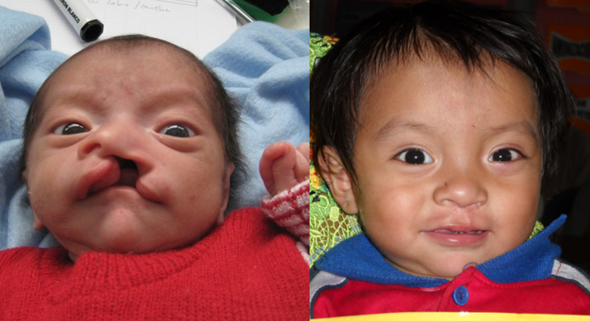

Partner for Surgery’s mission is to provide **impoverished Guatemalans** with sustainable access to medical and surgical care. We have a presence **year-round** in Guatemala, and our patients receive general and plastic surgery, as well as **specialized care** from gynecologists, neurologists, and urologists. From treating children with cleft palate to screening women for **cervical cancer**, we provide an array of medical and surgical services to patients who have no other options.

**Todd Peterson**, serving as a Peace Corps volunteer from 1997 to 1999, recalls two people in the rural village of Paquip who changed him forever:

*“The patriarch of my ‘adopted family’,* ***Don Ricardo****, had a band wrapped tightly around his waist. It concealed a* ***hernia he had endured for******25 years.******Virginia*** *never left her parents’ home in the daylight for 22 years because of her* ***cleft lip and palate.***

*“I convinced them both to travel with me to Antigua to seek help from a volunteer surgical team. Villagers began* ***raising money for their funerals*** *because they saw hospitals as places one went to die. They survived, and in fact* ***thrived!*** *Don Ricardo lived a long life with mobility, and* ***Virginia got married****. Their lives were changed, and* ***mine was too”.***

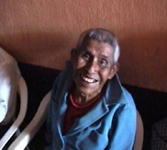

Todd’s parents visited Guatemala and were overwhelmed by what the people in Todd’s village had to endure. In 2001, Todd and his father **Frank** co-founded Partner for Surgery.

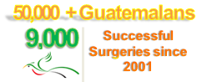

**Our Network**

**Provides cleft lip/palate child with one month of life-saving nutrition**

$ 35

$100

**Provides 10 women with cervical cancer screening/pre-cancerous cell treatment**

**Provides life-changing surgery for one child**

**Our Passion**

**Our Story**

$200

**provides for a volunteer nurse or doctor to serve in Guatemala for one week**