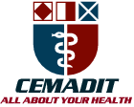
Research Center for Analytic Diagnosis and Imaging Trends (RECEADIT)
School of Health, Biomedical and Computer Sciences (SHBCS)
2021-2022 Academic Year
P.O. Box 19, Belo-Kom, Belo Sub-Division, Boyo Division, Cameroon, North-West Region,
Africa - Tel: + 1(910) 261-7785 or +237 6 52 49 78 82 or + (237) 6 77 68 99 32
cemadit@yahoo.com http://www.meditech-group.org
RECEADIT-CEMADIT Clinic Authorisation no/A/MINSANTE/SG/DOSTS/SDOS/SFSP
Motto: Health Care Research and Education for Services to Humanity

Motto: Health Care Research and Education for Services to Humanity

MEDITECH GROUP
CEMADIT
ALL ABOUT YOUR HEALTH

MEDITECH GROUP
RECEADIT
ALL ABOUT YOUR HEALTH

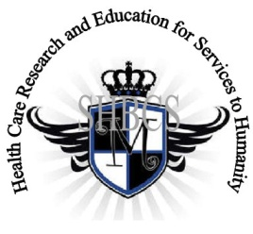

Ministry of Higher Education Ministry of Public Health Registration No. 3342 of August 31, 2011 Registration No. 4042 of August 31, 2011

GlobalGiving RECEADIT Mbam Community Health Care Project (29930)
Seventeenth Project Report of Monday, July 18^{th,} 2022
On behalf of our RECEADIT Humanitarian Team, I take this opportunity to thank you so very much for your generosity and willingness to join us and to partnership with us on our journey of serving humanity through the Guidance, the Blessings, the Love and the Grace of God Almighty.
We are glad to provide you with the following progress report and updates for our “Mbam Community Health Care Project (29930)” thanks to your generosity:
1) As we reported in our sixteenth Project Report, our main focus now is on our upgraded building program. For this Seventeenth Project Report, we want you to know that the Building update continues, with the addition of five rooms, attached to our Mbam Community Health Center, designed specifically to provide shelter for many of our Internally Displaced patients (See First, Second, Third, Fourth, and Fifth Illustration Photos);

2) This Seventeenth Project Report also continues to focus on our Increased Transportation Needs for our New Central Pharmacy Drug Program and the transportation of our Internally Displaced Patients, facilitated by our added four new Bikes which are instrumental in the Transportation and Distribution of Drugs/Medication, the transportation of our Internally Displaced Patients and other medical Equipment to RECEADIT Clinics at Kitchu, Mbam, Muteff, and Ngemsibo Remote, Rural Communities (See sixth, Seventh, Eighth, and Ninth Illustration Photos);

3) As we reported in our Sixteenth Project Report, the increase in malaria cases resulting from the onset of the Raining Season and the continued threat posed by Covid-19, has resulted in a continued increase in our Home and Community Visits, undertaken by our female and male nurses within the Kitchu, Mbam, Muteff and Ngemsibo remote, rural Communities where our RECEADIT Health Clinics are located (See Tenth and Eleventh Illustration Photos); and

4) Again, even though we have an Organized, Medical Training Program for all our RECEADIT workers and a New One Year Medical Training Program (See Twelfth Illustration Photo) , we must point out here once more, with lots of regrets and disappointment, that: a) the intensified war keeps interrupting the program ; and b) our School of Health, Biomedical and Computer Sciences (SHBCS), as well as all other schools in this part of the country, have not been operational since October 2016 due to the serious, ongoing political crisis and war in Cameroon.

We will continue to provide you with monthly reports and updates of our other projects, activities, accomplishments, and challenges.
We hope that you will continue with us on this our journey of serving humanity through the Guidance, the Blessings, the Love and the Grace of God Almighty, a journey which has taken us to this “Mbam Community Health Care Project” through our new link: https://goto.gg/29930

Jilly M. Ngwainmbi, RECEADIT Project Leader

Illustration Photos

First Illustration Photo

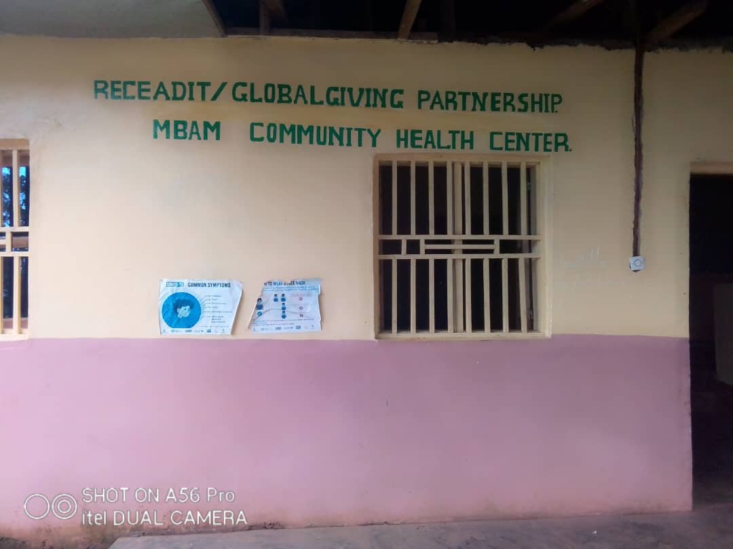

RECEADIT/GlobalGiving Partnership, Mbam Community Health Center

Second, Third, Fourth, and Fifth Illustration Photos Below are Five new Rooms Within Our Mbam Community Health Center, Designed to provide shelter for our Internally Displaced Patients.

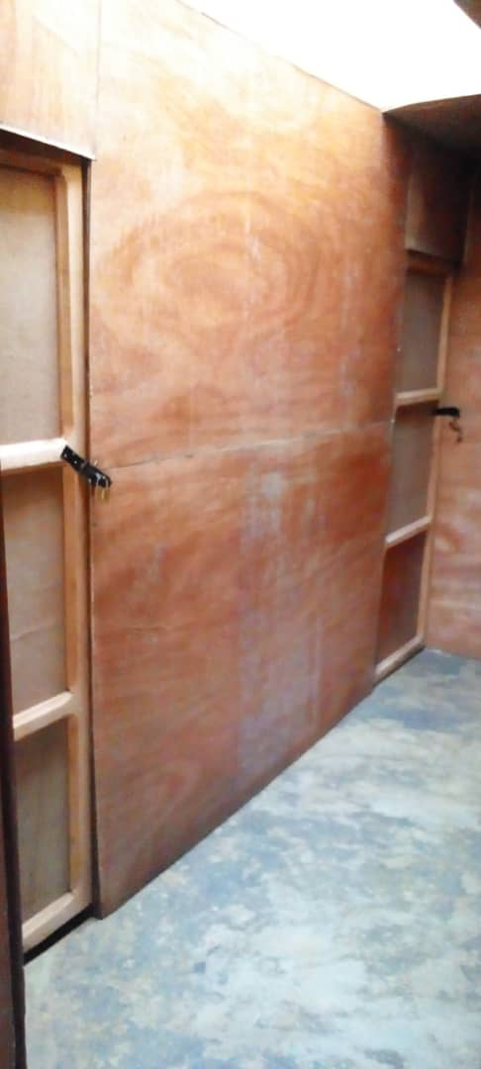
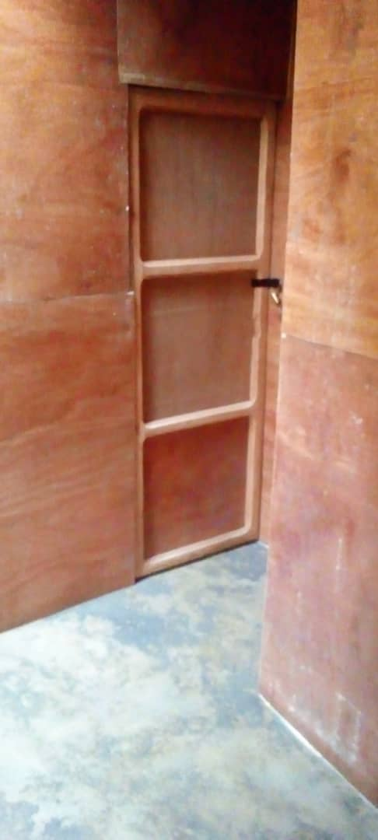
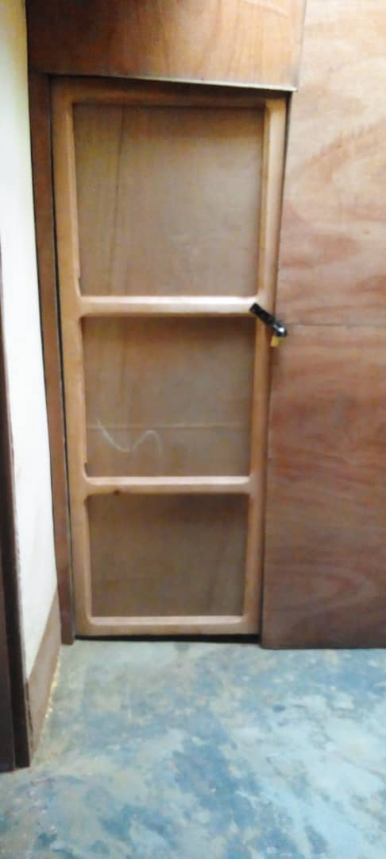
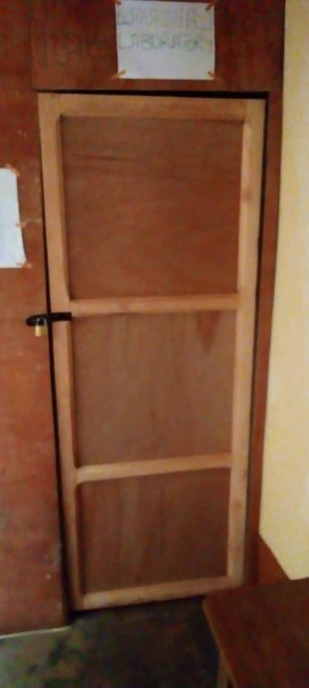

Sixth Illustration Photo

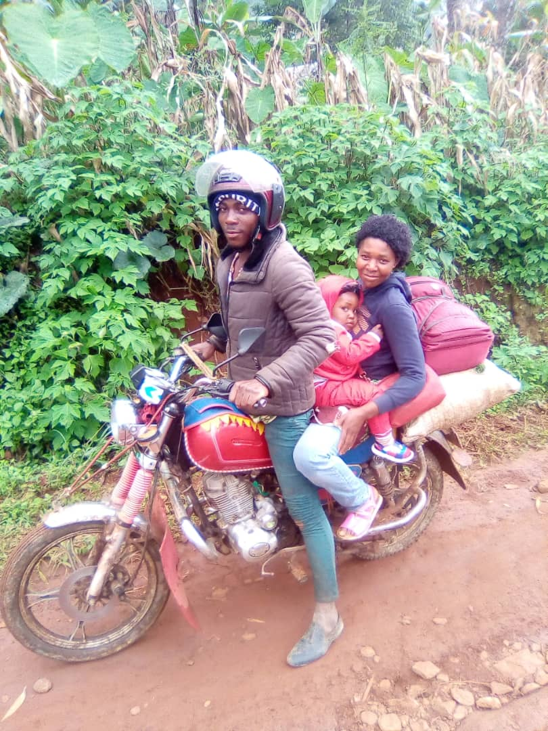

RECEADIT Biker Returning to RECEADIT Mbam Community Health Center with one Internally Displaced Patient and Her Child

Seventh Illustration Photo

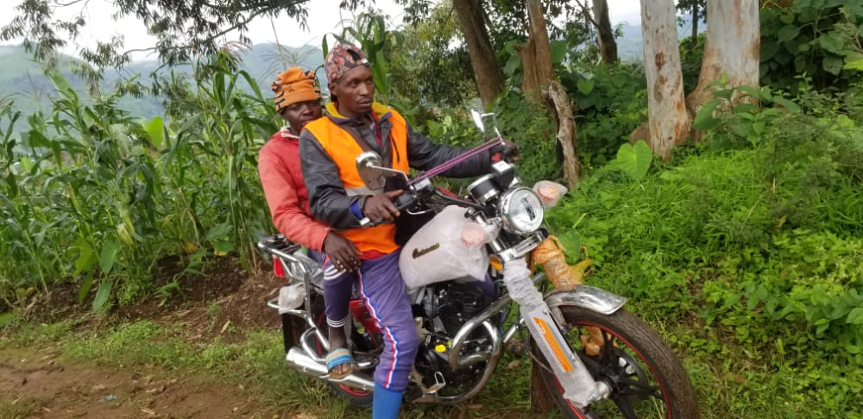
RECEADIT Biker Returning to RECEADIT Mbam Community Health Center with one Internally Displaced Patient

Eighth Illustration Photo

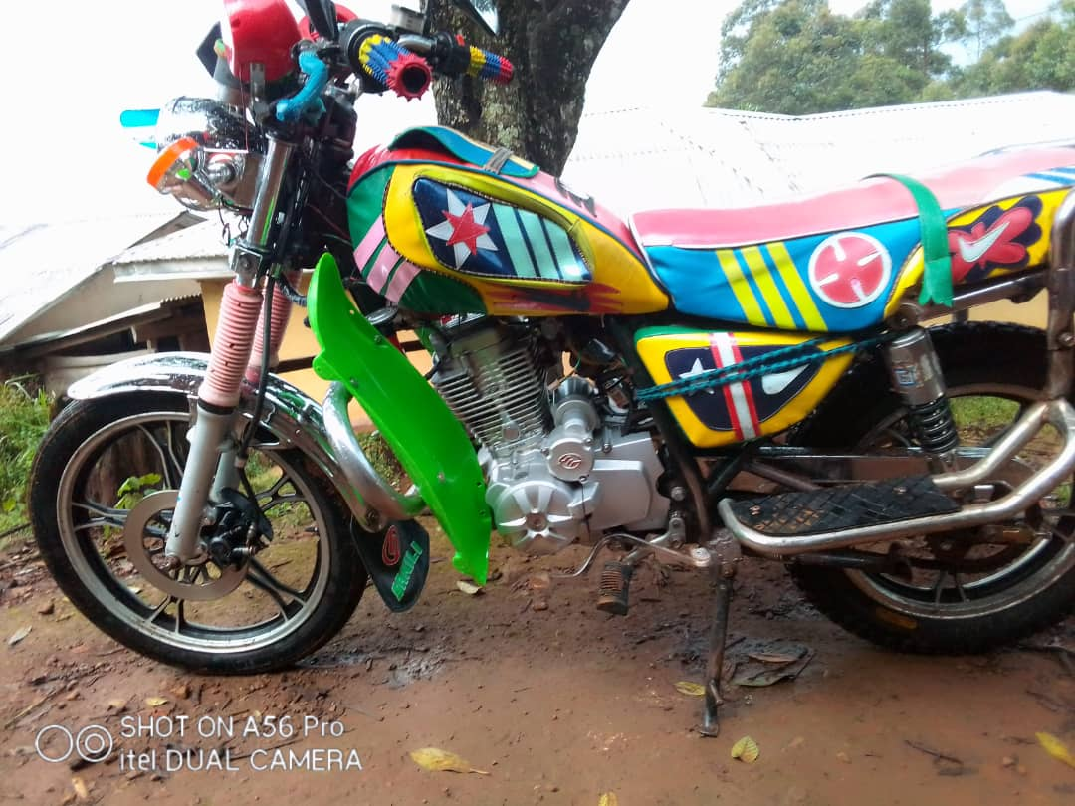
RECEADIT Bike Ready to Go Pick Up Internally Displaced Patients
Ninth Illustration Photo

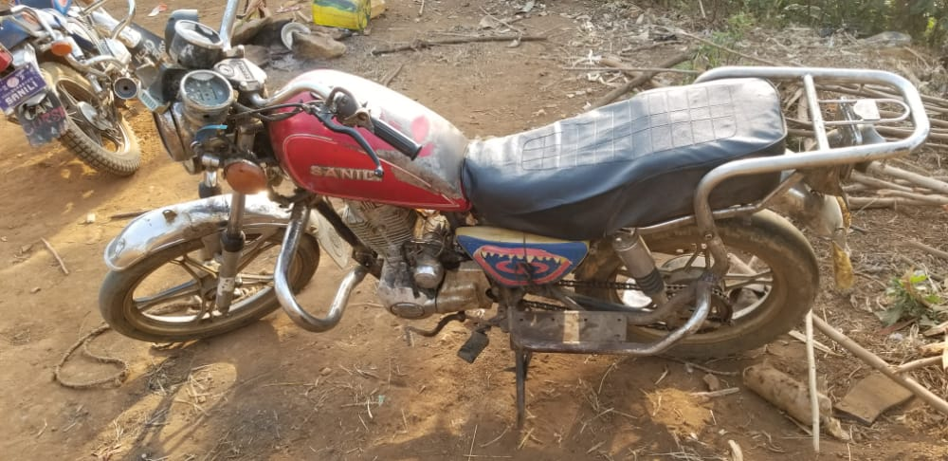

RECEADIT Bike Ready to Go Pick Up Internally Displaced Patients

Tenth Illustration Photo

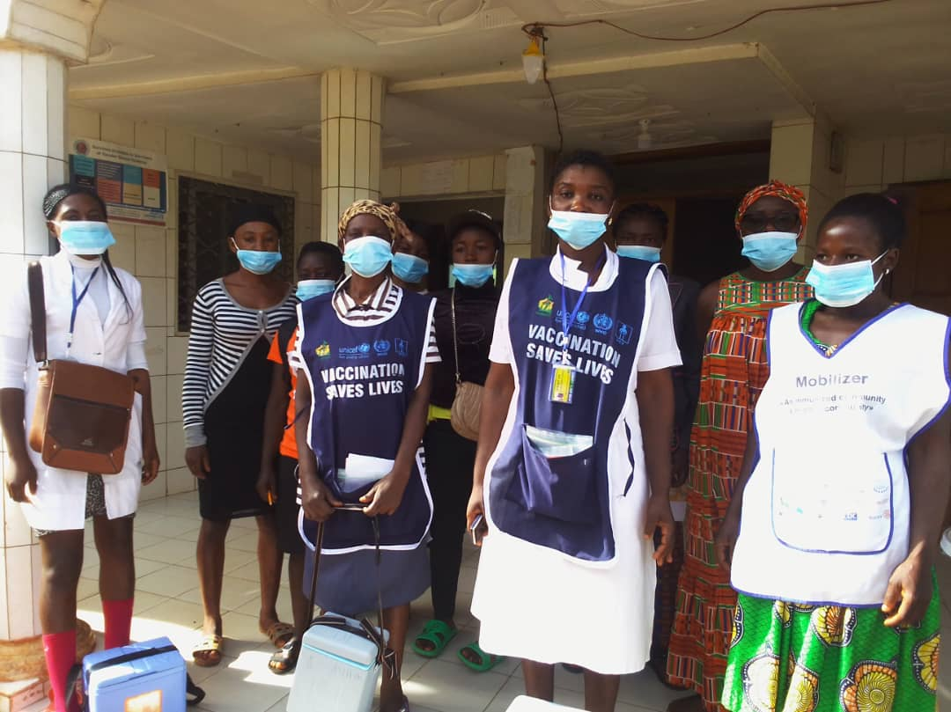

RECEADIT Female Nurses Ready for Their Community Vaccination Program

Eleventh Illustration Photo

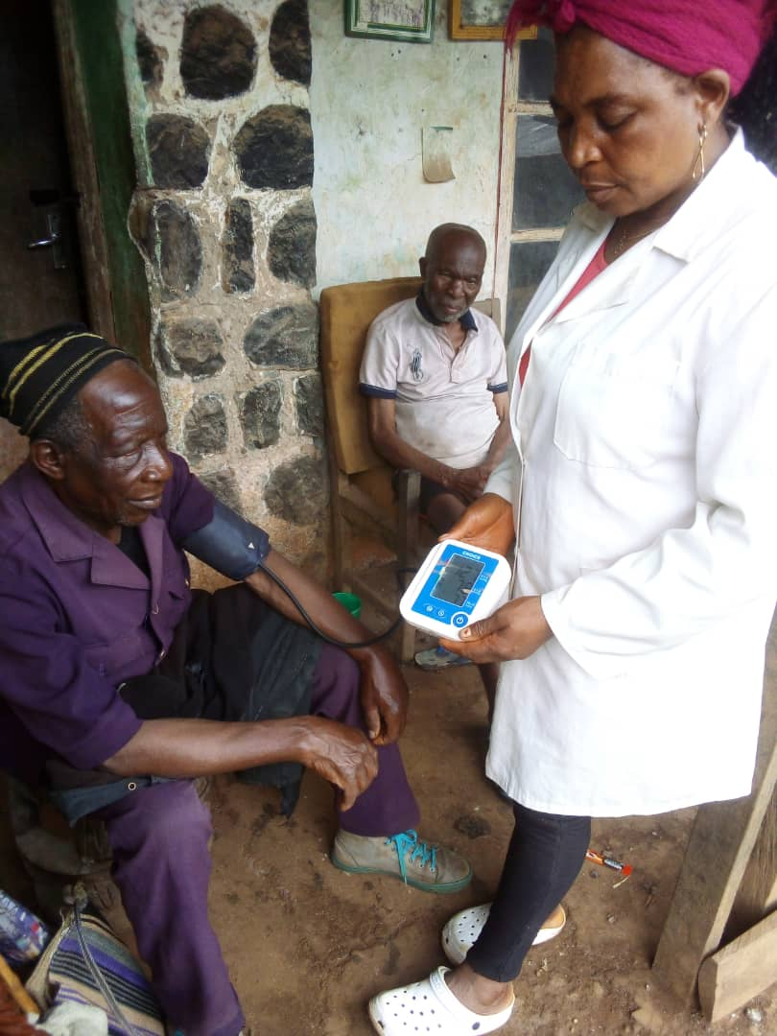

RECEADIT Female Nurse on Her Home Care Visit Attending to Patients

Twelfth Illustration Photo

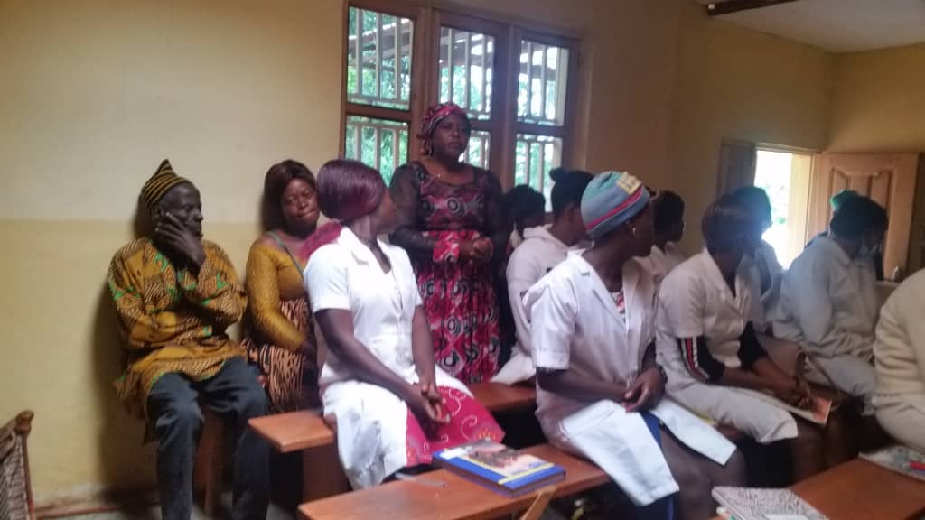

Students in the New One Year Medical Training Program Classes

