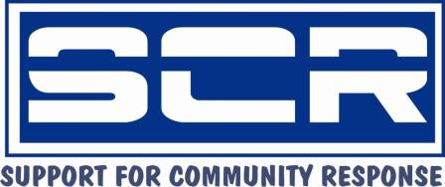
STIGMA REDUCTION WORKSHOP, 18th-19th July, 2012

The workshop was conducted at Tabora, Coast Province where the Afya HIV/AIDS support group meets. SCR worked with three group members who participated in the Positive Self Management Programme training to recruit participants and to carry out the training with another trainer who is conversant with this topic. During recruitment, priority was given to achieving a mixed group of participants, made up of those who have and have not overcome the stigma of living with the HIV virus, and those who are and are not part of a support group. Out of the total of 30 participants, 25 have not overcome stigma while 5 of them have (to the extent that they are able to share their HIV status without fear with their family members, friends and they can publicly share their status and experiences). 22 participants were from support groups and 8 participants have not joined any support group.

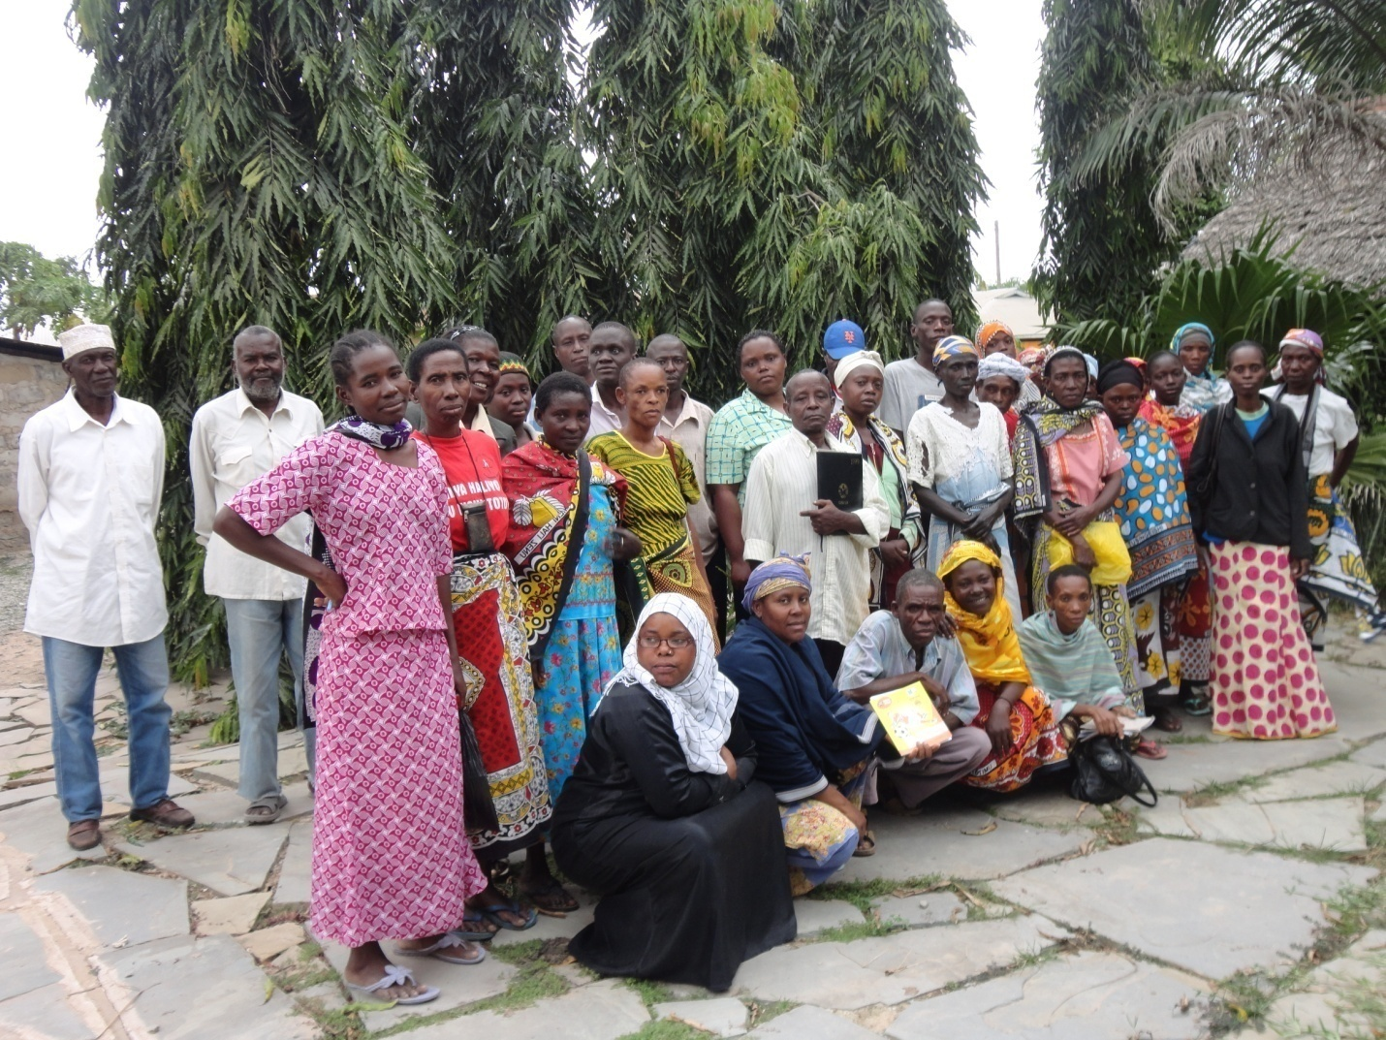

Participants pictured outside the training venue

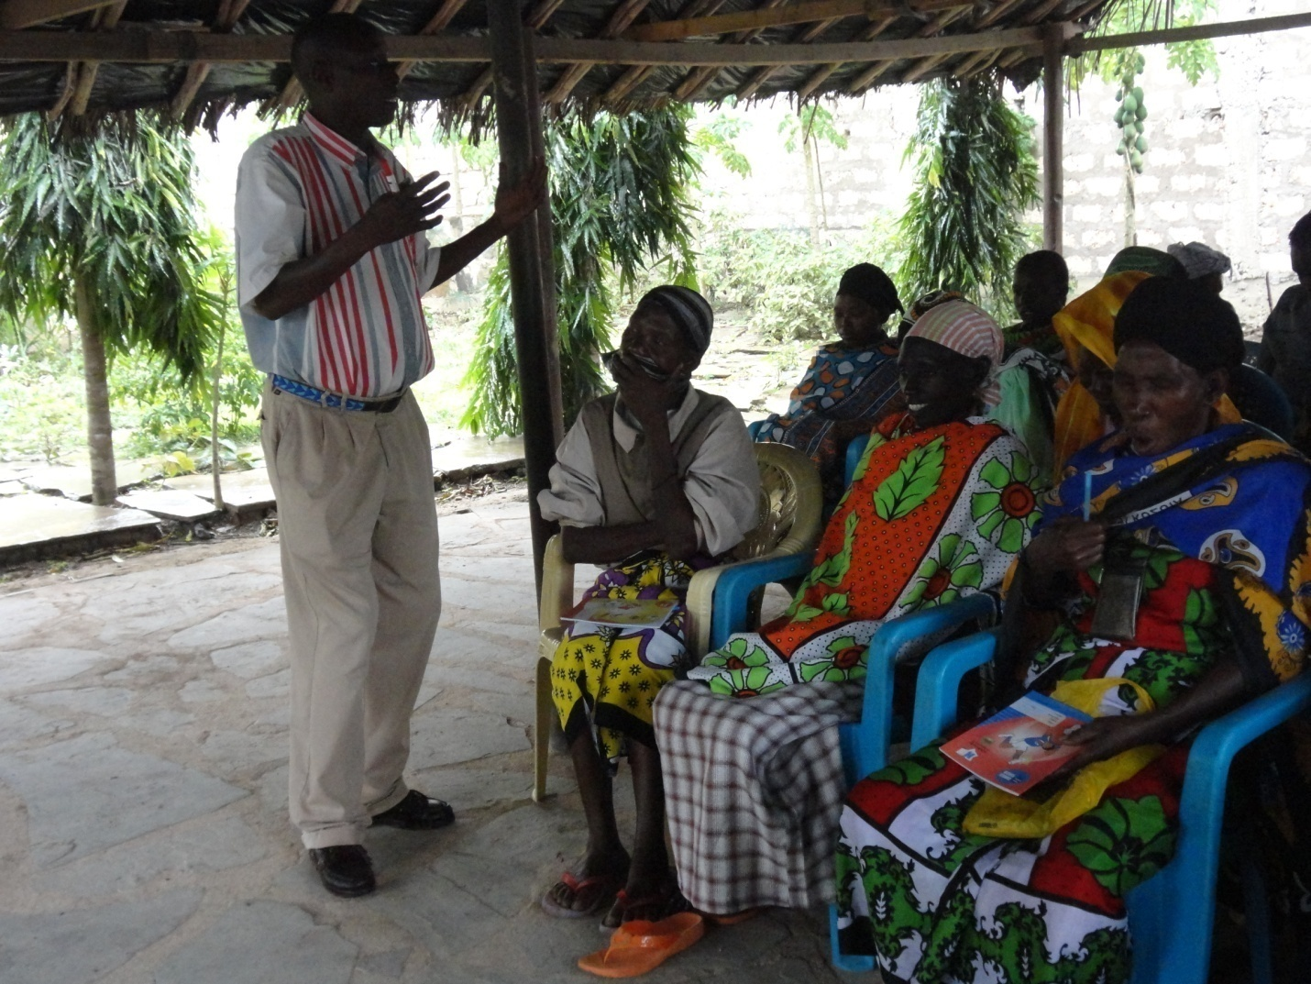

The Objective of the workshop was to help people living with HIV virus reduce both internal and external stigma so as to enable them live positively.

During the training the following topics were covered:
The current situation with regard to HIV/AIDS; Knowing/ disclosing your HIV status; Sharing of personal experiences sharing; Stigma/denial/ discrimination
Douglas Kaula giving a training session

Many participants shared their experience with HIV virus infection. The experiences were very touching (see examples in the Appendix). This sharing changed the perception of many on what they are going through either at home or outside home. This experience of sharing empowered participants in the fight against stigma, denial and discrimination.

Lessons learnt

- Many HIV positive people are suffering because they have not overcome stigma especially internal stigma (e.g. feelings of guilt. self-blame, etc.)
- Sharing experiences helps others to come out, thus overcoming stigma
- Disclosure is a long process and if not well handled can cause death
- Drug adherence is still a problem to many especially the old: over 50 years and above

Practical recommendations on how to deal with stigma

Participants made the following recommendations:
- Once a person is aware that is living with HIV virus he/she should accept that and be positive that the virus is not going to cause death immediately. They should seek medical help and join a support group.
- People living with the HIV virus should learn to disclose their HIV status to their close relatives and friends so that they can understand them and give them the necessary support whenever possible.
- Anyone living with the virus should try to keep him/herself busy .When idle they think a lot about their HIV positive status and get stressed in the process. They can run small businesses, attend religious meetings, visit and assist those in hospital and bed ridden.
- People living with HIV virus should go public and share their experiences so that those who are HIV positive can be empowered to overcome stigma and those who are HIV negative can accept and support those who are HIV positive.

Mwania Makau training on stigma reduction

An evaluation of the workshop found:
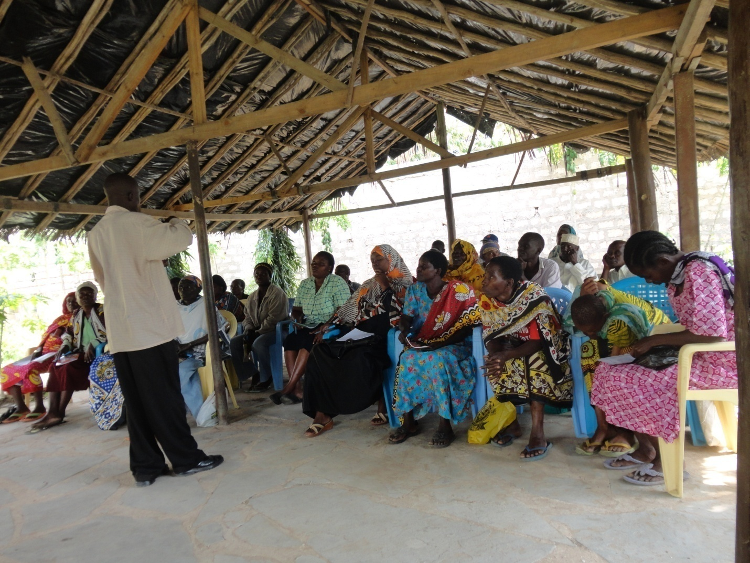
Challenges | How they were addressed | Recommendation for future
Training period was short | A few topics on stigma reduction were selected and discussed | Training session to take five days instead of two.
Low allowances | They were given the little that was assigned for them | Participants need a higher allowance to enable them buy food for the day they are in the workshop
Questions on other topics arose outside stigma reduction for example nutrition, drug adherence,  effects of ARVs | They were addressed lightly | These topics will be included in future training

Appendix One: Case Stories

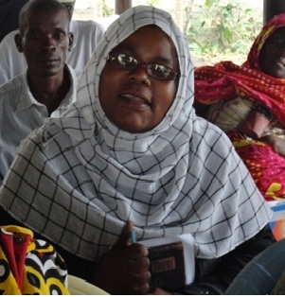
This is Mwanaisha from the Afya support group. Before she knew her HIV status she gave birth to her first born and after a few hours the infant died.

During her second pregnancy she was advised to learn her HIV status. She did not want to because she saw herself as healthy, but during the 7th month of the pregnancy she agreed to be tested. When she discovered that she was HIV positive she fainted, and when she gained consciousness the Hospital nurse took her home and she did not share this experience with anybody.

After giving birth she was advised by the hospital to breastfeed the baby exclusively for six months. After the sixth month the baby fell sick and suddenly died. Later she conceived again, but she had a miscarriage in the seventh month due to hypertension.

After all this she went back to the Voluntary Counseling and Testing (VCT) counselor who advised her to conceive after four years so as to allow her immunity to grow. After four years she discovered that her CD4 count was down to 900. She conceived and when she shared this with the husband he was angry, but later he accepted. At this level she overcame stigma, accepted her status and shared with other family members and finally to the public. Since she has gone public, the hospital staff were supportive and the doctor advised her to give birth through caesarian. She gave birth to twins (a boy and a girl) who are now 2 years old now and HIV negative. These children during their first year were supported with food by charitable organizations.

Mwanaisha says that she has her two children because she overcame stigma and she encourages anybody who is HIV positive to overcome stigma to avoid unnecessary suffering.
-----------------------------------------

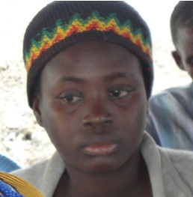
This is Tatu. In her home, while she was sick and bed ridden because of an opportunistic infection, her uncle found her brother washing the utensils she had used. The uncle caned the brother thoroughly and warned him never to wash them again but the brother continued nevertheless. After this experience, she managed to overcome her internal stigma and fear of telling others, and enlightened the family members on HIV/AIDS who have now accepted her. Today Tatu is happy as even the uncle shares with Tatu the same utensils during meal time.

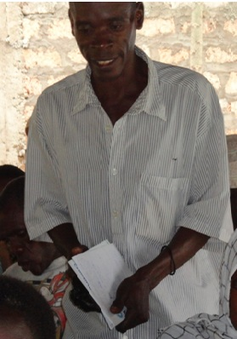
This is Hamisi Haji from the Mkilo support group. After he had just married, Hamisi became bedridden due to opportunistic infections caused by HIV virus infection.

After realizing that he was HIV positive he accepted the state, went home and told the wife who was shocked but after the wife realized that he was getting on well she also decided to know her HIV status. The husband escorted her to the VCT centre where she was tested and she tested HIV positive. Both of them accepted their status and Hamisi decided to share this information with the parent in-laws. The mother in-law was very bitter and rebuked them for going to VCT centre to know their HIV status because she did not find it necessary. Their visit was never enjoyable but with time she has accepted them and has seen the importance of what they did because they are doing well, otherwise they would have died a long time ago.

Appendix 2: Financial Report

STIGMA REDUCTION WORKSHOP
Income | Exchange Rate | Amount (£) | Total
Total received from Globalgiving/ICA:UK | 124.48 | 500 | 62,240
Expenditure
Line Item | Unit | Cost (Kshs) | Total
Participant lunch 30 pple x2 days @ksh 300 | 60 | 300 | 18,000
Training materials@ksh 10000 | 1 | 10000 | 10,000
Facilitation fee @ksh 1000 x 3 facilitators X 2 days | 6 | 1000 | 6,000
Supervision @ksh 1000 x 2 staff x3 days | 6 | 1000 | 6,000
venue @ksh2000 x 2 days | 2 | 2000 | 4,000
Preparation and set up | 1 | 5000 | 5,000
Stigma reduction specialist | 2 | 2000 | 4,000
participant transport 30 pple x2 days @ksh 100 | 60 | 100 | 6,000
Grand Total spent |  |  | 59,000
Balance (to be spent on follow up) |  |  | 3,240

